1) Selecione nome e dataNascimento dos alunos que começam com a letra "X".

[SELECT](http://localhost/phpmyadmin/url.php?url=https://dev.mysql.com/doc/refman/5.5/en/select.html) nome, dataNasc FROM leitor WHERE nome [LIKE](http://localhost/phpmyadmin/url.php?url=https://dev.mysql.com/doc/refman/5.5/en/string-comparison-functions.html#operator_like) 'L%'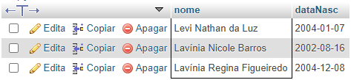

2)Selecione nome e telefone dos alunos que nasceram no mês x;

[SELECT](http://localhost/phpmyadmin/url.php?url=https://dev.mysql.com/doc/refman/5.5/en/select.html) nome, dataNasc FROM `leitor` WHERE month(dataNasc) = '08'

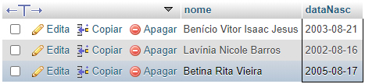

3)Selecione nome e telefone dos alunos que nasceram no ano x;

[SELECT](http://localhost/phpmyadmin/url.php?url=https://dev.mysql.com/doc/refman/5.5/en/select.html) nome, dataNasc FROM `leitor` WHERE [year](http://localhost/phpmyadmin/url.php?url=https://dev.mysql.com/doc/refman/5.5/en/date-and-time-types.html" \t "mysql_doc)(dataNasc) = '2003'

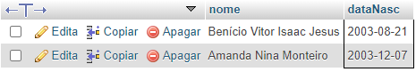

4) Ordene os alunos em ordem decrescente por Turma;

[SELECT](http://localhost/phpmyadmin/url.php?url=https://dev.mysql.com/doc/refman/5.5/en/select.html) nome, turma FROM `leitor` ORDER BY turma desc

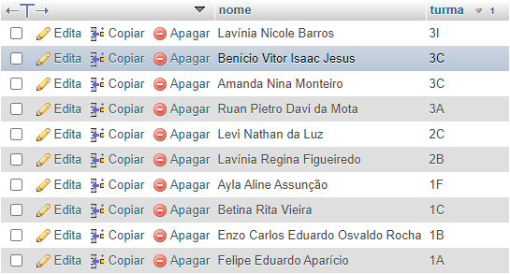

5) Selecione os livros do Gênero "X";

[SELECT](http://localhost/phpmyadmin/url.php?url=https://dev.mysql.com/doc/refman/5.5/en/select.html) titulo, genero FROM `livros` WHERE genero [LIKE](http://localhost/phpmyadmin/url.php?url=https://dev.mysql.com/doc/refman/5.5/en/string-comparison-functions.html#operator_like) 'Romance'

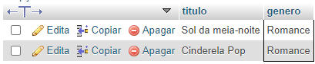

6) Quantos livros tem cadastrados;

[SELECT](http://localhost/phpmyadmin/url.php?url=https://dev.mysql.com/doc/refman/5.5/en/select.html) [COUNT](http://localhost/phpmyadmin/url.php?url=https://dev.mysql.com/doc/refman/5.5/en/group-by-functions.html#function_count)(\*) FROM `livros`



7) Selecione os livros do autor "X";

[SELECT](http://localhost/phpmyadmin/url.php?url=https://dev.mysql.com/doc/refman/5.5/en/select.html) titulo, autor, genero FROM `livros` WHERE autor [LIKE](http://localhost/phpmyadmin/url.php?url=https://dev.mysql.com/doc/refman/5.5/en/string-comparison-functions.html#operator_like) 'H.P. Lovecraft'

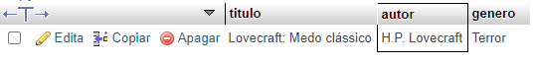

8) Selecione os empréstimos que aconteceram no mes "X";

[SELECT](http://localhost/phpmyadmin/url.php?url=https://dev.mysql.com/doc/refman/5.5/en/select.html) codEmprestimo, Empr, Dev FROM `emprestado\_devolvido` WHERE month(Empr) = '06'

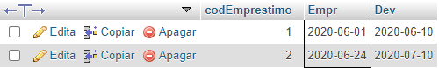

9) Selecione os empréstimos que aconteceram entre os anos "X" e "Y";

[SELECT](http://localhost/phpmyadmin/url.php?url=https://dev.mysql.com/doc/refman/5.5/en/select.html) codEmprestimo, Empr, Dev FROM `emprestado\_devolvido` WHERE Empr BETWEEN '2018-01-01' [and](http://localhost/phpmyadmin/url.php?url=https://dev.mysql.com/doc/refman/5.5/en/logical-operators.html" \l "operator_and" \t "mysql_doc) '2019-12-31'

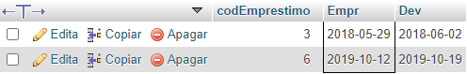

10) Selecione os bibliotecarios que são da cidade "X";

[SELECT](http://localhost/phpmyadmin/url.php?url=https://dev.mysql.com/doc/refman/5.5/en/select.html) nome, cidade FROM `bibliotecario` WHERE cidade [LIKE](http://localhost/phpmyadmin/url.php?url=https://dev.mysql.com/doc/refman/5.5/en/string-comparison-functions.html#operator_like) 'Ribeirão Pires'

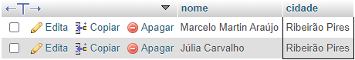

11)Ordene os bibliotecarios em ordem alfabética;

[SELECT](http://localhost/phpmyadmin/url.php?url=https://dev.mysql.com/doc/refman/5.5/en/select.html) nome FROM `bibliotecario` ORDER BY nome

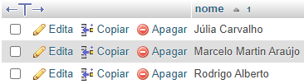

12) Ordene os livros por gênero;

[SELECT](http://localhost/phpmyadmin/url.php?url=https://dev.mysql.com/doc/refman/5.5/en/select.html) titulo, genero FROM `livros` ORDER BY titulo

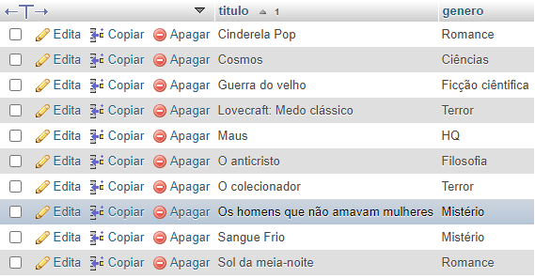

13) Selecione os livros da editora "X";

[SELECT](http://localhost/phpmyadmin/url.php?url=https://dev.mysql.com/doc/refman/5.5/en/select.html) titulo, genero, editora FROM `livros` WHERE editora [LIKE](http://localhost/phpmyadmin/url.php?url=https://dev.mysql.com/doc/refman/5.5/en/string-comparison-functions.html#operator_like) 'Companhia das letras'

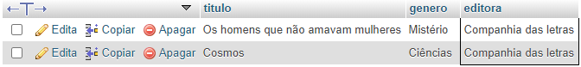

14) Selecione os livros dos autores "X" ou genero "Y" e que tenham menos de "Z" páginas;

[SELECT](http://localhost/phpmyadmin/url.php?url=https://dev.mysql.com/doc/refman/5.5/en/select.html) titulo, genero, autor, pag FROM `livros` WHERE (autor [LIKE](http://localhost/phpmyadmin/url.php?url=https://dev.mysql.com/doc/refman/5.5/en/string-comparison-functions.html#operator_like) 'Nietzche' [or](http://localhost/phpmyadmin/url.php?url=https://dev.mysql.com/doc/refman/5.5/en/logical-operators.html#operator_or) genero [LIKE](http://localhost/phpmyadmin/url.php?url=https://dev.mysql.com/doc/refman/5.5/en/string-comparison-functions.html#operator_like) '%Romance%') [and](http://localhost/phpmyadmin/url.php?url=https://dev.mysql.com/doc/refman/5.5/en/logical-operators.html#operator_and) pag<400

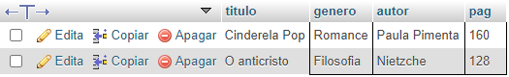

15) Selecione os livros com titulo que começam com a letra "X" e genero "X";

[SELECT](http://localhost/phpmyadmin/url.php?url=https://dev.mysql.com/doc/refman/5.5/en/select.html) titulo, genero FROM `livros` WHERE titulo [LIKE](http://localhost/phpmyadmin/url.php?url=https://dev.mysql.com/doc/refman/5.5/en/string-comparison-functions.html#operator_like) 'S%' [and](http://localhost/phpmyadmin/url.php?url=https://dev.mysql.com/doc/refman/5.5/en/logical-operators.html#operator_and) genero [LIKE](http://localhost/phpmyadmin/url.php?url=https://dev.mysql.com/doc/refman/5.5/en/string-comparison-functions.html#operator_like) '%Mistério%'



16) faça a média de paginas de todos os livros;

[SELECT](http://localhost/phpmyadmin/url.php?url=https://dev.mysql.com/doc/refman/5.5/en/select.html) [AVG](http://localhost/phpmyadmin/url.php?url=https://dev.mysql.com/doc/refman/5.5/en/group-by-functions.html#function_avg)(pag) FROM `livros`



17) faça a soma de páginas de todos os livros;

[SELECT](http://localhost/phpmyadmin/url.php?url=https://dev.mysql.com/doc/refman/5.5/en/select.html) [SUM](http://localhost/phpmyadmin/url.php?url=https://dev.mysql.com/doc/refman/5.5/en/group-by-functions.html#function_sum)(pag) FROM `livros`



18) Selecione os livros que tenham entre 4 e 6 exemplares

[SELECT](http://localhost/phpmyadmin/url.php?url=https://dev.mysql.com/doc/refman/5.5/en/select.html) titulo, exe FROM `livros` WHERE exe BETWEEN '4' [and](http://localhost/phpmyadmin/url.php?url=https://dev.mysql.com/doc/refman/5.5/en/logical-operators.html#operator_and) '6'

