# Motiro Status Report

## Motiro usage data

As of 06-December-2024, the Motiro app has been used by:

* 9141 volunteers
* 1324 staff
* from 572 teams
* belonging to 35 RCRC entities.

The Motiro app (https://motiro.com) works in 11 languages including the four official IFRC languages.

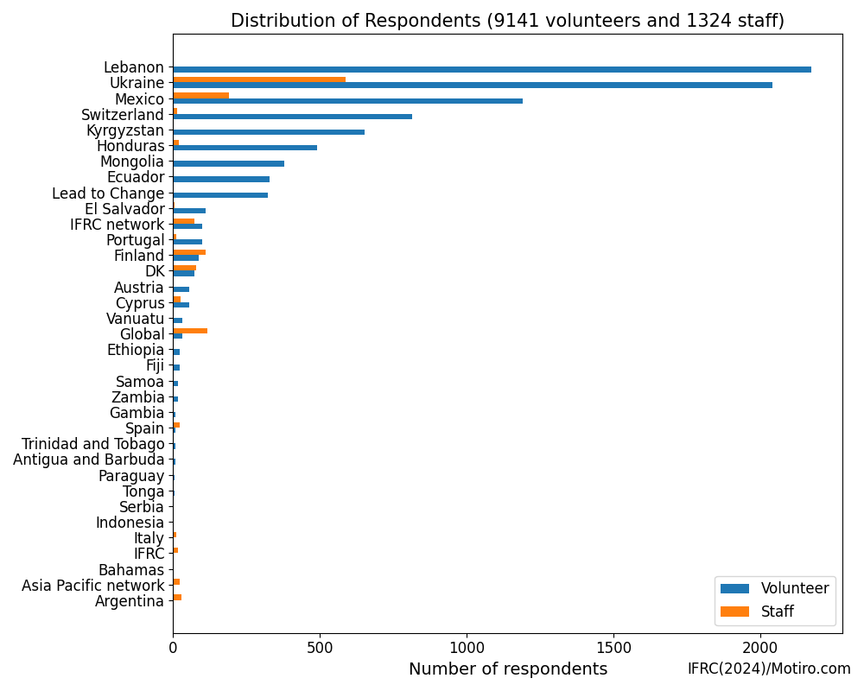

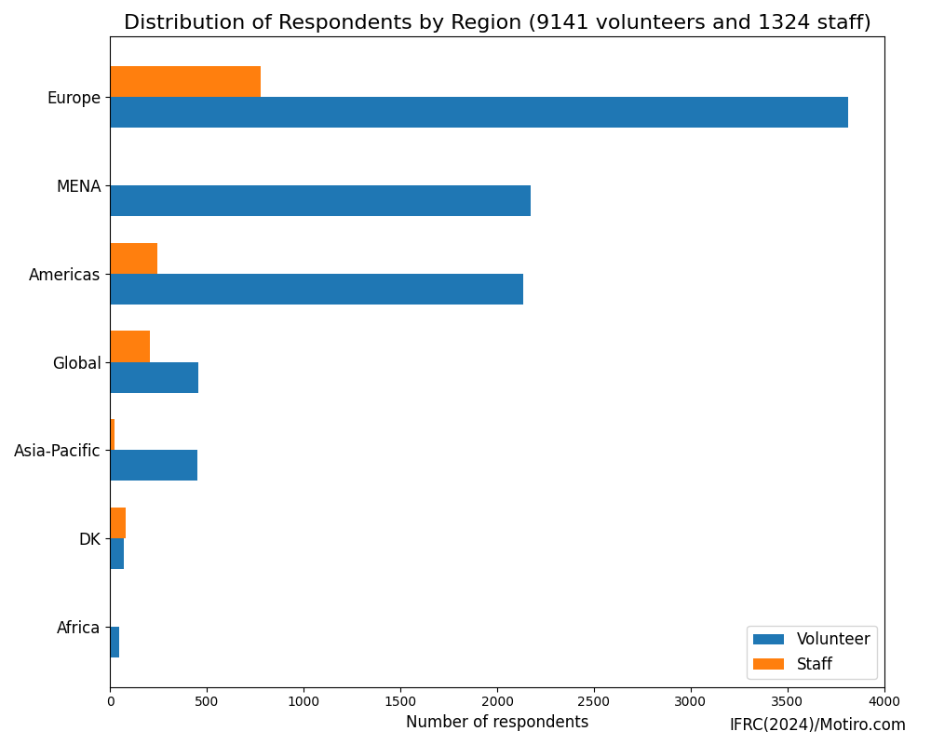

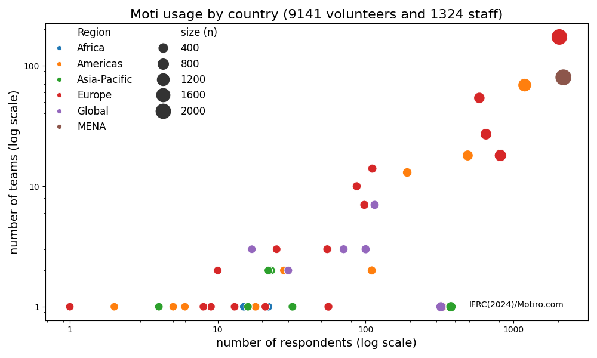

## Motiro findings

The app has been used to collect and analyse data on motivation to answer the following questions:

* What is the quality of volunteer and staff motivation and engagement?
* What are the key drivers of motivation and engagement?
* What motivates volunteers and staff to stay engaged in their team?
* What are the pathways toward improved motivation, engagement and well-being?

