20161795 고가해

The Sort reports.

RECT DATA SCREEN

for (int i = 0; i < MAX_SIZE; i++) {

printf("kuangdu:%f, gaodu:%f didian:%f\r\n", (shuzu + i)->width, (shuzu + i)->gaodu,(shuzu+ i)->kuandu* (shuzu+ i)->gaodu);

}

Realize method

4 method and the idea is come from the sort method

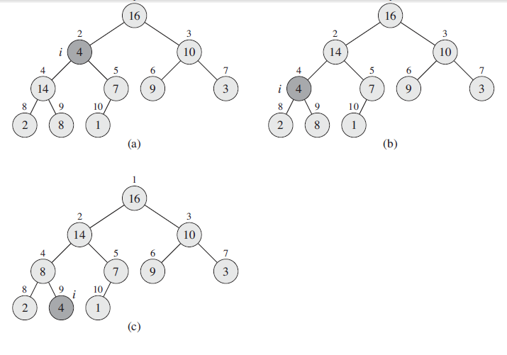

I used malloc to divide function and made the sort ,but if the data is too large the program will be error in this test and open register and assembly program.

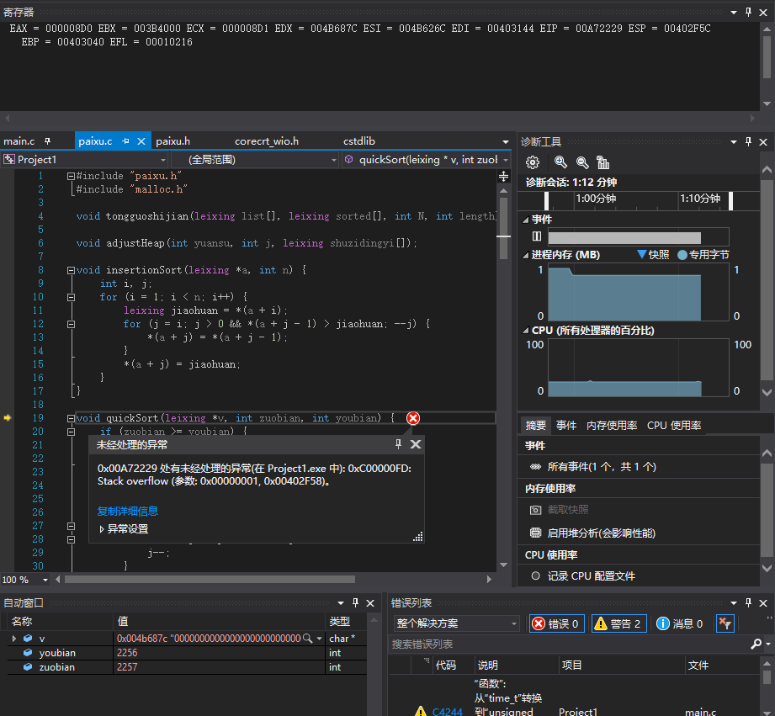

**void** heapSort(leixing *shuziji, **int** shuzi) {  
the most important algorithm is heapsort   
 **for** (**int** i = shuzi / 2 - 1; i >= 0; i--) {  
firstly i creatmax heap  
 adjustHeap(i, shuzi, shuziji);  
 }  
secondly i adjusted the heap structure exchange the heap element **and** ending element  
 **for** (**int** j = shuzi - 1; j > 0; j--) {  
  
 leixing jiaohuan = shuziji[0];  
 shuziji[0] = shuziji[j];  
 shuziji[j] = jiaohuan;  
  
 adjustHeap(0, j, shuziji);adjust heap  
 }  
}

The result

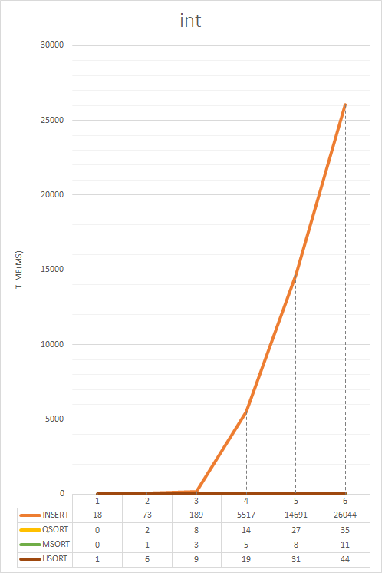int testing function

(void zhengshu(leixing * shuju);

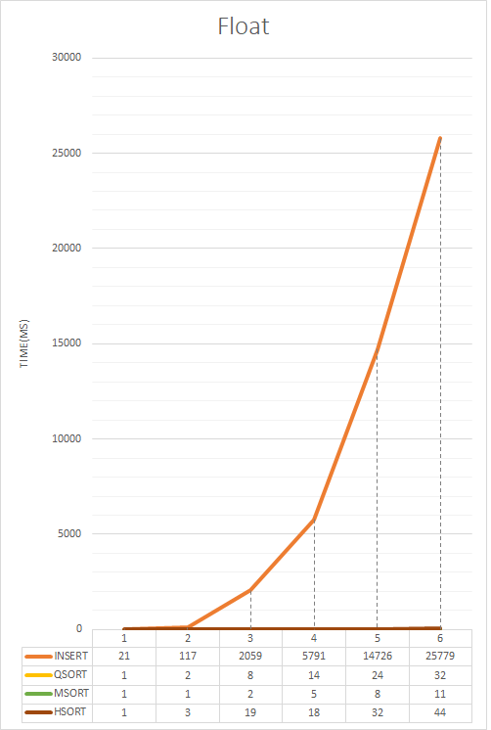And you should change the function in the head file

Float

void fudian(leixing * shuju)

And you should change the function in the head file

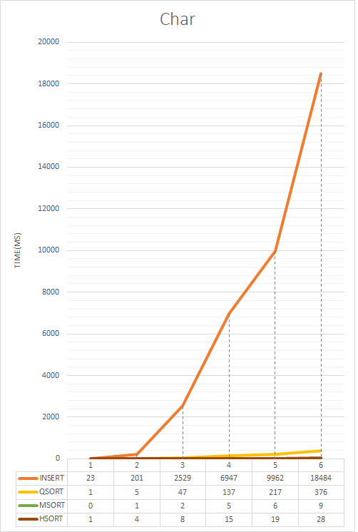Character’s testing data is over the standard the asm file has the error so I changed testing data

void zifu(leixing * shuju)

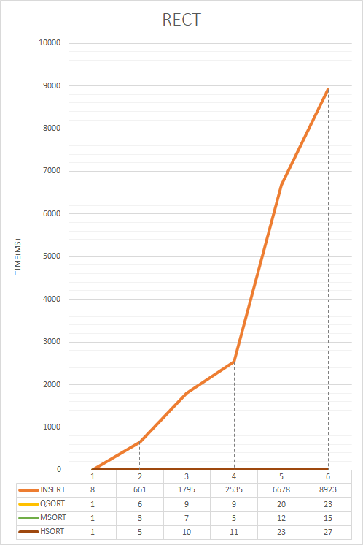And you should change the function in the head file

RECT’s testing code is also being too large so I changed the testing data and also used insert/quick/merge/heap sort

Reference data

https://blog.csdn.net/shaya118/article/details/41053833

http://blog.chinaunix.net/uid-25933104-id-3538914.html

https://blog.csdn.net/lgg201/article/details/5018463

https://blog.csdn.net/gl486546/article/details/54744232

https://blog.csdn.net/iluckyning/article/details/8140959

https://blog.csdn.net/gl486546/article/details/54707307

https://blog.csdn.net/pegasuswang_/article/details/20702919