RentEase:
Boarding House Rental Management System
Project Proposal
In Partial Fulfillment of the Requirements for Web Technologies

Prepared By:
Duterte, Gabriel Ryan P.
Embol, Angelika Jane
Evasco, Blamen N.

April 21, 2026

I. Project Overview
Finding suitable boarding accommodation remains a significant challenge for students, working individuals, and their parents or guardians due to fragmented information, reliance on manual inquiries, and the absence of a centralized management system. Most boarding house transactions are conducted offline through phone calls, walk-in visits, or informal social media postings, making it difficult to accurately verify room availability, rental status, and boarding conditions. Furthermore, rent monitoring and tenant record-keeping are commonly performed manually, increasing the likelihood of errors, delays, and miscommunication between landlords and tenants.
Existing literature and related platforms highlight the effectiveness of web-based rental systems in improving accessibility, transparency, and operational efficiency by allowing users to view, compare, and evaluate accommodation options more conveniently. Features such as digital reservation tracking, automated reporting, and role-based access control have been shown to significantly enhance the ability of landlords and administrators to manage tenants effectively, while digital monitoring tools provide parents and guardians with greater assurance regarding the safety and accommodation status of their dependents.
Despite these advancements, many existing systems lack functionalities specifically tailored for boarding house operations. Most do not support rent status monitoring, monthly income reporting, parent or guardian access, or detailed tenant history tracking. Moreover, there is often no centralized system capable of managing rooms, tenants, reservations, and financial records within a single boarding house while providing proper administrative oversight and audit trails.
To address these limitations, the proposed Boarding House Rental Management System (RentEase) is a centralized web-based platform designed to efficiently manage the full operations of a single boarding house. The system supports all three user roles — seekers, landlords, and administrators — and incorporates features such as reservation management, rent payment monitoring, monthly income reporting, and parent or guardian access for monitoring the boarding and payment status of their dependents. Through these capabilities, RentEase promotes transparency, accountability, and efficient boarding house management.

II. System Requirements and Features
2.1 User Levels
The system supports three distinct roles with specific permissions:

User Role | Access Permissions
User (Seeker /Boarder/ Tenant / Parent / Guardian) | Search rooms, submit reservations, and monitor rent status.
Owner / Landlord | Manage room listings, approve reservations, and track tenant payments.
Administrator | Oversee system activity, manage accounts, and maintain data integrity.

2.2 Core System Features
A. User Features
- Create and manage personal user profiles
- View available rooms within the boarding house and locational amenities
- Access detailed rental information, house rules, and room availability
- Submit room reservation or application requests
- Monitor reservation status and rent payment status
- Enable parent or guardian access for monitoring boarding and payment information
- Feedback / Ratings
B. Owner / Landlord Features
- Manage boarding house profile information
- Create, update, manage room details, including availability, pricing, and capacity
- Approve or reject room reservation requests
- Monitor tenant occupancy and room reservation request
- Track rent payment status (paid or unpaid)
- Generate monthly income summaries
- Reports
C. Admin Features
- Manage user and landlord accounts
- Monitor overall system activity and usage
- Generate comprehensive system reports (financial, occupancy, reservations)
- Ensure data accuracy, system integrity, and security compliance
- Control and oversee audit logs and system configurations

2.3 Monitoring, Reports, and Logs
A. Auto-Generated Reports
- Monthly rental income reports
- Rent payment status reports (paid and unpaid tenants)
- Occupancy and room availability reports
- Reservation and application statistics
B. User Activity Logs
- Record user actions such as login, reservation submissions, and approval decisions
- Track the identity of users performing specific actions and the corresponding date and time
C. Error Logs
- Automatically capture and store system errors
- Record error codes, affected users, date, and time
- Assist administrators in debugging and ongoing system maintenance

2.4 Non-Functional Requirements
The following non-functional requirements define the quality standards the system must meet:

Requirement | Description
Reliability | Ensures accurate data processing for all financial and reservation records with no data loss.
Security | Role-based access control (RBAC) is implemented to protect sensitive tenant and financial information.
Performance | Pages must load within 3 seconds; reservation and payment updates must reflect promptly across all users.
Accessibility | The system provides a responsive web interface accessible via both desktop and mobile browsers.
Scalability | The system architecture supports future expansion to accommodate additional rooms or boarding house units.

III. Technical Stack
The following technologies will be used in the development and deployment of RentEase:

Layer | Technology | Purpose
Frontend | HTML, CSS, React,JS | UI structure, styling, and dynamic component rendering
Backend | PHP(Laravel) | Server-side logic, API endpoints, and business rules
Database | MySQL | Relational data storage for users, rooms, payments, and logs
Web Server | Apache (XAMPP) | Local development server and HTTP request handling

React will be used as the frontend library for building a dynamic and responsive user interface, enabling real-time updates to room availability, reservation status, and payment records without full page reloads. PHP will handle all server-side operations including user authentication, data processing, and communication with the MySQL database. Apache via XAMPP will serve as the local development environment throughout the project lifecycle.

IV. Scope and Limitations
4.1 Scope
RentEase is designed to manage the full operations of a single boarding house. The system covers the following functional areas:
- User registration, authentication, and profile management for all three roles
- Room listing, availability management, and reservation processing
- Rent payment status tracking (paid or unpaid) and monthly income reporting
- Parent and guardian access for monitoring tenant boarding and payment status
- Administrative oversight including account management, audit logs, and system-wide reports

4.2 Limitations
The following are explicitly outside the scope of this system:
- Actual online payment processing — the system records and tracks payment status only; no payment gateway integration is included
- Multi-property management — the system is designed exclusively for a single boarding house
- Native mobile applications the system is web-based and accessed through a browser only
- SMS or email notifications — communication features are limited to in-system status monitoring

V. Data Flow Diagram (DFD)
5.1 DFD Level 0 — Context Diagram
The Boarding House Rental Management System serves as the central process that interacts with three external entities: User (Seeker/Parent/Guardian), Owner/Landlord, and Administrator.
Users provide registration data, login credentials, search queries, and reservation requests to the system. In return, they receive room information, reservation status, and rent payment status.
Owners/Landlords submit room details, reservation approvals, and payment updates, and receive tenant lists, reservation details, and income reports.
Administrators interact with the system by managing user accounts, system configurations, and report requests, and receive system reports, activity logs, and error logs.
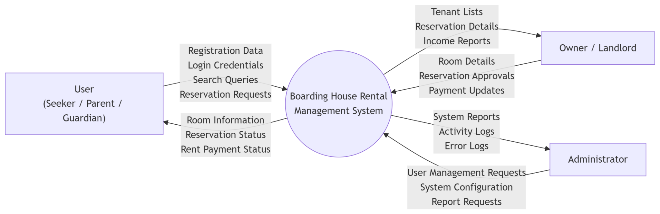

5.2 DFD Level 1 — Major Processes
The system is composed of the following major processes:

# | Process | Description
1.0 | User Management | Handles user registration, authentication, and profile management
2.0 | Boarding House and Room Management | Manages room details, pricing, and availability
3.0 | Reservation Processing | Processes reservation requests, approvals, and status updates
4.0 | Rent and Income Monitoring | Tracks rent payment status and generates monthly income reports
5.0 | Logging and Reporting | Records user activity logs, error logs, and generates system reports

Data flows between these processes and the system database to ensure accurate, secure, and up-to-date information is available to all authorized users.

Data Flow Description
- User Management exchanges registration data, login credentials, and user profiles with D1 (Users)
- Room Management sends and retrieves room details and availability data from D2 (Rooms)
- Reservation Processing handles reservation requests and status updates stored in D3 (Reservations)
- Rent Monitoring processes payment updates and rent status stored in D4 (Payments)
- Reporting and Logs collects activity data and error records stored in D5 (Logs)
These processes ensure accurate, secure, and real-time data flow across the system.
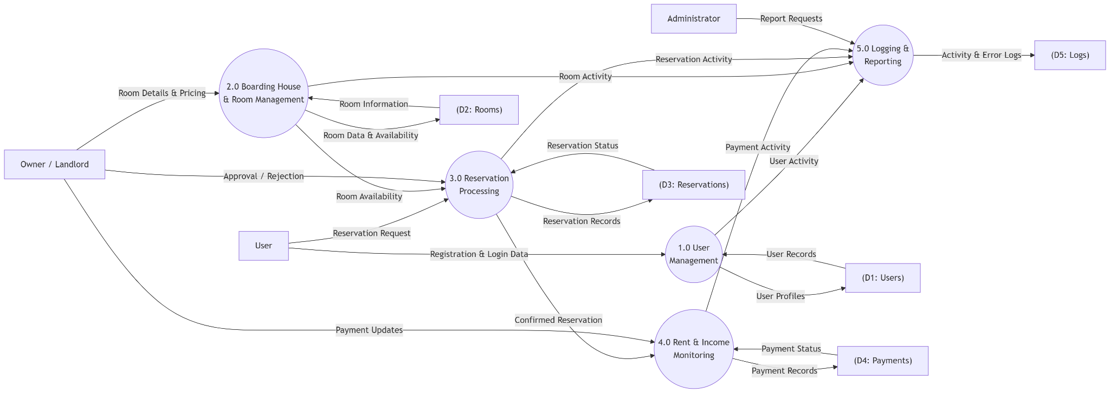

VI. Entity-Relationship Diagram (ERD)
6.1 Overview
The Entity-Relationship Diagram (ERD) defines the data structure of the RentEase system. It identifies the core entities, their attributes, and the relationships between them. The database is normalized to minimize data redundancy and ensure referential integrity across all system operations, including user management, room reservations, rent monitoring, and system logging.
6.2 Entities and Attributes
The system consists of seven core entities:
Users stores the account information for all system users regardless of role. Key attributes include user ID, full name, email address, password hash, role (seeker, parent, owner, or administrator), contact number, account status (active or inactive), and account creation date.
BoardingHouse holds the profile information of the boarding house managed by the owner. Key attributes include boarding house ID, owner ID, house name, address, description, and house rules.
Rooms contains the details of each room within the boarding house. Key attributes include room ID, boarding house ID, room number, room type, capacity, monthly rate, amenities, and availability status.
Reservations records all room reservation requests submitted by users. Key attributes include reservation ID, user ID, room ID, date submitted, move-in date, status (pending, approved, or rejected), and remarks.
Payments tracks the rent payment records for each tenant. Key attributes include payment ID, reservation ID, user ID, room ID, amount due, amount paid, payment status (paid or unpaid), payment date, billing period covered, and recorded by (landlord user ID).
ActivityLogs captures all significant user actions within the system for audit purposes. Key attributes include log ID, user ID, action performed, affected module, and timestamp.
ErrorLogs automatically records system errors to assist administrators in maintenance and debugging. Key attributes include error ID, error code, error message, affected user ID, and timestamp.
6.3 Relationships
The relationships between entities are as follows. A User may submit zero or more Reservations, but each Reservation belongs to exactly one User. A Room may be associated with zero or more Reservations, but each Reservation references exactly one Room. An approved Reservation may generate zero or more Payment records, and each Payment is linked to exactly one Reservation, one User, and one Room. A BoardingHouse contains one or more Rooms, and each Room belongs to exactly one BoardingHouse. A User who holds the Owner role manages exactly one BoardingHouse. All user actions are recorded in ActivityLogs, where each log entry references exactly one User. Each ErrorLog entry may optionally reference one User, identifying the account associated with the error at the time it occurred.

