Jaci Brown  
Amanda Riley  
Gabriel Sanchez-Jorgensen  
Hlee Xiong

2/22/24  
CSD310-O316  
Case Study Project Milestone 2 (Group 9)

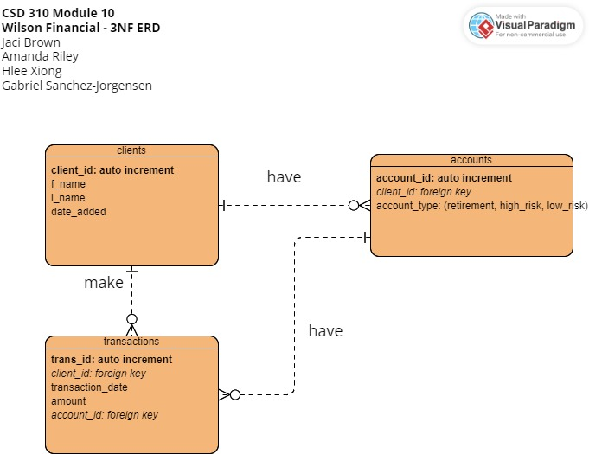

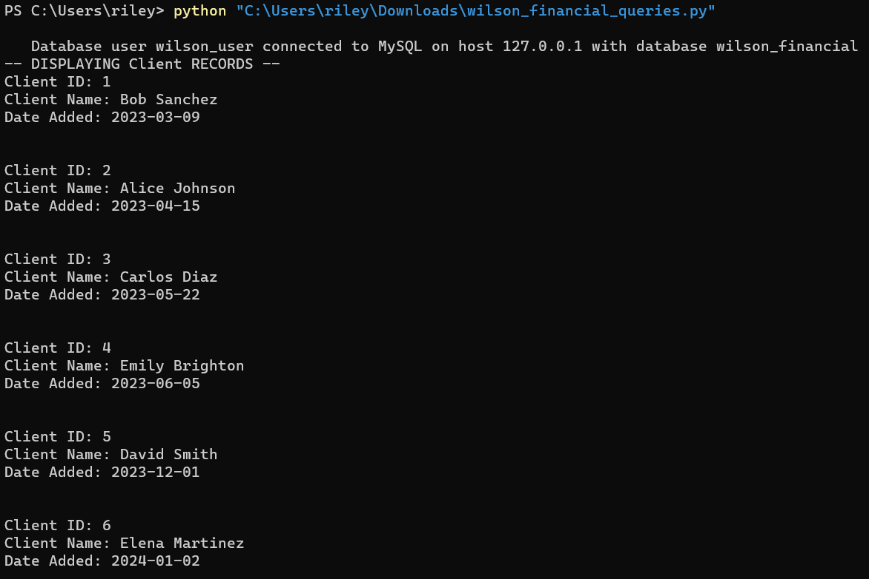

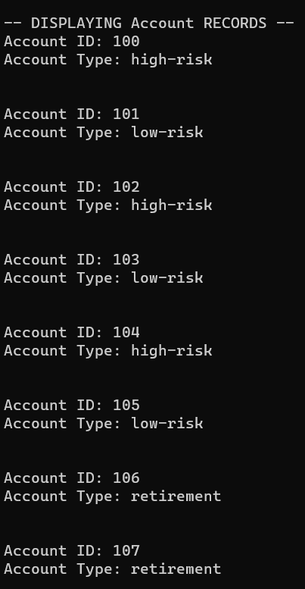

Note: Only first 8 and last 7 records pasted here due to the large number of transactions.

