Gabriel Sanchez-Jorgensen

Assignment Module 5.2

4/7/2024

Interview with Peter Sanchez Jorgensen

Can you share a memorable story from your childhood that you believe has shaped who you are today?

“At the end of middle school my class had a field trip to Washington D.C. It was really cool to see the capital, visit government buildings, see the Smithsonian and learn about history and the U.S. I also got to meet Maxwell Frost, the youngest representative in Maxwell Frost. It was a really great experience that made me want to get involved in government and politics.”

What are your most passionate hobbies, and how did you get involved with them?

“I’m a member of the boy scouts, I practice karate and like working out. I also like studying history and playing video games. When I was younger I mostly played video games, but I wanted to make an effort to have a more active life, get in shape, and prepare myself for college, so I started doing other things that sounded interesting and stuck with the ones I liked the most.”

Describe a moment or achievement in your life that you are particularly proud of.

“Last summer I had an internship with the city council of Davis. It was great because I got to see and work with local government and see what they do on a daily basis. I want to work in politics if that’s possible in the future, so it was a great way get some experience.”

Who has been the most influential person in your life and in what way?

“My older sister Gloria has been the biggest influence in my life. When I was little, she was always the one that took care of me and helped me with things like homework. Because of her I’m more organized and disciplined.”

If you could share one message or lesson with others, what would it be?

“May the force be with you.” I’m a Star Wars nerd, and I love this line. I think it helps to imagine “the force” is with you and on your side. It helps to keep the right attitude when approaching your goals.”

What are your future goals, and what steps are you taking to achieve them?

“When I graduate high school, I want to go to college and study history or politics. If I can’t get some kind of work in politics, I want to be a teacher. Right now I’m studying hard to get a good GPA and get into the best school I can. I’m also participating in a few extracurriculars to help with my application.”

.

How do you prefer to spend your free time, and why?

“I like hanging out with friends, either in person or online. I also love camping.”

Can you talk about a significant challenge you've overcome and what you learned from it?

“When I was in 9th grade I failed math. I had to go to summer school, and I took private tutoring to catch up. I learned I’m capable of doing math when I try and give myself time to do homework and practice.”

Describe your aesthetic.

“I like dark colors, mostly blacks and greys, some brown. I’m color blind, so maybe that’s why I don’t appreciate color much.”

Is there a specific place or activity that significantly impacts your well-being, and can you describe its importance to you?

“Maybe the gym- when I was younger I felt awkward about my body, and I started working out more. It really gave me the confidence to start trying other things that I enjoy doing now. And I still go work out as much as I can.”

Bio

Peter Sanchez-Jorgensen is 17 years old and a junior in high school. He was born in December 2006 in Columbus Ohio, but moved to Costa Rica when he was still a baby. After his parents divorced, he moved to California with his mother, older brother, and older sister. As a child, he was known for his creativity and remarkably stubborn will.

Peter and his family moved a lot before eventually settling down in Davis California. This made it hard for him to find and hold onto friends or have a normal, stable childhood. He spent a lot of time by himself, and because of this lacked a lot of confidence as a kid. However, after settling down in Davis, California, Peter lived in an apartment complex with a gym that he took full advantage of, working out every day, running and lifting weights. After some time, he quickly started becoming more active and confident, and started trying out new activities. He started taking karate lessons and now has a purple belt. He also joined the boy scouts and has several medals he is very proud of. These activities helped to further build a sense of confidence, and also gave him a set of loyal friends he cares about a lot.

Peter is passionate about history and government, his favorite subjects in school. When he was a little kid, he wanted to be a king. While he doesn’t believe this to be so realistic anymore, he will still will privately admit he really likes politics and the idea of holding power. But he would be happy to be a history teacher if those ambitions don’t work out.

He hopes to get into the best college he can, and study history or politics. Among his other interests, he loves Minecraft and Star Wars.

Hobbies



Peter is a boy scout and loves the outdoors.



Peter practices karate once a week and has made a lot of friends through this.

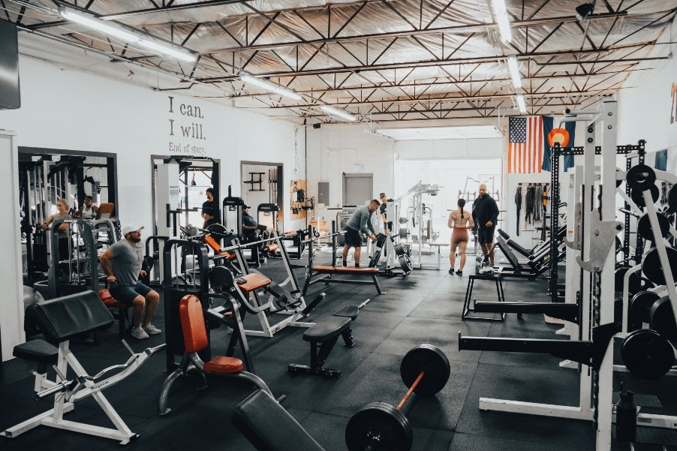

Developing a gym routine changed Peter’s life for the better and in some ways is the foundation for the well-rounded individual he is today.

Goals



Peter intends to get a black belt in karate.

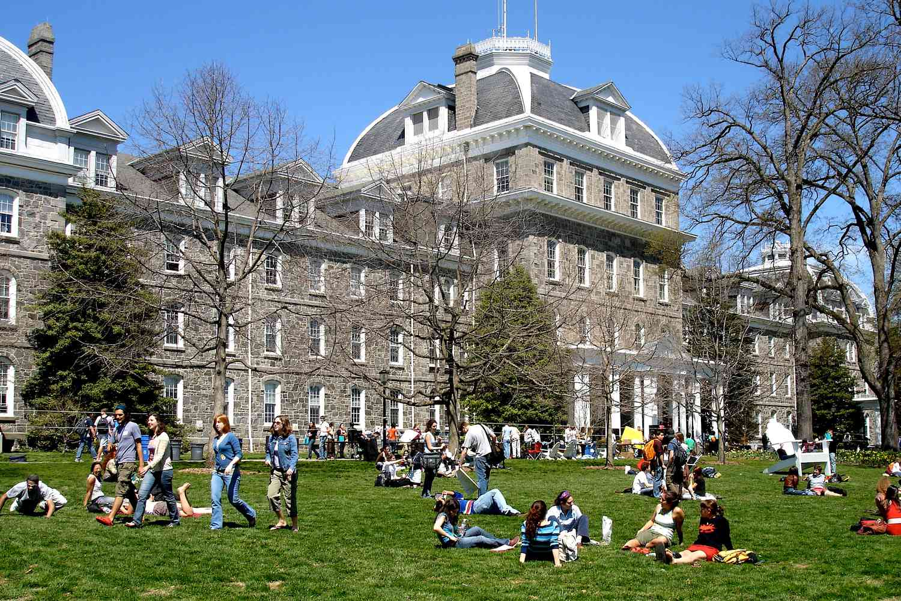

He hasn’t decided where he wants to go, but he wants to go the the best university he can.

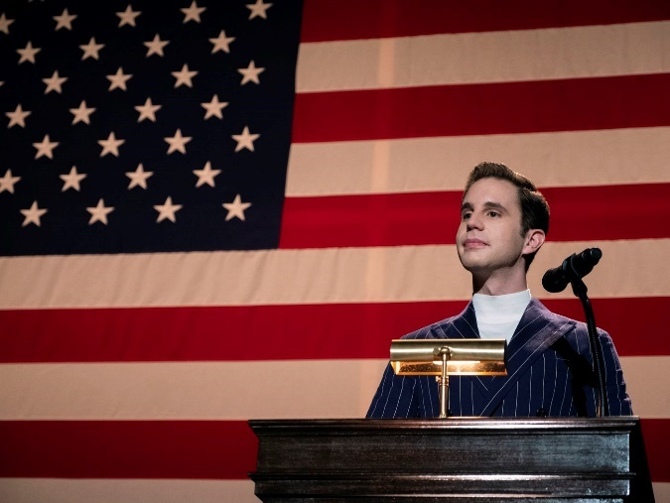

One day, Peter would like to be a politician or otherwise work in politics.

Portrait

Wireframe

(had some issues with wireframing tool. Actual color styling will not match this.)

Main page:

Peter’s Hobbies

Styling

Color palette:

Background- #43464B

Background for headers: #4B4E6D

Text: #E5E4E2