Okta ManageEngine User Provisioning Workflows

Prepared for:

**Okta Inc.**100 First Street  
San Francisco, CA 94105  
info@okta.com  
1-888-722-7871

## Setup Instructions

This document is designed to provide the required configuration to enable Okta Workflows to provision users to ManageEngine / ServiceDesk as Requesters and Technicians.

### Step 1 – Create Okta Groups

Go to your Okta tenant’s administration console, go to Directory > Groups and create the following groups:

1. Requesters
2. Technicians

These groups will be used to provision users to ManageEngine.

### Step 2 – Create Profile Attributes

In your Okta tenant’s administration console, go to Directory > Profile Editor and open the default Okta profile and add the following custom attributes:

1. requester_id
2. technician_id

These attributes will be used to store the respective Id’s once the users are provisioned to ManageEngine.

### Step 3 – Generate Authorization Code

Go to the Zoho API Console (<https://api-console.zoho.com/>) and create a new Self Client with the Scope of SDPOnDemand.users.ALL and set the time duration to 10 minutes.

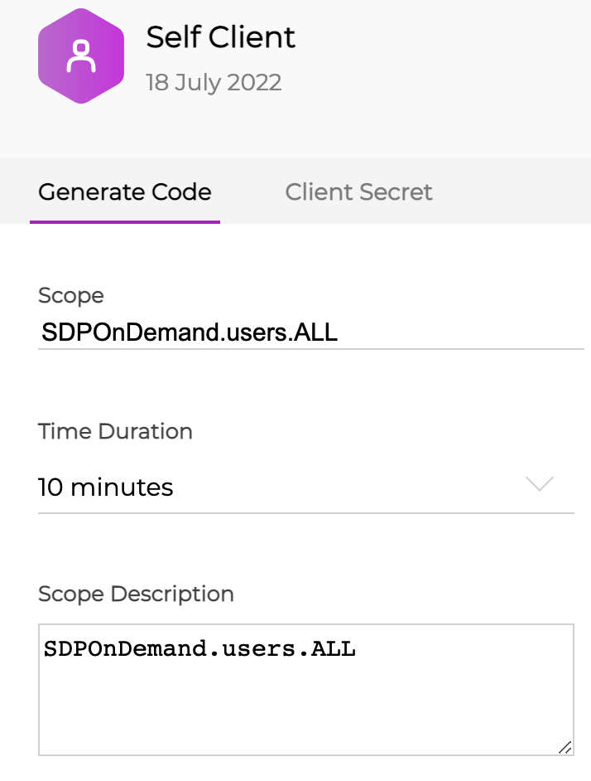

The console will then generate an Authorization Code that will be valid for 10 minutes.

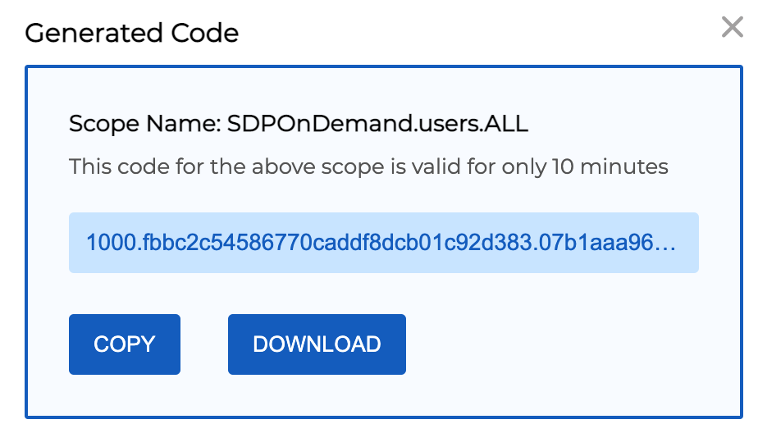

Also take note of the client id and client secret.

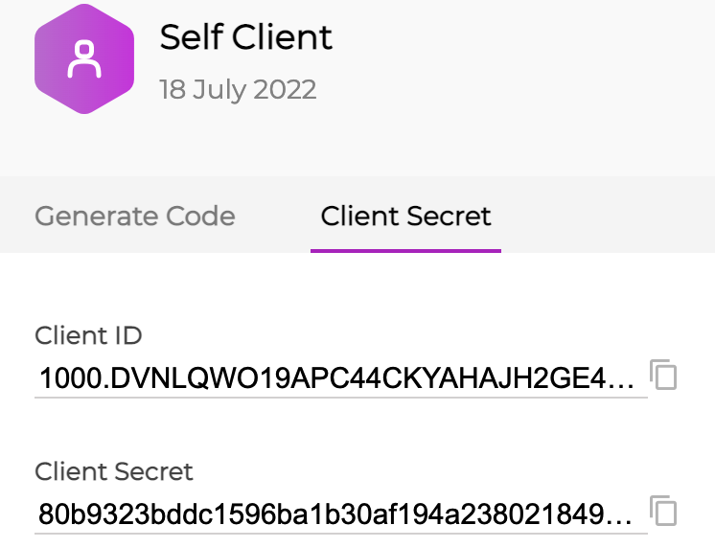

For more details, see the ManageEngine documentation here: <https://www.manageengine.com/products/service-desk/sdpod-v3-api/getting-started/oauth-2.0.html#generate-access-token-and-refresh-token>

### Step 4 – Generate Refresh Token

Using an API client like Postman, call the following endpoint POST <https://accounts.zoho.com/oauth/v2/token>

Note: Depending on your account configuration, the token endpoint may include “au” in the domain name.

<https://accounts.zoho.com.au/oauth/v2/token>

With the following x-www-form-urlencoded parameters:

|  |  |
| --- | --- |
| Name | Value |
| code | The Authorization Code generated in Step 3 |
| grant_type | authorization_code |
| client_d | The Client Id copied from Step 3 |
| client_secret | The Client Secret copied from Step 3 |
| redirect_uri | Any URL eg. https://www.zoho.com |

If successful, the response will include an access_token and a refresh_token.

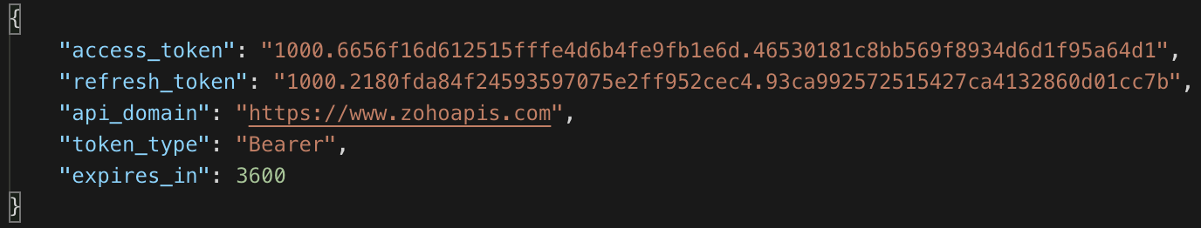

### Step 5 – Configure Okta Workflows

Open the Workflow console and create a new folder and import the supplied workflows. Then under tables, open the configuration table and add the following entries:

|  |  |
| --- | --- |
| Name | Value |
| client_d | The Client Id copied from Step 3 |
| client_secret | The Client Secret copied from Step 3 |
| refresh_token | The refresh token generated in Step 4 |
| access_token | Leave blank (This is used to cache the access token) |
| token_endpoint | <https://accounts.zoho.com/oauth/v2/token> or <https://accounts.zoho.com.au/oauth/v2/token> |

Under Connectors, create an Okta Connector if one does not already exist. Also create an API Connector with an Auth Type of None.

Open each flow and ensure the respective Okta and API Connectors have been selected within the Okta and API cards.

Ensure each flow has been enabled.

### Testing the Workflows

1. Add a user to the Requesters group in Okta. The respective user will be created as a Requester in ServiceDesk.
2. Remove the user from the Requesters group in Okta. The respective user will be removed as a Requester in ServiceDesk.
3. Add a user to the Technicians group in Okta. The respective user will be created as a Technician in ServiceDesk.
4. Remove the user from the Technicians group in Okta. The respective user will be removed as a Technician in ServiceDesk.