**Nome**: João Gabriel Fonseca

**Turma**: 10P

**Número**: 12

**Exercício 1**

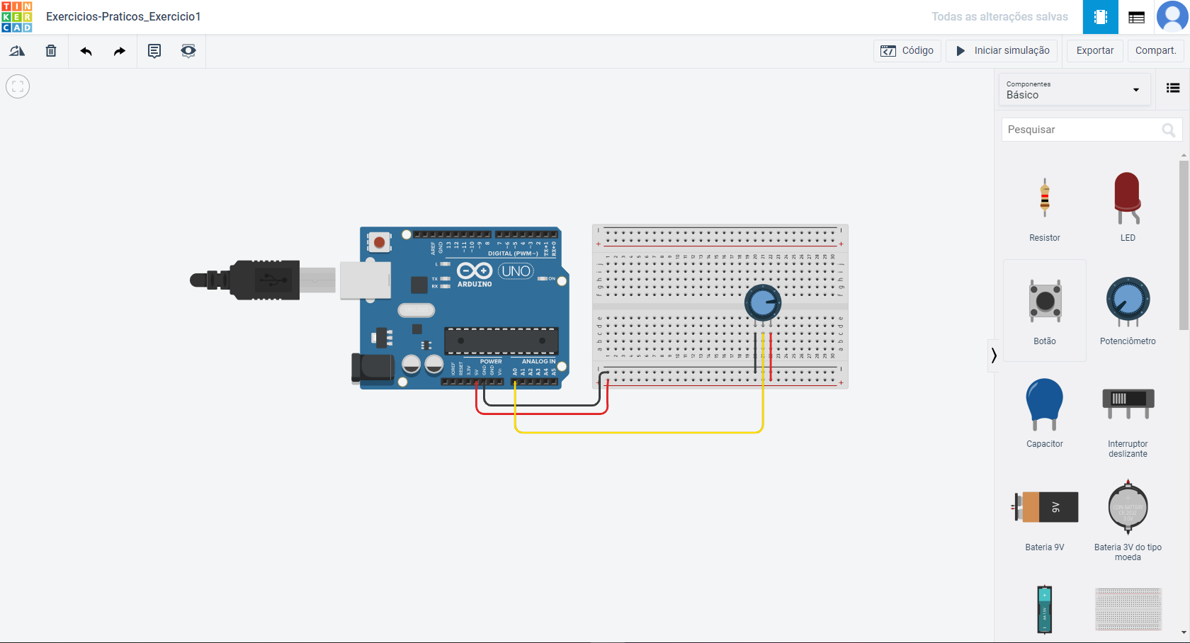

**LINK: https://www.tinkercad.com/things/8bDR6iuB2En-ingenious-jaiks-densor/editel?sharecode=60Ib1JwPSbqWKmQdIR4dx7crdJLNjH2l1unTwUbYi3s**

**Exercício 2**

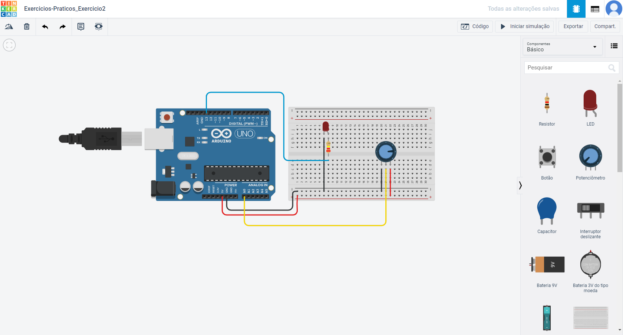

**LINK:** **https://www.tinkercad.com/things/3Ye8vm0zuV3-copy-of-exercicios-praticosexercicio1/editel?sharecode=gf06ZQNLgW-8rZGQDCb0Dcc11JvCy85t6S6YRxxXClo**

**Exercicio 3**

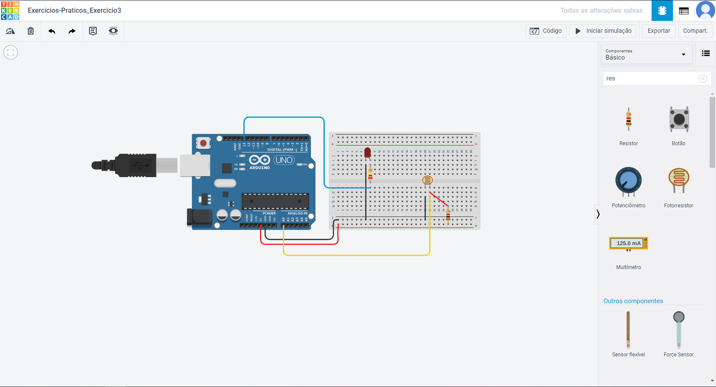

**LINK:** **https://www.tinkercad.com/things/f0QlUXddrYL-copy-of-exercicios-praticosexercicio2/editel?sharecode=Lb7JwXESyH6ZyG466y_odF38Okmct_r8n0Un0RhqDPw**

**Exercicio 4**

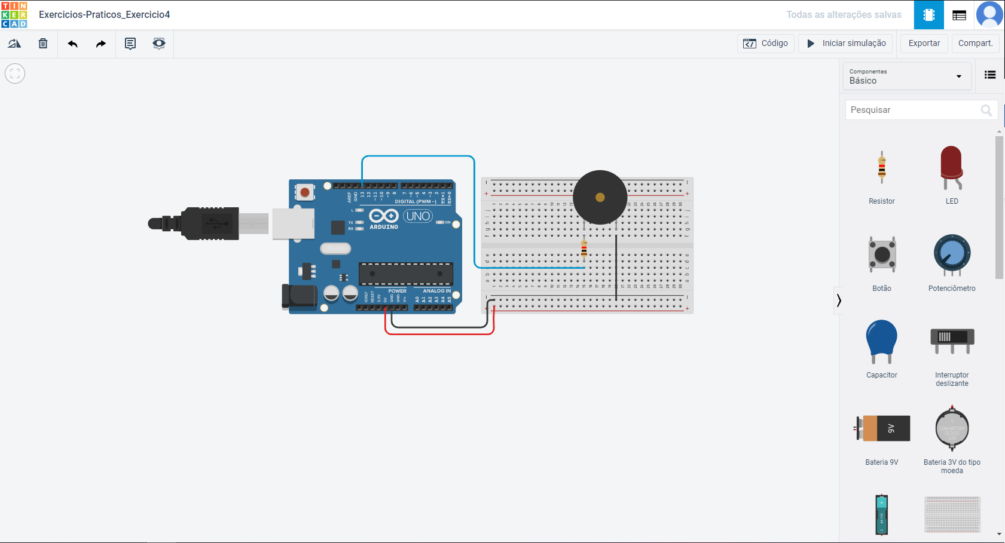

**LINK:** **https://www.tinkercad.com/things/54o6r9W5an4-copy-of-exercicios-praticosexercicio3/editel?sharecode=-p9cqnCq8No9A1Y1J-mYGUzt7cm19ehMH03ZF8-xIJg**

**Exercicio 5**

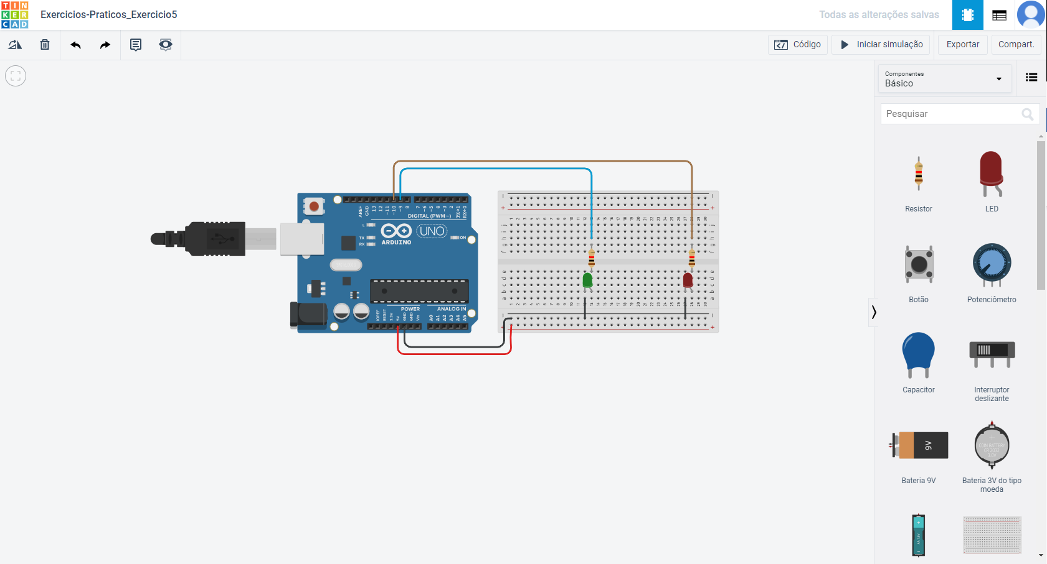

**LINK: https://www.tinkercad.com/things/0urrHLFHP4Z-copy-of-exercicios-praticosexercicio4/editel?sharecode=EF3llludNnB73ifkiv5HyMzy1G4nWcteKp1oeNrfnt8**