

edChain Data Transfer Application

**Discovery**

**Idea**

Higher education provides the freedom to pursue careers that inspires, to explore a person’s interests, and to greatly improve the probability of higher income and future job promotions. Unfortunately, higher education is expensive and can be restricted by geography. Currently, there are over $1.5 trillion dollars of student debt and merely 2% of educational content is digitized.

EdChain solves this problem by using a decentralized network and blockchain technology to enable students, educators, and employers to interact directly and participate in the exchange of education and learning without the involvement of intermediaries.

In order to access these courses, students often need to submit a request for financial-aid, and thus transmit financially sensitive documents to various loan providers.

Our application will allow students to securely transfer these sensitive documents and grant access to third-parties. The application is built using the Linnia Protocol on the Ethereum Network.

**User Stories**

A student is currently applying to one of the courses on edChain and is need of a loan to pay the tuition. This student uses our data transfer application on edChain to upload any relevant documents needed by third party loan providers. The application then gives the student the ability to grant permission to select third parties to access their documents for a given amount of time.

The third party then loads the documents into their local interface, where they can view the loan requests and the relevant documents from the various users.

**Proposed Technologies**

**Front end:** React, HTML, CSS, Bootstrap

**Back end:** Javascript

**Protocol:** Linnia (Ethereum Network)

* ConsenSys protocol on the Ethereum network which will be used to connect digital self-sovereignty to decentralized storage with access controls protecting data.
* Linnia plans to handle both data and metadata and also to handle the permissions and policies granted to third-parties to view the data.

**Decentralized Identity Provider:** MetaMask

* Browser add-on which will allow users to run Ethereum dApps in the current browser.

**Decentralized Storage:** IPFS

* Peer-to-peer protocol used to store and share documents in a distributed file system.

**API:** Infura

* API and developer tool which will be used to bootstrap to the Ethereum network.

**Testing:** Ganache, Truffle

* Testing network with built-in smart contract compilation, linking, deployment, and binary management.

**Design**

**Entity Relationship Diagram**

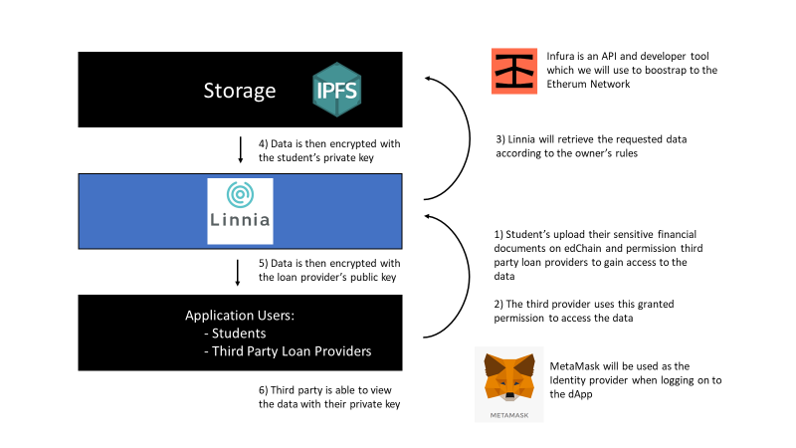

**User Interface**

**Student Interface:**

1. **Uploading information and loan amount**

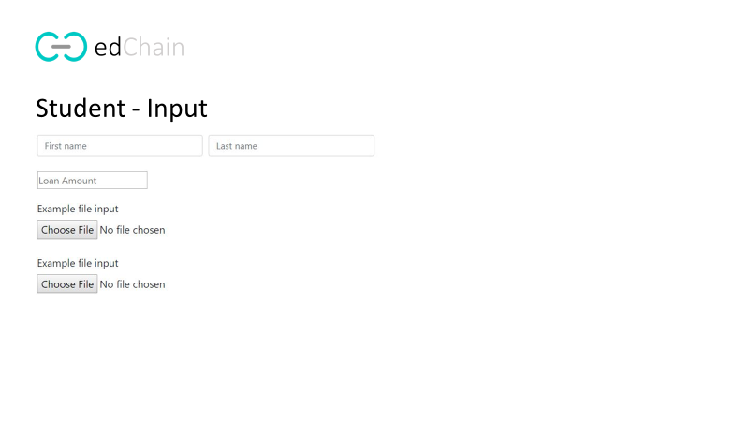

1. **Permission third-parties to access the information**

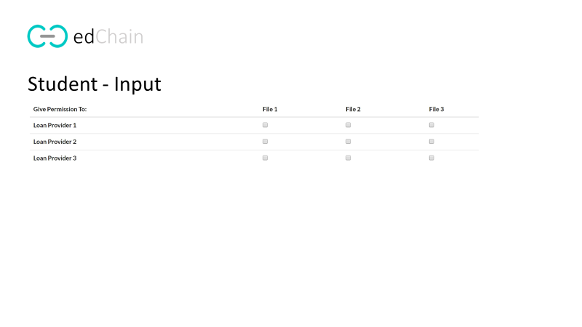

**Loan Provider Interface:**

1. **View documents from a given student**

