HW1 SOC-446W

Gabriel (Runye) Wang

2166594

Aug 30th 2017

Part 1:

The corpus I chose is the 5 books of *A Song of Ice and Fire*. There are 5 .txt files in total after I converted the original .pdf files. Here is a list of the total words of each book the words in total: A Game of Thrones: 298,000; A Clash of kings: 326,000; A Storm of Swords: 424,000; A Feast for Crows: 300,000; A Dance with Dragons: 422000; Total: 1,770,000 (source: Wikipedia).

*A Song of Ice and Fire* is a fantasy novel created by George. R. R. Martin, which was first published in 1996 and have made a phenomenal success since then. Later, HBO created the TV series Game of Thrones based on Martin’s masterpiece. The story was a fiction under the setting of medieval Europe mainland. It tells the story about the great houses and heroes from the continents Westeros and Essos in the point of views of several characters.

The reason I selected this corpus as my source is because first I am a huge fun of Game of Throne which also get me interested in the original books; second, the structure of the story the style of Martin’s writing are so fascinating that scholars are talking about research on this, so I feel this will be a corpus worthy of digging.

Ideally I will be able to guess the result of the finale, but this will definitely be a long shot. But I can definitely gain some insight of the way how Martin wrote and organize the story, maybe some reflection on the medieval history or even today’s society.

Part 2: 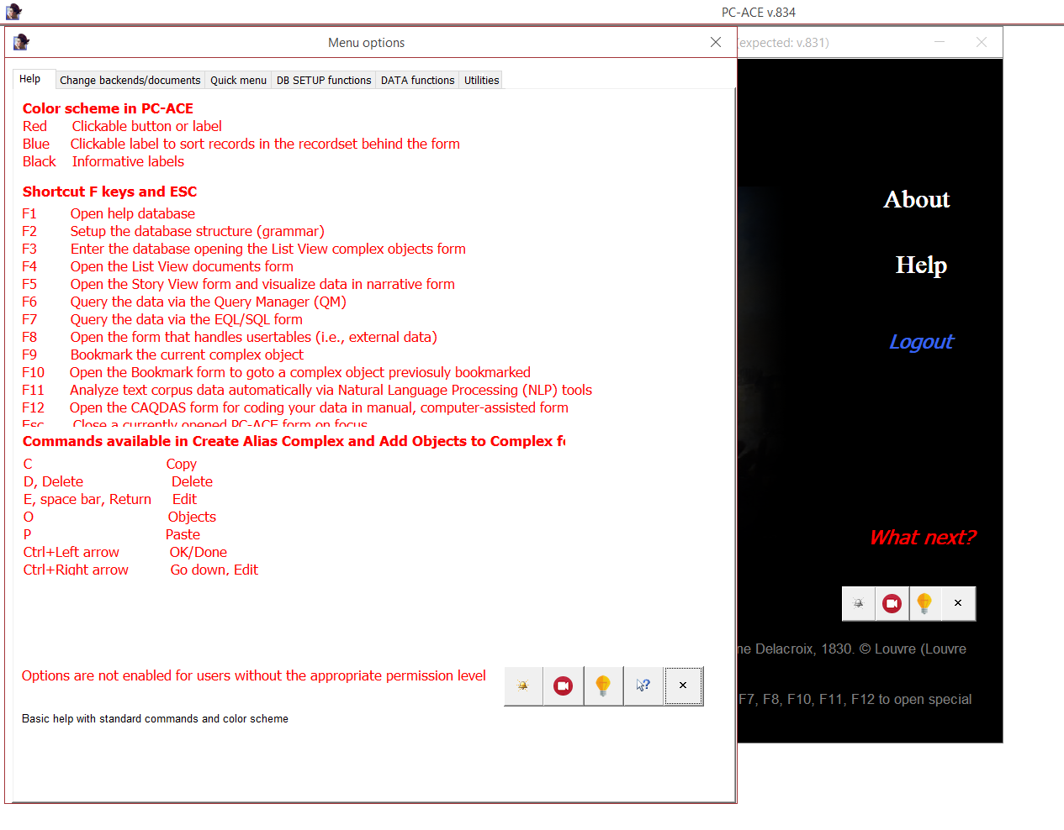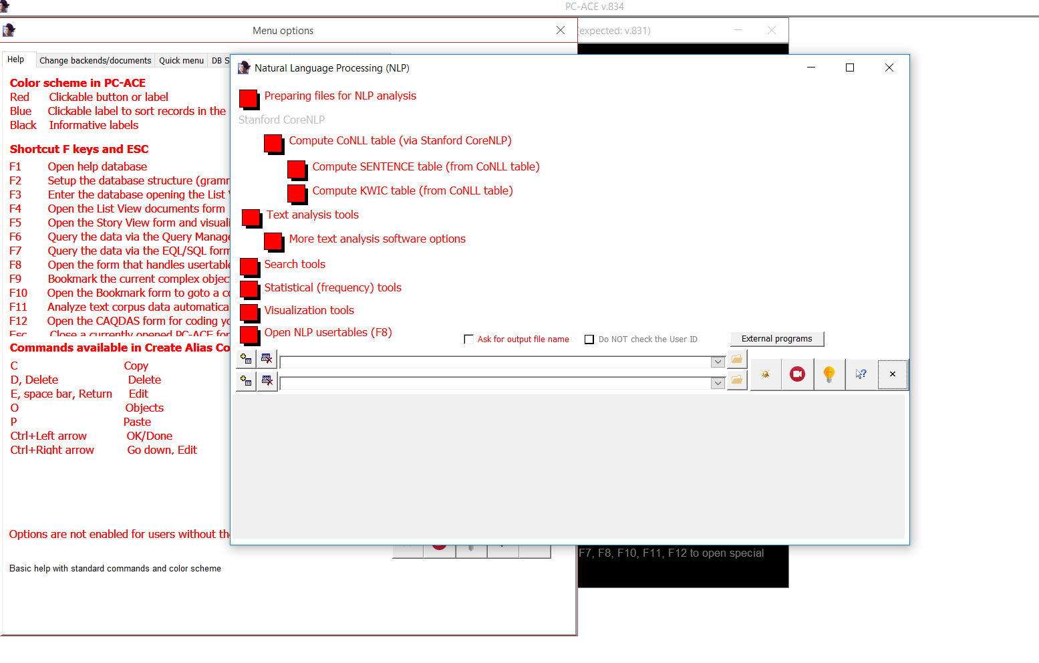

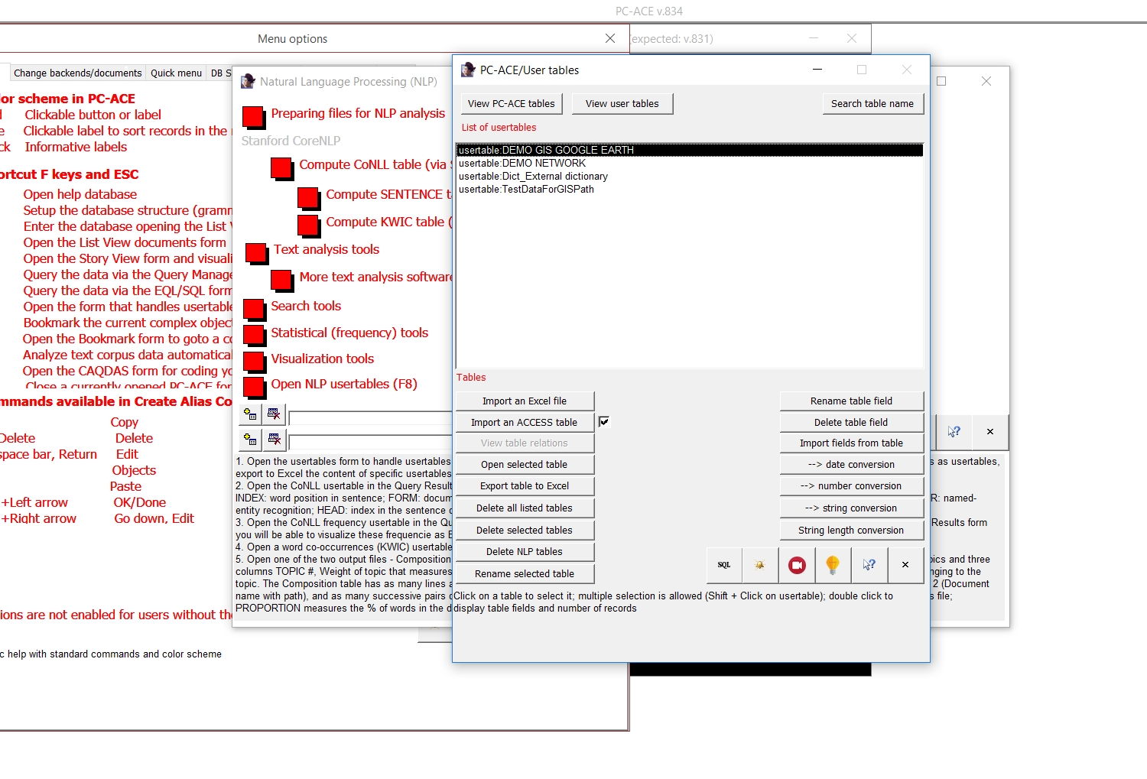

Part 3:

Distant Reading, as the name suggests is the opposite of Close Reading, the traditional methods to analyze literature. Moretti asked scholars to stop reading books words to words, instead he proposed quantitative analysis. Moretti created 57 graphs in his book ‘*Distant Reading’* that visualized the books he studied. This graphs charts and maps help us to focus on the larger picture and understand the literature in a bigger setting, history and society. Moretti proposed a distant reading instead of close reading because he believes that this is a more efficient way of learning literatures. It takes too long for human beings to read a book, so why not let computers do the hard labor and present the words in a more direct way for us to understand. Besides, scholars in the end became subjective. But data don’t lie and guarantee almost 100% objectivities. Indeed, machines can be trained to be a better reader and discover some insights that human beings missed. However, there are scholars arguing that Moretti’s method took away the humanity of reading that we must not only study those art but also appreciate it.