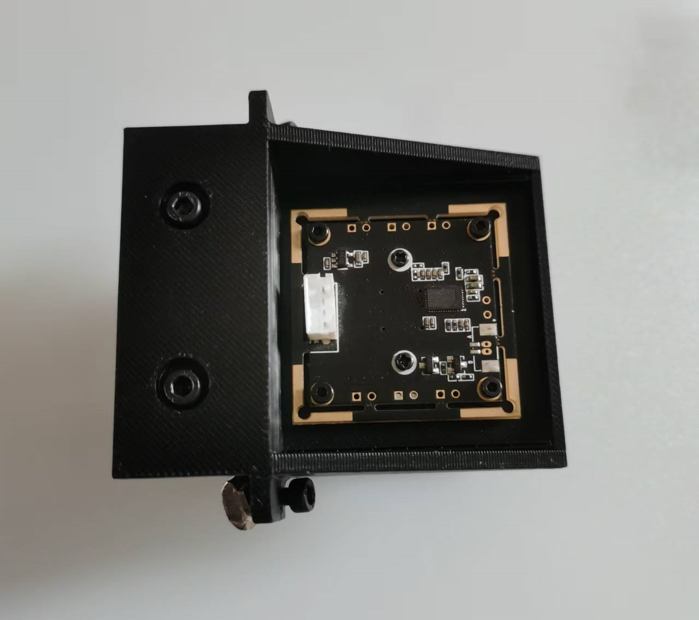
Tip: The direction of the camera must be the same as in the photo
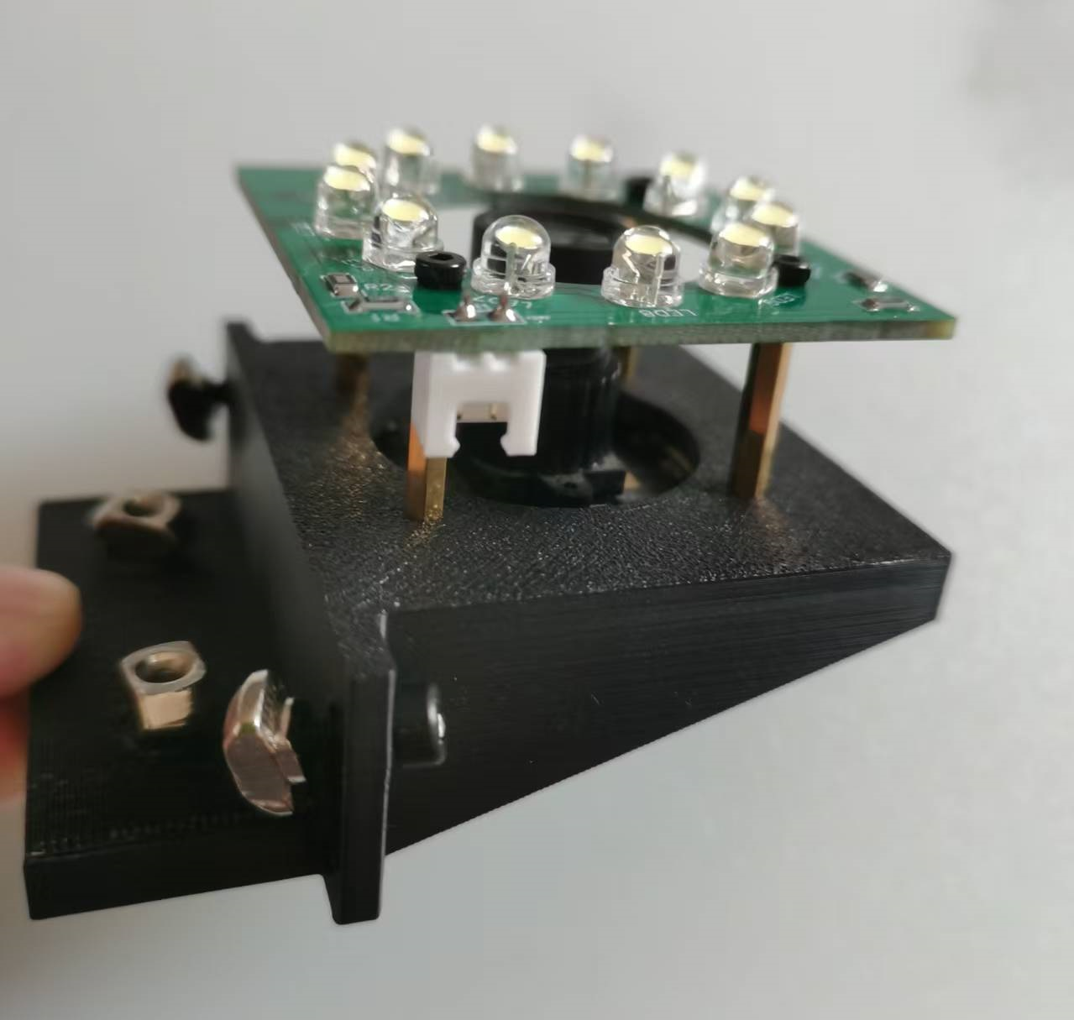
Tip 1: The length of the standoffs is 17mm.
Tip 2: Lock the 4 M3 screws to ensure the bottom camera is level.

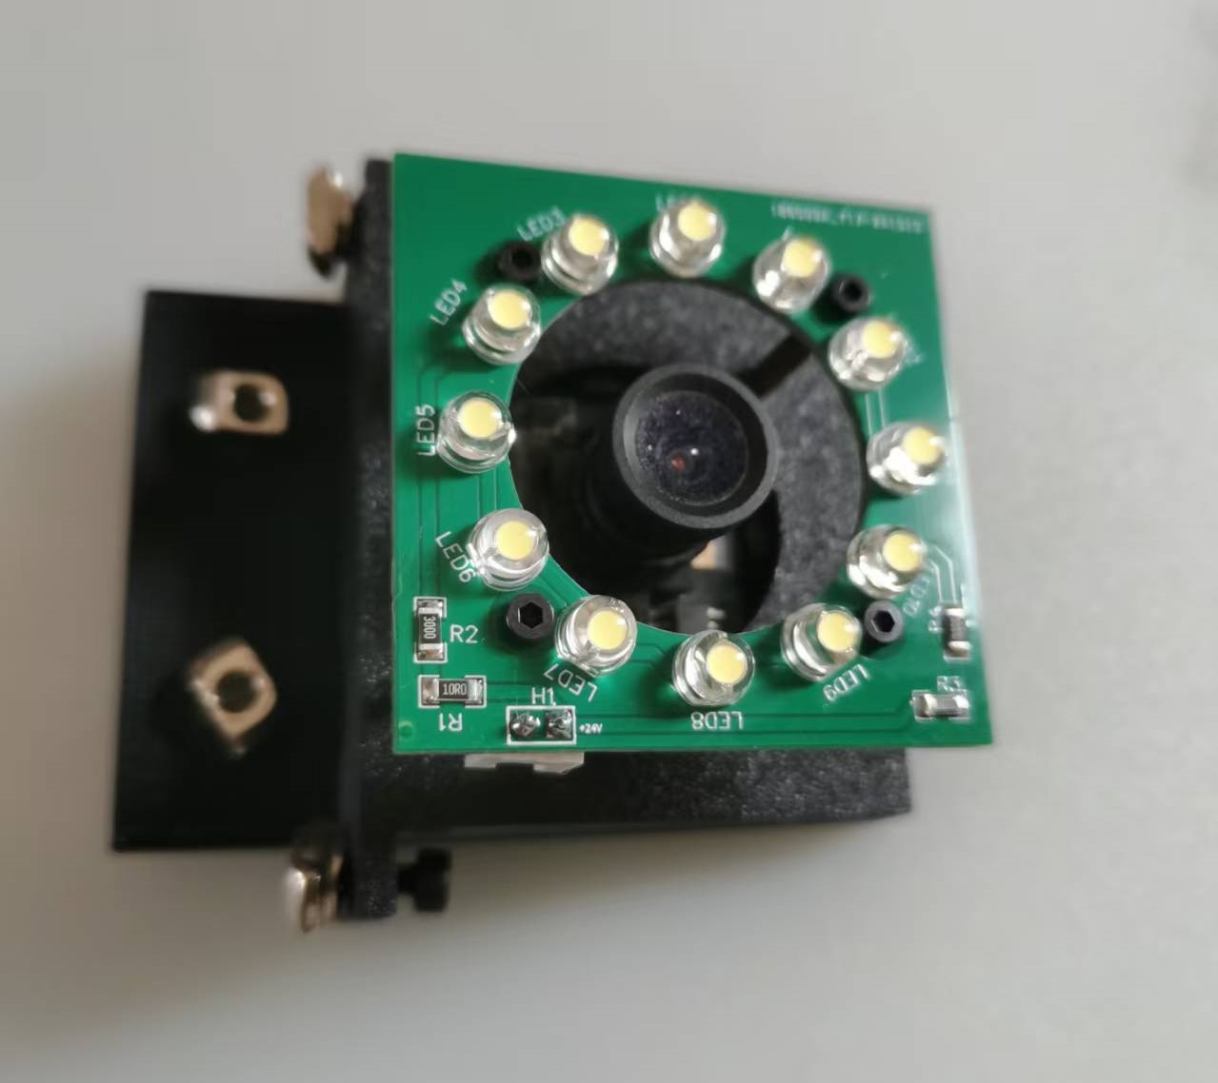

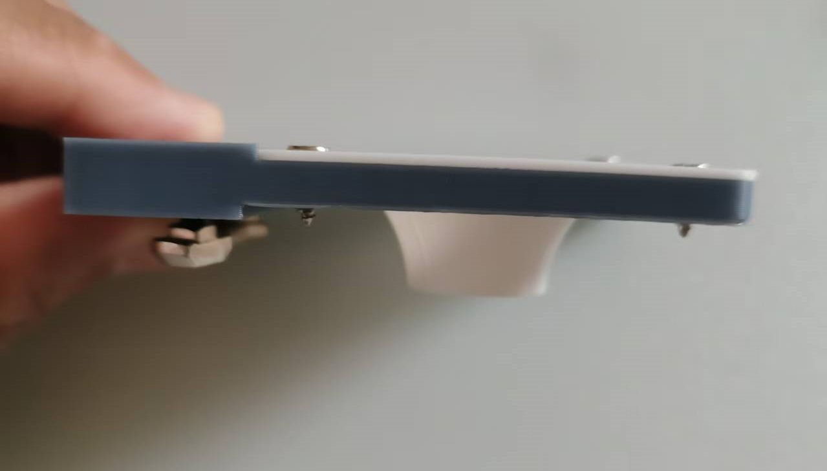

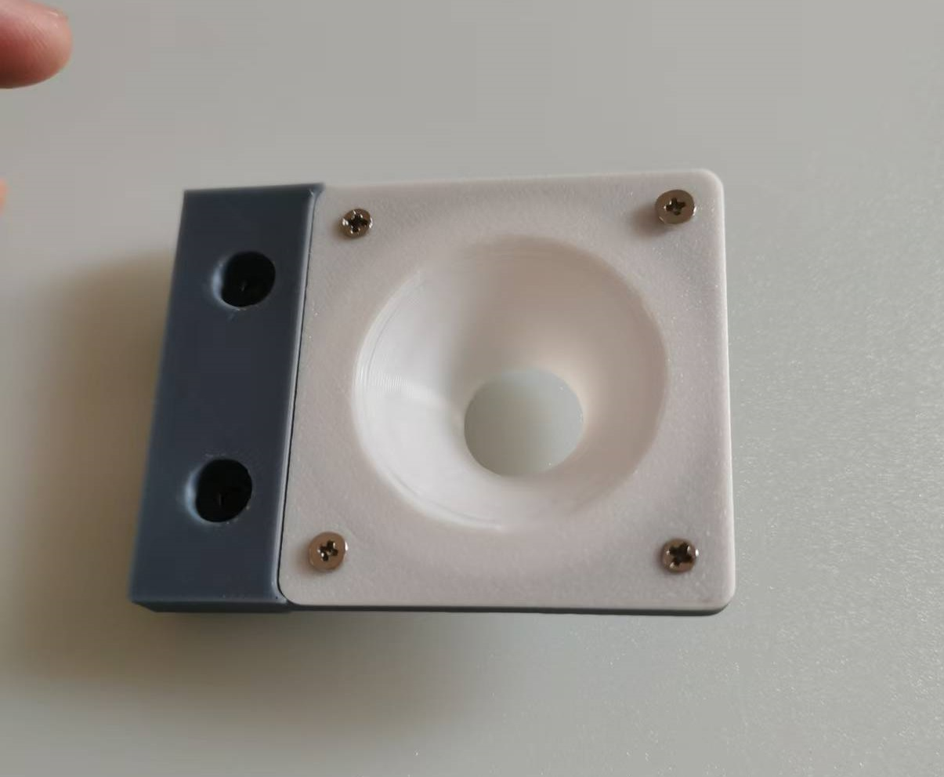
Tip: The diffuser plate can be printed with white or semi transparent PLA or ABS.
