Instalador de Docker: Docker Desktop Installer.exe
Instalar mongodb desde power shell

docker run -d -p 27017:27017 --name mydatabasee mongo:4.2

Arrancar mongo db desde Docker Desktop
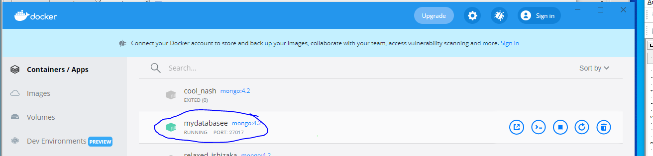
Ejecutar mongodb en Power Shell

docker exec -it mydatabasee bash

Ejecutar el entorno mongo en Power Shell
mongo

MongoDB shell version v4.2.17
connecting to: mongodb://127.0.0.1:27017/?compressors=disabled&gssapiServiceName=mongodb
Implicit session: session { "id" : UUID("dabe8e51-d58c-4aae-90c8-373687ae9c9c") }
MongoDB server version: 4.2.17
Server has startup warnings:
2021-10-09T18:48:42.933+0000 I STORAGE [initandlisten]
2021-10-09T18:48:42.933+0000 I STORAGE [initandlisten] ** WARNING: Using the XFS filesystem is strongly recommended with the WiredTiger storage engine
2021-10-09T18:48:42.933+0000 I STORAGE [initandlisten] ** See http://dochub.mongodb.org/core/prodnotes-filesystem
2021-10-09T18:48:43.922+0000 I CONTROL [initandlisten]
2021-10-09T18:48:43.922+0000 I CONTROL [initandlisten] ** WARNING: Access control is not enabled for the database.
2021-10-09T18:48:43.922+0000 I CONTROL [initandlisten] ** Read and write access to data and configuration is unrestricted.
2021-10-09T18:48:43.922+0000 I CONTROL [initandlisten]
2021-10-09T18:48:43.922+0000 I CONTROL [initandlisten]
2021-10-09T18:48:43.922+0000 I CONTROL [initandlisten] ** WARNING: /sys/kernel/mm/transparent_hugepage/enabled is 'always'.
2021-10-09T18:48:43.922+0000 I CONTROL [initandlisten] ** We suggest setting it to 'never'
2021-10-09T18:48:43.922+0000 I CONTROL [initandlisten]
---
Enable MongoDB's free cloud-based monitoring service, which will then receive and display
metrics about your deployment (disk utilization, CPU, operation statistics, etc).

The monitoring data will be available on a MongoDB website with a unique URL accessible to you
and anyone you share the URL with. MongoDB may use this information to make product
improvements and to suggest MongoDB products and deployment options to you.

To enable free monitoring, run the following command: db.enableFreeMonitoring()
To permanently disable this reminder, run the following command: db.disableFreeMonitoring()
---

>// Comandos de base de datos

use mydatabasee
db.createCollection("Employee")
db.Employee.insertMany([ {FirstName: "dos", LastName: "dos2", UserName: "dos3", Password:"dos4",Campo4:4}])
db.Employee.find().pretty()

