|  |  |
| --- | --- |
| **Architetture dei Sistemi**  **di Elaborazione** | Delivery date:  7/01/2022 |
| **Extra Points Part 1** | Solving this track gets you a *max of 2 additional points*. Expected delivery of extrapoints1.zip must include:   * Zipped project folder, * **4 minutes video** to describe your project. |

Using the LandTiger Emulator available on Keil uVision, you are requested to implement the following single-player game. Please note that all the non-ideality behaviors (see Figure 1 below) must be enabled and considered by your software. The RIT and Timers scaling switches can be enabled for debugging faster the project.

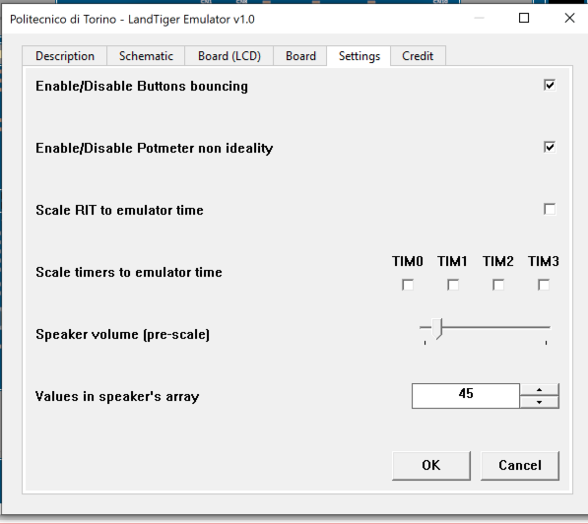

Figure 1 - Emulator Configuration

The game called “*Pong*” implemented by your software must reproduce the behaviour of the classic table tennis-themed arcade game, originally released in 1972 by Atari.

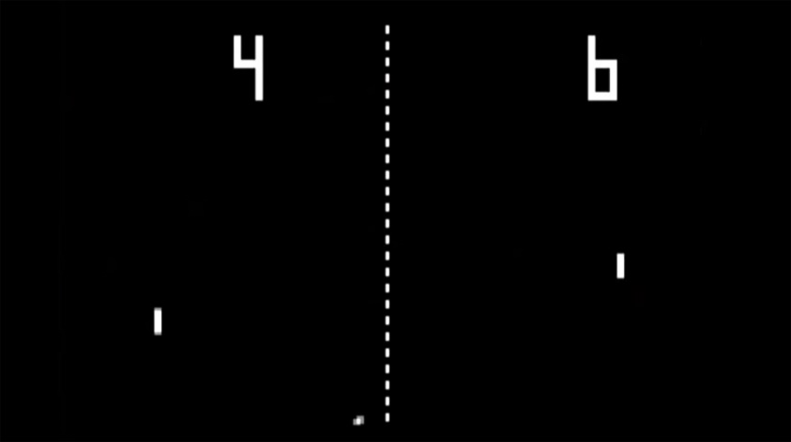

Figure 2 – Screenshot of a Pong match

For this project, start by implementing a single-player version of the game where the player must not let the ball fall below the paddle. The paddle can only move horizontally, and the player operates it through the potentiometer available in the LandTiger board.

The game field should be implemented vertically, i.e., the paddle will be in the bottom portion of the LCD display with red walls (5px thick) on the left, upper and right portion of the display for the ball to bounce on, as represented in the Figure below.

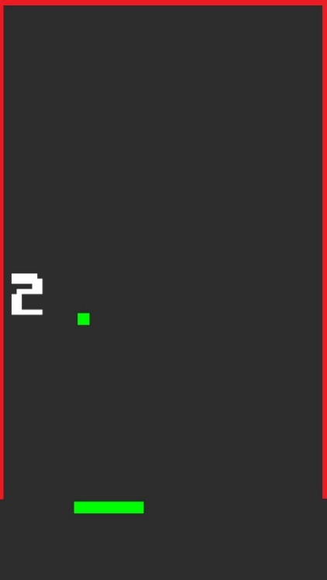

**Score**

Figure 3 – Game field for a single-player match

When the ball hits a wall, it should bounce with a reflection angle equal to the incident one. For instance, if a ball going downwards hits the left **wall** with an incident angle of 30°, then it will bounce downwards with the same 30° angle, as shown below.

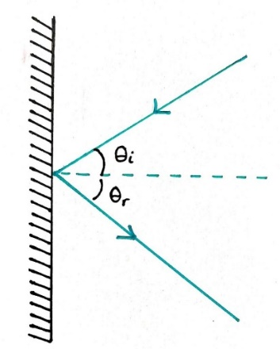

Figure 4 – Ball bouncing on a wall

When the ball hits the paddle, the reflection angle **must not always be equal** to the incident one, for example, depending on what part of the paddle is hit by the ball. Pick a strategy and explain in the video your choices. The choice on **how fast** the ball moves is left unconstrained. Complex solutions, e.g., spinning the ball by hitting it with the paddle at a certain angle, will be considered when evaluating the project.

The paddle should be **32px high from the bottom part** of the screen and **10px thick**, and the **ball should be a 5x5px square**.

Whenever the ball hits a wall or the paddle, the buzzer should emit a lower pitched note (when bouncing on the wall) and a higher pitched note (when bouncing on the paddle). In both cases, choose the frequency of the note to be played.

Every time the ball hits the paddle, the score is incremented by 5. If the score is greater than 100, whenever the paddle touches the ball, it is incremented by 10 points. The score must be printed on the left side of the screen, at mid high (160px from both the bottom and top part of the LCD). The score is saved in between games, and the new record (the maximum score since the board was last reset) is displayed in the top right corner. The initial record to beat is 100 points. Whenever the board is powered off or the RESET button is pressed, the score is reset as well. If the ball falls below the paddle, a message “You lose” should be displayed.

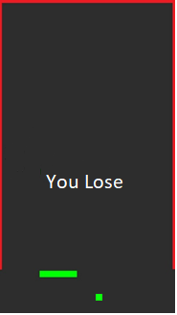

Figure 5 – Game over

The user should **start the game** by pressing the button KEY1. When the game starts, the ball should be touching the right wall at mid high (160px from both the bottom and top part of the screen) and go downwards with an angle of 45°. To **pause the game and later resume it**, the user should press the button KEY2. In case of **game over**, to **prepare a new game** the player should press the INT0 button, followed by KEY1 to start it.

**Pause** the game

**Start** the game

**Reset** the game

Figure 6 – Buttons configuration