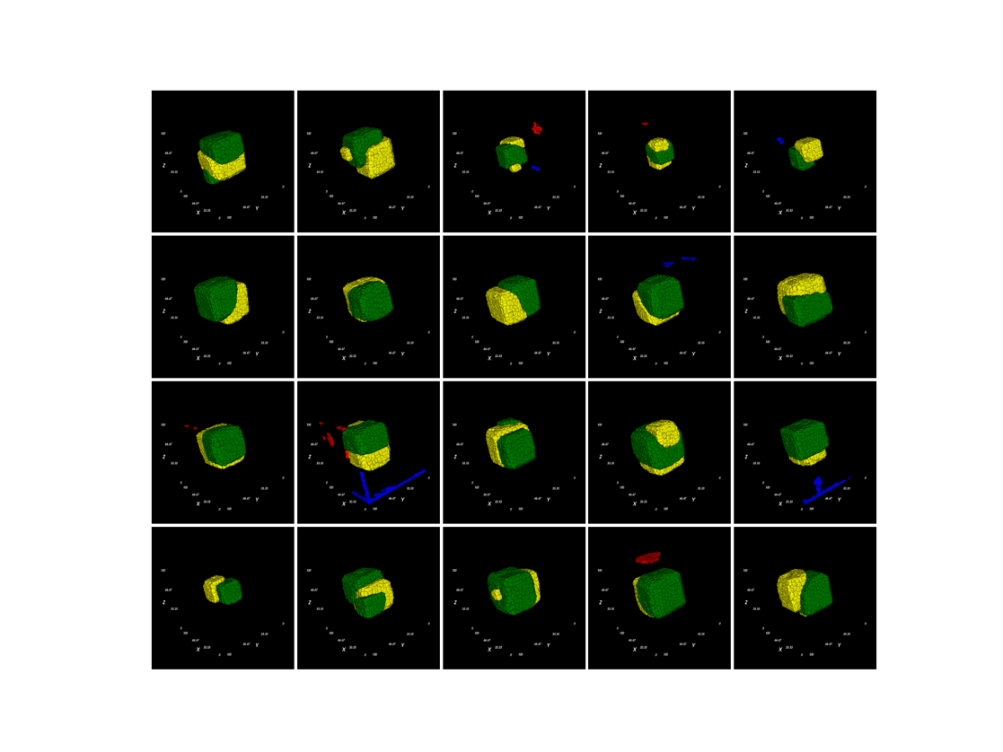
Mitosis for every cell

 | A | B | A’ | B’ | motility | activation
A | 45 | 49 | 40 | 49 | 100 | 4,500
B | 49 | 45 | 49 | 40 | 100 | 4,500
A’ | 40 | 49 | 20 | 49 | 1 | 0
B’ | 49 | 40 | 49 | 20 | 1 | 0
Title: elongation_control

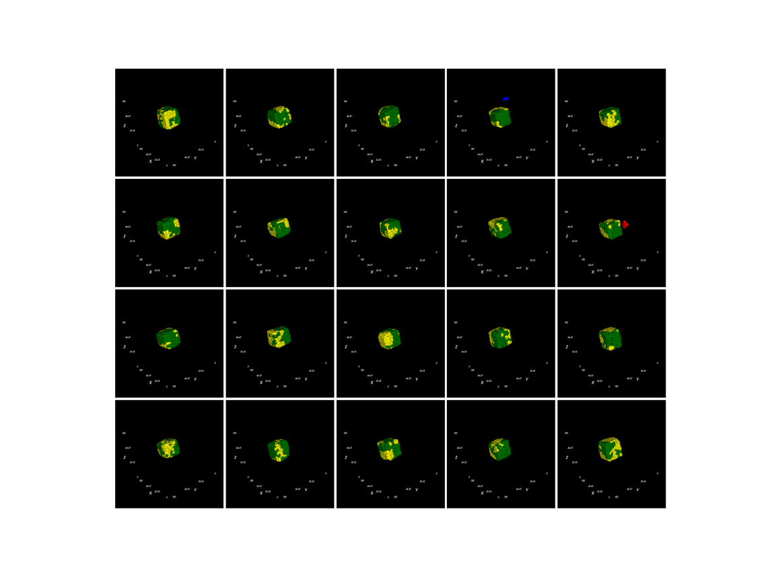

Mitosis for every cell

 | A | B | A’ | B’ | motility | activation
A | 40 | 49 | 45 | 49 | 100 | 4,500
B | 49 | 40 | 49 | 45 | 100 | 4,500
A’ | 45 | 49 | 20 | 20 | 1 | 0
B’ | 49 | 45 | 20 | 20 | 1 | 0
Title: elongation_try2

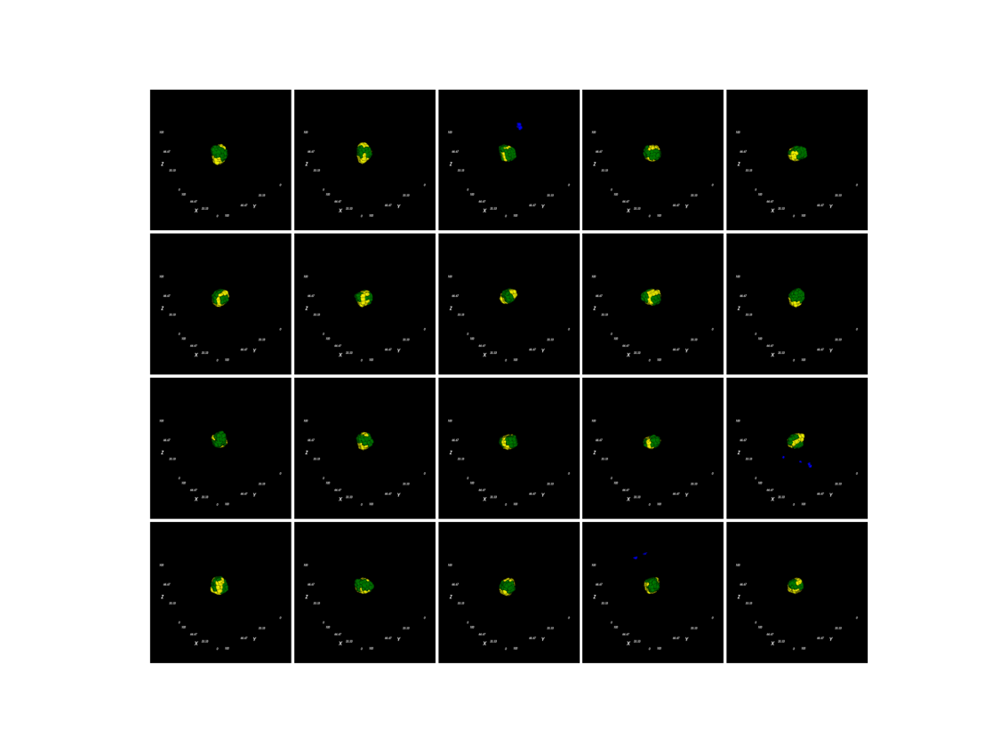
Mitosis for A/B only

 | A | B | A’ | B’ | motility | activation
A | 40 | 49 | 45 | 49 | 100 | 4,500
B | 49 | 40 | 49 | 45 | 100 | 4,500
A’ | 45 | 49 | 20 | 20 | 1 | 0
B’ | 49 | 45 | 20 | 20 | 1 | 0
Title: elongation_try3

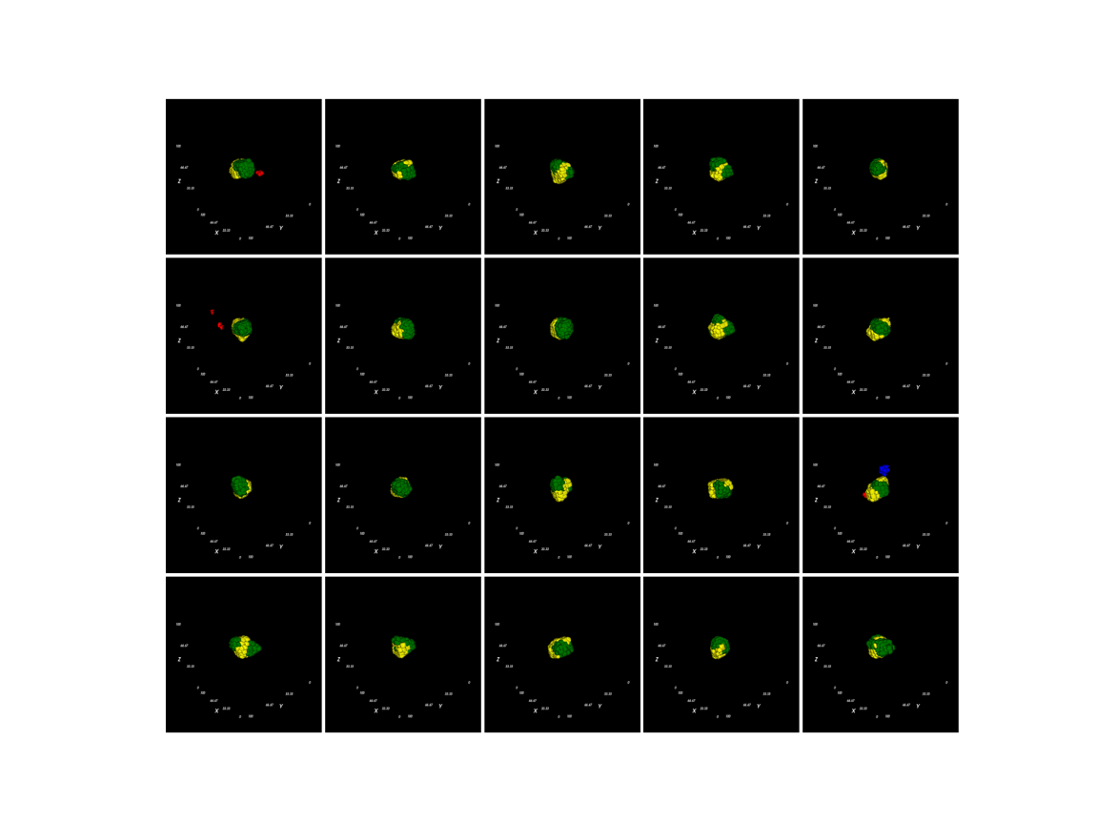

Mitosis for A/B only

 | A | B | A’ | B’ | motility | activation
A | 40 | 49 | 45 | 49 | 100 | 9,000
B | 49 | 40 | 49 | 45 | 100 | 9,000
A’ | 45 | 49 | 20 | 20 | 1 | 0
B’ | 49 | 45 | 20 | 20 | 1 | 0
Title: elongation_try4

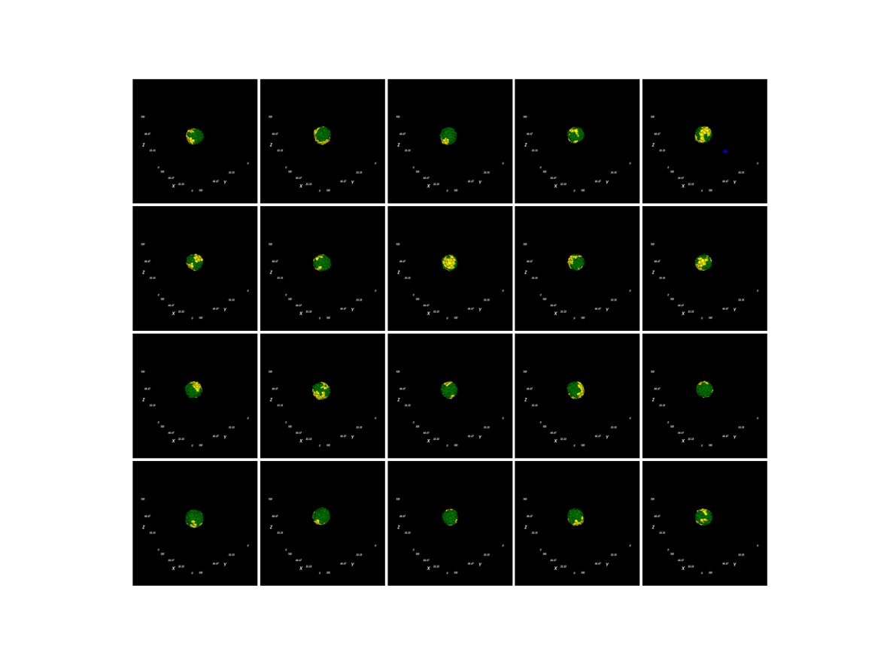
Mitosis for A/B only

 | A | B | A’ | B’ | motility | activation
A | 40 | 49 | 45 | 49 | 100 | 9,000
B | 49 | 40 | 49 | 45 | 100 | 9,000
A’ | 45 | 49 | 20 | 20 | 100 | 0
B’ | 49 | 45 | 20 | 20 | 100 | 0
Title: elongation_try5

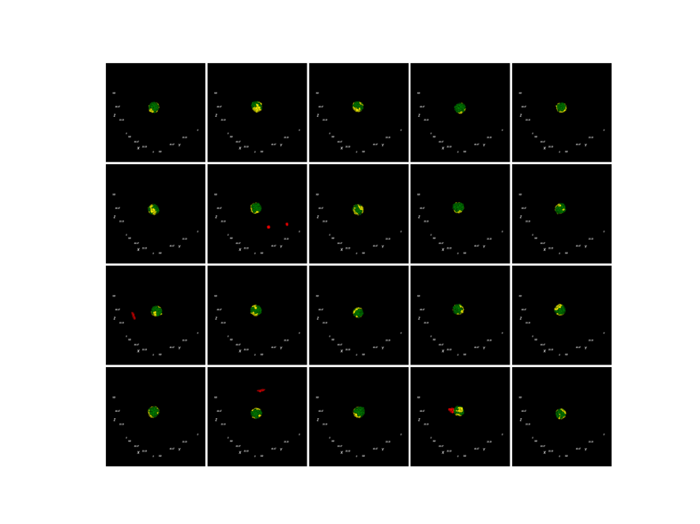

Mitosis for A/B only

 | A | B | A’ | B’ | motility | activation
A | 40 | 49 | 45 | 49 | 100 | 4,500
B | 49 | 40 | 49 | 45 | 100 | 4,500
A’ | 45 | 49 | 20 | 20 | 100 | 0
B’ | 49 | 45 | 20 | 20 | 100 | 0
Title: elongation_try6

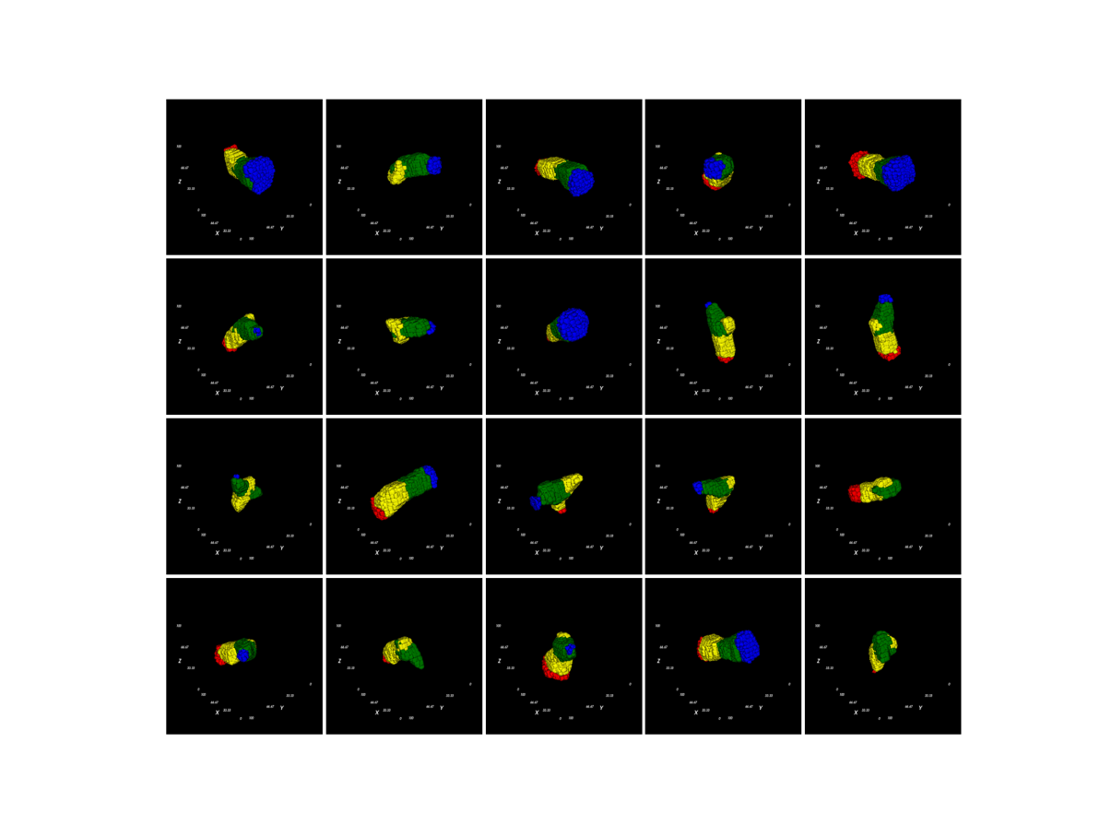
Mitosis for A/B only, Calvin’s adhesions

 | A | B | A’ | B’ | motility | activation
A | 30 | 49 | 49 | 49 | 100 | 10,000
B | 49 | 30 | 49 | 49 | 100 | 10,000
A’ | 49 | 49 | 5 | 5 | 1 | 0
B’ | 49 | 49 | 5 | 5 | 1 | 0
Title: elongation_impl2_control

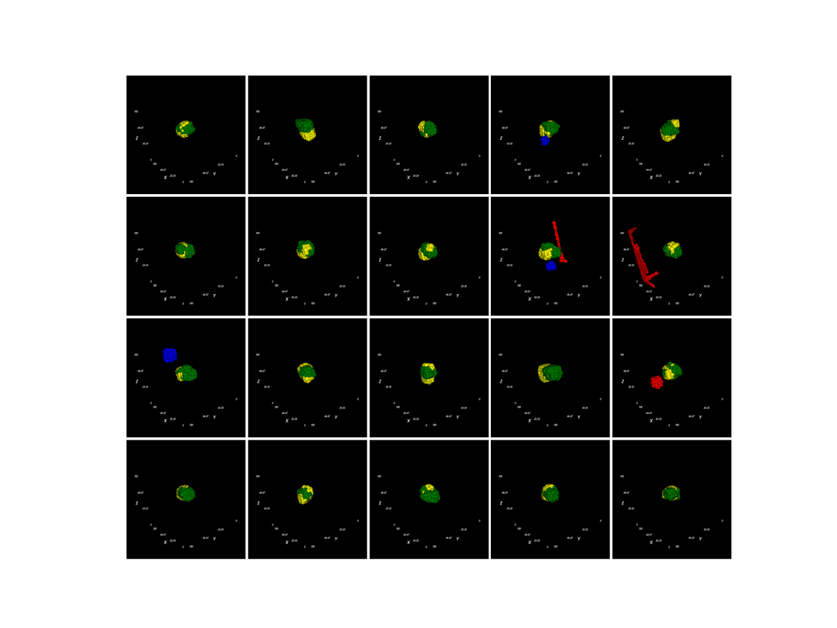
Mitosis for A/B only, inferred adhesions

 | A | B | A’ | B’ | motility | activation
A | 40 | 49 | 45 | 49 | 100 | 10,000
B | 49 | 40 | 49 | 45 | 100 | 10,000
A’ | 45 | 49 | 20 | 20 | 1 | 0
B’ | 49 | 45 | 20 | 20 | 1 | 0
Title: elongation_impl2_try1

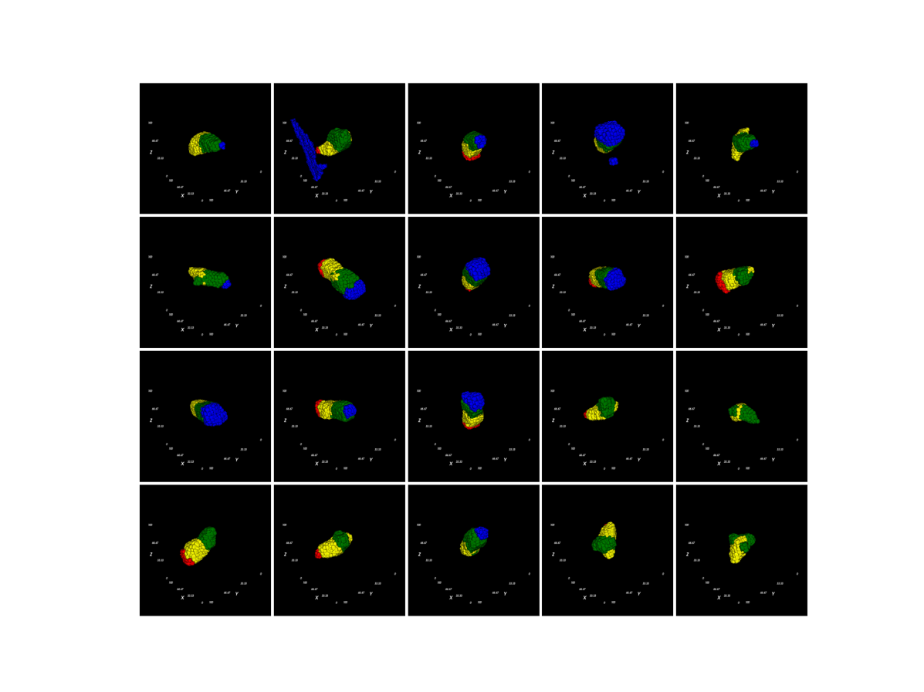
Mitosis for A/B only, change 40 25

 | A | B | A’ | B’ | motility | activation
A | 25 | 49 | 45 | 49 | 100 | 10,000
B | 49 | 25 | 49 | 45 | 100 | 10,000
A’ | 45 | 49 | 20 | 20 | 1 | 0
B’ | 49 | 45 | 20 | 20 | 1 | 0
Title: elongation_impl2_try2

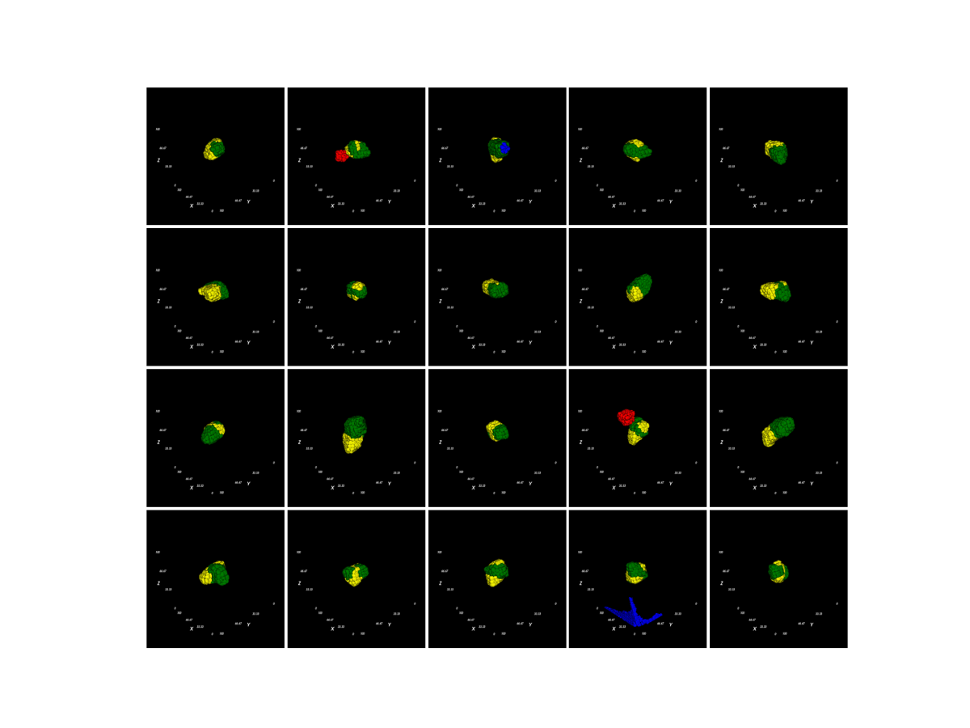
Mitosis for A/B only, change 40 35

 | A | B | A’ | B’ | motility | activation
A | 35 | 49 | 45 | 49 | 100 | 10,000
B | 49 | 35 | 49 | 45 | 100 | 10,000
A’ | 45 | 49 | 20 | 20 | 1 | 0
B’ | 49 | 45 | 20 | 20 | 1 | 0
Title: elongation_impl2_try3

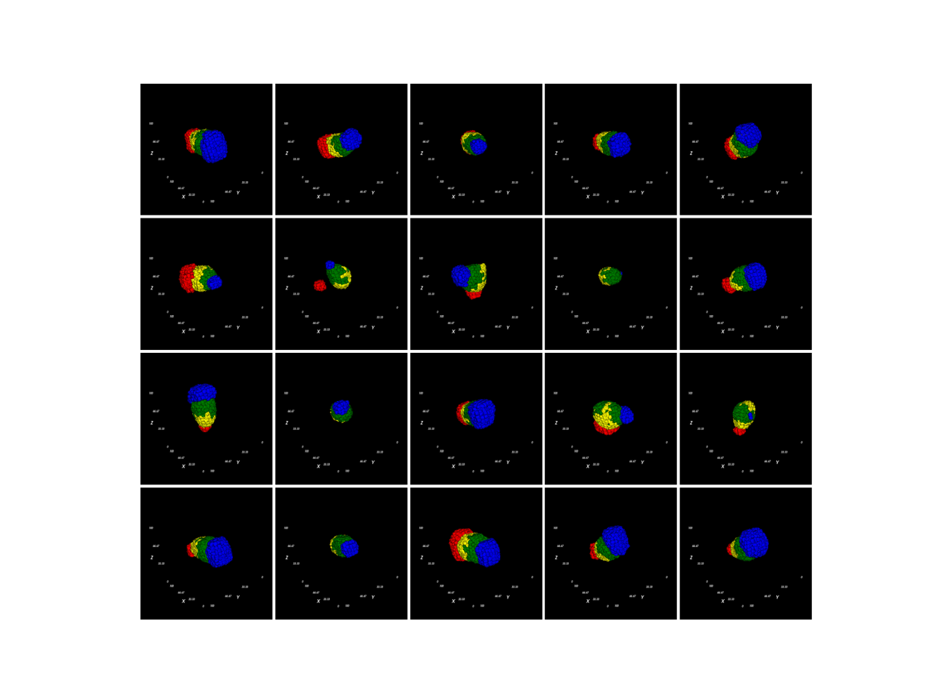
Mitosis for A/B only, using AA/BB = 25, const. motility

 | A | B | A’ | B’ | motility | activation
A | 25 | 49 | 45 | 49 | 100 | 10,000
B | 49 | 25 | 49 | 45 | 100 | 10,000
A’ | 45 | 49 | 20 | 20 | 100 | 0
B’ | 49 | 45 | 20 | 20 | 100 | 0
Title: elongation_impl2_try4

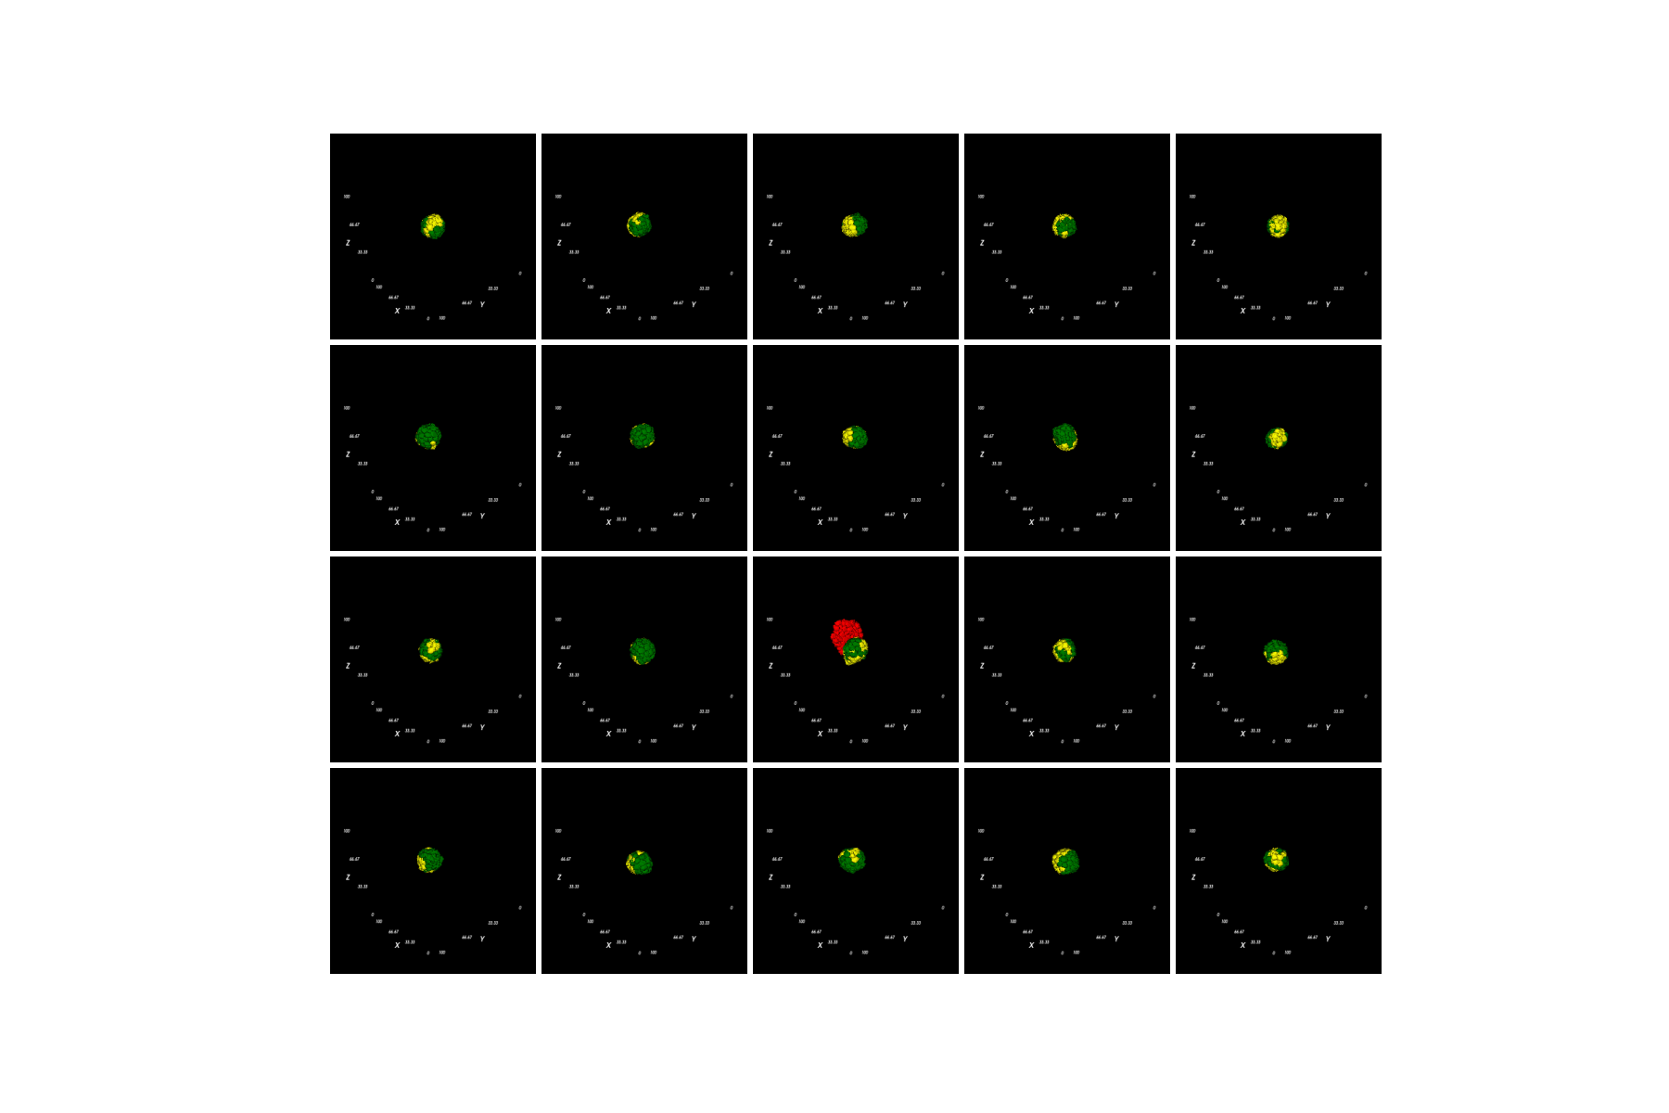

Mitosis for A/B only, using AA/BB = 25, const. motility

 | A | B | A’ | B’ | motility | activation
A | 25 | 49 | 45 | 49 | 100 | 4,500
B | 49 | 25 | 49 | 45 | 100 | 4,500
A’ | 45 | 49 | 20 | 20 | 100 | 0
B’ | 49 | 45 | 20 | 20 | 100 | 0
Title: elongation_impl2_try5
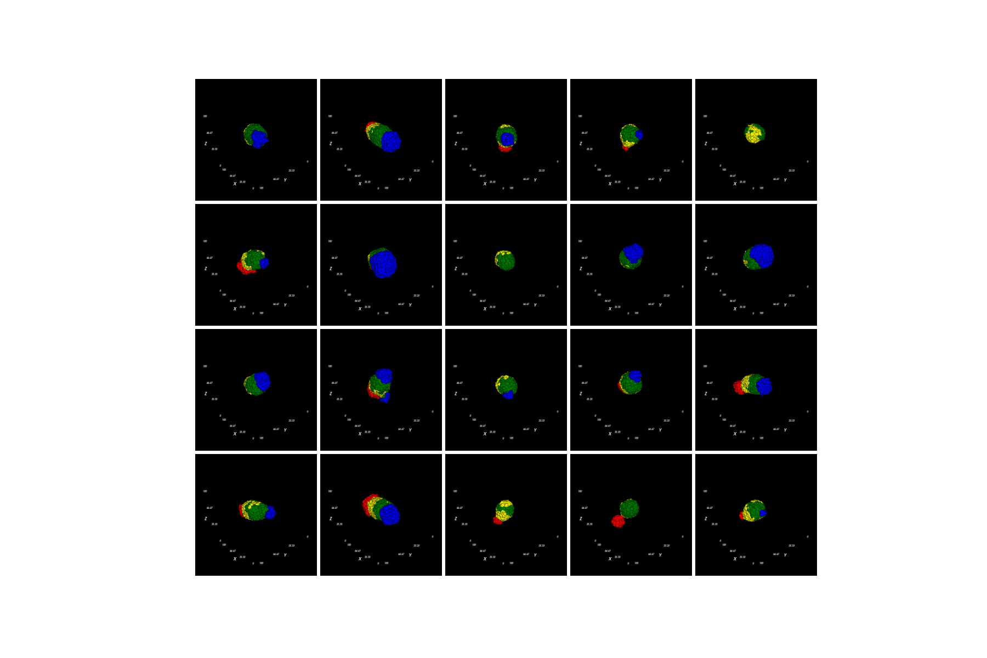
Mitosis for A/B only, using AA/BB = 30, const. motility

 | A | B | A’ | B’ | motility | activation
A | 30 | 49 | 45 | 49 | 100 | 10,000
B | 49 | 30 | 49 | 45 | 100 | 10,000
A’ | 45 | 49 | 20 | 20 | 100 | 0
B’ | 49 | 45 | 20 | 20 | 100 | 0
Title: elongation_impl2_try6

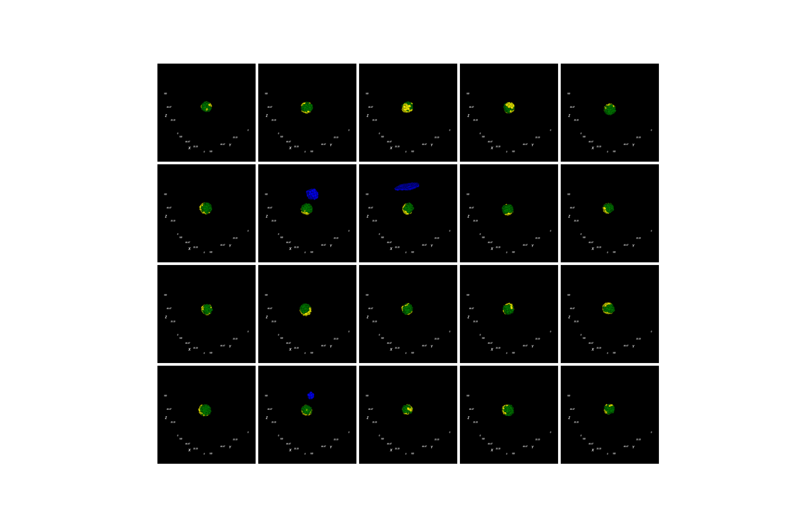

Mitosis for A/B only, using AA/BB = 30, const. motility

 | A | B | A’ | B’ | motility | activation
A | 30 | 49 | 45 | 49 | 100 | 4,500
B | 49 | 30 | 49 | 45 | 100 | 4,500
A’ | 45 | 49 | 20 | 20 | 100 | 0
B’ | 49 | 45 | 20 | 20 | 100 | 0
Title: elongation_impl2_try7
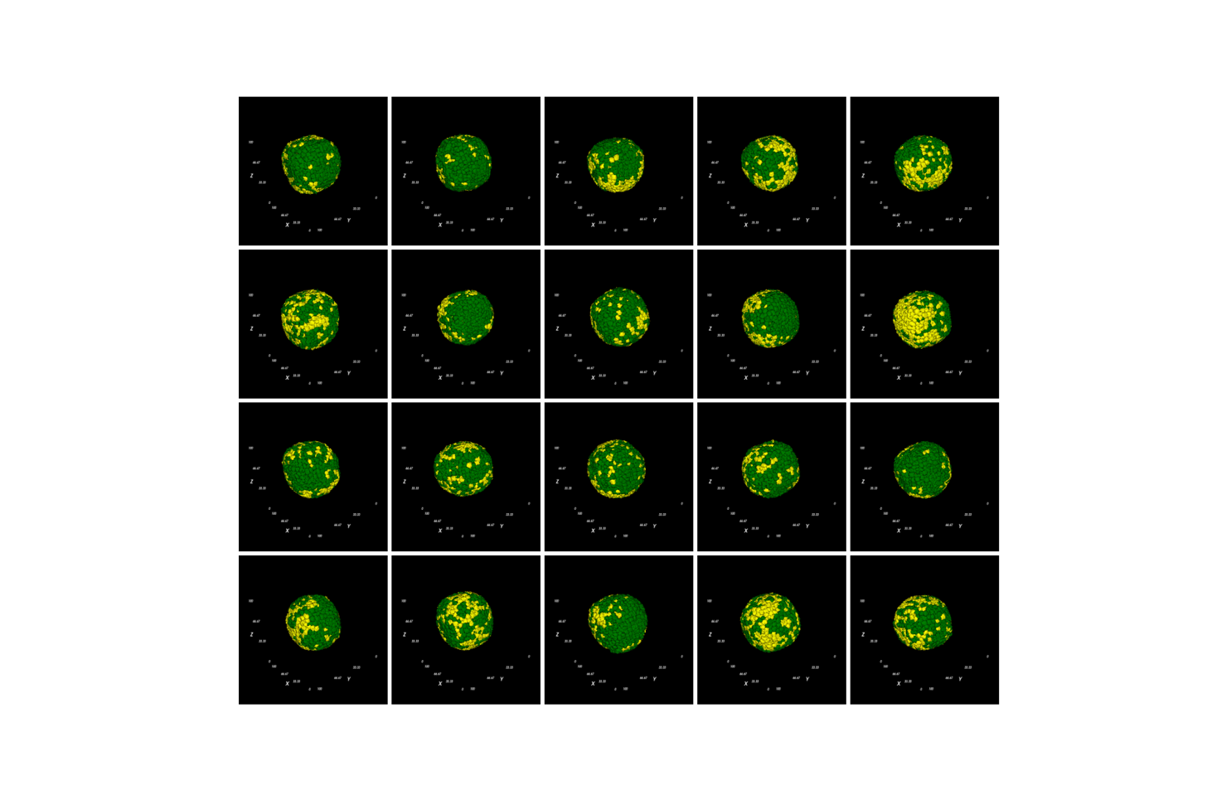
Mitosis for all cells, using AA/BB = 30, const. motility

 | A | B | A’ | B’ | motility | activation
A | 30 | 49 | 45 | 49 | 100 | 4,500
B | 49 | 30 | 49 | 45 | 100 | 4,500
A’ | 45 | 49 | 20 | 20 | 100 | 0
B’ | 49 | 45 | 20 | 20 | 100 | 0
Title: elongation_impl2_try8

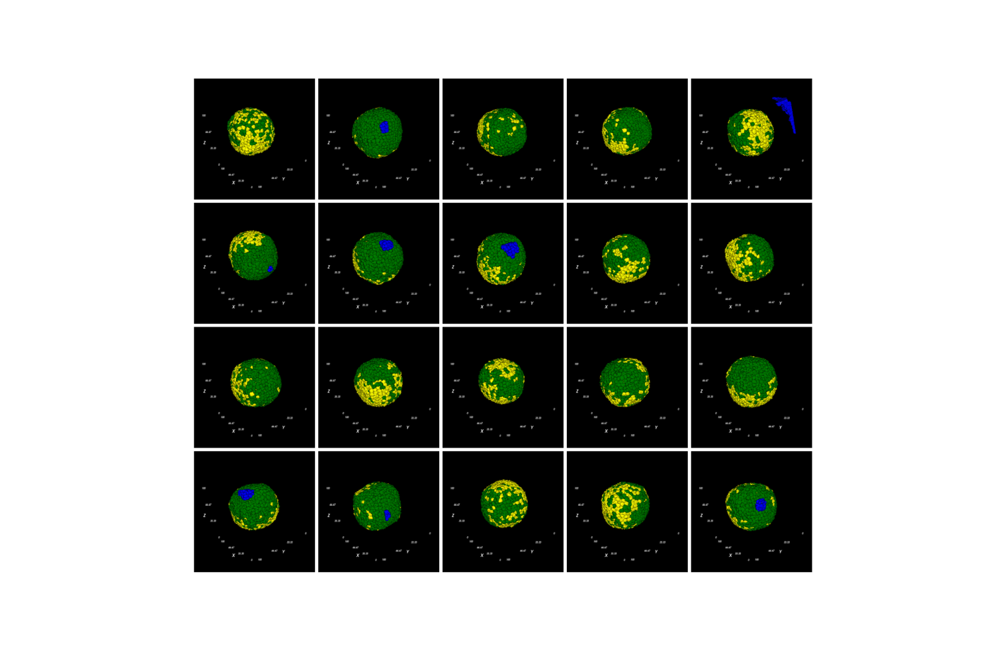

Mitosis for all cells, using AA/BB = 30, const. motility

 | A | B | A’ | B’ | motility | activation
A | 30 | 49 | 45 | 49 | 100 | 10,000
B | 49 | 30 | 49 | 45 | 100 | 10,000
A’ | 45 | 49 | 20 | 20 | 100 | 0
B’ | 49 | 45 | 20 | 20 | 100 | 0
Title: elongation_impl2_try9
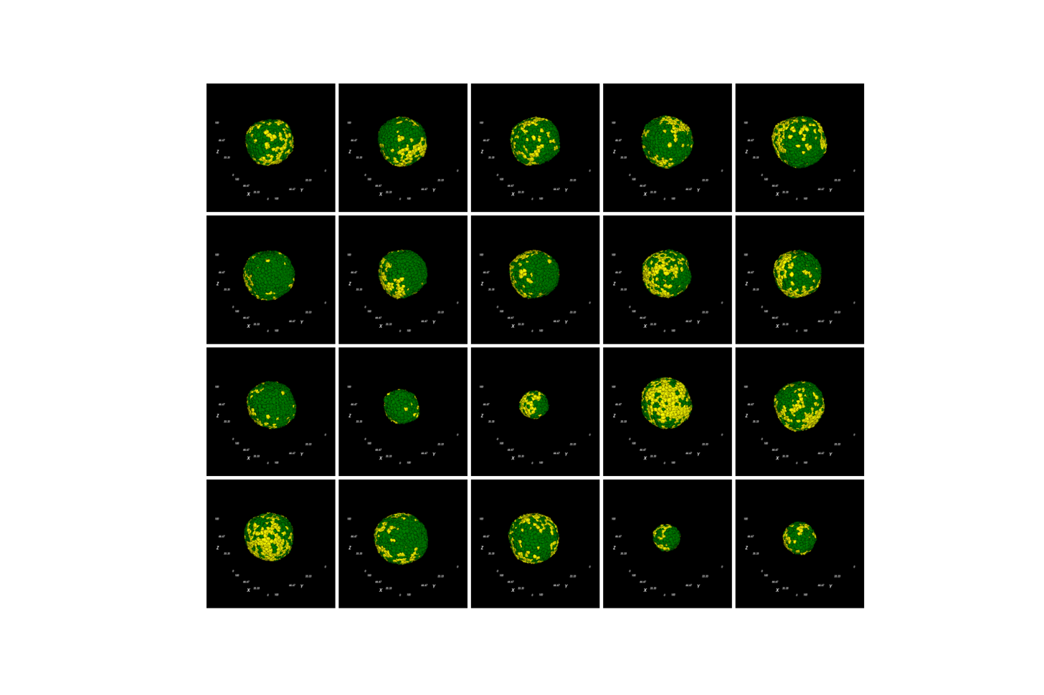
Mitosis for all cells, 5,263 activation

 | A | B | A’ | B’ | motility | activation
A | 30 | 49 | 45 | 49 | 100 | 5,263
B | 49 | 30 | 49 | 45 | 100 | 5,263
A’ | 45 | 49 | 20 | 20 | 100 | 0
B’ | 49 | 45 | 20 | 20 | 100 | 0
Title: elongation_impl2_try10

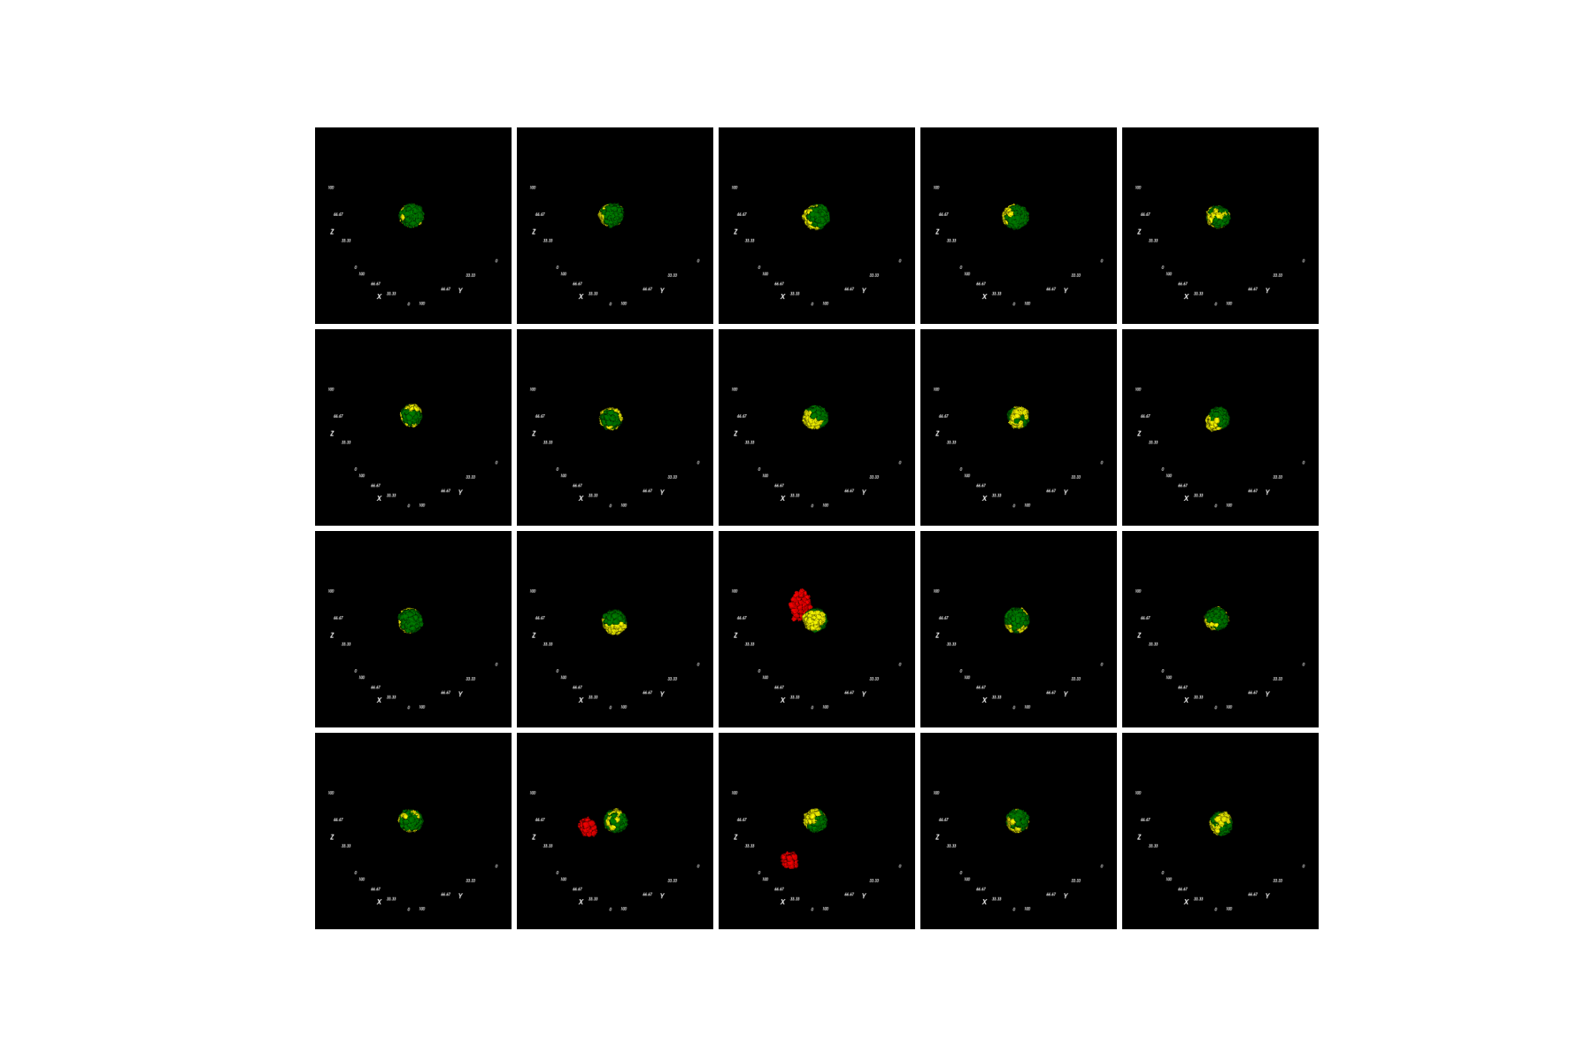

Mitosis for A/B only, 5,263 activation

 | A | B | A’ | B’ | motility | activation
A | 30 | 49 | 45 | 49 | 100 | 5,263
B | 49 | 30 | 49 | 45 | 100 | 5,263
A’ | 45 | 49 | 20 | 20 | 100 | 0
B’ | 49 | 45 | 20 | 20 | 100 | 0
Title: elongation_impl2_try11

