**Freshie’s Day**

**Narrative Report**

To formally welcome all the aspiring freshmen of Batangas State University PB Main II, the Supreme Student Council conducted a one day event entitled “Freshies’ Day” held at the University Gymnasium last September 10, 2018. The program is consists of Organizational Booth Competition and the search for Mr. and Ms. Campus Frosh 2018.

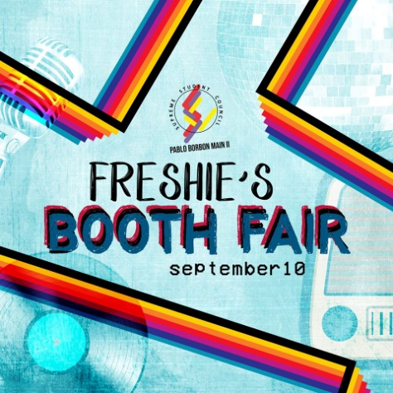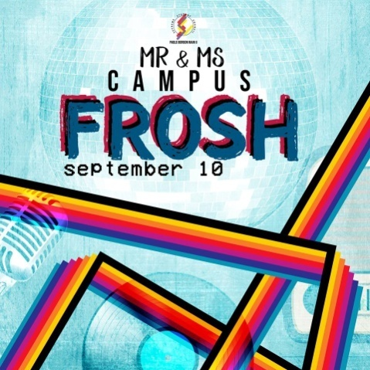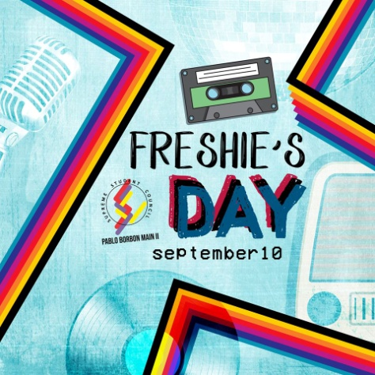

*Freshie’s Day Mr. and Ms. Campus Frosh Freshie’s Booth Fair*

The program started at exactly 8:00 am in which every organization officers together with the SSC PB Main II officers and Mrs. Eleonor E. Sepillo conducted the ribbon cutting ceremony for this prestigious event. Afterwards, the venue was opened to all the students of the university as well as the opening of each organization’s booth in which the set-up is like a Carnival where the students were able to experience the ambiance of being in an amusement park. Each organization was tasked to prepare different kind of games assigned to them and give them the opportunity to use it to earn funds for their organization.

The highlight of this event is the Mr. and Ms. Campus Frosh in which each organization has their representatives to represent their program. The pageant is consists of first year students who possesses the beauty, charm and wit. The program was hosted by Mr. Sherald Agustin and Ms. Francois Manrique who are both Chemical Engineering students. The invocation and National Anthem was lead by the CHeFe Harmonics. Dr. Jessie A. Montalbo, Dean of CICS and Executive Director of SSC PB Main II gave his Opening Remarks before the event finally started.

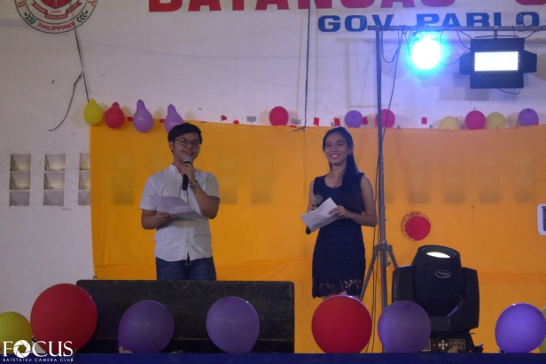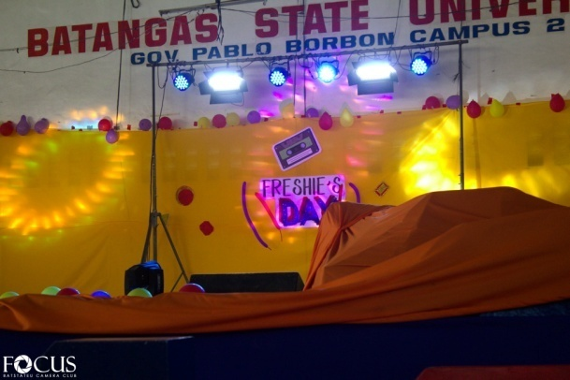

`

*Sherald Agustin and Francois Manrique hosting the event*

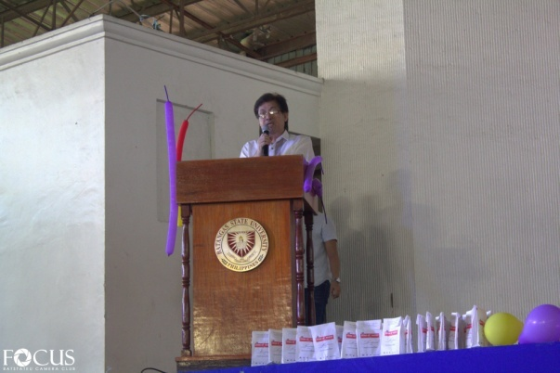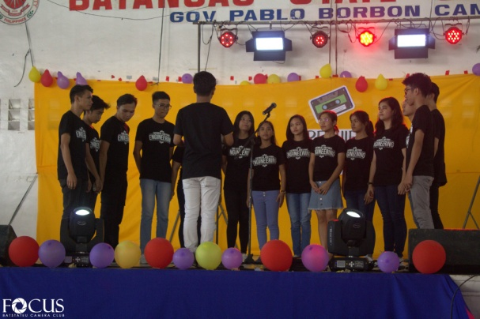

*Dr. Jessie A. Montalbo for his Opening Remarks*

*CheFe Harmonics lead the Invocation and National Anthem*

Sixteen (16) pairs of aspiring freshies from different organization battled for the title of being the first holder of such pageant. Everyone was delighted seeing the candidates dancing on their production number. Their production number fired up the whole corner of the University Gymnasium, a great way to start the pageant indeed. The aura that they provided proved how much they strived for the crown.

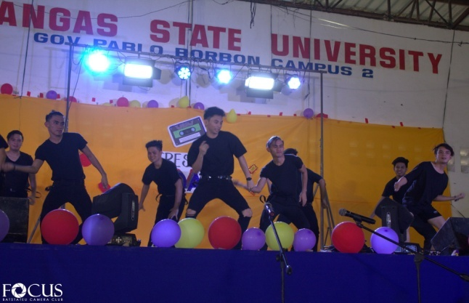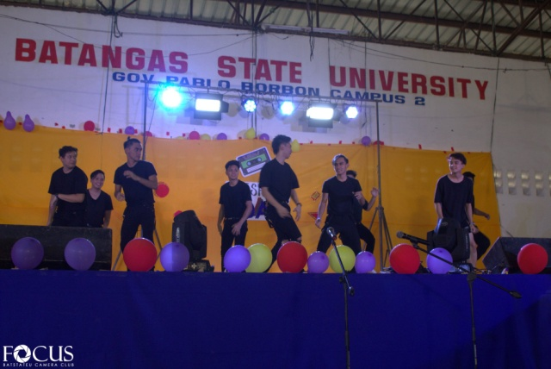





*16 pairs of Candidates in their Production Number*

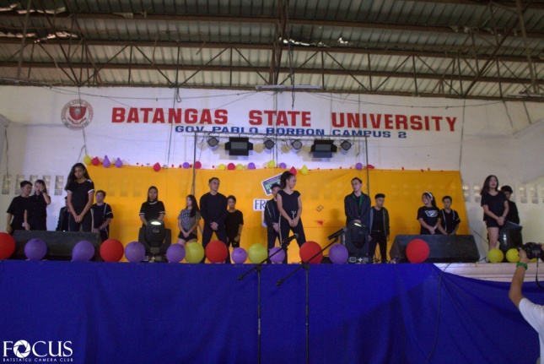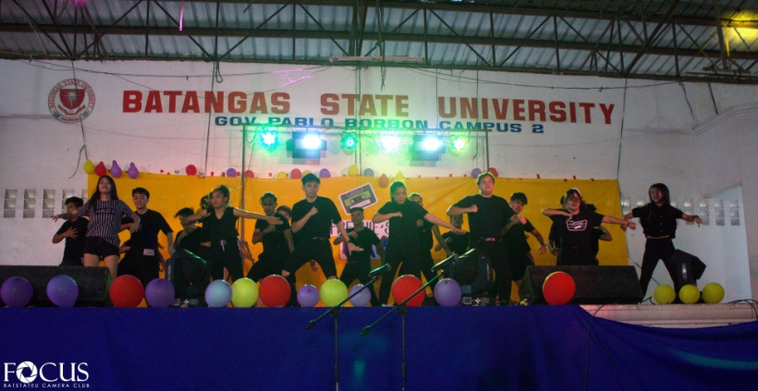 After every portion, different students from the University show their amazing talents by presenting their Intermission Number. Also to make the whole event productive for the audience especially to the Freshmen.

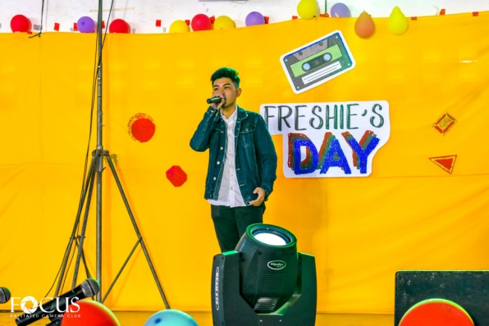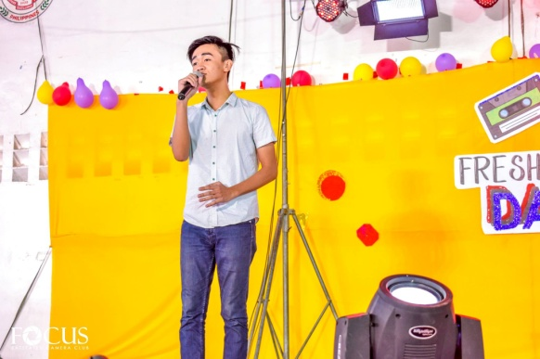

*CEAFA Dance Company*

*Roldan and John in their Intermission Number*

Eroll Brual, the Committee Head on Sports and Cultural first discussed the criteria for Judging. While Jewel Bawal, President of SSC PB Main II introduced the Board of Judges.

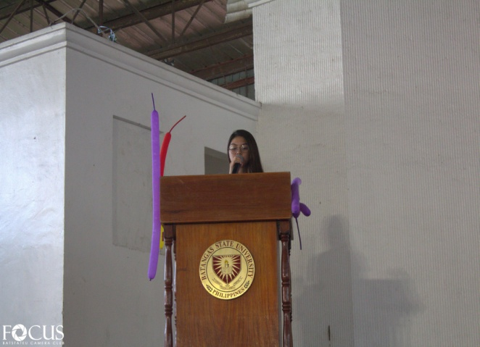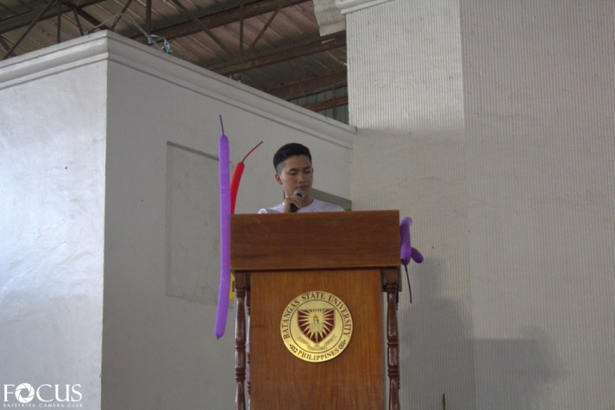

*Jewel Bawal introducing the Board of Judges*

*Eroll Brual discussing the Criteria for Judging*

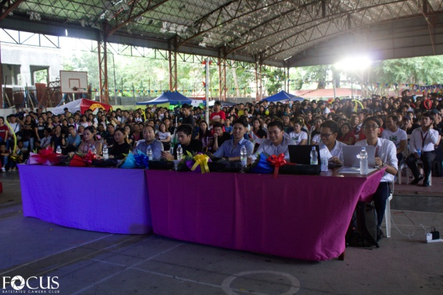

*The Board of Judges and the audience at their back*

There are three portions in which will be the basis on who will make it into top 5 particularly Theme Wear, Beach Wear and Formal Wear.

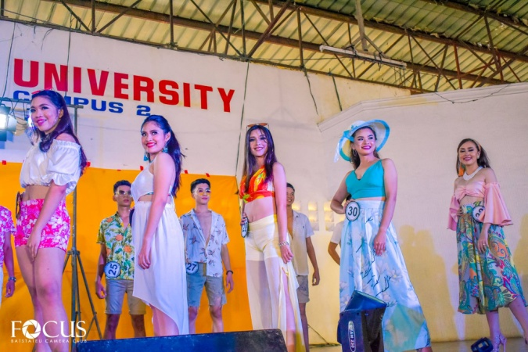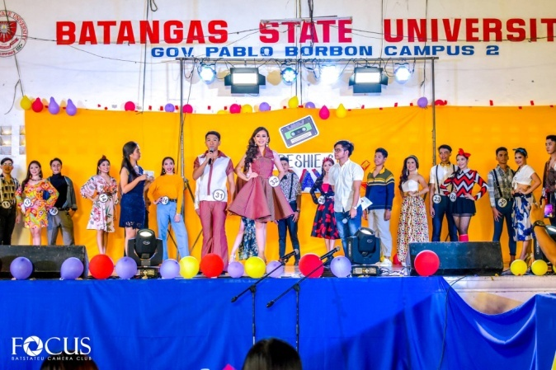

*Beach Wear*

*Theme Wear*

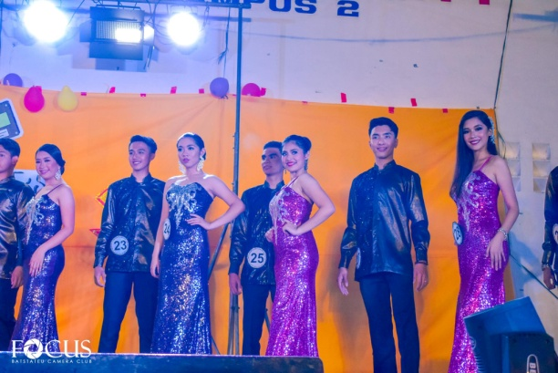

*Formal Wear*

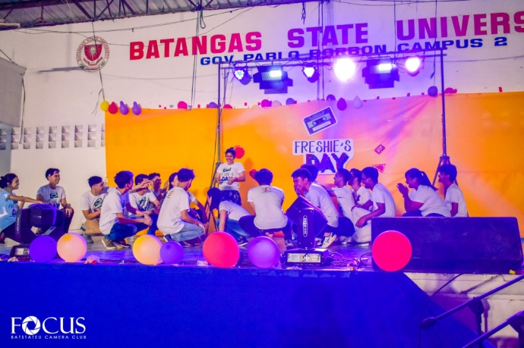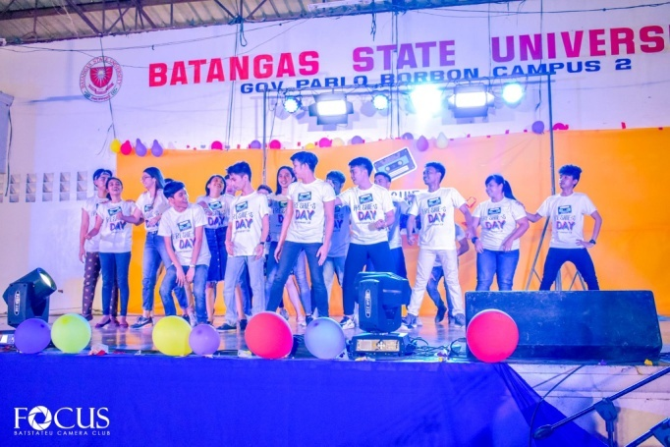 To spice up the event, the SSC PB Main II Officers presented an intermission number. It shows that the student council does not only excel in quality service through leadership, but also talented in different aspects. This only proves how committed the council is in providing service for the student body.

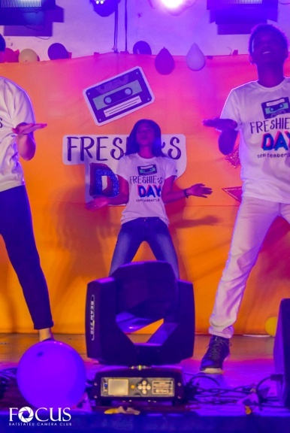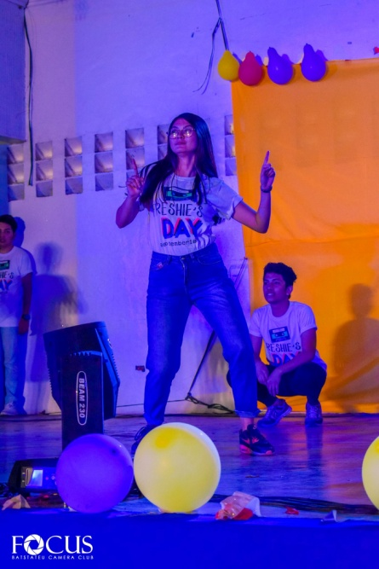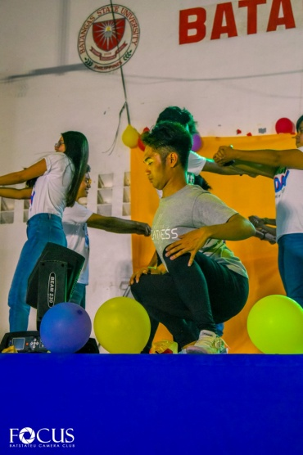

*SSC PB Main II in their Intermission Number*

All the audiences are very excited to finally witness who will rise as the Mr. and Ms. Campus Frosh 2018 Top 5. And the tension continually rises as the hosts introducing who make it into top 5.

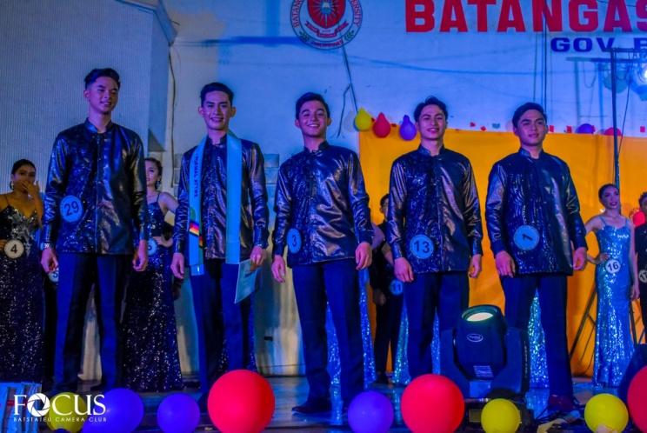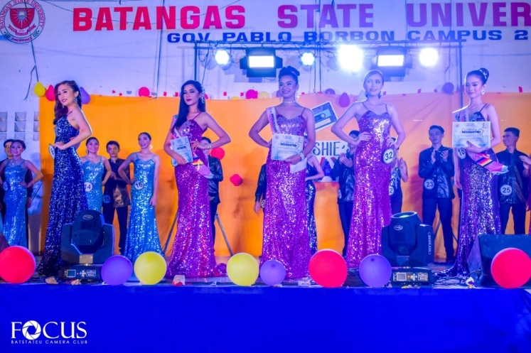 The top 5 were announced and right after that is the Question and Answer portion. They answered the different “Hashtags” topic in which they will give their point of view about it and that proves how deserving are they for the crown.

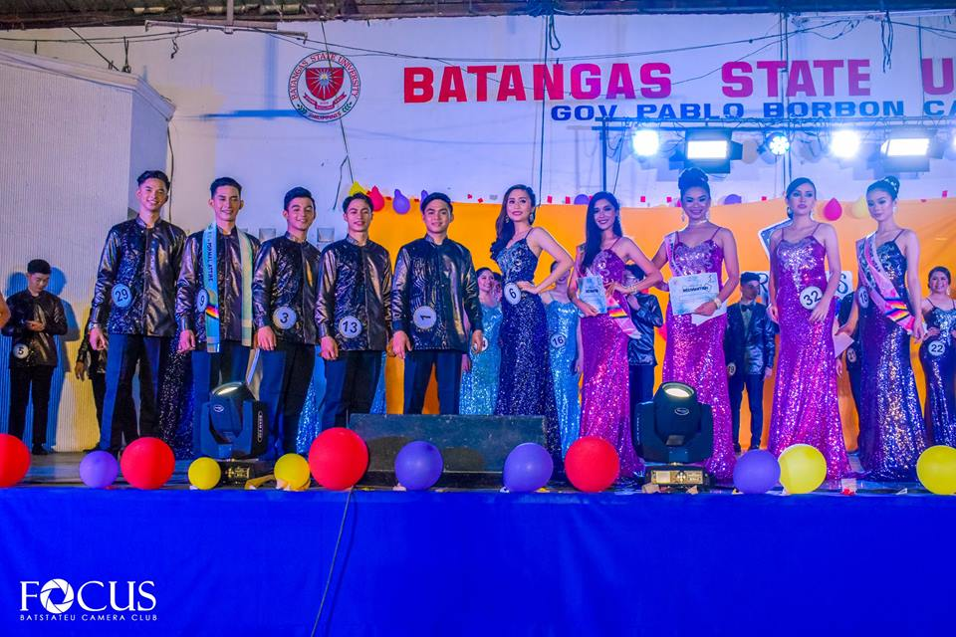

*Mr. and Ms. Campus Frosh 2018 Top 5*

The winners were announced right after the Question and Answer portion. The announcement for the best Organization Booth was also done. Nobody can explain how successful the event is. It’s a success for everyone who extended their effort just to make this event possible.

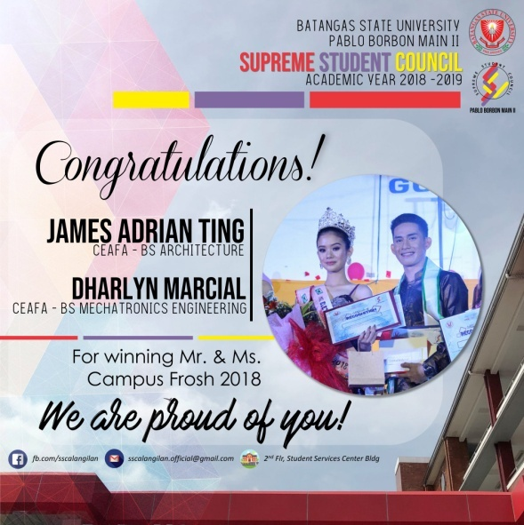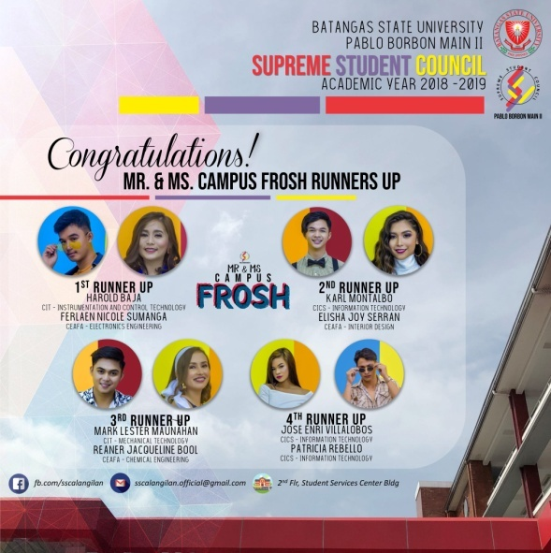

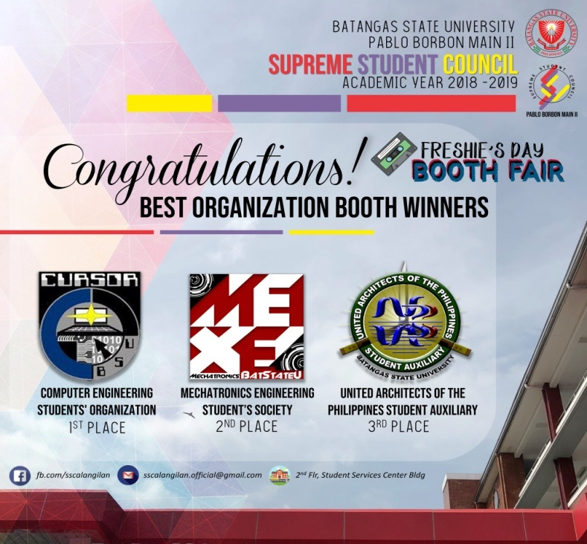

*Winners for Best Orgnaization Booth*

*Mr. and Ms. Campus Frosh 2018 Runners Up*

*Mr. and Ms. Campus Frosh 2018*