Capstone Project Machine Learning Engineer Nanodegree

Naoki Shibuya

March 20, 2016

Plot and Navigate a Virtual Maze

Definition

***Project Overview***

A robot mouse in a virtual maze finding an optimal way to the destination by its own – that’s what I

programed in this project which took an inspiration from the micro mouse competition.

***Problem Statement***

The rule is simple: in the first run, the robot mouse tries to map out the maze to not only find the center, but also figure out the best paths to the center. The robot must enter to the goal within the time limit but it is free to continue exploring the maze after finding the goal. In subsequent runs, the robot mouse is brought back to the start location. It must attempt to reach the center in the fastest time possible, using what it has previously learned.

A simplified model of the world is provided along with specifications for the maze and robot. My main objective is to implement a logic that achieves the fastest times possible in a series of test mazes.

***Scoring***

The robot’s score for the maze is equal to the number of time steps required to execute the second run, plus one thirtieth the number of time steps required to execute the first run. A maximum of one thousand time steps is allotted to complete both runs for a single maze.

Analysis

***Data Exploration and Visualization***

The shape of every test mazes is a square. The start location is always at the left bottom corner

(rows-1, 0), and the goal room always occupies 4 cells in the center.

The robot has three obstacle sensors, mounted on the front of the robot, its right side, and its left side. Obstacle sensors detect the number of open squares in the direction of the sensor. It is assumed that the robot’s turning and movement is perfect.

At the start location, both left and right sides have walls so that it can only move forward. The sensors will return the distance between the robot and walls in a tuple as in (left distance, forward distance, right distance).

On each time step of the simulation, the robot may choose to rotate clockwise or counterclockwise ninety degrees, then move forwards or backwards a distance of up to three units.

If the robot tries to move into a wall, the robot stays where it is. After movement, one time-step has passed, and the sensors return readings for the open squares in the robot’s new location and/or orientation to start the next time unit.

Rotation is expected to be an integer taking one of three values: -90, 90, or 0, indicating a counterclockwise, clockwise, or no rotation, respectively. Movement follows rotation, and is expected to be an integer in the range [-3, 3] inclusive. The robot will attempt to move that many squares forward (positive) or backwards (negative), stopping movement if it encounters a wall.

**Maze 01 (12x12)**

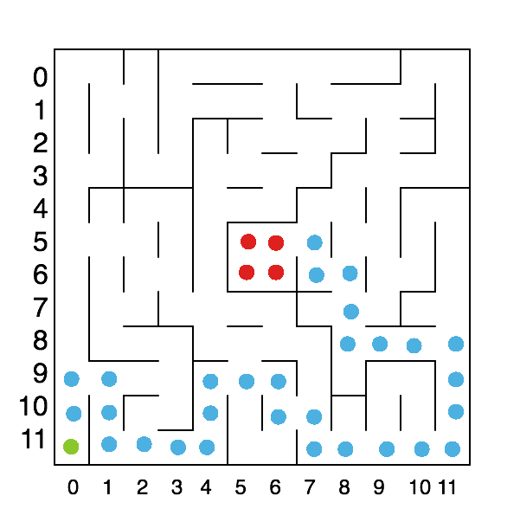

The start location is (11, 0) and it is shown with the green ball. The goal area is located in the center and it is shown with the red balls. At the start location, the robot is facing north and its sensors will return (0, 11, 0).

The shortest path from the start location to the goal area is indicated the blue balls. It takes 30 single steps from the start location to the goal area. The robot is however allowed to take maximum 3 steps in one time step. Therefore, the minimum time steps required to arrive the goal should be 17. This also means the robot should prefer straight path than left/right turns.

**Maze 02 (14x14)**

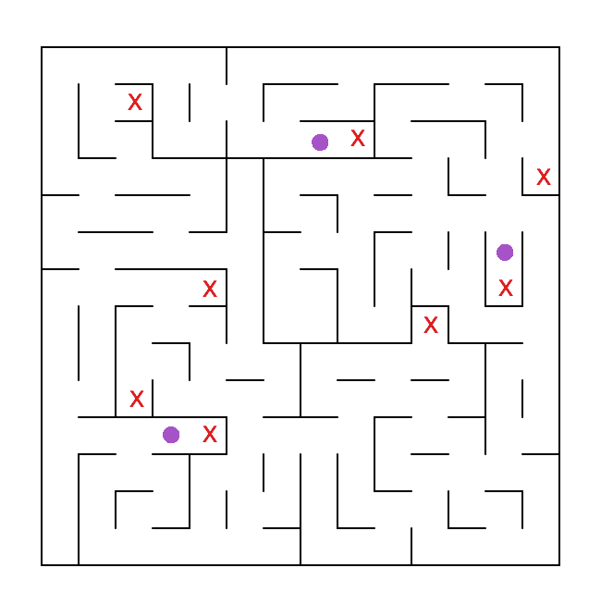

The robot should identify and avoid dead ends. The robot should recognize any one-way path to

dead ends as well.

In this maze visualization, I marked dead ends with red X marks and

one way path to the dead ends with

purple balls.

**Maze 03 (16x16)**

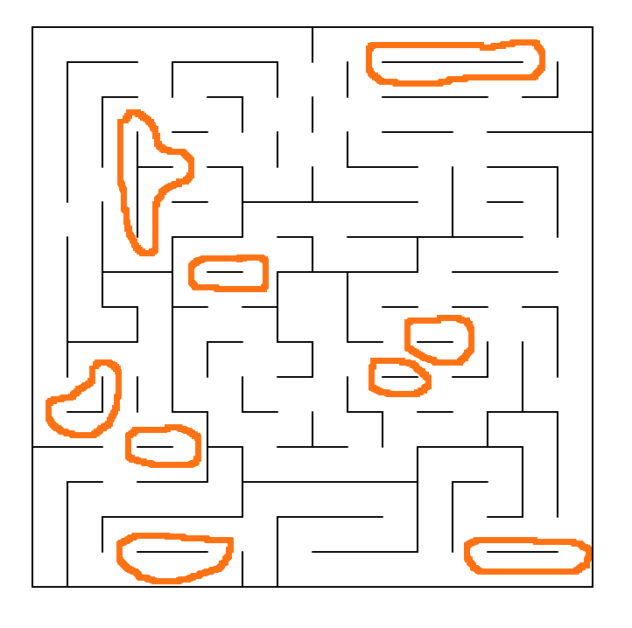

The robot should avoid going through a loop many times.

In this maze, I indicated some of the potential loops in orange lines. The robot may fall into the same path again and again there.

During the first run, the robot should keep track of how often it has visited each location in the maze and prefers to explore where it visited less often.

***Algorithms and Techniques***

If the robot explores the entire maze, we can use A* algorithm to find the shortest path from the start location to the goal area. Therefore, in the first run, the robot should try exploring the maze as much as possible and expand the mapping area so that, in the second run, the robot can apply the A* search algorithm to find the optimal path and moves. On the other hand, the robot should try reaching the goal as fast as possible in the first run as it affects the score value and if too much time is spent in the first run, it may not be able to leave enough time for the second run.

For the first run, I will use the following techniques for the robot controller to explore the maze and expand the mapping area while seeking the goal area:

• Random move

• Random move with dead-end path detection

• Counting number of visits for each location in order to expand into less visited area

• The counting logic with heuristic prediction of the distance to the goal

The random move controller will take the robot to different paths randomly. It is not most efficient way to expand the mapping area but it gives the baseline performance to compare with more advanced techniques. Also, this controller will prove that the robot movements and rotations are handling walls properly.

The dead-end path detection will prevent the robot to enter dead-ends more than once making it more efficient to expand the mapping area than the pure random controller.

The counting number of visits for each location will give the robot chances to move to less frequently visited locations. It will also make the robot moves out of loops.

The heuristic values will be used to make the robot move towards the goal area making it faster to reach the goal area.

For the second run, I will use A* search on the mapped area from the first run in order to find the optimal path/moves to the goal.

In A* search, G values give the cost of reaching to each location in the maze from the start position. The turning left or right is given higher cost than the forward move. Heuristic values gives the distance of each location in the maze from the goal area. A* search uses the F values which are combination of G values and Heuristic values to find the optimal path from the start location to the goal area.

As the maze structure is well defined, I will use the test maze data to test the A* search program. I’ll provide a separate python script to run the test without using the robot tester program.

***Benchmark***

I’ll provide different controllers (Random, Dead-End, Counter, Heuristic) to compare the scores which should improve as more advanced techniques are introduced. The random controller will set the worst score benchmark. Later, I’ll discuss the A* search results with the full maze details, which will set the optimal path/moves as the best benchmark.

Methodology

***Data Pre-processing***

The maze specification and robot's sensor data is provided and 100% accurate. Therefore, there is no data pre-processing is required.

***Implementation***

**Utilities**

In utility.py, I have implemented utilities to handle common tasks.

**Delta** is an array of directions. Each item in Delta is a pair of (row direction, column direction). For example, [ -1, 0 ] means North direction.

Delta = [[-1, 0], # go north

[ 0, 1], # go east

[ 1, 0], # go south

[ 0, -1]] # go west

A change in direction can be expressed by an index move in Delta. For example, a right turn means adding 1 to the index. When the current direction is North (index=0), a right turn results in the direction change to East (index=1).

**Steering** is an Enum class for direction change. Rather than remembering what -1 means, I can simply use Steering.L to mean a left turn.

class Steering(Enum):

L, F, R = (-1,0,1) # Left, Forward, Right

def str (self):

return self.name

**Direction** is an Enum class for direction. The enum value of this class corresponds to the index values in Delta so that I do not need to remember the actual index value and use the Enum name instead. This class handles direction manipulation operations such as reversing direction or adjusting to change the direction by a Steering value.

class Direction(Enum):

N, E, S, W = range(4) # North, East, South, West

def reverse(self):

return Direction((self.value+2)%4)

def adjust(self, steering):

return Direction((self.value+steering.value)%4)

def delta(self):

return Delta[self.value]

def steer(self, direction):

diff = direction.value - self.value if diff ==3:

diff = -1 if diff ==-3:

diff = 1

return Steering(diff)

def str (self):

return self.name

The robot decides direction and moves its location. **Heading** is a class that encapsulates both direction and location. It is mutable and as such all methods will return a new Heading object.

class Heading(object):

def init (self, direction, location): self.direction = direction self.location = location

def str (self):

return '{} @ ({:>2d},{:>2d})'.format(

self.direction.name, self.location[0], self.location[1])

def adjust(self, steering, movement):

direction = self.direction.adjust(steering)

delta = direction.delta()

location = [ self.location[i]+delta[i]*movement for i in range(2) ]

return Heading(direction, location)

# move forward

def forward(self, movement=1):

return self.adjust(Steering.F, movement)

# move to left

def left(self, movement=1):

return self.adjust(Steering.L, movement)

# move to right

def right(self, movement=1):

return self.adjust(Steering.R, movement)

# move backward with turning

def backward(self, movement=1):

return self.reverse().forward(movement)

# only reverse the direction def reverse(self):

return Heading(self.direction.reverse(), self.location)

The robot’s sensor values are given in a tuple format. Again, directly handling it can be error-prone. Making the code more human readable is a way to avoid such problems.

**Sensor** is a class that encapsulates sensor values. I can get a distance to a wall by specifying the steering value, and also find out if the robot is in a dead-end or not.

class Sensor:

def init (self, sensors):

self.sensors = sensors

def distance(self, steering):

steering_sensor_index_map = { Steering.L : 0,

Steering.F : 1, Steering.R : 2

}

return self.sensors[steering_sensor_index_map[steering]]

def isDeadEnd(self):

return max(self.sensors)==0

# both sides are walls def isOneWay(self):

return self.sensors[0]==0 and self.sensors[1]>0 and self.sensors[2]==0

def str (self):

return str(self.sensors)

**Goal** is a class that encapsulates the goal area in a maze so that I can check whether a location is in the goal area or not.

class Goal(object):

def init (self, rows, cols): self.goal_row_max = rows/2 self.goal_row_min = rows/2-1 self.goal_col_max = cols/2 self.goal_col_min = cols/2-1

def isGoal(self, location):

row, col = location

return self.goal_row_min <= row and row <= self.goal_row_max and \

self.goal_col_min <= col and col <= self.goal_col_max

**Grid** encapsulates two dimensional array so that I can associate maze locations to calculated values. I can get and set values using getValue and setValue methods, making the code readable that using the array index syntax.

class Grid(object):

def init (self, rows, cols ,init_val):

self.rows = rows self.cols = cols

self.grid = [ [ copy.deepcopy(init_val) for c in range(cols) ] for r in range(rows) ]

self.shape = (rows, cols)

def getitem (self, row):

return self.grid[row]

def getValue(self, location):

return self.grid[location[0]][location[1]]

def setValue(self, location, value):

self.grid[location[0]][location[1]] = value

def isValid(self, location):

row, col = location

return 0 <= row and row < self.rows and 0 <= col and col < self.cols

There are several subclass of Grid. Namely,

• **Mapper** for mapping the maze,

• **Counter** for counting the number of visits for each cell,

• **DeadEnd** for marking dead-end paths, and

• **Heuristic** to generate and holds the heuristic values

**A* search**

In planner.py, I’ve implemented A* star search (findOptimalMoves) to calculates the optimal moves from the start location to the goal area. Having a standalone program makes it easy to test the

search algorithm directly with the test maze files.

The program can be run by the planner.sh script as follows:

./plan.sh <maze_number>

To find the optimal path and moves for the test_maze_01.txt, use the following:

./plan.sh 01

Mapper class can read the test maze file format so that the search algorithm knows where it can move to.

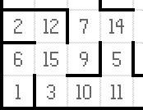

Note: it reads the maze file only when testing the A* search logic. It will not do so while running the tester program to test the actual robot controllers.

A* star search then uses Heuristic values and g-values to calculate f-values. The optimal path will be printed into the console as shown below:

-- Path --

|  |  |  |  |  |  |  |  |  |  |  |
| --- | --- | --- | --- | --- | --- | --- | --- | --- | --- | --- |
| , | , | , | , | , | , | , | , | , | , | , |
| , | , | , | , | , | , | , | , | , | , | , |
| , | , | , | , | , | , | , | , | , | , | , |
| , | , | , | , | , | , | , | , | , | , | , |
| , | , | , | , | , | , | , | , | , | , | , |
| , | , | , | , | , | ,*,W, | | | , | , | , |
| , | , | , | , | , | , | ,N,W, | | | , | , |
| , | , | , | , | , | , | , ,N, | | | , | , |

, , , , , , , ,N,W,W,W

E,S, , ,E,E,S, , , , ,N

N,S, , ,N, ,E,S, , , ,N N,E,E,E,N, , ,E,E,E,E,N Path Length: 30

The optimal moves are returned in a list of (steering, movement) pairs. The list of moves can be applied from the start location to reach the goal with the minimum steps.

A sample is shown below for the test maze 01. The optimal path length is 30 but the actual moves required is only 17 since the robot can take up to 3 steps in one direction.

-- Moves -- (F,2)

(R,1) (R,2) (L,3) (L,2) (R,2) (R,1) (L,1) (R,1) (L,3) (F,1) (L,3) (L,3) (R,2) (L,1) (R,1) (L,1)

# of Moves: 17

***Refinement***

**Robot Controllers**

In controller.py, I defined a Controller base class which declares methods that the robot class interact with. There are various sub-classes of this class for specific logic implementations.

The following is a list of controllers used for the first run to explore the maze:

• **Controller_Exploration** a base class for first run controllers

• **Controller_Random** extends Controller_Exploration to implement the random move

• **Controller_DeadEnd** extends Controller_Random with dead-end path detection

• **Controller_Counter** extends Controller_DeadEnd with the location visit counter allowing it to move to less visited locations for better exploration/expansion and avoid loops

• **Controller_Heuristic** extends Controller_Counter using the heuristic to decide direction when two possible directions has same counter value to reach the goal faster

In the second run, the robot internally switches to the following controller to reach to the goal following optimal moves calculated with the mapped area of the maze.

• **Controller_Exploitation** uses the findOptimalMoves to get a list of optimal moves to follow based on the available information on the maze structure from the first run

**Robot**

The tester program can be run as follows:

./run.sh <controller_name> <maze_number> (<tick_interval_in_seconds>)

For example, to run the random controller with maze 02:

./run.sh random 02

For debugging purpose, you can specify a delay seconds between each time step. The following adds 1 second between each time step so that you can actually follows the log messages.

./run.sh random 02 1

The following is a list of controller names:

• random

• deadend

• counter

• heuristic

Results

***Model Evaluation and Validation***

**Optimal Moves**

The optimal moves are measured by using the A* search.

|  |  |  |
| --- | --- | --- |
| **Test maze** | **Path Length** | **Required Moves** |
| 01 | 30 | 17 |
| 02 | 43 | 23 |
| 03 | 49 | 25 |

The above numbers can be achieved if the robot has 100% mapping coverage of the maze as all robots are using the same search implementation in the 2nd run.

Maze 01 Optimal Moves

-- Path --

, , , , , , , , , , ,

, , , , , , , , , , ,

, , , , , , , , , , ,

, , , , , , , , , , ,

, , , , , , , , , , ,

, , , , , ,*,W, , , ,

, , , , , , ,N,W, , ,

, , , , , , , ,N, , ,

, , , , , , , ,N,W,W,W E,S, , ,E,E,S, , , , ,N N,S, , ,N, ,E,S, , , ,N N,E,E,E,N, , ,E,E,E,E,N

Path Length! 30

-- Moves -- (F,2)

(R,1)

(R,2) (L,3) (L,2) (R,2) (R,1) (L,1) (R,1) (L,3) (F,1) (L,3) (L,3) (R,2) (L,1) (R,1) (L,1)

# of Moves! 17

There are alternate paths that have the same length (=30). The above move is selected as the A*

search gives preference to straight paths by adding extra move cost to left and right turns.

For example, the following path’s length is 30 but the number of moves is 20 which is worse than the optimal moves by 3 steps.

-- Path --

, , , , , , , , , , ,

, , , , , , , ,E,S, ,

, , , , ,E,E,E,N,S, ,

, , , ,E,N, , ,S,W, ,

, , , ,N, , ,S,W, , , E,E,S, ,N, ,*,W, , , , N, ,E,S,N, , , , , , , N, , ,E,N, , , , , , , N, , , , , , , , , , , N, , , , , , , , , , , N, , , , , , , , , , , N, , , , , , , , , , ,

Path Length! 30

-- Moves -- (F,3)

(F,3)

(R,2) (R,1) (L,1) (R,1) (L,1) (L,3) (F,1) (R,1) (L,1) (R,3) (L,1) (R,1) (R,2) (R,1) (L,1) (R,1) (L,1) (R,1)

# of Moves! 20

Maze 02 Optimal Moves

-- Path --

, , , , , , , , , , , , ,

, , , , , , , , , , , , ,

, , , , , , , , , , , , ,

, , , , , , , , , , , , ,

, , , , , , , ,S,W,W,W,W,W

, , , , , ,S,W,W, , , , ,N

E,E,E,S, , ,*, , , , , , ,N N, , ,E,S, , , , , , , , ,N N, , , ,S, , , , , , , ,E,N N, , , ,E,S, , , , , , ,N, N, , , , ,E,E,E,S, , , ,N, N, , , , , , , ,S, ,E,E,N, N, , , , , , , ,E,E,N, , , N, , , , , , , , , , , , ,

Path Length! 43

-- Moves -- (F,3)

(F,3)

(F,1) (R,3) (R,1) (L,1) (R,2) (L,1) (R,1) (L,3) (R,2)

(L,2) (L,1) (R,2) (L,3) (R,1) (L,3) (F,1) (L,3) (F,2) (L,1) (R,2) (L,1)

# of Moves! 23

Maze 03 Optimal Moves

-- Path --

E,E,E,E,E,E,E,S, , , , , , , ,

N, , , , , , ,E,S, , , , , , , N, , , , , , , ,E,E,E,E,S, , , N, , , , , , , , , , , ,S, , , N, , , , , , , , , , , ,S, , , N, , , , , , , , , , , ,E,E,S, N, , , , , , , , , , ,S,W,W,W, N, , , , , , , , , , ,S, , , , N, , , , , , , ,*, ,S,W, , , , N, , , , , , , ,N,W,W, , , , , N, , , , , , , , , , , , , , , N,W,W, , , , , , , , , , , , , E,E,N, , , , , , , , , , , , , N, , , , , , , , , , , , , , , N, , , , , , , , , , , , , , , N, , , , , , , , , , , , , , ,

Path Length! 49

-- Moves -- (F,3)

(R,2) (L,1) (L,2) (R,3) (F,3) (F,3) (F,2) (R,3) (F,3) (F,1) (R,1) (L,1) (R,1) (L,3) (F,1) (R,3) (L,2) (R,1) (R,3) (L,2) (R,1) (L,1) (R,2) (R,1)

# of Moves! 25

Again, there can be a different path with the same number of moves. For example, the following path length is 45 (shorter than above) and it takes 25 moves (the same). The reason this was not chosen is because the list of moves contains less number of forward moves. In other words, there are more left and right turns which costs more than forward moves (in the physical micro mouse

-- Path --

, , , , , , , , , , , , ,

, , , , , , , , , , , , ,

, , , , , , , , , , , , ,

, , , , , , , ,S,W,W, , ,

, , , , , , , ,S, ,N, , ,

, , , , , ,S,W,W, ,N, , ,

, , , , , ,*, , , ,N,W, ,

, , , , , , , , , , ,N,W,W

, , , , , , , , , , , ,E,N

, , , , , , , , , , , ,N, E,E,S, , ,E,E,E,S, , , ,N, N, ,E,S, ,N, , ,S, ,E,E,N, N, ,S,W, ,N, , ,E,E,N, , , N, ,E,E,E,N, , , , , , , ,

Path Length! 45

-- Moves -- (F,3)

(R,2) (R,1) (L,1) (R,1) (R,1) (L,1) (L,3) (L,3) (R,3) (R,2) (L,2) (L,1) (R,2) (L,3) (R,1) (L,1) (L,2) (R,1) (L,1) (R,3) (L,2) (L,2) (R,2) (L,1)

# of Moves! 25

**Random and Dead-End controllers**

Both the random and the dead-end controllers use random moves chosen from the available directions. As such, they give different outcome for every run. Moreover, it may or may not reach to the goal. I took 10 trial results to evaluate the average numbers for them.

**Random Controller**

The random controller does reach to the goal but not always. As the maze size increases, the success rate goes down. The robot turns left or right randomly at the dead-ends but it does not recognize the one-way path to them. Hence, it may repeatedly visit the same dead-ends over and over. After examining the log details, it became evident that the random logic spent lots of time in the dead end paths. Note: the below average values exclude rows with Goal=No.

Test Maze 01 Results

|  |  |  |  |  |  |  |  |
| --- | --- | --- | --- | --- | --- | --- | --- |
| **Trial** | **1st Run** | | | **2nd Run** | | | **Score** |
| **Goal?** | **Moves** | **Coverage** | **Goal?** | **Path Length** | **Moves** |
| **1** | Yes | 831 | 95.14% | Yes | 30 | 17 | 44.767 |
| **2** | Yes | 210 | 66.67% | Yes | 34 | 21 | 28.067 |
| **3** | Yes | 111 | 38.19% | Yes | 34 | 21 | 24.767 |
| **4** | Yes | 108 | 43.06% | Yes | 30 | 21 | 24.667 |
| **5** | Yes | 179 | 56.25% | Yes | 30 | 17 | 23.033 |
| **6** | Yes | 638 | 89.58% | Yes | 30 | 17 | 38.333 |
| **7** | Yes | 60 | 36.11% | Yes | 32 | 19 | 21.067 |
| **8** | No | n/a | n/a | n/a | n/a | n/a | n/a |
| **9** | Yes | 256 | 72.92%% | Yes | 36 | 22 | 30.600 |
| **10** | No | n/a | n/a | n/a | n/a | n/a | n/a |
| **Average** | 80.00% | 299.125 | 60.71% | 80.00% | 32 | 19.375 | 29.413 |

Test Maze 02 Results

|  |  |  |  |  |  |  |  |
| --- | --- | --- | --- | --- | --- | --- | --- |
| **Trial** | **1st Run** | | | **2nd Run** | | | **Score** |
| **Goal?** | **Moves** | **Coverage** | **Goal?** | **Path**  **Length** | **Moves** |
| **1** | Yes | 399 | 86.22% | Yes | 43 | 26 | 39.367 |
| **2** | Yes | 172 | 52.55% | Yes | 49 | 31 | 36.800 |
| **3** | Yes | 258 | 55.61% | Yes | 47 | 31 | 39.667 |
| **4** | Yes | 251 | 50.51% | Yes | 47 | 30 | 38.433 |
| **5** | No | n/a | n/a | n/a | n/a | n/a | n/a |
| **6** | No | n/a | n/a | n/a | n/a | n/a | n/a |
| **7** | Yes | 737 | 72.45% | Yes | 43 | 25 | 49.633 |
| **8** | Yes | 805 | 89.29% | Yes | 43 | 23 | 49.900 |
| **9** | No | n/a | n/a | n/a | n/a | n/a | n/a |
| **10** | No | n/a | n/a | n/a | n/a | n/a | n/a |
| **Average** | 60.00% | 437 | 67.77% | 60.00% | 45.33 | 27.67 | 42.300 |

Test Maze 03 Results

|  |  |  |  |  |  |  |  |
| --- | --- | --- | --- | --- | --- | --- | --- |
| **Trial** | **1st Run** | | | **2nd Run** | | | **Score** |
| **Goal?** | **Moves** | **Coverage** | **Goal?** | **Path Length** | **Moves** |
| **1** | No | n/a | n/a | n/a | n/a | n/a | n/a |
| **2** | No | n/a | n/a | n/a | n/a | n/a | n/a |
| **3** | No | n/a | n/a | n/a | n/a | n/a | n/a |
| **4** | Yes | 618 | 84.38% | Yes | 51 | 26 | 46.667 |
| **5** | No | n/a | n/a | n/a | n/a | n/a | n/a |
| **6** | No | n/a | n/a | n/a | n/a | n/a | n/a |
| **7** | No | n/a | n/a | n/a | n/a | n/a | n/a |
| **8** | Yes | 226 | 53.12% | Yes | 63 | 36 | 43.600 |
| **9** | Yes | 361 | 66.41% | Yes | 49 | 26 | 38.100 |
| **10** | Yes | 519 | 75.78%% | Yes | 51 | 31 | 48.367 |
| **Average** | 40.00% | 431 | 67.97% | 40.00% | 53.5 | 29.75 | 44.184 |

**Dead-End Controller**

The dead-end controller avoids dead-end paths by keep track of dead-end paths. As a result, the success rate is higher than the random controller. Having said that, it can still fail to reach the goal from time to time due to the random move choice. The mapping coverage is slightly higher than

the random controller, too. However, higher coverage does not always translates to better scoring in the 2nd run, indicating the robot needs better logic than just randomly wandering about.

It was observed that the dead-end controller spent lots of time in loops. We need a controller that avoid going through the same path again and again.

Test Maze 01 Results

|  |  |  |  |  |  |  |  |
| --- | --- | --- | --- | --- | --- | --- | --- |
| **Trial** | **1st Run** | | | **2nd Run** | | | **Score** |
| **Goal?** | **Moves** | **Coverage** | **Goal?** | **Path Length** | **Moves** |
| **1** | Yes | 62 | 38.89% | Yes | 50 | 32 | 34.133 |
| **2** | Yes | 282 | 81.25% | Yes | 36 | 23 | 32.467 |
| **3** | Yes | 426 | 81.94% | Yes | 30 | 17 | 31.267 |
| **4** | Yes | 227 | 81.25% | Yes | 36 | 23 | 30.633 |
| **5** | Yes | 545 | 92.36% | Yes | 30 | 17 | 35.233 |
| **6** | Yes | 267 | 66.67% | Yes | 30 | 17 | 25.967 |
| **7** | Yes | 147 | 56.25% | Yes | 38 | 22 | 26.967 |
| **8** | Yes | 137 | 60.42% | Yes | 38 | 25 | 29.633 |
| **9** | Yes | 972 | 97.92% | Yes | 30 | 17 | 49.467 |
| **10** | Yes | 258 | 76.39% | Yes | 32 | 21 | 29.667 |
| **Average** | 100.00% | 332.300 | 73.33% | 100.00% | 35.00 | 21.400 | 32.543 |

Test Maze 02 Results

|  |  |  |  |  |  |  |  |
| --- | --- | --- | --- | --- | --- | --- | --- |
| **Trial** | **1st Run** | | | **2nd Run** | | | **Score** |
| **Goal?** | **Moves** | **Coverage** | **Goal?** | **Path Length** | **Moves** |
| **1** | Yes | 440 | 67.86% | Yes | 45 | 25 | 39.733 |
| **2** | Yes | 180 | 50.51% | Yes | 49 | 31 | 37.067 |
| **3** | Yes | 533 | 79.59% | Yes | 43 | 25 | 42.833 |
| **4** | Yes | 827 | 91.33% | Yes | 47 | 28 | 55.633 |
| **5** | No | n/a | n/a | n/a | n/a | n/a | n/a |
| **6** | Yes | 97 | 41.33% | Yes | 61 | 36 | 39.300 |
| **7** | Yes | 517 | 82.14% | Yes | 43 | 27 | 44.300 |
| **8** | No | n/a | n/a | n/a | n/a | n/a | n/a |
| **9** | Yes | 490 | 59.18% | Yes | 43 | 28 | 44.400 |
| **10** | No | n/a | n/a | n/a | n/a | n/a | n/a |
| **Average** | 70.00% | 440.571 | 67.42% | 70.00% | 47.29 | 28.571 | 43.324 |

Test Maze 03 Results

|  |  |  |  |  |  |  |  |
| --- | --- | --- | --- | --- | --- | --- | --- |
| **Trial** | **1st Run** | | | **2nd Run** | | | **Score** |
| **Goal?** | **Moves** | **Coverage** | **Goal?** | **Path Length** | **Moves** |
| **1** | Yes | 348 | 69.53% | Yes | 59 | 31 | 42.667 |
| **2** | Yes | 178 | 48.83% | Yes | 57 | 33 | 39.000 |
| **3** | Yes | 188 | 39.45% | Yes | 49 | 28 | 34.333 |
| **4** | Yes | 913 | 85.55% | Yes | 51 | 25 | 55.500 |
| **5** | Yes | 333 | 59.77% | Yes | 53 | 29 | 40.167 |
| **6** | Yes | 584 | 85.16% | Yes | 51 | 28 | 47.533 |
| **7** | Yes | 703 | 85.55% | Yes | 51 | 26 | 49.500 |
| **8** | Yes | 473 | 76.56% | Yes | 51 | 29 | 44.833 |
| **9** | Yes | 305 | 58.59% | Yes | 59 | 31 | 41.233 |
| **10** | Yes | 676 | 87.89% | Yes | 53 | 29 | 51.600 |
| **Average** | 100.00% | 470.100 | 69.69% | 100.00% | 53.40 | 28.900 | 44.637 |

**Dead-End Controller Part 2**

I’ve experimented with the dead-end controller by making it back off from the dead-ends with negative movement value. The idea is using one back off move rather than turn left or right twice to move away from the dead-ends. This proves to be a bad idea after observing the log. When the robot backs off and moves out of a dead-end, it can only move either left or right as the forward move will bring it back into the dead-end path, limiting the move options to maximum 2. It is

actually better to turn left or right at dead-ends just like the original controller does. Then, when the robot is moving out of the dead-end path, it has maximum 3 directional options making the exploration more effective.

**Counter and Heuristic controllers**

The counter controller and the heuristic controller have no randomness. They give the same results every time. Therefore, I measured their performances by one trial for each controller.

**Counter Controller**

The counter controller keeps track of how often each location has been visited and explores less visited locations. The coverage rate is high with less moves than previous controllers in the maze

01 and the maze 02. The controller is avoiding loops very well.

However, it does a bad job in the test maze 03 because it is not aware of where the goal is and earnestly exploring the maze away from the goal.

Test Maze 01 Results

|  |  |  |  |  |  |  |  |
| --- | --- | --- | --- | --- | --- | --- | --- |
| **Trial** | **1st Run** | | | **2nd Run** | | | **Score** |
| **Goal?** | **Moves** | **Coverage** | **Goal?** | **Path Length** | **Moves** |
| **1** | Yes | 170 | 86.11% | Yes | 32 | 17 | 22.733 |

Test Maze 02 Results

|  |  |  |  |  |  |  |  |
| --- | --- | --- | --- | --- | --- | --- | --- |
| **Trial** | **1st Run** | | | **2nd Run** | | | **Score** |
| **Goal?** | **Moves** | **Coverage** | **Goal?** | **Path Length** | **Moves** |
| **1** | Yes | 378 | 91.84% | Yes | 45 | 27 | 39.667 |

Test Maze 03 Results

|  |  |  |  |  |  |  |  |
| --- | --- | --- | --- | --- | --- | --- | --- |
| **Trial** | **1st Run** | | | **2nd Run** | | | **Score** |
| **Goal?** | **Moves** | **Coverage** | **Goal?** | **Path Length** | **Moves** |
| **1** | Yes | 806 | 98.83% | Yes | 51 | 25 | 51.933 |

**Heuristic Controller**

The heuristic controller uses the heuristic values to guide the robot to move towards the goal. When there are two directions where both has the same counter value, it will choose the one with a smaller heuristic value.

The result is much better than any other controllers in all mazes. Test Maze 01 Results

|  |  |  |  |  |  |  |  |
| --- | --- | --- | --- | --- | --- | --- | --- |
| **Trial** | **1st Run** | | | **2nd Run** | | | **Score** |
| **Goal?** | **Moves** | **Coverage** | **Goal?** | **Path Length** | **Moves** |
| **1** | Yes | 103 | 54.17% | Yes | 34 | 18 | 21.500 |

Test Maze 02 Results

|  |  |  |  |  |  |  |  |
| --- | --- | --- | --- | --- | --- | --- | --- |
| **Trial** | **1st Run** | | | **2nd Run** | | | **Score** |
| **Goal?** | **Moves** | **Coverage** | **Goal?** | **Path Length** | **Moves** |
| **1** | Yes | 183 | 68.37% | Yes | 47 | 29 | 35.167 |

Test Maze 03 Results

|  |  |  |  |  |  |  |  |
| --- | --- | --- | --- | --- | --- | --- | --- |
| **Trial** | **1st Run** | | | **2nd Run** | | | **Score** |
| **Goal?** | **Moves** | **Coverage** | **Goal?** | **Path Length** | **Moves** |
| **1** | Yes | 109 | 35.55% | Yes | 59 | 33 | 36.700 |

***Justification***

The best performing controller is the heuristic controller in terms of the score value. The below table compares the result with the best path length and optimal moves for each test maze.

|  |  |  |  |  |
| --- | --- | --- | --- | --- |
| **Test maze** | **Best Path**  **Length** | **Best Path**  **Optimal Moves** | **Heuristic**  **Controller**  **Path Length** | **Heuristic**  **Controller**  **Moves** |
| 01 | 30 | 17 | 34 | 18 |
| 02 | 43 | 23 | 47 | 29 |
| 03 | 49 | 25 | 59 | 33 |

The heuristic controller uses much less moves in the first run than any other controllers and yet it can achieve good moves to take the robot to the goal in the second run.

Conclusion

***Free-Form Visualization***

It is easily possible to make a maze more difficult for particular expansion/goal-seeking logic. I

came up with a new maze (Maze 04) to prove that point as shown below.

**Maze 04 (16x16)**

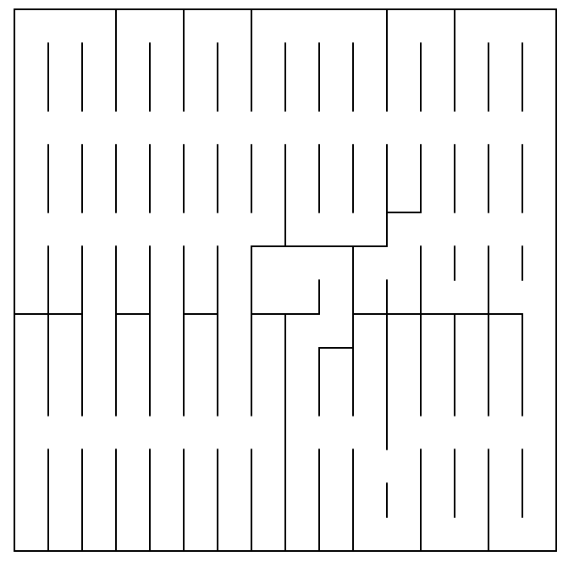

This maze has many dead-ends and loops. The random controller performs very badly in this maze with low success rate. The dead-end controller performs much better but not as good as the counter controller since there are many loops in this maze. The heuristic controller performs much better than the random controller and the dead-end controller.

Test Maze 04 Results for Heuristic Controller

|  |  |  |  |  |  |  |  |
| --- | --- | --- | --- | --- | --- | --- | --- |
| **Trial** | **1st Run** | | | **2nd Run** | | | **Score** |
| **Goal?** | **Moves** | **Coverage** | **Goal?** | **Path Length** | **Moves** |
| **1** | Yes | 370 | 76.17% | Yes | 52 | 25 | 37.400 |

Unlike with the test maze 03 (109 moves in the first run), the heuristic controller spent 370 moves in the first run, indicating the heuristic controller was not very fast to find the goal in this maze.

This result is expected as I actually made the maze really hard for the heuristic controller. The below diagram of the optimal moves for the test maze 04 shows the reason why.

-- Path --

, , , , , , , , , , , , , , ,

, , , , , , , , , , , , , , ,

, , , , , , , , , , , , , , ,

, , , , , ,E,E,E,E,E,E,E,E,E,S

, , , , , ,N, , , , , , , , ,S

, , , , , ,N, , , , , , , , ,S

, , , , , ,N, , , , , , , , ,S

, , , , , ,N, ,*,W, , , , , ,S

, , , , , ,N, , ,N, , , , , ,S

, , , , , ,N, ,E,N, , , , , ,S

, , , , , ,N, ,N, , , , , , ,S

, , , , , ,N, ,N, , , , , , ,S

E,E,E,E,E,E,N, ,N,W,W,S,W,W,W,W N, , , , , , , , , ,N,W, , , , N, , , , , , , , , , , , , , , N, , , , , , , , , , , , , , ,

Path Length! 52

-- Moves -- (F,3)

(R,3)

(F,3) (L,3) (F,3) (F,3) (R,3) (F,3) (F,3) (R,3) (F,3) (F,3) (R,3) (F,1) (L,1) (R,1) (R,1) (L,2) (R,3) (R,1) (L,2) (L,1)

# of Moves! 22

The optimal path to the goal requires the robot to go almost full circle around the goal area, making the heuristic values less useful.

The counter controller, however, performs better than the heuristic controller in this maze: Test Maze 04 Results for Counter Controller

|  |  |  |  |  |  |  |  |
| --- | --- | --- | --- | --- | --- | --- | --- |
| **Trial** | **1st Run** | | | **2nd Run** | | | **Score** |
| **Goal?** | **Moves** | **Coverage** | **Goal?** | **Path Length** | **Moves** |
| **1** | Yes | 145 | 48.83% | Yes | 74 | 31 | 35.900 |

The counter controller spent only 145 moves in the first run. The second run of the counter controller is much worse than that of the heuristic controller. But the counter controller outperforms the heuristic controller in the first run by large.

The reason for the counter controller to performs better than the heuristic controller in this maze was because it has no bias for the goal location which is advantage of the heuristic controller in other mazes.

***Reflection***

The initial challenge for me was to divide the project into smaller problems to tackle with. I’ve decided to have separate test program for the A* search program as I realized it does not require a running robot to test the search algorithm. Then, I’ve divided each enhancements to the robot controller into different python classes making it easier to add improvements in terms of coding and also the actual test scores. Throughout the project, I was making common tasks into utility classes so that I do not need to write similar logic or handling in different places (i.e. Direction, Steering, Sensor, Grid).

The next challenge for me was to find problems in expanding the maze mapping area. I had issues like dead-ends and looping. Over the time, I’ve added effective logging to analyse the robot behaviour and look for potential issues. This was largely a trial-and-error process for me since I did not have much experience in the maze solving problem before. It was a great learning process for me.

Finally, the most difficult and interesting part was how to expand the mapping area of the maze while reaching to the goal at minimum time required in the first run. Unlike in the second run, where the robot simply uses A* search to find the optimal path and travel to the goal accordingly, the first run was full of challenges due to the unknown area to be explored. Overall, I built a series

of controllers to add improvement bit by bit making the process simpler than without such structural

approach to solve the main problem. I believe the final controller gives fine performance in the real micro mouse scenario with some improvement for continuous domain support.

***Improvement***

In this project, everything (time, location, move and turn) is in a discrete domain. In the real micro mouse competition, everything is in a continuous domain.

For example, the distance from the robot to the wall is measured in continuous value with some sensor errors. The robot movement itself would have some randomness. Therefore, the robot would need to perform SLAM (simultaneous localization and mapping) to explore the maze.

Moreover, the robot needs to use PID control to continuously adjust the direction and turns so that it

can wander around in the maze without colliding with the walls. The speed needs to be controlled rather than just number of steps. Turns will be continuous rotations. Moreover, the robot may be able to move diagonally rather than zigzag which is not allowed in the discrete domain.

Talking about the real micro mouse competition, the fact that the robots are physical adds many more complexity. The path finding logic is probably one of the easiest part of the whole robot construction. There are many aspects to take care in physical robots: what sensors to use, what kind of motors and how heavy it can be, how much memory size available to use, etc. Maybe I could have a sensor rotating on top of the robot mapping neighboring areas simultaneously just like a google car. The possibilities are endless.