PROPOSAL:

DESIGN & DEVELOPMENT OF E-PORTAL
FOR
TANZANIA BUREAU OF STANDARDS
TENDER CODE: PO20120676

PREPARED BY: SMARTLINE SOLUTIONS LIMITED



TABLE OF CONTENTS
REVISION HISTORY 3
EXECUTIVE SUMMARY 4
1. INTRODUCTION 6
2. OBJECTIVES 7
2.1. Objectives 7
2.2. Deliverables 7
3. SCOPE OF WORK AND METHODOLOGY 8
3.1. System Requirements Specification 8
3.2. System Design 8
3.3. Online Portal 9
3.3.1. Development Tools 9
3.3.2. Online Database 9
3.3.3. Import/Export License Management 9
3.3.4. Case Management 9
3.4. Training and User manuals 10
3.5. Progress Reports 10
3.6. Support 10
3.7. Testing & Documentation 11
3.8. System Security 11
3.9. Hosting and Hardware Requirements 14
4. IMPLEMENTATION PLAN 15
5. QUALITY ASSURANCE 18
5.1. Standards, Practices, Conventions and Metrics 18
5.2. Review and Audits 18
6. FINANCIAL PROPOSAL 20
6.1.1. E-portal development 20
6.1.2. Recurrent Costs 20
7. PROJECT TEAM 21
Site references 37

REVISION HISTORY
Name | Date | Reason For Changes | Version

EXECUTIVE SUMMARY
This proposal document contains an overview of the proposed e-portal for Tanzania Bureau of Standards.

NOTICES

Confidentiality and Proprietary Information

Smartline Solutions has created this document for your evaluation. The information contained in all sheets of this proposal constitutes confidential or privileged information. It is furnished for your institution in confidence with the understanding that it will not, without written permission of Smartline Solutions, be disclosed to third parties, or used for other purposes.

Not a Binding Contract

This document does not constitute a binding agreement between the parties involved. Such agreements would depend on the execution of appropriate contracts.

INTRODUCTION

Smartline Solutions Limited is delighted to participate in this invitation to tender with a view of presenting an e-portal Solution to your highly esteemed organization.
We recognize that in order to assist Tanzania Bureau of Standards achieve its core objective, a versatile, pervasive yet secure and friendly to use e-portal solution is critical. We present you a solution that meets all those requirements perfectly: It is a strong and secure solution that shall be used in manipulation of data, with a user interface that stands out, running on an optimized database to speed up transactions, utilizing of the latest technology, the leeway for us, a company with experienced developers and engineers. We propose a solution that shall stand out of the crowd.

The proposed solution shall have a user friendly interface with role based hierarchical content management structure, a versatile content management module in terms of upload, approvals, and publishing, a Search Engine Optimized (SEO) portal that is secure and robust. The design shall be professionally done taking into consideration usability, ergonomics, modern and emerging technologies and scalability. The solution shall utilize the latest technological advances such as Mobile Device Clients detection over the web availability, user, employee and customer portals - all these available in one central comprehensive solution.
At Smartline Solutions Limited, COMMITMENTS MADE ARE COMMITMENTS KEPT, this we do by using proven methodologies in our implementation with the core being our emphasis on our need to understand the client’s business and how that business is done, and transforming web and enterprise technologies to the best advantage of the client.
It is our desire that granted the opportunity, we will seek to demonstrate to you the unique capabilities and features of our capabilities in web and portal development, in the near future.

OBJECTIVES

Objectives

Tanzania Bureau of Standards intends to address the myriad challenges faced by traders in importing and exporting while adhering to Tanzania Bureau of Standards regulations.
In this regard, Tanzania Bureau of Standards (with the assistance of TMEA) seeks to develop an online database on existing rules, procedures, legislation and regulations governing the import/export business in Tanzania and a workflow system to facilitate the application and management of import / export licenses and permits. This database is envisioned to be an important reference point for import/export traders as they prepare to engage in trading activities both locally and internationally.
The database will also be useful in sensitizing the traders on import/export requirements including licensing requirements hence making them better informed of the import/export procedures.
In the short and medium term, the database is expected to raise the level of awareness of the traders on the regulations and procedures of import/export business. In the long term, this is expected to assist in reducing delays in cargo clearance due to incorrect licenses or import/export procedures by the trader as well as assist Tanzania Bureau of Standards achieve its mission.
The database is also envisioned to form a critical component of the Single Window concept by providing a one-stop location for all information required by traders to do their business.
This consultancy is to develop and deploy the online web-based database system for the same.

Deliverables
The deliverables for this project will include the following:
- Software requriements specification
- Business mapping report
- System design documents
- Online portal as per SRS with
  - Online database
  - Importation and exportation license management
  - Case management
- One year hosting
- User manuals
- Training (including TOTs)
- Three months Support

SCOPE OF WORK AND METHODOLOGY

We propose to implement the project in a period of four months with five phases, namely: 1) Project Planning that will take 2 weeks, 2) Design and Development 3 months, Testing & Deployment 3 weeks, Post Implementation Support that will take three months.
We anticipate that TMEA/TBS will have a Project Implementation Committee that will coordinate the various activities, components and phases with the technical team of Smartline Solutions.
At the end of each phase a Phase completion report will be prepared and presented to the Project Implementation Committee.

System Requirements Specification

An SRS document will be produced as an output of the needs analysis phase aimed at gathering the specific functional requirements of the e-portal.
The purpose of this SRS document is to present a detailed description of the e-portal. It will explain the purpose and features of the system, the interfaces of the system, what the system will do, the constraints under which it must operate and how the system will react to external stimuli. The SRS is intended for both the stakeholders and the developers of the system.

System Design

System design will serve as a crucial phase of the e-portal development. This phase will highly depend on the SRS document resulting from the needs analysis phase. Our systems analyst and development team will use the Unified Modeling Language to come up a clear visualization of the e-portal system’s architecture. The following visual models will be produced as a result of the UML design process:
- Use case diagrams
- Class diagrams
- Component diagrams
- Activity diagrams
Once a clear design of the system has been established and signed off by our project manager, the development process shall begin.

Online Portal

The e-portal will be developed as a multi-tiered information system The portal will be implemented as a suite of web applications accessed via a web browser over an Internet link or an intranet link (for internal use).

Development Tools
The tools we will use to implement the enterprise portal are open source and are as follows:
- Symfony web development framework
- PHP
- MySQL database

Online Database

The online database existing rules, procedures, legislation and regulations governing the import/export business in Tanzania. The structure of the data and application logic behind its subsequent manipulation will be refined during the needs analysis & design phases of the project.

Import/Export License Management

A management information system shall be built within the e-portal to automate the application process and management of import/export licenses within Tanzania. A set of workflows each with a clearly set out set of start points, end points and status shall be defined using in our UML driven design phase using activity diagrams.

Case Management

The exact requirements of the Case Management module within the e-portal will be captured within the needs analysis phase. Seamless integration will be provide to the Import/Export license MIS in order for TBS to receive a maximum value add from the e-portal.

Training and User manuals

In order to ensure effective adoption and functioning of the system, User Training will be carried-out to develop necessary competencies for the staff of ALL. The training will cover the following components:
- Awareness and institutionalization of the system at ALL sites
- System User Training, including raising and resolving queries

Progress Reports

We will prepare and present inception, interim and final reports at the various phases of the design, development and implementation of the proposed system.
Inception report will be used to address the understanding of the requirements, necessary methodological procedures and to secure a common vision. Interim reports will be used to outline the progress in design, development and implementation of the system.
The final report will be used to outline the way the various components have been addressed during the design, development and implementation of the system.
More importantly, we will ensure regular and structure consultations during the design, development and implementation of the system.

Support

The implementation support will include the following components:
- Deployment and Configuration
- Customization to ensure smooth and effective functioning
- Integration with existing systems
- Addressing emerging issues

A Support Centre will be set-up by Smartline Solutions to address all problems/issues related to the use of the integrated system. Some of the issues to be addressed will include:
- Functioning and Performance of the systems
- Response to inquiries
- Online Support to the users

Testing & Documentation

Various acceptance tests will be carried out during the project lifecycle and it is advisable to perform a soft launch of the solution, opening it up for testing by internal staff members.

Also, focus groups should be established during the lifecycle of the project, to allow for the project stakeholders to get adequate feedback on the solution and implement any suggestions or amendments.

Documentation will be provided (some documentation will be collaboratively created) for the system. The documentation package will consist of:

- Requirements Specifications
- Design Documents
- Technical documentation (within source code)
- User Documentation
- Acceptance Test Documents

System Security

We propose a three-tier solution with a:
- Database layer
- Application layer
- Client layer
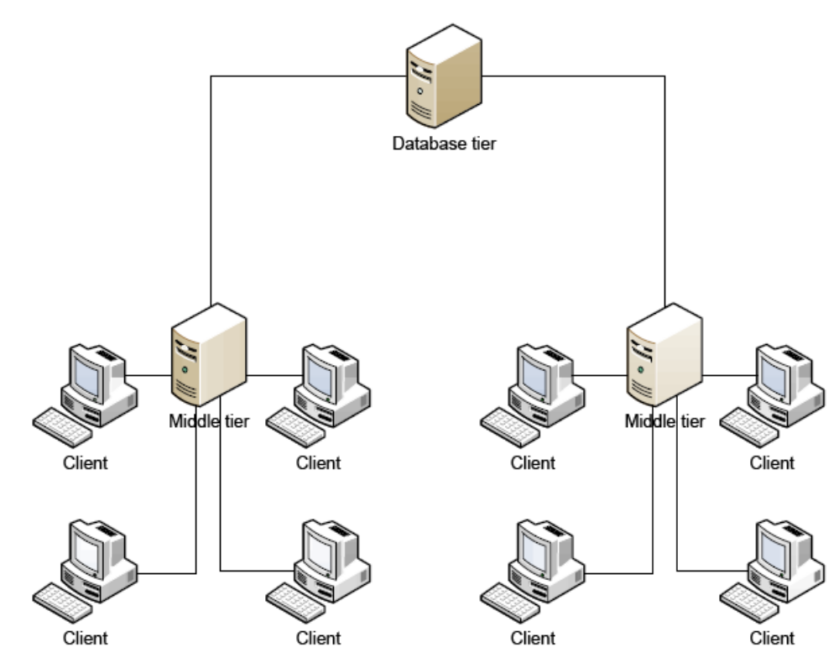
The database layer and application layers shall be replicated on a redundant server for backup.
The solution shall utilize web services to integrate it for web access from remote sites through a web server.
Displayed below is an example of the access into the system:
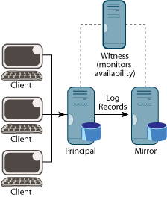
Object-Level Security
The e-portal security module shall consist of roles and permissions that you can assign to users who have access to the portal. The security roles determine the access that users have and the tasks that users can perform on the objects that exist in the database.
Security System Database Objects
The security system divides the database into the following objects.

Object | Description
Table Data | The actual data that is stored in the tables.
Table | The tables themselves.
Form | The forms that are used to view and enter data.
Report | The reports that are used to present the data.
Dataport | The dataports that are used to import and export data.
Code unit | The code units that are used in the database.
XMLport | The XML ports that are used to import and export data in XML format.
System | The system tables in the database that allow the user to make backups, change license files, and so on.

Hosting and Hardware Requirements

We recommend managed server hosting of the solution that is coupled with additional services related to hardware, software, implementation services, backup capabilities, archiving capabilities and a support and maintenance team.

The system will run as a server application and will need the following hardware specifications to run efficiently and support scalability:

- Application Server/Database Server

CPU | 2*1.593GHz
RAM | 4GB
Hard Disk | 2 * 73 GB

- Backup Server

CPU | 2*1.593GHz
RAM | 4GB
Hard Disk | 2 * 73 GB

IMPLEMENTATION PLAN

We propose to implement the project in a period of four months with five phases, namely: 1) Project Planning that will take 2 weeks, 2) Design and Development 3 months, Testing & Deployment 3 weeks, Post Implementation Support that will take three months.
The various components and the duration can be summarized as follows:

No. | Description | Duration in Months
1 | Project Planning | 2 weeks
2 | Design and Development | 3
 | Needs analysis
 | Design
 | Development
3 | Testing & Deployment | 3 weeks
 | Testing
 | Integration
 | Deploying/Hosting
 | User Training
4 | Post Implementation Support | 3
 | Monitoring
 | User Training

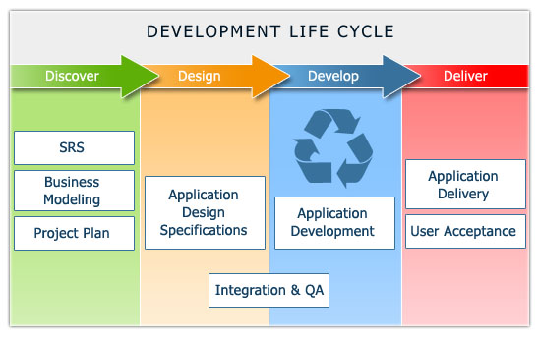
Figure 4: Project Lifecycle

The implementation plan for the various components and phases can be further summarized as follows:
No. | Description |  | Duration |  | Implementation Plan
 |  |  |  |  | Months
 |  |  |  |  |  | 1 | 2 | 3 | 4 | 5 | 6 | 7 | 8 | 9 | 10 | 11
1 |  | Project Planning |  | 0.5 |  | X
2 |  | Design and development |  | 3 |  |  | X | X | X
 |  | Needs analysis
 |  | Design
 |  | Development
3 |  | Testing & Deployment |  | 0.75 |  |  |  |  | X
 |  | Testing
 |  | Integration
 |  | Deploying/Hosting
 |  | User Training
4 |  | Post Implementation Support |  | 3 |  |  |  |  |  | X | X | X
 |  | Monitoring
 |  | User Training

QUALITY ASSURANCE
At Smartline Solutions, we believe in developing software of the utmost quality and in this regard, we shall prepare a Software Quality Assurance (SQA) Plan is to establish the goals, processes, and responsibilities required to implement effective quality assurance functions for the project.

This Software Quality Assurance Plan (SQAP) will define the activities performed to provide assurance that the software-related items delivered to the customer conform to the established and contracted technical requirements.

The SQAP also describes how the project will be audited to ensure that the policies, standards, practices, procedures, and processes applicable to the project are followed.

The overall SQA activity will be planned and managed according to international Software Engineering Standards. As specified by these standards, the SQAP is structured according to ANSI/IEEE Std. 730.1-1989 (IEEE Standard for Software Quality Assurance Plans).

The Software Quality Assurance Plan provides the framework necessary to ensure a consistent approach to software quality assurance throughout the project life cycle. It defines the approach that will be used to monitor and assess software development processes and products to provide objective insight into the maturity and quality of the software.

Standards, Practices, Conventions and Metrics
Monitoring of compliance and adherence to standards is ensured through the reviews and audits procedures by our systems analyst who will act as the software Quality Assurance Manager for this project.

Review and Audits
Reviews and audits are part of the Software Verification and Validation (SVV) activity.
Accordingly, all reviews and audits, as well as the necessary arrangements and methods for these reviews and audits will be specified in the Quality Assurance Plan.

The following reviews are foreseen:
- User Requirements Review (UR/R) and approval of the User Requirements Document;
- Software Requirements Review (SR/R) and approval of the Software Requirements Document;
- Detailed Design Review (DD/R) and approval of the Detailed Design Document, code etc.
- Audit of the code during production.

Technical reviews will be used for all requirements. Technical reviews evaluate specific software elements to verify progress against plan.
Walkthroughs will be used for the early evaluation of documents, models, designs and code in the project phases.
Software inspections will be used for the evaluation of documents and code in the phases, before technical review or testing.
Audits are independent reviews that assess compliance with software requirements, specifications, baselines, standards, procedures, instructions, codes and contractual and licensing requirements.

FINANCIAL PROPOSAL

E-portal development
No | Description | People | Days | Unit Price (USD) | Total Cost
1 | Developer | 1 | 120 | 600 | 72000
2 | Developer | 1 | 120 | 600 | 72000
3 | System Analyst | 1 | 30 | 800 | 24000
4 | Accommodation | 3 | 120 | 150 | 54000
5 | Transport | 4 | 2 | 50 | 400
6 | Per diem developers | 2 | 120 | 70 | 16800
7 | Per diem analyst | 1 | 30 | 70 | 2100
 | TOTAL |  |  |  | 241300

Recurrent Costs
ITEM | COST | AMOUNT (USD)
Hosting the Domain | Annual | 400
Hosting the Web portals | Annual | 1,800
Management tools (Google Statistics) Account | Annual | 300
Web portal Management Services | Monthly | 600

PROJECT TEAM

EDWIN SENO – Systems Analyst
Key Qualifications:
7+ years experience in software development
Exceptional skills in transforming business requirements to technical solutions
Proficiency in C# & Java programming languages
Expertise in Microsoft SharePoint Installation, customization and implementation
Education:
October 2004 to October 2008 University of Nairobi- Kenya
BSc. Computer Science, First class honors
Software Projects:
Company | Date | Role | Description
Care International in Kenya | July –October 2012 | System Analyst/Developer | Implementation & Development of a Fleet Management System used to manage vehicles operated by all Non-Governmental Agencies operating in Dadaab, Kenya including UNHCR, Red Cross, GIZ, NRC among others. Care Kenya has the mandate of managing and servicing all these vehicles.
Central Corridor Transit Transport Facilitation Agency | April – July 2012 | System Analyst/Developer | Design & Development of a Performance monitoring system for the Central Corridor. Involved data capturing, analytical reporting with graphs, SMS integration, GPS data integration and a robust backend module for administrative activities.
Divine Assinter Ltd | 2010 | Lead Developer | SMS service development. Development and deployment of an SMS content retailing system running on shortcode 4445 across all mobile networks in Kenya. SMS ‘bible’, ‘rights’, ‘katiba’ or ‘rich’ to 4445.
Comet Ventures Ltd | 2010 | Lead Developer | Database migration, System Security auditing and the design & development of security controls for the company’s money transfer system. The system is currently being used by Dubai Bank and Family Bank.
Leisure and Travel Guides East Africa Ltd | 2010 | Mobile Web Developer | Development of a dynamic Mobile(WAP) Portal for the Go Places brand owned by the company: m.goplaceskenya.com
Aga Khan Hospital | 2009 | Lead developer | Development of a Nurse call reporting system that would interface to the nurse call system hardware and generate high level reports for management. Developed in C# and MySQL.
SMS Junkie | 2009 – 2010 | Lead Developer | The project involved the development and deployment of value added services using a premium SMS short code - 3004. The solution allows SMS Junkie to retail mobile content ranging from ringtones, wallpapers, information services and quotes using the SMS short code. Additional Services for finding houses and job information were also developed. E.g. SMS ‘house’ to 3004
Brazafric Enterprises Limited | 2009 | Mobile web developer | The project involved the design, development, testing and deployment of a mobile WAP portal for the Brazafric group of companies: m.braz-group.com
Landmark Education East Africa | 2009 | Lead Systems consultant | The project involved the design, development, testing and deployment of an information system that maintains records of all the graduates and participants of the institution’s corporate and self empowerment training programs.

Boniface Irungu Mwendia – Software Developer

Detailed Tasks Assigned:
Software Development
System Analysis and Design
Training of users
Client/user system maintenance
Key Qualifications:
3+ years experience in Mobile and website software development
Exceptional skills in transforming business requirements to technical solutions
Proficiency in PHP, Joomla CMS, & Java programming languages
Education:
May 2005 - March 2007 Institute of Advanced Technology
International: Diploma in Computer Studies – National Computing Center (United Kingdom)
2007-2010: Jomo Kenyatta University of Agriculture and Technology
Bachelor’s of Science in Computer Technology
Major: Software Engineering
Attainment: Second Class Honors

2003 –2006: Baricho High School
Kenya Certificate of Secondary Education (Mean Grade B Minus)
Software Projects:
Company | Date | Role | Description
Care International in Kenya | July –October 2012 | Software Developer | Implementation & Development of a Fleet Management System used to manage vehicles operated by all Non-Governmental Agencies operating in Dadaab, Kenya including UNHCR, Red Cross, GIZ, NRC among others. Care Kenya has the mandate of managing and servicing all these vehicles.
Central Corridor Transit Transport Facilitation Agency | April – July 2012 | Software Developer | Design & Development of a Performance monitoring system for the Central Corridor. Involved data capturing, analytical reporting with graphs, SMS integration, GPS data integration and a robust backend module for administrative activities.
Smartline Solutions Limited | 2009 | Software Developer | -Web Application Development using Joomla CMS, PHP, Java Hibernate and Web Services.  -Support System users and also involved in System maintenance  -Debug and maintain code.  -PHP Mobile Website maintenance>>>http://www.jamobi.co.ke
Flex Communications Ltd (Nairobi, Kenya) | 2011 | Developer | -Web Application Development using J2EE, Action Script and PHP.  -General IT support.  -Vehicle Tracking analysis and Report Generation.
Next Technologies Ltd | 2010 |  | -Computer Networking.  -Computer Hardware Repair and Services.  -Data entry, typing and editing documents

Samuel Kyalo – Software Developer

Membership in Professional Societies:
Member, Institute of Electrical and Electronic Engineers (IEEE)
Detailed Tasks Assigned:
Software Development
System Analysis and Design
Training of users
Client/user system maintenance
Key Qualifications:
6+ years experience in software development
I.T. Consultant: Linux / Unix and Windows Office Automation
System Analyst and Developer
Microsoft certified Professional in
o Microsoft Dynamics NAV 2009 C/SIDE Introduction
o Microsoft Dynamics NAV 2009 Financials and Core set-up
o Microsoft Dynamics NAV 2009 Installation and configuration
o SQL server 2003
o SQL server 2005

A CISCO networking specialist in
o Basics of networking, configurations and Trouble shooting
o Router configurations, Network management and Sub netting
o Switching and Wireless
A Microsoft certified System developer (M.C.S.D) in the .NET technology

Education:
Maseno University - Kenya
B.Sc. Degree Course in Computer Science
MIS Projects:
Company | Date | Role | Description
MINISTRY OF HOUSING -CIVIL SERVANTS HOUSING SCHEME | 2010 | I was part of the development team developing the mortgage, Contracts and Rentals management  system of the ministry of housing scheme. The system was to track the deposits, allocation of the  houses, the mortgage related functionalities, their repayments. A module to cater for the  contractors who do construction and maintenance of the houses was also provided. The rental  module was to cater for the rent collection management and tenancy recording. | Software developer assigned to the development of several website projects. Backend Joomla development, Java, PHP. Unix/Linux Security administration
STANDARD INVESTMENT BANK | 2010 | Being the developer charged with the duty in the development of the Fund administration system  that was to be used by the fund administrators/ Investment managers to track the investments  carried out by fund managers and to track the investment portfolios of the different funds in the  Unit trust aspect.
AFRICAN UNION ( | 2009 | Training of all the AU_IBAR project accountants and regional officers on the Microsoft  Dynamics 2009 software. Entry of budgets, expenses, cash book entries, and Report extraction
JUBILEE INSURANCE FINANCIAL SERVICES LTD | 2009 | Participated in the design and implementation of the Funds Investments system for JFSL. This  was to cover Equities, Money market and mortgages. The most outstanding feature of the system  being its Bond Calculator.
KENYA RE-INSURANCE | 2009 | Data migration and verification for the new ERP acquired from our company to cater for all of  the monetary and accounting functions of Kenya-Re. The data was to be channeled through  XML dataports.
KENYA CIVIL AVIATION AUTHORITY | 2008 | Design and implementation of the entire payroll of KCAA with an integration of an EFT to the  Paying Banks to process the Payments. This also involved migration of data from the G.O.K  servers.
NYAYO TEA ZONES | 2008 | Design, implementation and training on the Payroll software implemented using Microsoft  Dynamics.

George Githae – Software developer
A creative, hardworking and focused individual focusing on requirements specification, analysis, design and implementation of information systems over Client-Server architectures as well as mobile platforms.
Software Projects
Company | Date | Role | Description
Kenya airports authority | 2012 | Software developer | It involved the redesign of the Kenya Airports Authority website and integration to their flight information display system.
Pesacom Africa Ltd | 2012 | Software developer | The project involved the design, development, testing and deployment of a mobile money system that allows for transfers, deposits, withdrawals and bill payments using mobile money. It is currently in it beta phase

Simon Gatungo Njenga – Software Developer

Detailed Tasks Assigned:
Software Development
System Analysis and Design
Training of users
Client/user system maintenance
Key Qualifications:
5+ years experience in Mobile and website software development
Exceptional skills in transforming business requirements to technical solutions
Proficiency in PHP & Java programming languages
Education:
May 2005 - March 2007 Institute of Advanced Technology
International: Diploma in Computer Studies – National Computing Center (United Kingdom)
July - September 2006: Microsoft Certified Systems Administrator (MCSA)
August/September 2005: Network Support Specialist (N+)
May/June 2005: User Support Professional (A+)
Feb 2000 – November 2003: Muhoho High School
Kenya Certificate of Secondary Education (Mean Grade B plain)

Software Projects:
Company | Date | Role | Description
Smartline Solutions Limited | 2009 | Software Developer in the Ministry of Finance GIS based Economic Stimulus Programme Web portal | The project involved the design, development, testing and deployment of and a real time web and WAP portal for the Economic Stimulus program for the Ministry of Finance. Technologies involved are PHP, MySQL, Google GIS, Joomla CMS, and WUFL for device detection and PDA/Mobile content adaptation.
Smartline Solutions Limited | 2010-2011 | Mobile web developer | The project involved the design, development, testing and deployment of a mobile WAP portal for the jua kali sector
JJ People International (Nairobi, Kenya) | 2007-2009 | Developer | Translated the UML entity diagram into Web layers, DAO layers, Business layers etc.  Implemented requirements related to data transfer between the backend and the front-end using JSON and Spring MVC.  Implemented the view layer with JSP’s and JSTL Expression Language.  Designed the low level architecture for the web interface using JavaScript and HTML, styling with CSS, and Ajax for asynchronous interacting with the backend.  Adopted the Model View Controller design pattern using Spring MVC to optimize management of the user initiated events in the Web layer.

Amos Kibe – Software Developer

Detailed Tasks Assigned:
Software Development
Training of users
Key Qualifications:
1+ year experience in web development, sms development and systems integration using web services
Proficiency in PHP, Java,Symfony framework & MySQL database
Education:
2008 - 2011 Africa Nazarene University: Bachelor of Science in Computer Science

Software Projects
Company | Date | Role | Description
RedCross Kenya | 2012 | Software Developer | Disaster Management System with reporting, monitoring and SMS messaging tools
Care International | 2012 | Software Developer | SMS Messaging system
Brazafric Enterprises Limited | 2009-2010 | Mobile web developer | The project involved the design, development, testing and deployment of a mobile WAP portal for the Brazafric group of companies.
Landmark Education East Africa | 2010 | Support engineer | The project involved the design, development, testing and deployment of an information system that maintains records of all the graduates and participants of the institution’s corporate and self empowerment training programs.  I am currently offering training and support for the system.

Site references

Firm’s Name:
Trademark East Africa
Assignment Name: Design, Development & Implementation of Performance Monitoring System |  | Country: Kenya
Location within Country: Dar es Salaam, Tanzania |  | Professional Staff provided by Your Firm/Entity (profiles):4
Name of Client: Trademark East Africa |  | No. of Staff: 4
Address: |  | No of man-months; Duration of Assignment: 3
Start Date (Month/Year): April 2012 | Completion Date (Month/Year):  July 2012
Name of Associated Firms. If any: N/A |  | No. of Months of Professional Staff provided by Associated Firms: N/A

Firm’s Name:
JICA Project on Capacity Building for the Customs Administrations of the Eastern African Region (Kenya)
Assignment Name: Network Design and Installation (KRA /TRA one-stop border post (OSBP) Pilot at Namanga) | Country: Kenya
Location within Country: Kenya / Tanzania (Namanga Boarder) | Professional Staff provided by Your Firm/Entity (profiles):3
Name of Client: JICA/Kenya Revenue Authority/Tanzania Revenue Authority | No. of Staff: 3
Address: | No of man-months; Duration of Assignment: 3
Name of Associated Firms. If any:  Safaricom Kenya  Airtel Tanzania | No. of Months of Professional Staff provided by Associated Firms: 2

Firm’s Name:
Care International in Kenya (Kenya)
Assignment Name: Design, Development & Implementation of Fleet Management System |  | Country: Kenya
Location within Country: Nairobi, Dadaab |  | Professional Staff provided by Your Firm/Entity (profiles):2
Name of Client: Care International in Kenya |  | No. of Staff: 2
Address: |  | No of man-months; Duration of Assignment:1
Start Date (Month/Year): August 2012 | Completion Date (Month/Year):  September 2012
Name of Associated Firms. If any: N/A |  | No. of Months of Professional Staff provided by Associated Firms: N/A

Firm’s Name:
Gusii Coffee Co-operative Farmer’s Union (Kenya)
Assignment Name: Design, Development & Implementation of Coffee Milling & Marketing System |  | Country: Kenya
Location within Country: Nairobi |  | Professional Staff provided by Your Firm/Entity (profiles):2
Name of Client: Gusii Coffee Farmer’s Co-operative Union |  | No. of Staff: 2
Address: |  | No of man-months; Duration of Assignment:
Start Date (Month/Year): December 2011 | Completion Date (Month/Year):  June 2012
Name of Associated Firms. If any: N/A |  | No. of Months of Professional Staff provided by Associated Firms: N/A

Firm’s Name:
Kenya Airports Authority (Kenya)
Assignment Name: Re-design and Content Enhancement Services for Kenya Airports Authority Corporate website |  | Country: Kenya
Location within Country: Nairobi |  | Professional Staff provided by Your Firm/Entity (profiles):3
Name of Client: Kenya Airports Authority |  | No. of Staff: 3
Address: P.O. Box 19001 |  | No of man-months; Duration of Assignment:
Start Date (Month/Year): September 2011 | Completion Date (Month/Year):  January 2012
Name of Associated Firms. If any: N/A |  | No. of Months of Professional Staff provided by Associated Firms: N/A

Firm’s Name:
Office of the Deputy Prime Minister and Ministry of Finance (Kenya)
Assignment Name: Economic Stimulus Program Website and Geographical Information System |  | Country: Kenya
Location within Country: Nairobi |  | Professional Staff provided by Your Firm/Entity (profiles):2
Name of Client: Office Of The Deputy Prime Minister & Ministry Of Finance (Kenya) |  | No. of Staff: 2
Address: P.O. Box 30007 |  | No of man-months; Duration of Assignment:
Start Date (Month/Year): December 2010 | Completion Date (Month/Year):  May 2011
Name of Associated Firms. If any: N/A |  | No. of Months of Professional Staff provided by Associated Firms: N/A

Firm’s Name:
Comet Ventures
Assignment Name: Database migration, System Security auditing and the design & development of security controls for the company’s money transfer system. The system is currently being used by Dubai Bank and Family Bank. |  | Country: Kenya
Location within Country: Nairobi |  | Professional Staff provided by Your Firm/Entity (profiles):2
Name of Client: Comet Ventures |  | No. of Staff: 2
Address: cashswiftglobal.com |  | No of man-months; Duration of Assignment:  4 Months
Start Date (Month/Year): December 2010 | Completion Date (Month/Year):  May 2010
Name of Associated Firms. If any: N/A |  | No. of Months of Professional Staff provided by Associated Firms: N/A

Firm’s Name:
Minreklame ApS (Denmark)
Assignment Name: Development of an Iphone application that allows the Danish company to publish mobile based product catalogues that can be viewed by their customers in Denmark and some other Scandinavian countries |  | Country: Denmark
Location within Country: Nairobi |  | Professional Staff provided by Your Firm/Entity (profiles):2
Name of Client: Minreklame ApS (Denmark) |  | No. of Staff: 2
Address: cashswiftglobal.com |  | No of man-months; Duration of Assignment:  4 Months
Start Date (Month/Year): September 2010 | Completion Date (Month/Year):  October 2010
Name of Associated Firms. If any: N/A |  | No. of Months of Professional Staff provided by Associated Firms: N/A

