Detection of Harmonical Changes using Weighted Graph Traversal
*Note: Sub-titles are not captured in Xplore and should not be used

Gabriel A. Santiago Plaza
University of Puerto Rico- Río Piedras Campus
San Juan Puerto Rico
gabriel.santiago21@upr.edu
Randall E. Cone
Salisbury University
Maryland, US
recone@salisbury.edu

Abstract— Artificial Intelligence is undoubtedly one of the most prevalent topics in contemporary Computer Science As researchers in this field, we use a variety of techniques to “teach” computer systems how to solve complex and difficult problems. Instead of using typical, statistically-oriented AI methods, we develop a graph-theoretic AI agent, augmented by modern tonal music theory, to detect harmonic changes in Baroque musical scores, such as major mode Fugues and Preludes from J.S. Bach’s Well-Tempered Clavier, Book I. In this approach, we seek a middle-ground between Graph Theoretic AI and Modern Tonal Theory to convert scores into computer-accessible data, in order to implement the algorithms for logical and intuitive reasoning necessary to identify harmonic changes throughout a given score. In further detail: We developed an artificially-intelligent, weighted multigraph agent which represents and navigates common chord progressions of scores, usually following the Tonal “Circle of Fifths”, with the root node as the either the tonic chord or starting musical key. With such a graph-based agent, we incorporate graph-traversal algorithms, where navigation between vertices represent chord progressions in a score. Finally, we used Scalar Vector Graphics (SVG) to artistically represent the harmonic sequences the agent perceived, using transforming petal-shaped Bezier curves. We will continue to improving the accuracy, and eventually parallelize our algorithm.

Keywords—Weighted Graph Traversal Algorithms, Data-visualization

Introduction
The Baroque era has a variety of scores that follow different chord progressions, usually following the Circle of Fifths. The Circle of Fifths is fundamental to study the harmonic sequences, so we can see the patterns in progressions. In the Baroque era, composers would write scores that follow the Circle of Fifths.
Using this as our advantage, we created a graph that is connected to each other, using the Circle of Fifths progression within a score’s key signature. We connected each vertex, or diatonic chord possible in a scale, with its perfect fifth, and created a directed graph. We added a weight that corresponds to circle of fifths progressions, and we added common exceptions, that have lesser weight. because it is less likely in some cases.
Our goal was to find a way for this graph to be traversed, using operations based on which notes are playing, and how important they are to determine the chord progression sequence. For this, we redefine a chord as a label that describes a set of notes that are being played during a given time. If we can traverse through the notes in a score, and recognize which notes correspond to which chord that note could belong to, we can identify which is the harmony for that given moment. So we designed an algorithm that applies Modern Tonal Harmony Theory to help identify which is the best path for the graph to be traversed.
Using algorithms that focuses one voice at a time, we got results that show a possible chord progression the score might follow. With the agents result, we wanted to visualize the data with something that represents circle transformations, using flower petals as reference. They change color and transform depending on measures of the score and chord name.

Methodology
We used Python and MuseScore’s XML to parse the cores and put them into Python dictionaries. Then, for each part in a SATB score, we create graph following it’s key signature, like Figure 1 for C major.
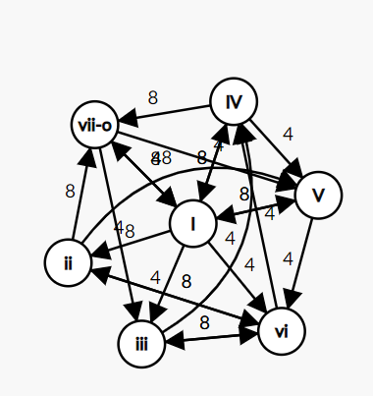
Figure 1: Harmony Graph

We then divided the parsed Note Objects into a vertical format, that groups of notes played, converted into Note Objects, inside subdivisions of a measure. For BWV-846 Fugue, each measure had 4 subdivisions, one for each beat of the measure. Each subdivisions had a max capacity of notes participating in the subdivision, which was calculated using Algebraic Divisibility Theorems. This illustration demonstrates what it does.
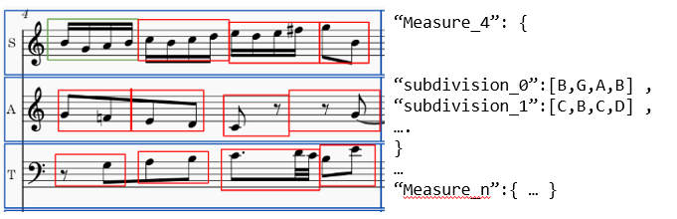
Figure 2: Parsed Notes per measure.
With this data structure, we feed it to out agent, in which it will use Modern Tonal Harmony theory to predict which chords are being played in each subdivision.

Traversal Algorithm
The agent first selects its pivot vertex as the first degree (I) of the scale, in BWV-846 would be C major, or CM. We then start analyzing the notes that are being played, and determine the intensity of every chord, and only the most intense chords are going to be considered during the first iteration of the algorithm. The intensity is defined as:
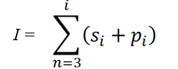
Where i is the note of each chord (triad in this case), s is the presence of the notes played, and p is the number of times a note was played.
The agent goes through every intense chord in the list. If the intense chord is connected to the pivot vertex, then it chooses the possible winners, using the edges weight as a determining factor.

A running example could be, if we have Figure 3 as input, and the pivot is Dm.
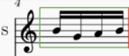
Figure 3: Measure_4, subdivision_0

The input has an array of B, G, A, B. We then calculate that the most intense chords are Em, and GM, since Em is a set composed of these 3 notes: E, G, B; and GM, is composed of G, B, D. We can see that G and B are both present in the subdivision, and they are both part of Em and GM. Since the pivot is Dm, these are Dm connected edges.
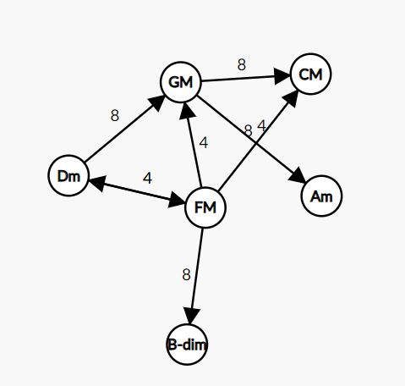
Figure 4: Graph from Dm.
We can see that even though Em has the same intensity, GM is the only one that is connected to Dm, so the winner ends up being GM. If Em was also connected, it will be decided by the intervals that are being played. For example, since for Em there is no note E, in the subdivision_0 then we say it is less likely to be that triad. Similarly, if the first note of the chord, and the third note are being played in the subdivision, we say it is more likely to be that chord, because it created a major or minor 3rd , which is a fundamental concept in Harmony.

If there is no connection between the vertex, the agent checks for every adjacent chord in the pivot and verifies if they are connected to any of the intense chords, since we considered that for each subdivision, you can have two chord progressions inside of it. If they find a connection, we choose the best connection using the same equation as we determine the connected possible winners.

At the end, if it did not find a connection, it disables those chords, and finds for the second most intense chords, and applies the same algorithm. If all the chords are in the disabled chords, then the algorithm determines it as undefined, because it has not yet learned anything that is not diatonic in harmony.
If it found some possible winners, it chooses the last possible winner, as its new pivot for the next iteration.

Results
The agent produced results that we later wanted to visualize using SVG. These next figures are examples of different scores.
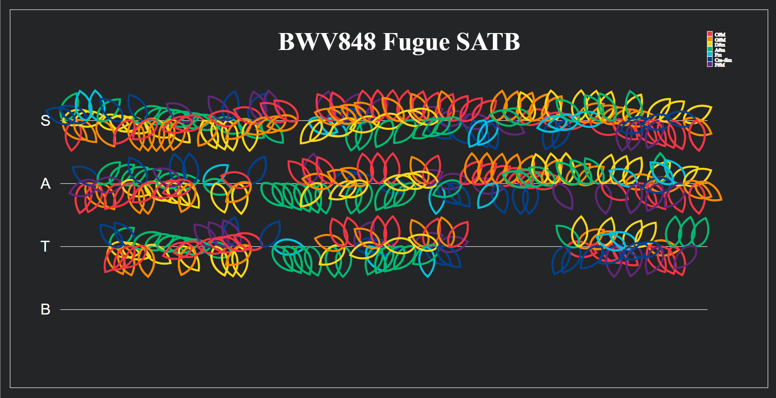
Figure 5: BWV848 Fugue
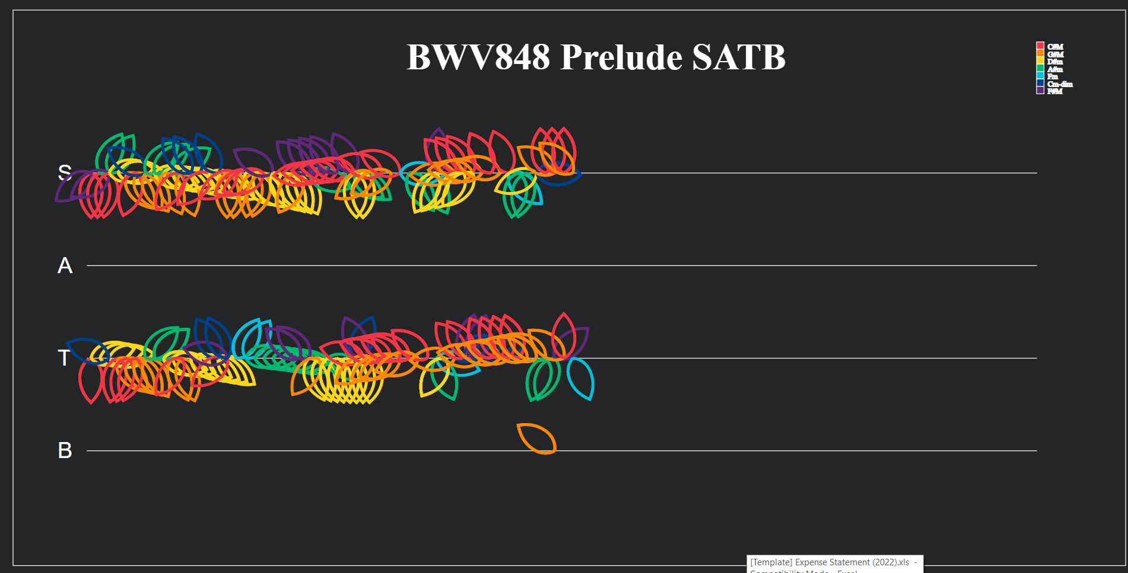
Figure 6: BWV848 Prelude
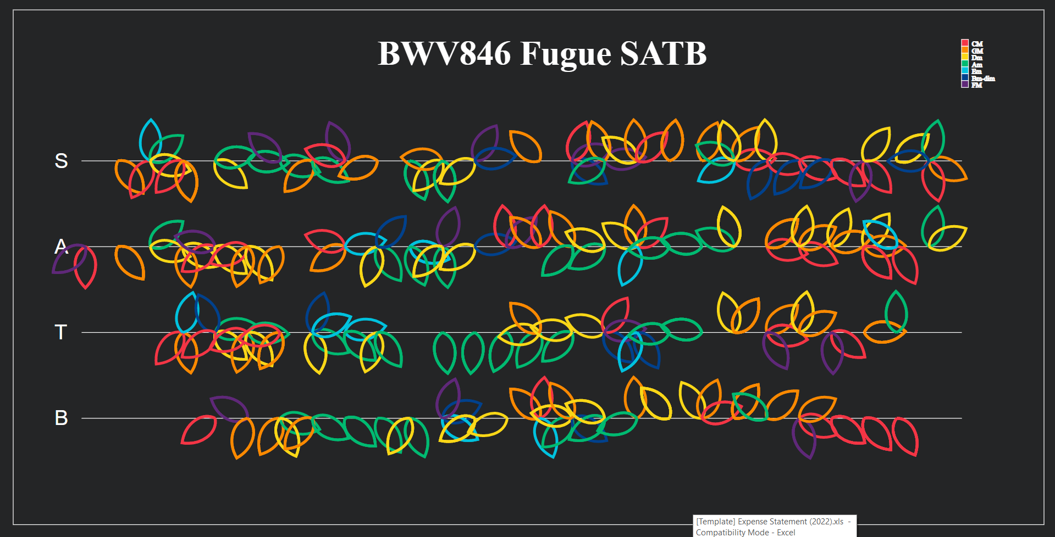

Figure 7: BWV846 Fugue
These are the petal-shaped Bezier curves, where each petals center is the number of measures in the score. The color changing is the different chord being played in each subdivision. The translations are affected by the number of measures in the score, so bigger scores have closer centers. For each measure they also rotate, at a rate of
$rotation=\frac{numberOfMeashures}{360}$
But they also rotate depending on which chord was identified, where each petal points to the degree of the chord in the Circle of Fifths.
Every gap represents unidentified chords. That means the algorithm detected an algorithm that it did not recognize and did not have the tools to work on it, or at least it wasn’t connected to the graph.

future work
Since it can be an exponential problem, we believe that it is parallelizable. We can implement algorithms inspired by MapReduce algorithms to speed up the process.
We also want to work with expanding the agent’s knowledge on chromatic or real sequences, those sequences that not necessarily are connected to the key signature, but it worked beautifully because of Modern Tonal Harmony exceptions. Following that we want to be able to say which chords are being played when the four part results are merged together.
The accuracy can improve with better algorithms too that take account, not only the previous winner as a pivot for deciding who are the winners for each subdivision, but also take in account of what comes after, to see for more accuracy, or reverse traversing and compare results.

Conclusion
When we define logical based intelligence, we are “teaching” an agent to use a more human-like reasoning to solve problems, in this case, how we study and perceive music from a Modern Tonal Harmony point of view. We can use graph-traversing to represent the multiple options of chords, and we can create structured rules to choose the best chord to describe a phrase in a score. Much like we as musicians think about harmonic sequences, we can define more AI agents that use human-like ways to solve other problems, as this is the future of Artificial Intelligence

References

- Kostka, Stefan M, and Dorothy Payne. Tonal Harmony. Mcgraw-Hill, 2009..

