# Arduino Setup

The MATLAB Support package for Arduino, downloads Arduino IDE 1.8.1. **Ensure that you do not modify the libraries inside this IDE.**

## Move the sketchbook location

1. Create a folder in your hard drive for Arduino. Example – C:\Users\mgovinda\Documents\Arduino
2. The IDE’s location can be identified by typing the following in MATLAB –

>> arduinoio.IDERoot

ans =

'C:\ProgramData\MATLAB\SupportPackages\R2018a\3P.instrset\arduinoide.instrset\arduino-1.8.1'

1. Go to this folder and open the Arduino Application.

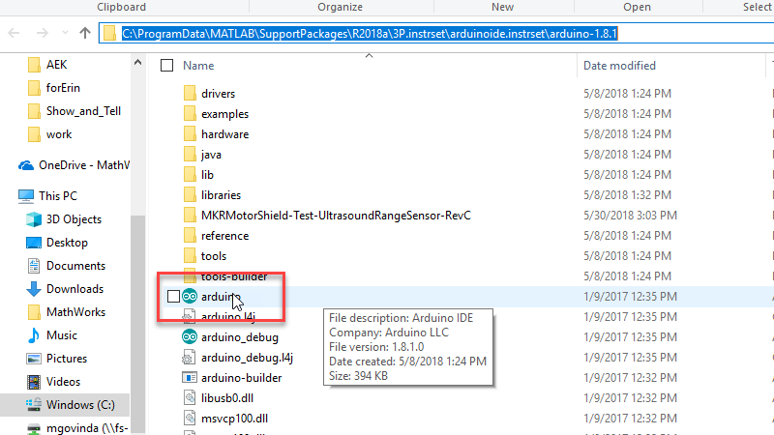

1. In the IDE, go to File 🡪 Preferences and open the Sketchbook location.

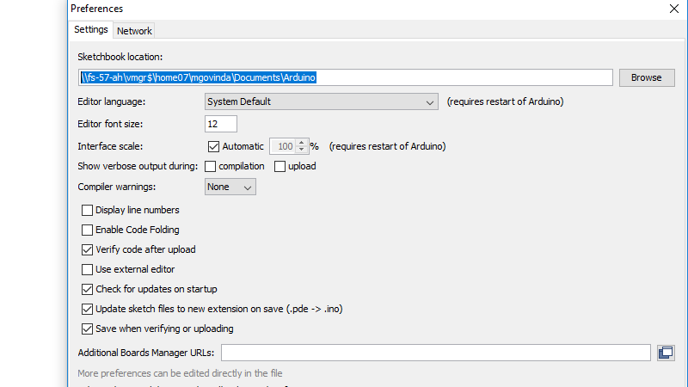

1. Copy all the contents of this folder and move it to the folder you created in Step 1.
2. Change the sketchbook location to your newly created location. In this case – C:\Users\mgovinda\Documents\Arduino
3. Press OK and then close the Arduino IDE.