HOW TO INSTALL

Golf Deputy is easy to install on both an existing WordPress website, or on a new one. If you already have an existing WordPress installation, skip to Step #3.

Steps to install Golf Deputy:

- Get your free WordPress website at wordpress.com.

OR

Install WordPress on your own server by downloading the latest version from wordpress.org and following the installation instructions.

- Find a theme you like from WordPress Themes, or stick with their default theme (Golf

Deputy works on almost all themes “right out of the box”).

- Purchase Golf Deputy on CodeCanyon.

- Download the files from CodeCanyon.

- Install the plugin by going to your WordPress Admin area and selecting PLUGINS > ADD NEW and clicking “Upload Plugin” near the top of the page.

- Upload the ZIP file from CodeCanyon.

- Activate the plugin.

Once activated, you will see a “Golf Deputy” menu item in your Admin area. From this menu, you can add new course and tournaments, edit existing ones or change the settings that Golf Deputy uses.

If you have any problems with installation, you can leave a comment on CodeCanyon or email support@golfdeputy.com.

SETTING UP GOLF DEPUTY

Once Golf Deputy is installed and activated on your WordPress golf tournament website, there are four main areas and one optional area you should complete before your tournament. All of these areas can be found under the “Golf Deputy” menu within your Admin area.

ADD NEW GOLF COURSE
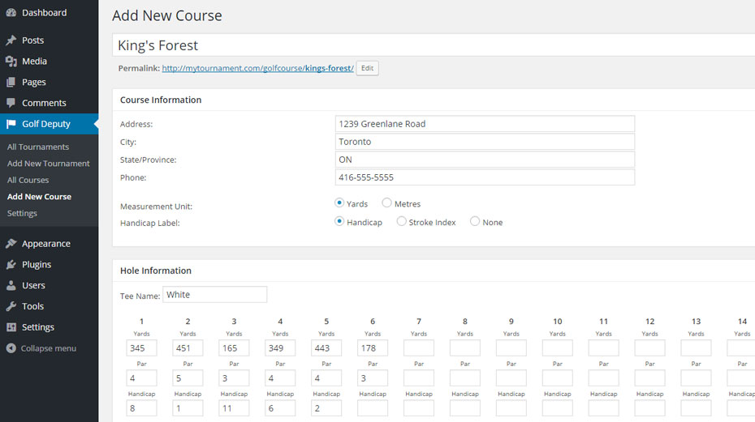

The “Add New Course: area allows you to define the golf course your tournament will be held on. These figures are used to calculate the “against par” score on stroke formats and are helpful to display on all formats.

- The “Course Information” area provides basic information about the course you will play on.

- The “Hole Information” area allows you to give a tee name, hole distance/yardage, par and the handicap / stroke index of each hole.

ADD NEW TOURNAMENT: TOURNAMENT INFORMATION AREA
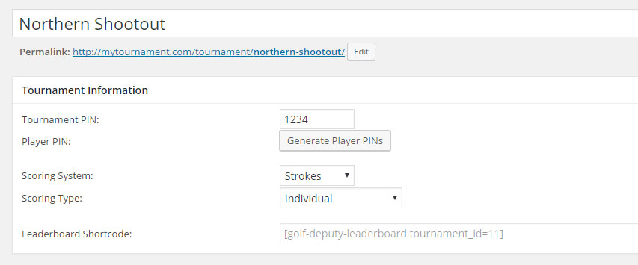

The Tournament Information area allows you to input vital information for your golf tournament:

- The “Tournament PIN” is what your golfers will be required to enter to gain access to score their matchup(s). The “Tournament PIN” gives your golfers access to score all matchups, including several at a time.
- The “Generate Player PINs” button will create random, 4-digit numbers for each golfer/matchup. These PINs (displayed beside their name/match in the next section) will allow a golfer to score only their matchup by entering this PIN.
  - A note on PINs: if a golfer or team will be scoring more than their own round (e.g. theirs and a friend), you must provide them the “Tournament PIN”. The “Player/Match PIN” will only allow them to score one player/match.

- “Scoring System” allows you to choose either match play, stroke or stableford.

- “Scoring Type” lets you pick which format to score with: individual or team.

- The “Leaderboard Shortcode” (which will display after your first save a draft or publish your tournament) is the shortcode that can be placed anywhere on your website to display the current leaderboard for your tournament

IMPORT PLAYER DATA (CSV)

The “Import CSV” allows you to import a CSV of player(s) and their round data (round #, win points). To activate the “Import” button, you must first either Save A Draft of your tournament, or Publish it. Until then, the “Import” button will be disabled:
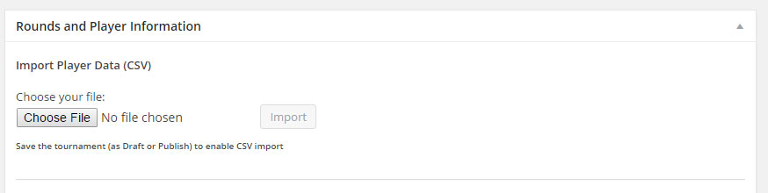

Once the tournament is saved, the “Import” button will be enabled:

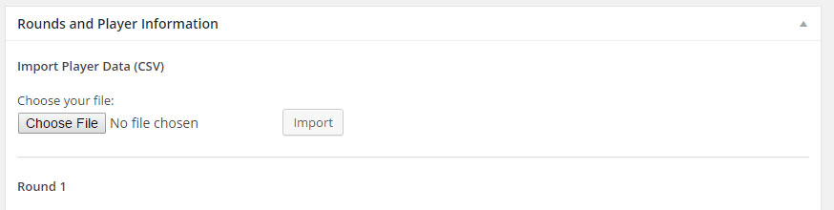

A sample CSV file has been provided in your Golf Deputy plugin directory, named “sample-import.csv”. It is highly recommended that you use this CSV as a starting point for your data import.

PLAYER AND ROUNDS AREA
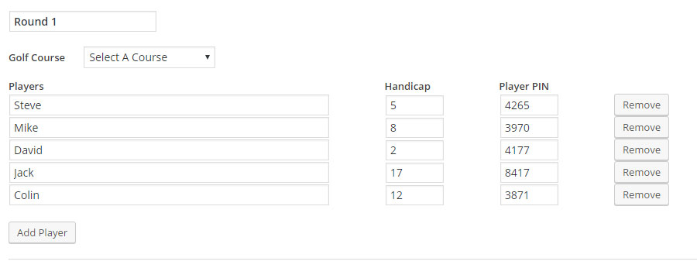

* this screenshot shows the “Stroke Play” format being used. If you are running a match play tournament, the “Team 2 Players” column will display, and you can input Player or Team names. The “Win Points” per round option will also display when “Match Play” is selected as the Scoring System.

The Rounds Area allows you to input each round’s matchups / players and win points for that round:

- By default, each round will be “Round 1”, “Round 2”, etc. These names can be customized to your liking and preference.
- The “Golf Course” is where your tournament will be played and will be a dropdown of the courses you have created from the “Add New Course” area above.
- STROKE/STABLEFORD ONLY: The “Players” column shows the names of your golfers, their individual handicaps.
- MATCH PLAY ONLY: “Team 1 Players” and “Team 2 Players” are listed as they are matched up; i.e. slot #1 on Team 1 plays slot #1 on Team 2.
- The “Player/Match PIN” column will display the golfer’s/match’s individual player access PINs.

- You can add players, add rounds and remove both as needed.

- The “Win Points” is what is given for each matchup win in the tournament calculations

  - (Match Play only).

SPONSORS AREA
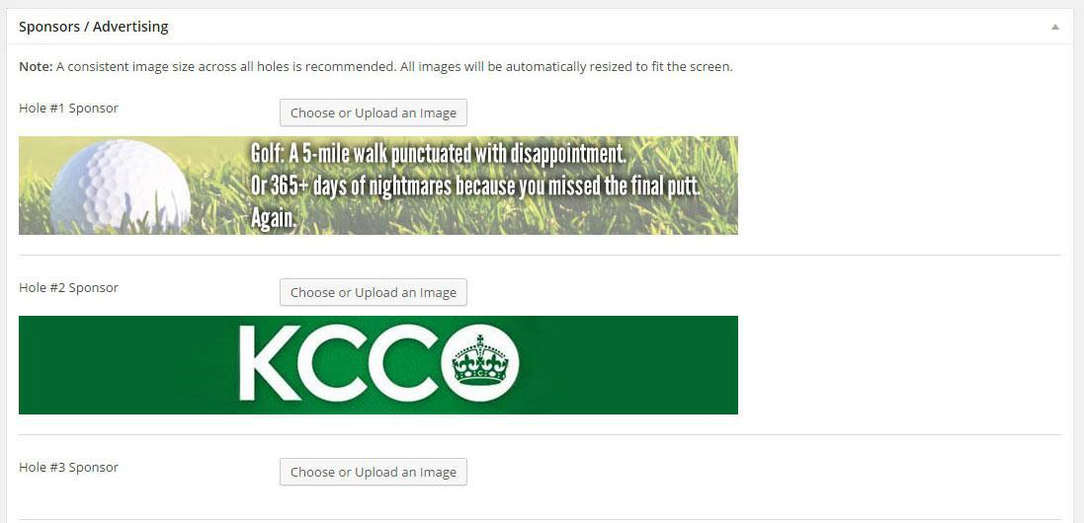

The Sponsors Area allows you to add hole sponsors for each hole of your tournament. Most image types are supported (e.g. JPG, PNG, GIF) and it is recommended that all of the sponsor images be the same pixel size. To appear nicely on desktop and mobile devices, 750 x 350 is a good size to start with.

These sponsor images will appear at the top of the scoring board for each hole, when your golfers log their scores:
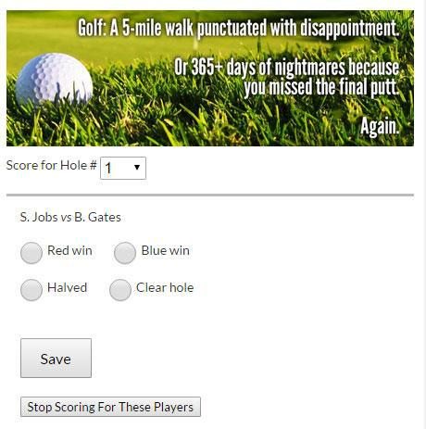

SETTINGS PAGE
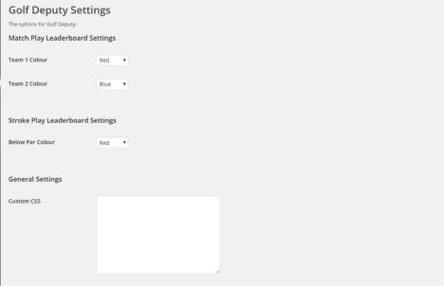

The Settings page allows you to change the colours for your two teams (Match Play) or the “under par” colour (Stroke Play). These colours are displayed on the live leaderboard. It also allows developers to add their own custom CSS to the Golf Deputy plugin.

If you have any questions about how to set up Golf Deputy, email support@golfdeputy.com.

