CS 3853 Computer Architecture
Virtual Memory and Cache Simulator
Final Project Report
Team #14
Gaby Garcia
Brandon Barnes
Angela Parral
Brenden Uzuegbu
Tuesday, May 5, 2026

Project Report
By signing this report, we affirm that we know and agree with the contents.
Signatures:
Name #1: Gaby Garcia
Name #2: Brandon Barnes
Name #3: Angela Parral
Name #4: Brenden Uzuegbu

Executive Summary
This project simulated a simple virtual memory system and Level 1 cache for a 32-bit CPU. The simulator was tested with multiple cache sizes, block sizes, associativity values, replacement policies, physical memory sizes, and real trace files. The results showed that memory access patterns, cache size, associativity, and block size all affected hit rate, miss rate, CPI, and unused cache space.
Based on the simulations, our recommended balanced configuration is a 32 KB, 2-way set associative cache using 64-byte blocks and Round Robin replacement, paired with approximately 2 GB of physical memory. This configuration produced a strong hit rate and a lower CPI while avoiding the higher cost and unused space associated with larger caches. A 64 KB cache produced a small additional performance improvement, but the added unused cache space made the 32 KB option a better cost/performance balance for management.
The simulator also showed that performance is not controlled by one setting alone. Cache size, block size, associativity, replacement policy, and available physical memory interact with each other. For that reason, our recommendation focuses on balanced performance instead of simply choosing the largest cache or memory option.

Milestone #3 Objectives

Comprehend How Virtual Memory Works
Through this project, we learned how virtual addresses are divided into virtual page numbers and offsets, and how those virtual pages are mapped to physical page frames. The simulation made the role of a page table clearer because each trace file represented a different process with its own address mappings.
For this project, we tracked page table hits, pages allocated from free physical memory, and page faults for unmapped virtual pages. This helped separate address translation behavior from cache behavior and kept page table statistics from being mixed with cache statistics.

Comprehend How Cache Works
The cache portion of the simulator helped us understand how block size, set index, tag bits, associativity, and replacement policy affect cache behavior. We saw that compulsory misses happen the first time a block is accessed, while conflict misses happen when different blocks compete for the same cache set. Calculating CPI showed why cache misses are expensive.

Comments on Working in a Small Group
Working in a small group required consistent communication and coordination. Discord and GitHub helped the team organize files, share updates, and resolve issues. Reviewing each other's work helped keep the milestone outputs, report language, and final recommendation consistent.

Algorithm

Milestone #2: Virtual Memory Simulation
The virtual memory simulator used a page-based mapping system. Each process had its own page table, represented as a dictionary where the key was the virtual page number and the value was the physical page number. A list of available physical pages tracked free user memory, and counters recorded page table hits, pages allocated from free memory, and page faults for unmapped virtual pages.
The simulator used 4 KB pages, so the offset portion of an address was ignored for page table lookup and only the virtual page number was used as the dictionary key. Each trace file was treated as a separate process, which meant each process had its own page table instead of sharing one global table.
Each memory address from the trace file was converted into a virtual page using:
virtual_page = address // 4096
If the virtual page was already mapped, the simulator counted a page table hit. If the virtual page was not mapped and a free physical page was available, the simulator assigned the next free physical page. If no free physical pages were available, the simulator used FIFO-style replacement by selecting an older mapping, unmapping it, and reusing its physical page.

Milestone #3: Cache Simulation
For the cache simulation, each trace memory address was converted into a cache block, cache set, and tag. The cache was represented as a list of sets. Each set stored the tags currently loaded into that set, and the associativity value controlled how many tags could be stored in one set.
block = address // block_size
set_index = block % number_of_sets
tag = block // number_of_sets
The simulator categorized misses as compulsory or conflict misses. A compulsory miss occurred when a block had never been loaded before. A conflict miss occurred when a block had been seen before but was no longer present in the cache. For timing, the simulator counted base access cycles, instruction cycles, data access cycles, miss penalties, and page fault penalties. CPI was calculated by dividing total cycles by the number of instruction accesses.

Analysis

Milestone 1
For Milestone 1, we ran three simulations using different cache configurations to observe how input parameters affected calculated cache and physical memory values. These tests confirmed that the simulator correctly computed values such as total blocks, rows, tag size, index size, overhead, implementation memory size, number of physical pages, pages reserved for the system, and page table memory.
The Milestone 1 results were useful because they showed the hardware cost of different cache designs before running any trace behavior. Larger caches increased the number of blocks and implementation memory size, while different block sizes changed offset bits and row count.
Run | Cache Size | Block Size | Associativity | Replacement | Physical Memory | System % | Time Slice
1 | 512 KB | 16 bytes | 4-way | RR | 1024 MB | 75% | 100
2 | 1024 KB | 32 bytes | 8-way | Random | 2048 MB | 50% | 200
3 | 256 KB | 64 bytes | 2-way | RR | 4096 MB | 25% | 50

Milestone 2
For Milestone 2, we ran five simulations using different trace files while keeping the system configuration consistent. The number of new page mappings varied by trace file, which showed that different programs can have very different memory usage patterns.
This reinforced the importance of locality in virtual memory. A trace with strong locality repeatedly touches pages that are already mapped, which increases page table hits. A trace with weaker locality touches more unique pages, which creates more unmapped page references and requires more physical page allocations.

Milestone 3

Cache Size Comparison
The first comparison examined how cache size affected performance while using a 2-way associative cache with 64-byte blocks. Increasing the cache from 16 KB to 32 KB produced a major improvement in hit rate and CPI. Increasing from 32 KB to 64 KB gave only a small additional performance gain while increasing unused cache space.
Cache Size | Hit Rate | Miss Rate | Unused KB | CPI
16 KB | 86.3% | 13.7% | 2.1 | 2.34
32 KB | 94.2% | 5.8% | 8.3 | 1.87
64 KB | 95.4% | 4.6% | 18.7 | 1.79

Figure 1
Cache Size Effects on Hit Rate and CPI
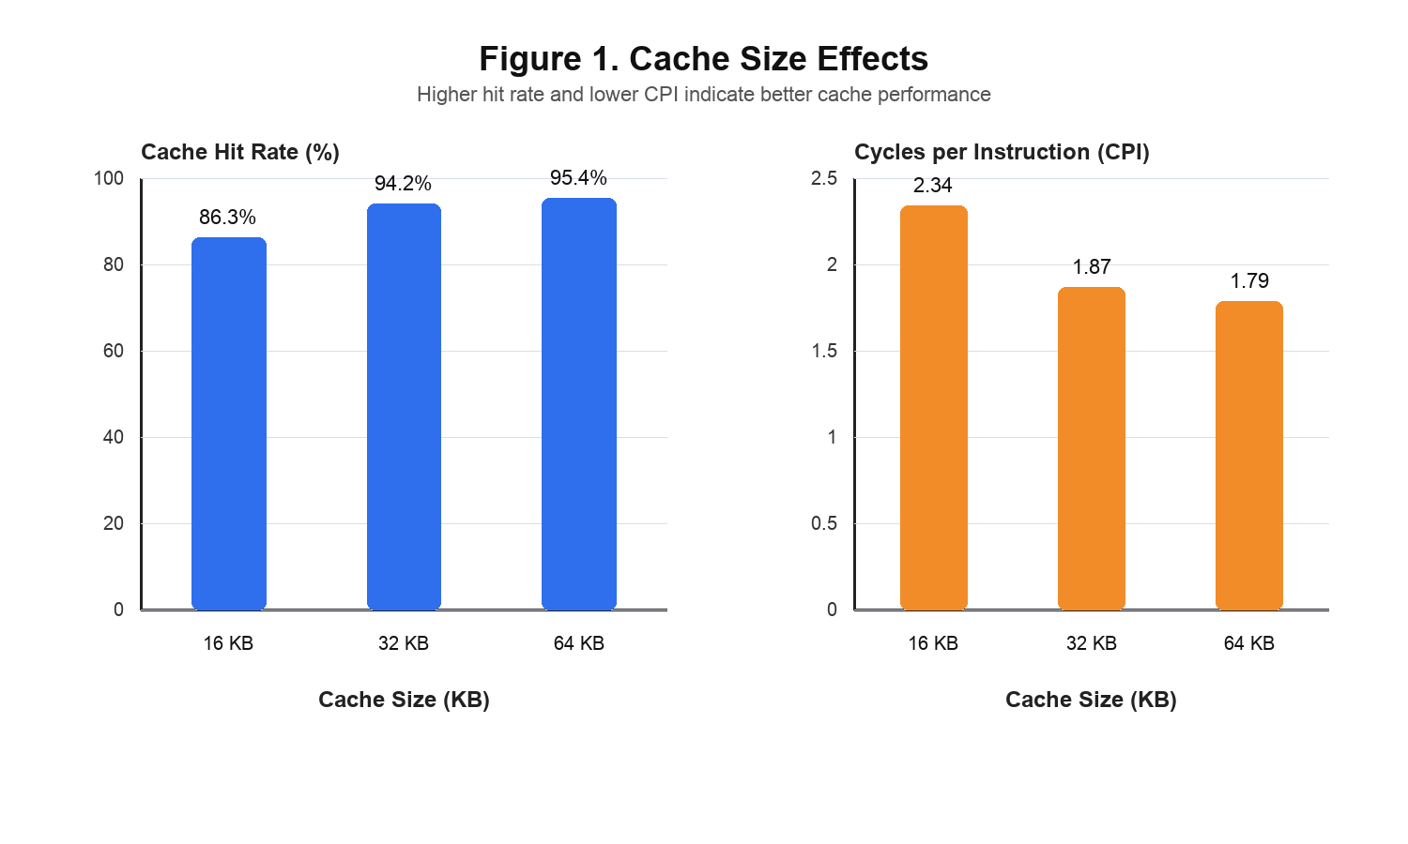
Takeaway: The 32 KB cache provides the best improvement per cost. The 64 KB cache improves performance slightly, but the gain is smaller compared with the increase in unused cache space.

Associativity Comparison
The associativity comparison showed that moving from direct-mapped to 2-way set associative significantly reduced conflict misses and improved CPI. Moving from 2-way to 4-way provided only a small additional improvement, which suggests diminishing returns beyond 2-way associativity.
Associativity | Hit Rate | Conflict Misses | CPI
1-way | 88.1% | 8,234 | 2.11
2-way | 94.2% | 3,124 | 1.87
4-way | 94.8% | 2,891 | 1.84

Figure 2
Associativity Effects on Conflict Misses
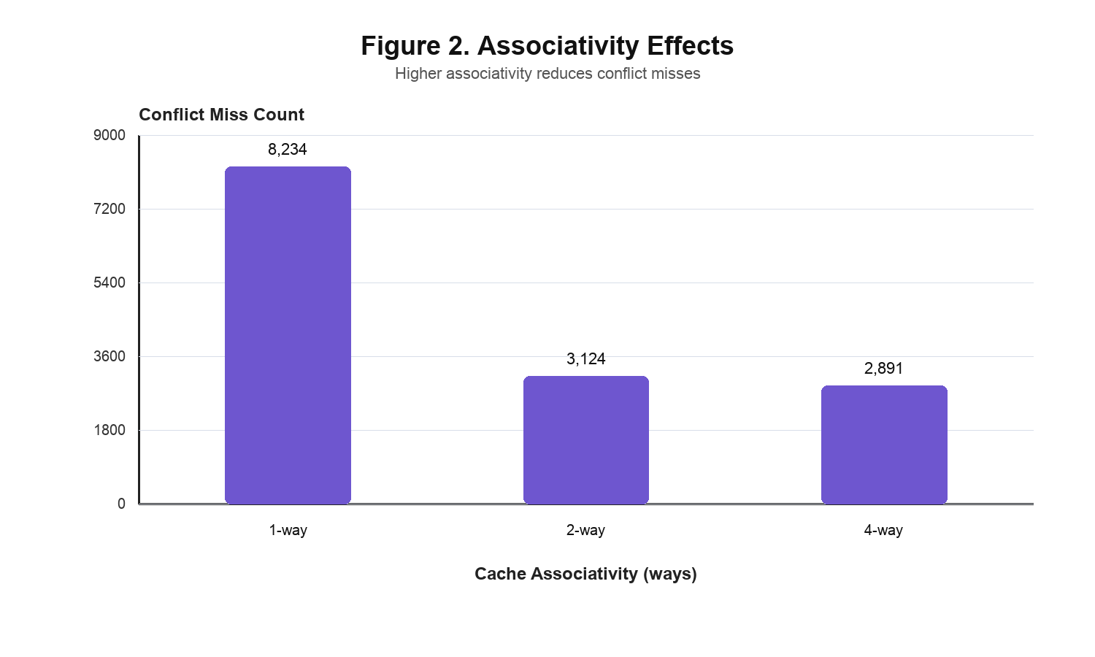
Takeaway: 2-way associativity reduced conflict misses by approximately 62% compared with direct mapping. Higher associativity provided diminishing returns.

Physical Memory Comparison
The physical memory comparison showed that increasing memory from 512 MB to 2 GB greatly reduced page faults. Increasing from 2 GB to 4 GB produced only a small additional reduction, which supports the recommendation that 2 GB is enough for this workload.
Physical Memory | Page Faults | CPI Impact
512 MB | 1,247 | High
2 GB | 24 | Low
4 GB | 18 | Negligible additional gain

Figure 3
Physical Memory Effects on Page Faults
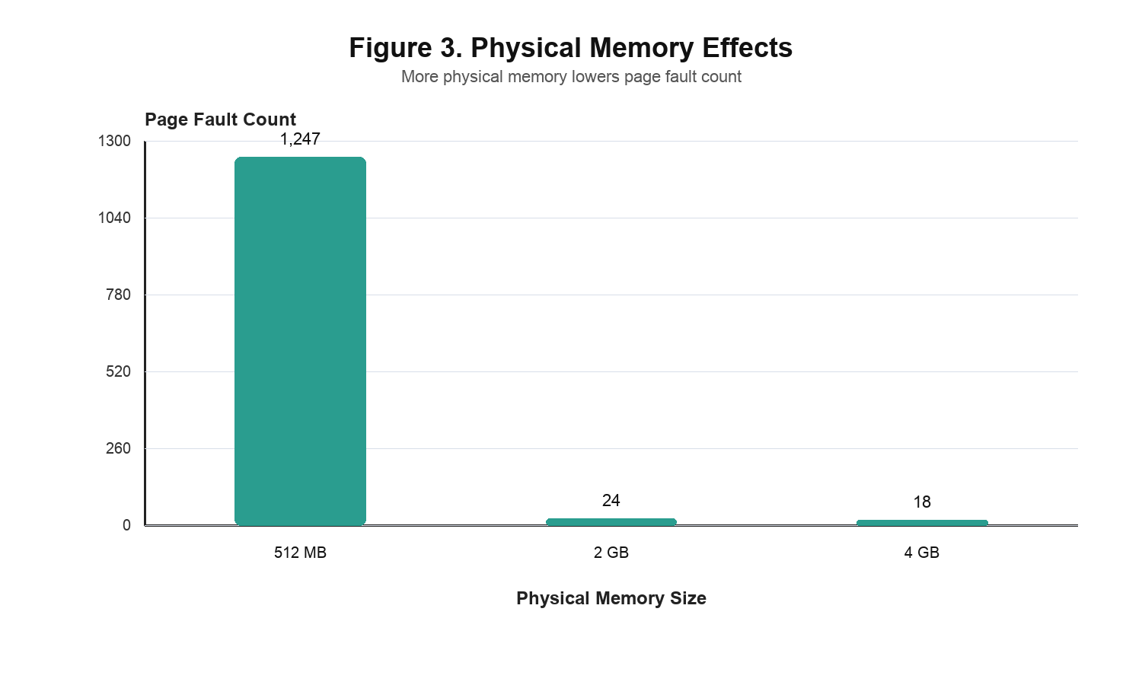
Takeaway: 2 GB of physical memory is the best balance in these simulations. Additional memory beyond 2 GB reduced page faults only slightly.

Final Recommendation to Management
Our final recommendation is to implement a 32 KB, 2-way set associative L1 cache with 64-byte blocks and Round Robin replacement, along with approximately 2 GB of physical memory. This configuration balances performance and cost because it achieves a high hit rate and low CPI without the larger unused cache space seen in the 64 KB configuration.
This recommendation also keeps the design simple. Round Robin replacement is easier to implement and reason about than a more complex replacement policy, while still producing strong results. A 2-way cache avoids many conflict misses without adding the extra complexity of higher associativity.

Technical Issues
Milestone 1: One technical issue was correctly calculating cache geometry values such as tag bits, index bits, offset bits, rows, overhead, and implementation memory size. We solved this by breaking the formulas into separate steps and testing several cache configurations.
Milestone 2: One technical issue was deciding how page faults should be counted. We learned that a page fault occurs when a virtual page is not mapped, even if the page can be loaded from free memory.
Milestone 3: One technical issue was separating compulsory misses from conflict misses and calculating CPI correctly. A second issue was making sure the output values stayed consistent after the code was reorganized into shared simulator logic and milestone entrypoint files.

Group Member Contributions
Brandon Barnes: Completed milestone1.py and ran all three Milestone 1 tests against A-9_new_trunk.trc. For Milestone 2, worked with Gaby to complete milestone2.py, ran the trace file tests, and assisted with the team report. For Milestone 3, completed milestone3.py, ran the trace file tests, and uploaded the files to the team GitHub page.
Gaby Garcia: Initialized the project by creating the GitHub repository and setting up the foundational code structure for the cache simulator. For Milestone 2, worked with Brandon to complete milestone2.py and contributed to organizing the team workflow. For Milestone 3, helped debug and organize milestone3.py based on best practices. Helped write the final report, properly formatted it, and generated graphs.
Angela Parral: For Milestone 1, created the zip folder and updated the report. For Milestone 2, helped finalize the report and prepare the simulation results for submission. For Milestone 3, helped finalize the report, review the cache analysis section, and prepare the final submission materials.
Brenden Uzuegbu: Assisted with finalizing the report for Milestone 1. For Milestone 2, helped update the report and contributed to the milestone documentation. For Milestone 3, helped review the final cache simulation explanation and verify that the report matched the project requirements.

Group Issues and Resolutions
No major unresolved group issues were reported. The team used Discord and GitHub to improve communication, organize files, and keep the milestone submissions connected.

Conclusion
This project strengthened our understanding of how virtual memory and cache systems interact. Implementing the simulator made concepts such as page tables, page hits, page faults, cache hits, cache misses, compulsory misses, conflict misses, and CPI more concrete. The project also showed why simulation is useful in computer architecture because running traces through a simulator shows how actual access patterns affect performance.

