

Escuela de Ingeniería Computación

Bases de Datos 1

Adriana Álvarez Figueroa

**I Proyecto**

**MATCH ME**

**Manual de usuario**

Alexis Arguedas Cruz

Gabriela Garro Abdykerimov

Yanil Gómez Navarro

9 de octubre, 2015

II Semestre

**Match.me user manual**

The present document is a guide to interact with match.me. You can make a profile and fill it with your information.

With the obtained information, the system will look for the people who are compatible to be your partner, given the information of both and guiding itself by what you input to the application.

**User:**

System sign in

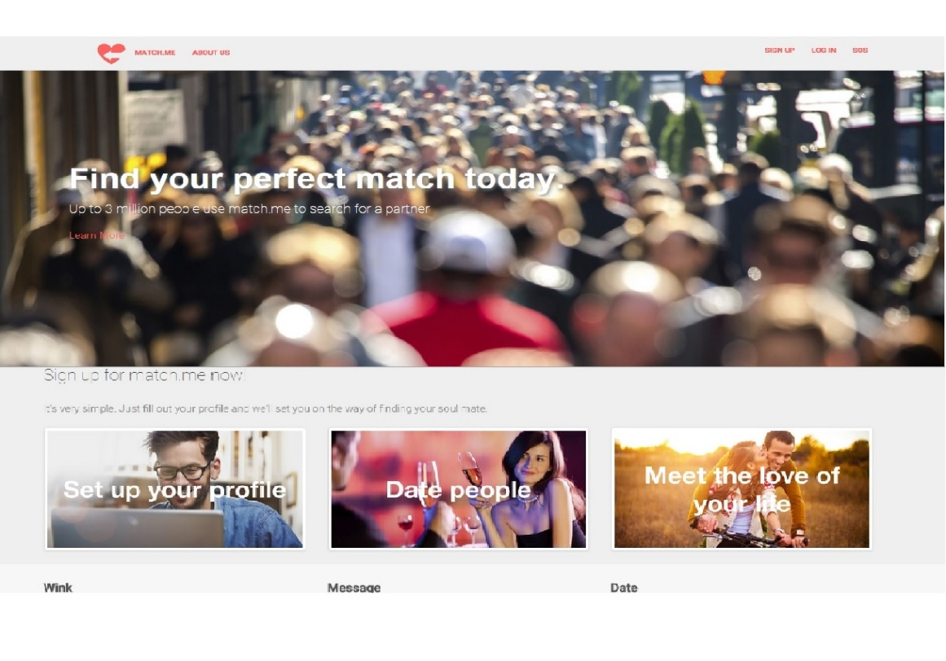Type the url <http://172.26.50.118/MatchMe/HTMLs/> on your browser, preferably Chrome, and it will direct you to our homepage.

**Create a match.me account**

Select “Sign up”, and a modal will show up with the next values:

* Email
* Password
* Confirm password

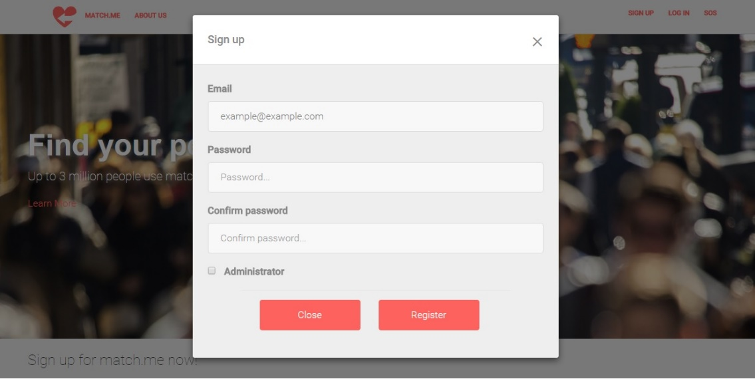

After filling out this form, select “Register”. The application is going to direct you to create your profile. Some of this data is obligatory.

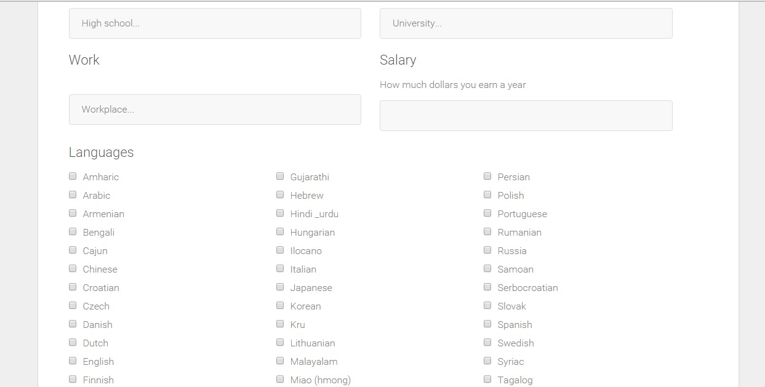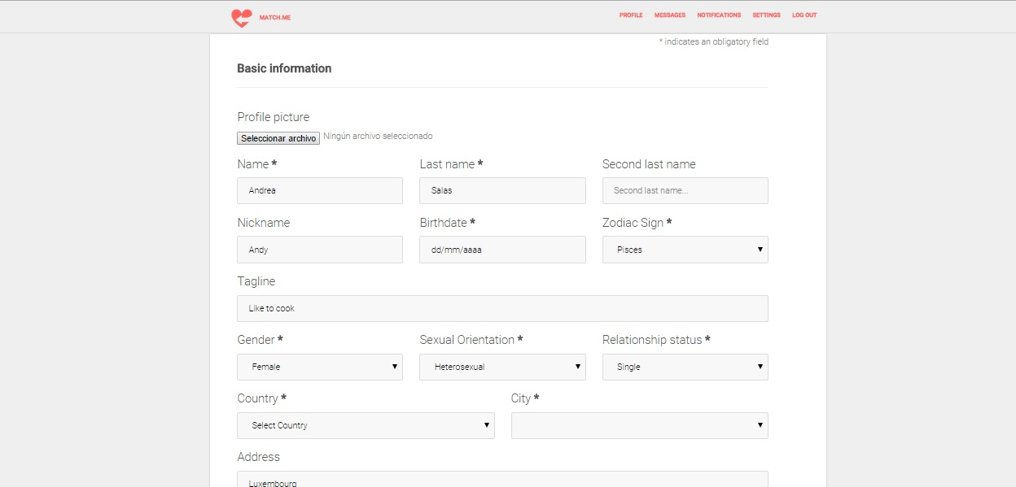

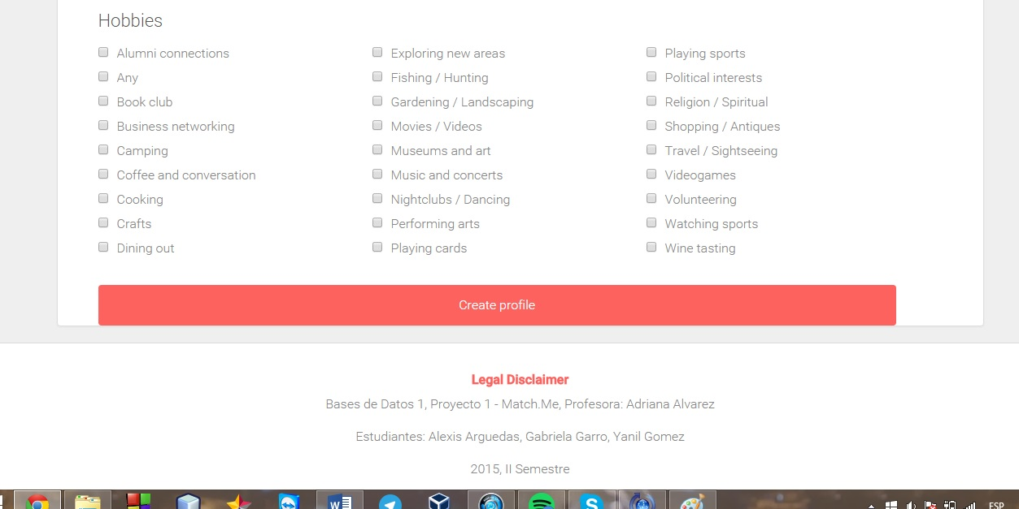

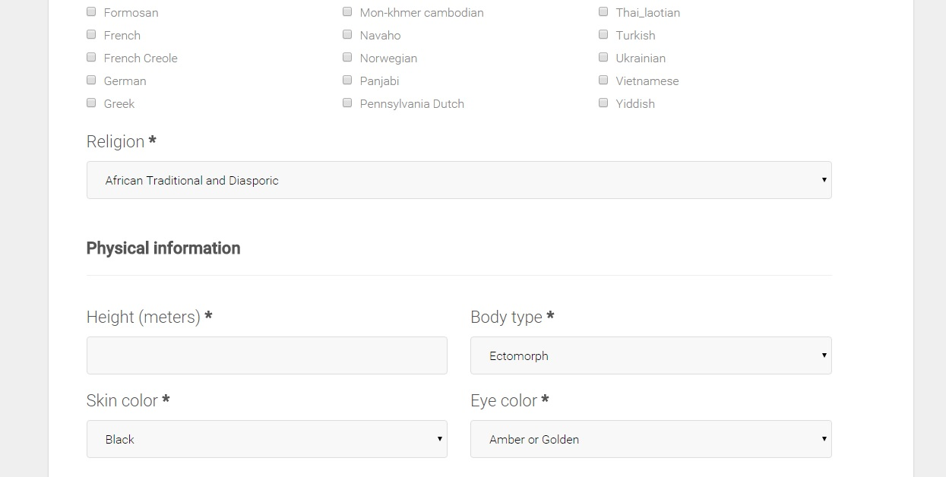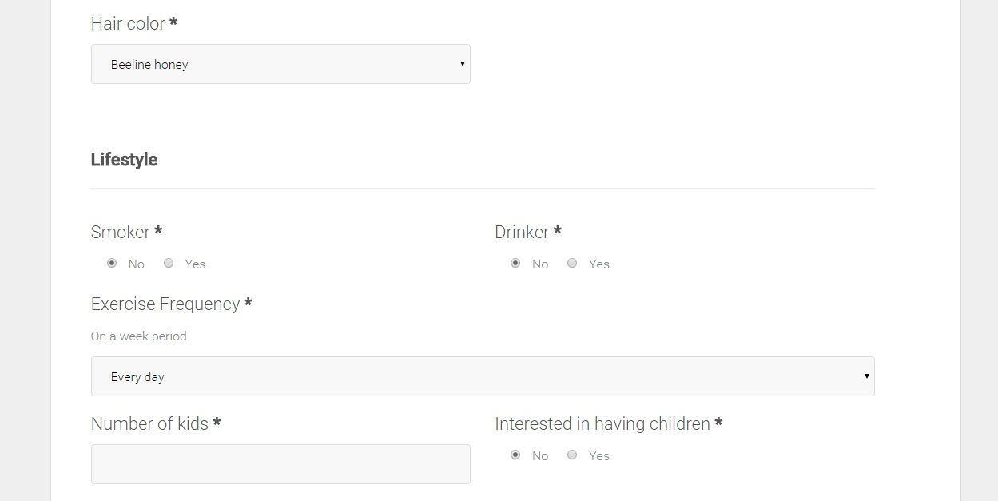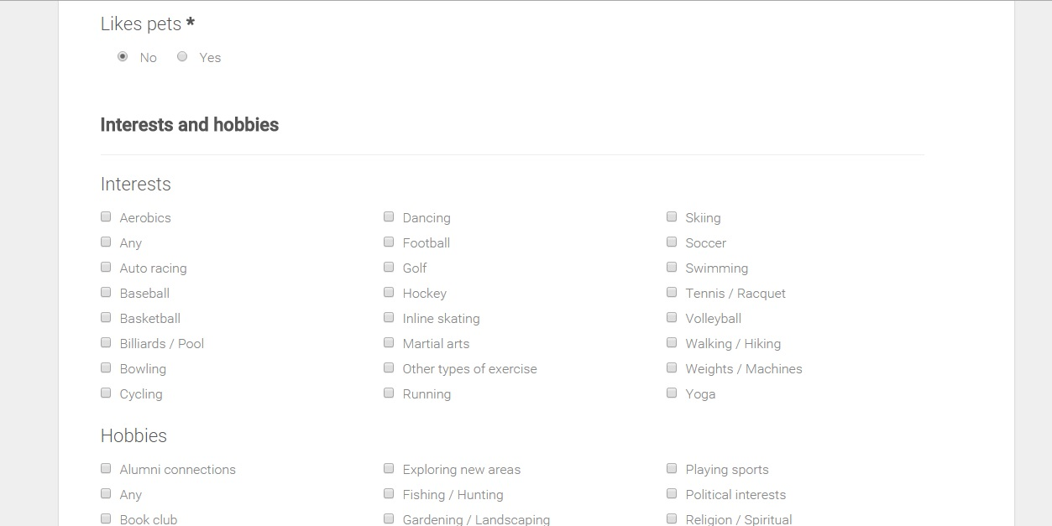

After finishing filling out this information, and if nothing obligatory is null, your profile will be created.

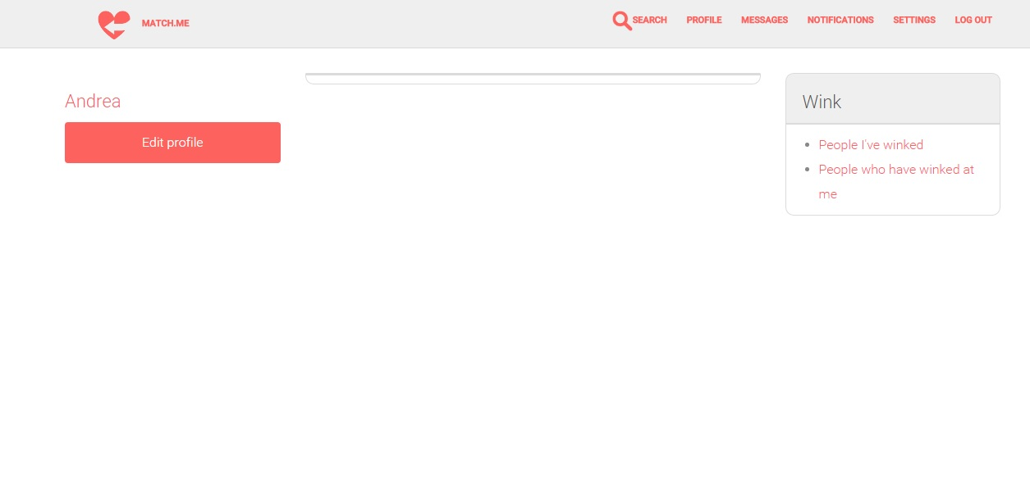

By clicking on your name, the application will direct you to your profile

On your profile you can see all of your personal information and your profile picture. The people who visit your profile are able to “Wink” at you or “Match” you. You can visualize this from your homepage.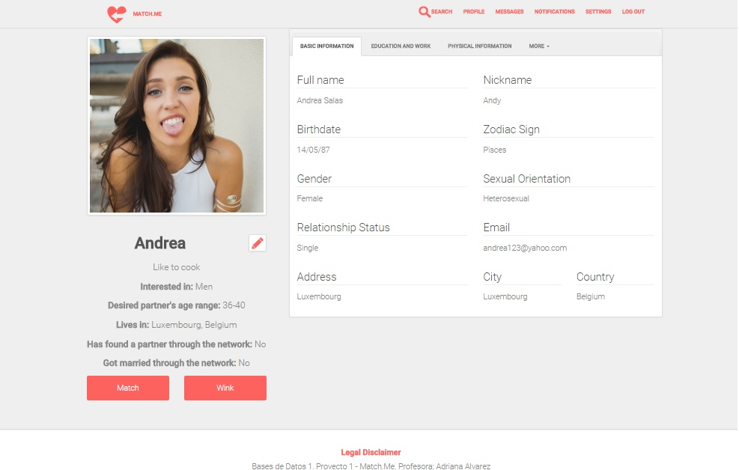

If you want to edit your profile, you can do so from this icon next to your name.

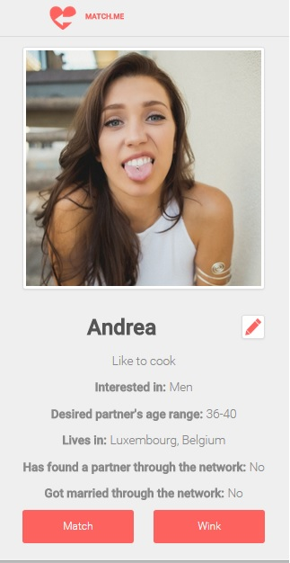

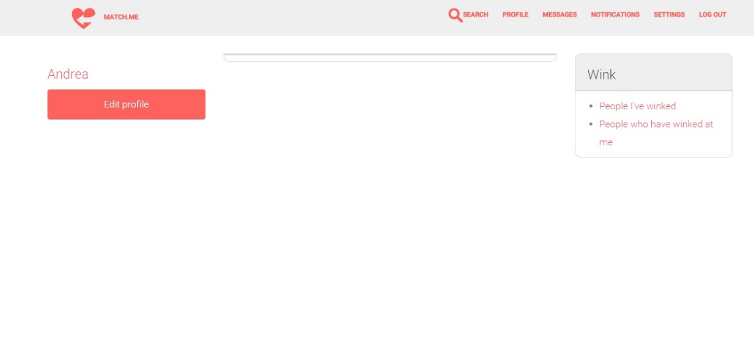Or you can also access to your profile edition page by clicking “Edit profile” on your homepage.

Your edit profile page is similar to the create profile one. You can submit changes with City, country or birthday null.

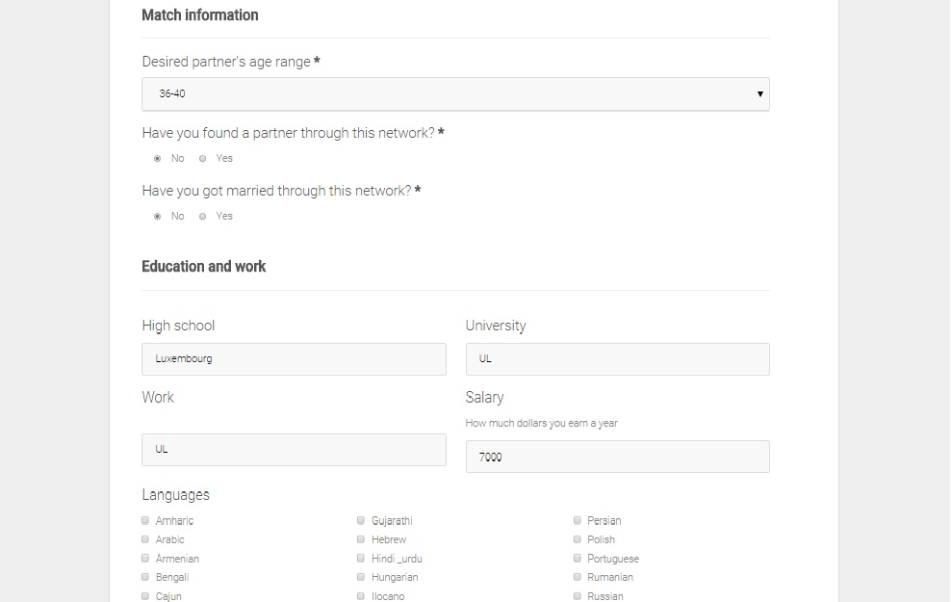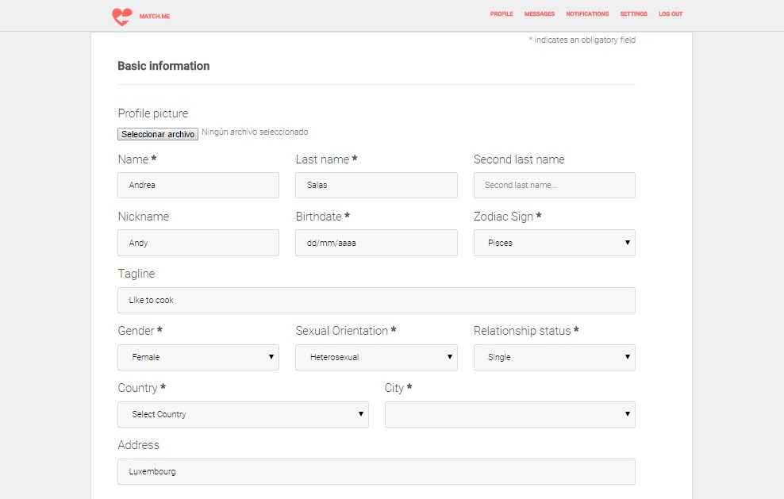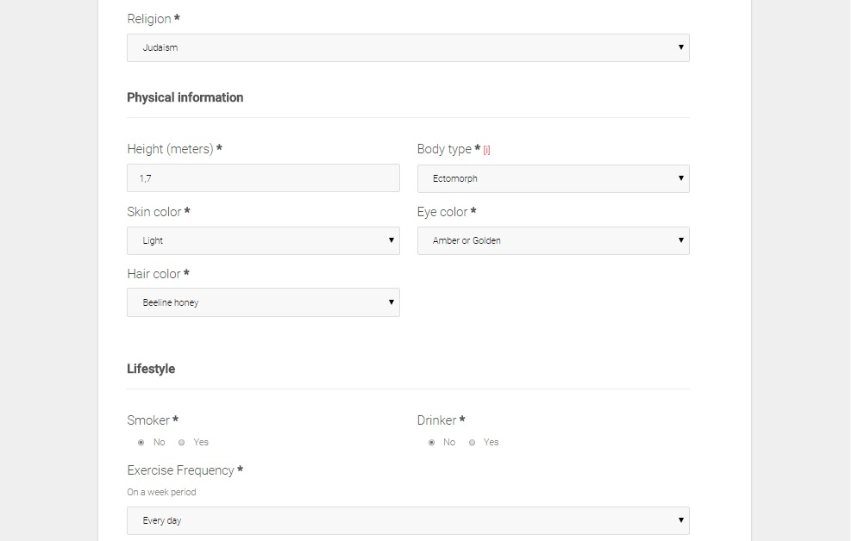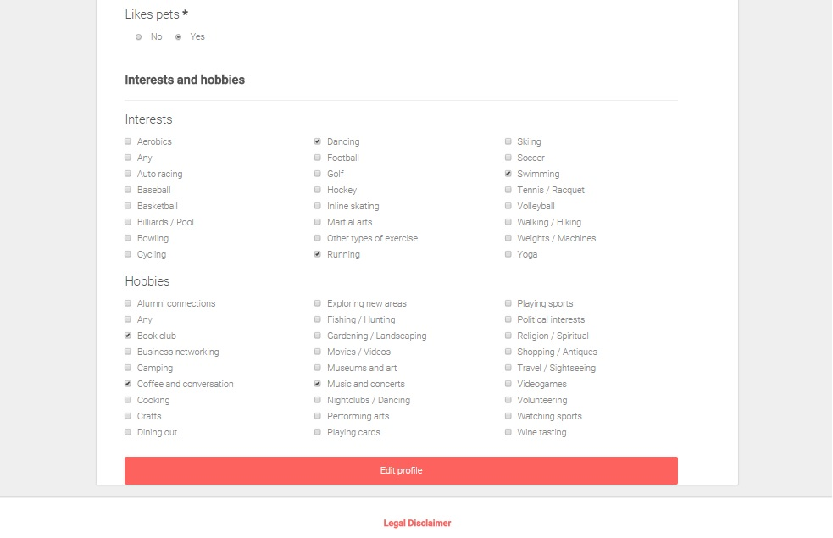

To log out, click Log out on the navigation bar. It will prompt you with a confirmation box asking if you really want to log out.



If you already have a match.me account, you can click on Log in on our homepage, and it will prompt you with a modal with the next entries:

* Email
* Password

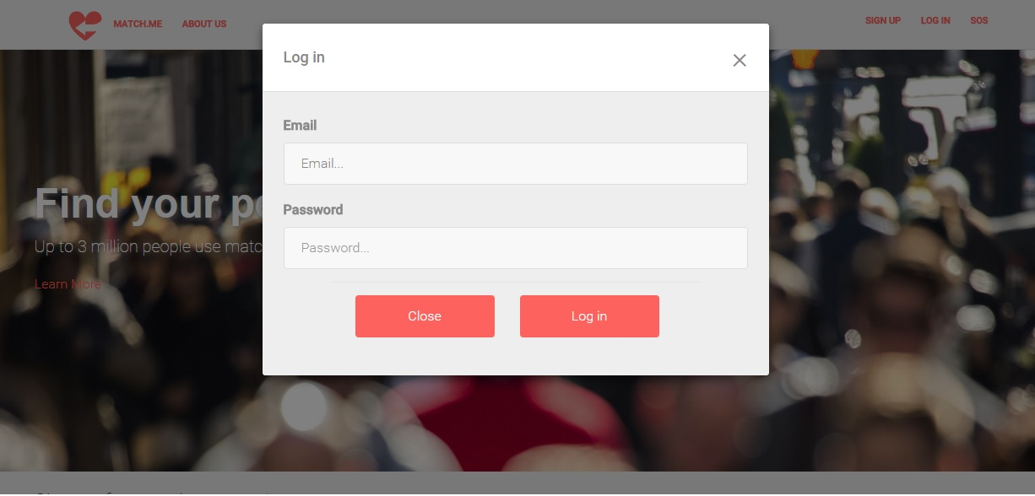

Fill them up with your information and click Log in.

To see your information, click on Profile on the navigation bar.



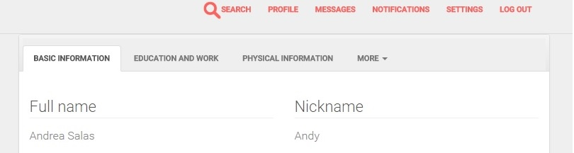On your profile, you are going to see a table with different tabs, on which your information is organized. If you want to see it, click on every tab.

If you want to look for people by their name, last names, age, city, country, hobbies, interests, eye color, hair color, skin color, sexual orientation, body type, languages, gender, religion, zodiac sign, relationship status or exercise frequency, you can do so.

Select “Search”



It will lead you to a page with all former search values, as follows:

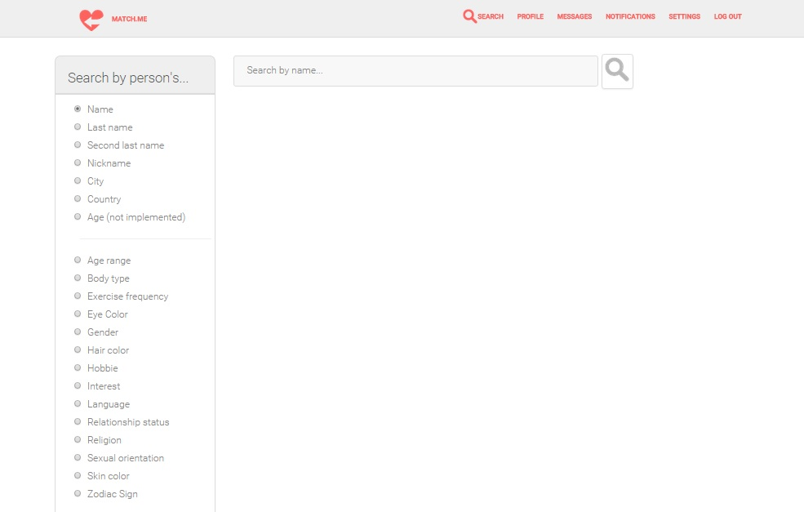

Select the search you want to do and write the text that you want to look for. In case you want to look for parametrized values, select from the catalog that will be shown. The people who match the search value are going to appear when you search for them with the search icon.

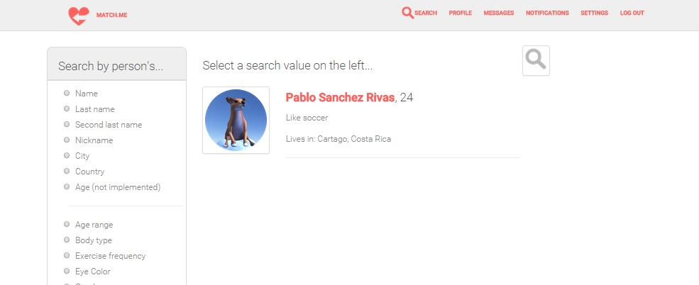

In order to see which people you have winked at, select “People I`ve winked” on your homepage. A modal will pop up showing you their names.



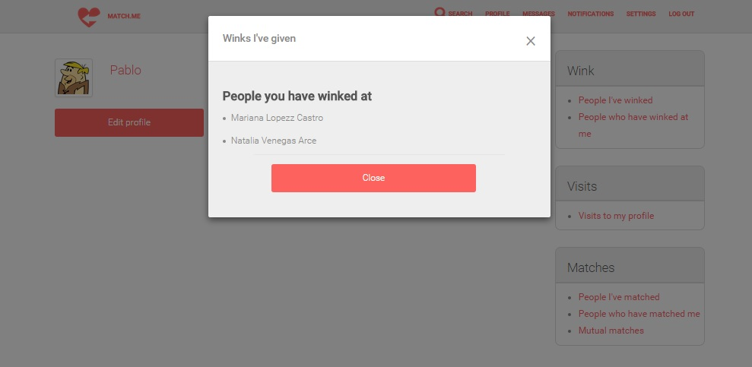

In order to see which people have winked at you, select “People who have winked at me” on your homepage. A pop-up will appear showing you who has winked at you.



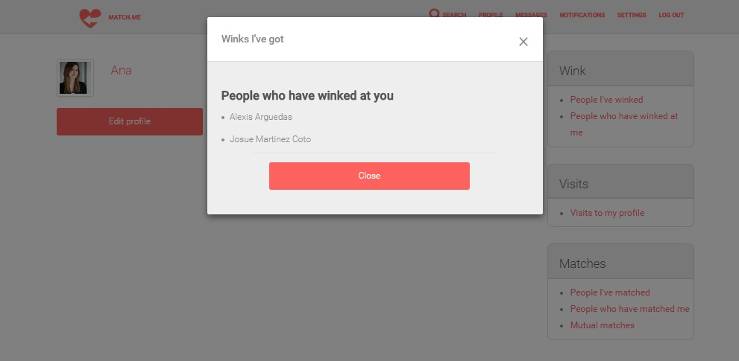

When visiting a person, which is only posible if your search for them first, you can either Wink at them or select that you matched if you met. The button will actualize immediately.

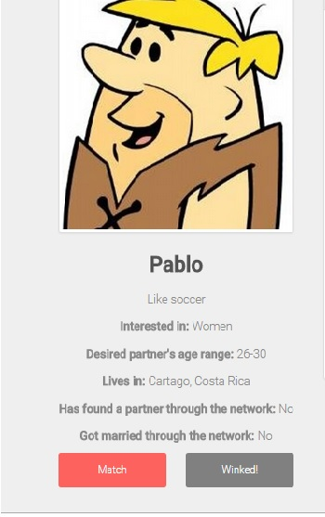

Both values are going to be registered and are going to be visible by the user you winked or matched.

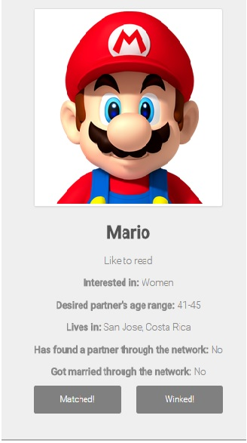

To see who has visited your profile, select “Visits to my profile” on your homepage.

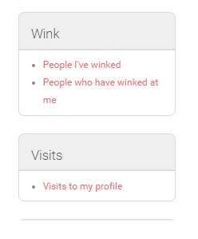

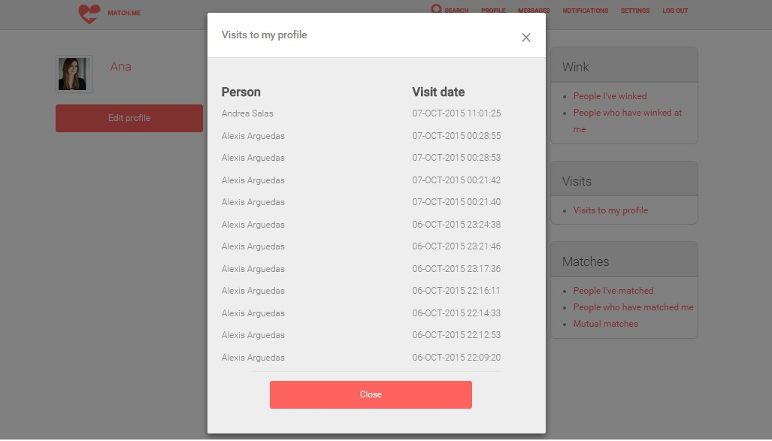

To see who has matched you, select “People who have matched me”. To see who you have matched, select “People who have matched me”; both on your homepage. In both cases a modal will show up with the asked for data.

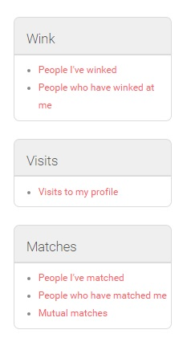

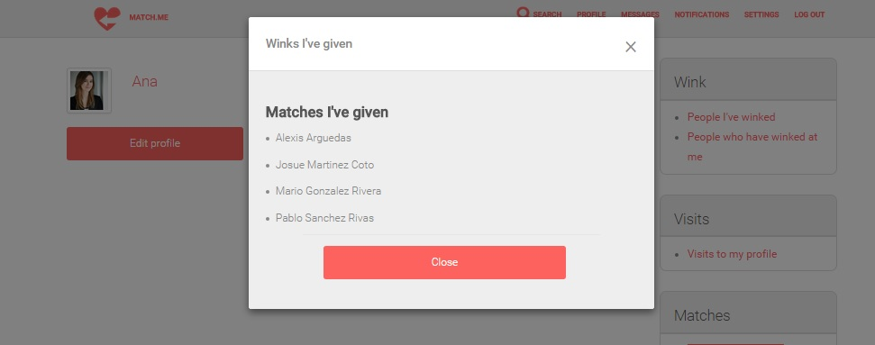

You can also visualize your mutual matches; which means someone you have matched and who has matched you back. You can see this by clicking on “Mutual Matches” on your homepage. A modal will show up with their names.



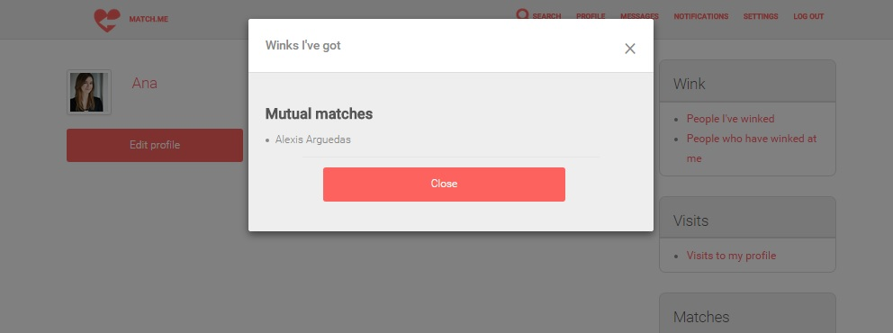

**Administrator**

Log into the system normally, by inputting your

* Email.
* Password.

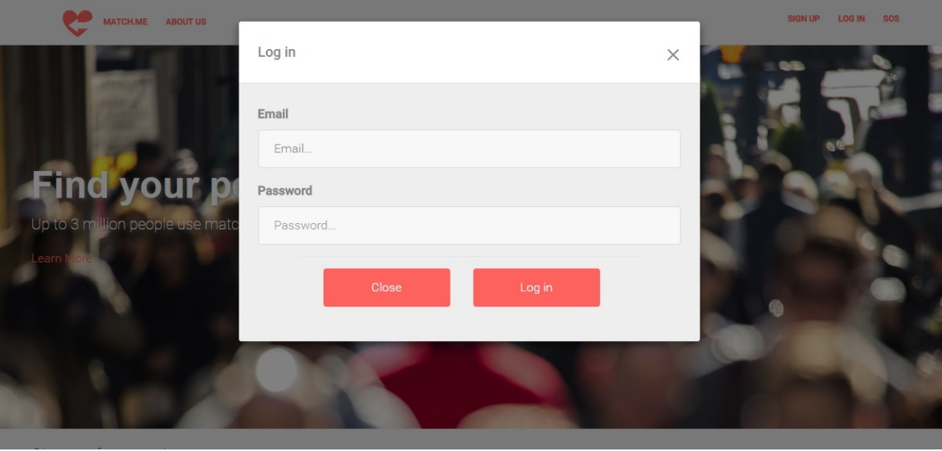And selecting Log in. If you were designated on the database as an administrator, the system will identify you as such.

As an administrator you can modify the catalog’s entries.

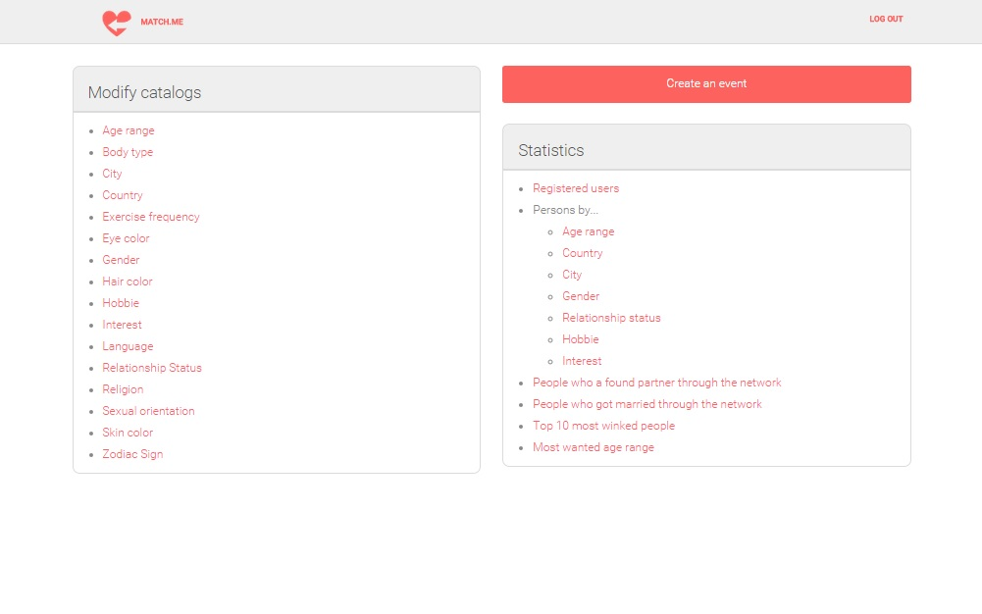

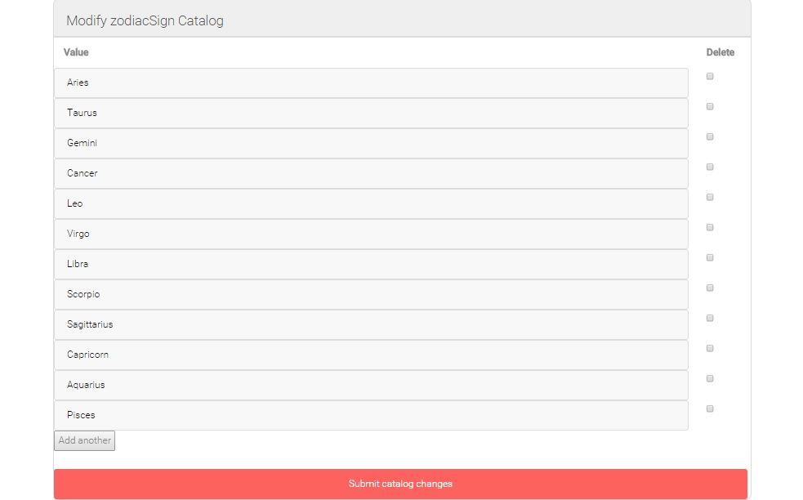Select the value you want to delete and click on Submit catalog changes. You can also add values (only one per submit) to the catalog.

You can also see statistics on the application, as follows:



You can create events and invite by email immediately people on the city it will be held.



