Search: ADD, DISCLAIMER
Drifting Reinforcement Learning New Notes

1º Experiment: 24h “arena” 3.2M steps experiment
Experiment Properties:
- facilitate drifting if x < 130 or x > 170 (ADD desenho) (DISCLAIMER não falamos na apresentação, demos a entender que o facilitate drifting era no circuito todo)
- timestep of the webots world is 0.032 instead of 0.008 which was being chosen for the “track” map (DISCLAIMER não falamos na apresentação)
- reward function:
$R=\left\{\begin{matrix}-100 & \text{if }I_{crash} \\ -7.5 & \text{el}\text{if }d_{center}≥5 \\ 0.2+30I_{checkpoint}+50 & \text{el}\text{if }v>25∧{30}^{∘}<θ_{h}<{60}^{∘}∧d_{center}<5 \\ 0.2+30I_{checkpoint}+10 & \text{el}\text{if }v>25∧-{90}^{∘}<θ_{h}<{30}^{∘}∧δ<0∧d_{center}<5 \\ 0.2+30I_{checkpoint}+10 & \text{el}\text{if }v>25∧{60}^{∘}<θ_{h}<{90}^{∘}∧δ>0∧d_{center}<5 \\ 0.2+30I_{checkpoint} & elif d_{center}<5\end{matrix}\right.$
Where: $I_{crash}$ is whether the car has hit a wall, $v$ is the cruising speed of the vehicle, $d_{center}$ is the distance to the closest point in the centerline, $I_{checkpoint}$ is whether the car has reached 1 of the six checkpoint spread evenly across the circuit, $θ_{h}$ is the drift angle of the car (heading_error) (between the car’s heading direction and the centerline’s heading direction), $δ$ is the steering value (-1 is left, +1 is right)

2º Experiment: 5h “arena” 2.4M steps 0.008 timestep normalised rewards facilitate drifting full space n_steps 2048
Experiment Properties:
- facilitate drifting EVERYWHERE (ADD desenho)
- timestep of the webots world is 0.008 instead of 0.032
- PPO n_steps argument was the default 2048
- reward function:
$$R=\left\{\begin{matrix}-10 & if I_{crash} \\ -0.2 & elif d_{center}≥5 \\ 0.2+1 & elif v>25∧{30}^{∘}<θ_{h}<{60}^{∘}∧d_{center}<5∧I_{making_{p}rogress} \\ 0.2+0.2 & elif v>25∧-{90}^{∘}<θ_{h}<{30}^{∘}∧δ<0∧d_{center}<5∧I_{making_{p}rogress} \\ 0.2+0.2 & elif v>25∧{60}^{∘}<θ_{h}<{90}^{∘}∧δ>0∧d_{center}<5∧I_{making_{p}rogress} \\ 0.2 & elif d_{center}<5∧I_{making_{p}rogress} \\ 5 & if I_{checkpoint}\end{matrix}\right.$$

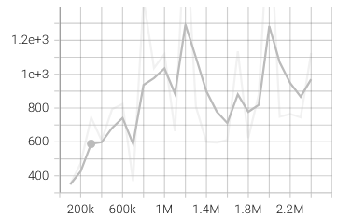 | 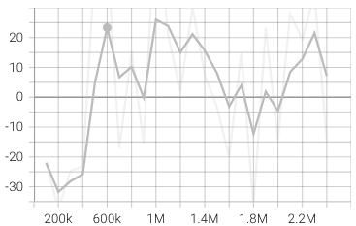
eval_mean_ep_length | eval_mean_reward
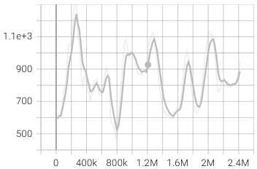 | 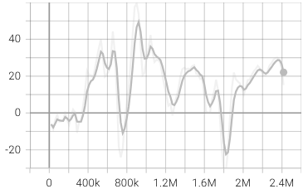
rollout_mean_ep_length | rollout_mean_ep_length

3º Experiment: 11h “arena” 4.1M steps 0.008 timestep normalised rewards facilitate drifting full space n_steps 8192
Experiment Properties (same as the experiment before except for the n_steps parameter):
- facilitate drifting EVERYWHERE (ADD desenho)
- timestep of the webots world is 0.008 instead of 0.032
- PPO n_steps parameter was set to 8192 (!!!)
$$R=\left\{\begin{matrix}-10 & if I_{crash} \\ -0.2 & elif d_{center}≥5 \\ 0.2+1 & elif v>25∧{30}^{∘}<θ_{h}<{60}^{∘}∧d_{center}<5∧I_{making_{p}rogress} \\ 0.2+0.2 & elif v>25∧-{90}^{∘}<θ_{h}<{30}^{∘}∧δ<0∧d_{center}<5∧I_{making_{p}rogress} \\ 0.2+0.2 & elif v>25∧{60}^{∘}<θ_{h}<{90}^{∘}∧δ>0∧d_{center}<5∧I_{making_{p}rogress} \\ 0.2 & elif d_{center}<5∧I_{making_{p}rogress} \\ 5 & if I_{checkpoint}\end{matrix}\right.$$
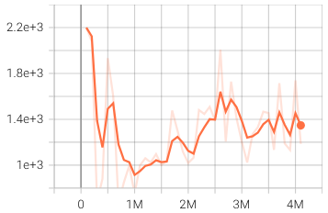 | 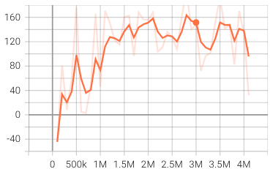
eval_mean_ep_length | eval_mean_reward
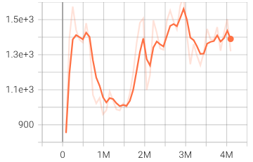 | 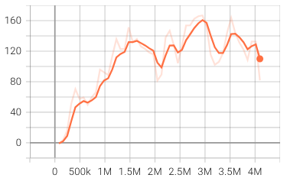
rollout_mean_ep_length | rollout_mean_ep_length

4º Experiment: 12h “arena” 4.1M steps 0.008 timestep normalised rewards facilitate drifting full space n_steps 8192
Experiment Properties:
- facilitate drifting if x < 130 or x > 170 (ADD desenho)
- timestep of the webots world is 0.032 instead of 0.008 (!!!)
- PPO n_steps parameter was set to 2048
- reward function:
$$R=\left\{\begin{matrix}-20 & if I_{crash} \\ -0.15 & elif d_{center}≥5 \\ 0.1+1 & elif v>25∧{30}^{∘}<θ_{h}<{60}^{∘}∧d_{center}<5∧I_{making_{p}rogress} \\ 0.1+0.2 & elif v>25∧-{90}^{∘}<θ_{h}<{30}^{∘}∧δ<0∧d_{center}<5∧I_{making_{p}rogress} \\ 0.1+0.2 & elif v>25∧{60}^{∘}<θ_{h}<{90}^{∘}∧δ>0∧d_{center}<5∧I_{making_{p}rogress} \\ 0.1 & elif d_{center}<5∧I_{making_{p}rogress} \\ 5 & if I_{checkpoint}\end{matrix}\right.$$
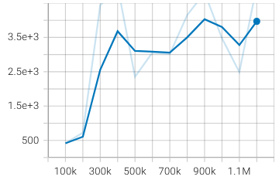 | 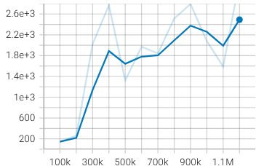
eval_mean_ep_length | eval_mean_reward
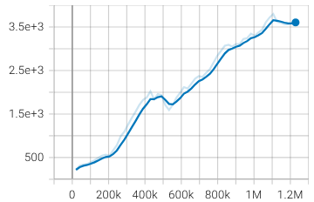 | 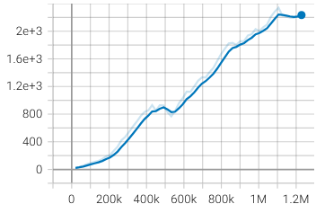
rollout_mean_ep_length | rollout_mean_ep_length

Conclusion
Experiments 2 (grey), 3 (orange) and 4 (blue):
Can't tell which has a greater impact on stable learning: increasing the Webots timestep from 0.008 s to 0.032 s, or only allowing drift assistance only in certain locations instead of throughout the entire track.
Increasing the n_steps parameter (buffer size) of the PPO model from 2048 to 8192 improved learning (+reward).
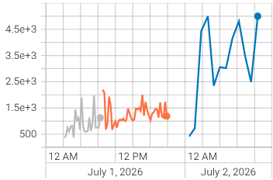 | 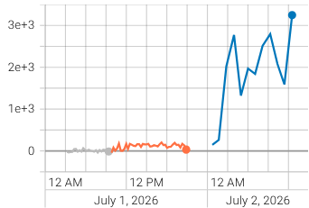
eval_mean_ep_length | eval_mean_reward
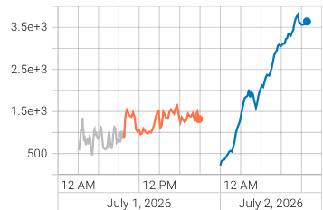 | 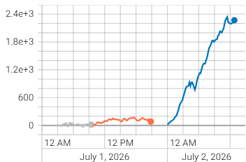
rollout_mean_ep_length | rollout_mean_ep_length

Experiments 1 (red) and 4 (blue):
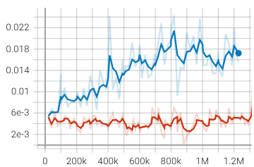 | 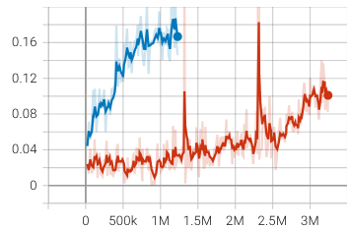
approx_kl | clip_fraction
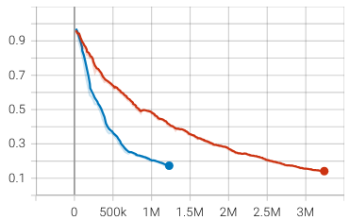 | 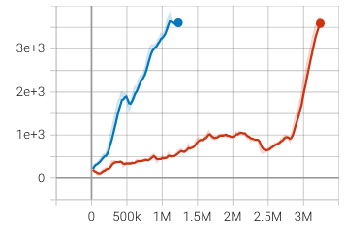
std | rollout_mean_ep_length

Experiment 4 (with normalised rewards) had more aggressive results, the std (exploration) from ppo reduced much quicker and it learned to stay alive much faster than experiment 1 (with non-normalised rewards).
Possible reasons:
- Drift reward 50 -> 1 (-50x) (dense reward)
- Reward for steering correctly to enter drifting state 10 -> 0.2 (-50x) (dense reward)
- Far from centerline penalty -7.5 -> -0.15 (-50x) (dense reward)
- Checkpoint reward 30 -> 5 (-6x) (sparse reward)
- Crash penalty -100 -> -20 (-5x) (sparse reward)
- Progress reward (if not far from centerline) 0.2 -> 0.1 (-2x) (dense reward) (!!!)

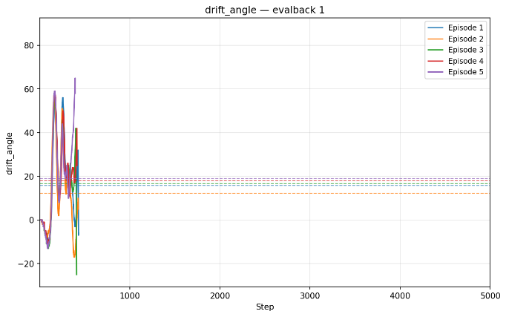 | 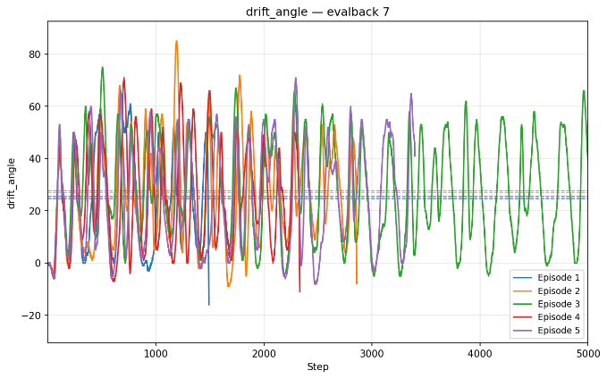
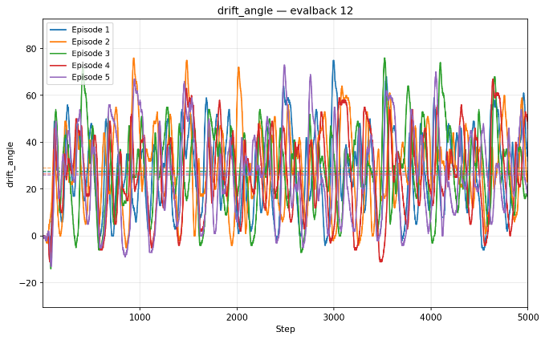 | 