BANDIT WRITEUPS

**Level 0->1**

Question -

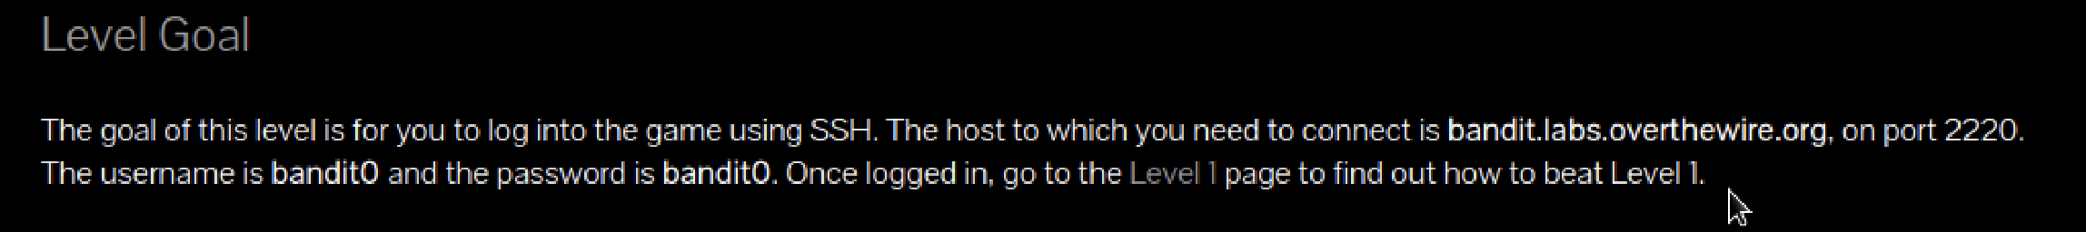

Solution –

Use the command – ssh [bandit0@bandit.labs.overthewire.org](mailto:bandit0@bandit.labs.overthewire.org) -p 2220

Then follow these steps

**Level 1->2**

Question –

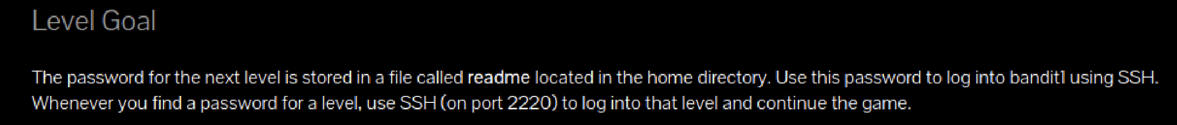

Solution –

Use the command- ssh [bandit1@bandit.labs.overthewire.org](mailto:bandit1@bandit.labs.overthewire.org) -p 2220

Use the password obtained in the previous level to login into this level

Then follow these steps -

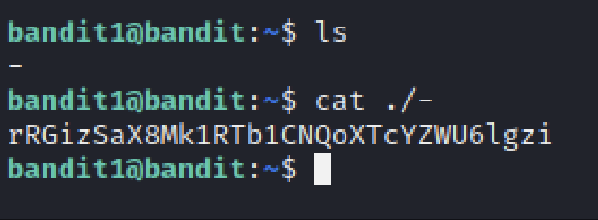

**Level 2->3**

Question -

Solution –

Use the command- ssh [bandit2@bandit.labs.overthewire.org](mailto:bandit2@bandit.labs.overthewire.org) -p 2220

Use the password obtained in the previous level to login into this level

Then follow these steps

**Level 3->4**

Question –

Solution –

Use the command- ssh [bandit3@bandit.labs.overthewire.org](mailto:bandit3@bandit.labs.overthewire.org) -p 2220

Use the password obtained in the previous level to login into this level

Then follow these steps

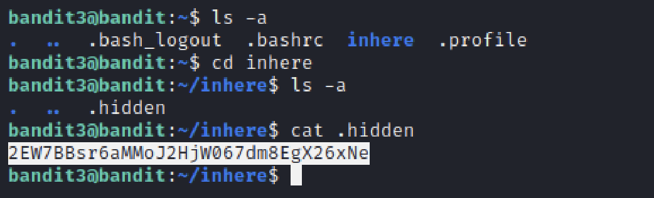

**Level 4->5**

Question –

Solution –

Use the command- ssh [bandit4@bandit.labs.overthewire.org](mailto:bandit4@bandit.labs.overthewire.org) -p 2220

Use the password obtained in the previous level to login into this level

Then follow these steps

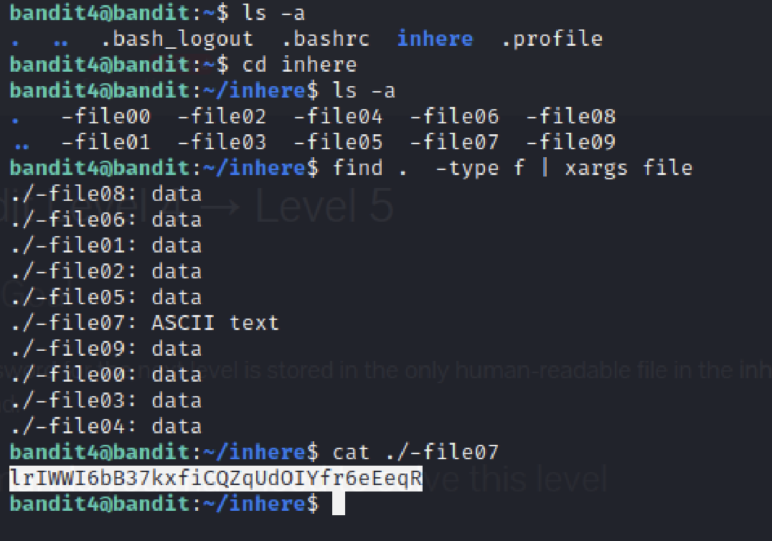

The find command is used to look for files. “xargs file” is passed as the file is mentioned to be human-readable.

**Level 5->6**

Question

Solution –

Use the command- ssh [bandit5@bandit.labs.overthewire.org](mailto:bandit5@bandit.labs.overthewire.org) -p 2220

Use the password obtained in the previous level to login into this level

Then follow these steps

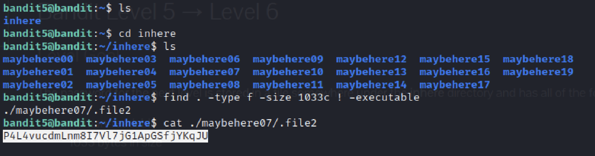

The arguments to the find command are the size of the file and it is mentioned to be not executable.

**Level 6->7**

Question

Solution –

Use the command- ssh [bandit6@bandit.labs.overthewire.org](mailto:bandit6@bandit.labs.overthewire.org) -p 2220

Use the password obtained in the previous level to login into this level

Then follow these steps

The find command now has user, group and size as the arguments. The “2>/dev/null” is used to filter the files which deny permission.

**Level 7->8**

Question

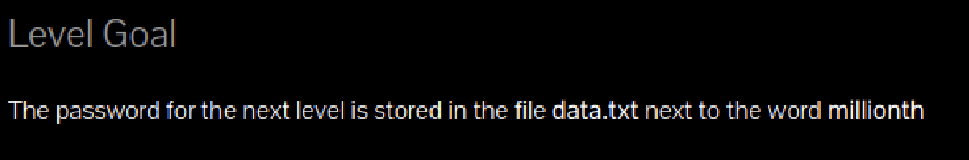

Solution –

Use the command- ssh [bandit7@bandit.labs.overthewire.org](mailto:bandit7@bandit.labs.overthewire.org) -p 2220

Use the password obtained in the previous level to login into this level

Then follow these steps



The grep command is used to find the strings in a given file

**Level 8->9**

Question

Solution –

Use the command- ssh [bandit8@bandit.labs.overthewire.org](mailto:bandit8@bandit.labs.overthewire.org) -p 2220

Use the password obtained in the previous level to login into this level

Then follow these steps

The uniq -c command gives all the unique strings with the number of repetitions. Out of all the strings, only one string appears once. Which is the password for the next level.

**Level 9->10**

Question

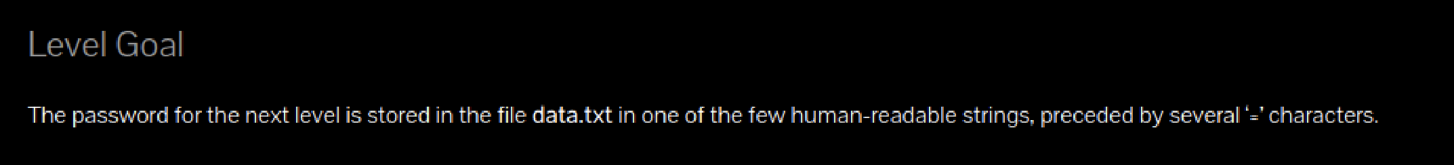

Solution –

Use the command- ssh [bandit9@bandit.labs.overthewire.org](mailto:bandit9@bandit.labs.overthewire.org) -p 2220

Use the password obtained in the previous level to login into this level

Then follow these steps

**Level 10->11**

Question

Solution –

Use the command- ssh [bandit10@bandit.labs.overthewire.org](mailto:bandit10@bandit.labs.overthewire.org) -p 2220

Use the password obtained in the previous level to login into this level

Then follow these steps –

Level 11->12

Question



Solution –

Use the command- ssh [bandit11@bandit.labs.overthewire.org](mailto:bandit11@bandit.labs.overthewire.org) -p 2220

Use the password obtained in the previous level to login into this level

Then follow these steps –

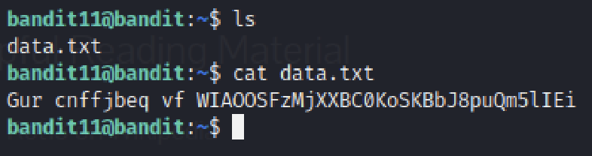

As mentioned in the question, the letters are rotated by 13 positions. So, this is a rot 13 cypher text. Hence, I used an online tool to decode the cipher.

This password can now be used to log in to the next level.

**Level 12->13**

Question

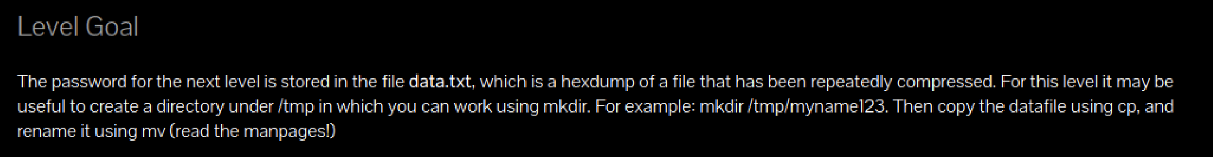

Solution –

Use the command- ssh [bandit12@bandit.labs.overthewire.org](mailto:bandit12@bandit.labs.overthewire.org) -p 2220

Use the password obtained in the previous level to login into this level

Then follow these steps –

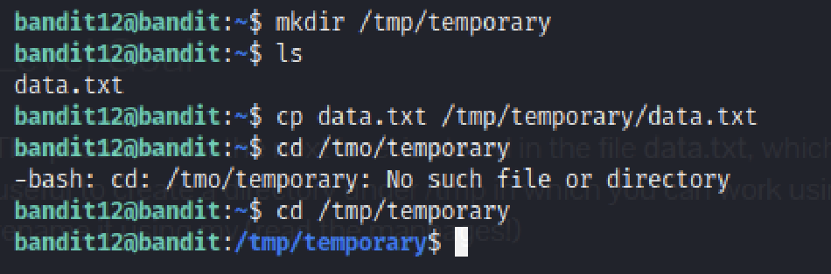

Using the mkdir command, a new directory is created and the file data.txt is copied to that directory.

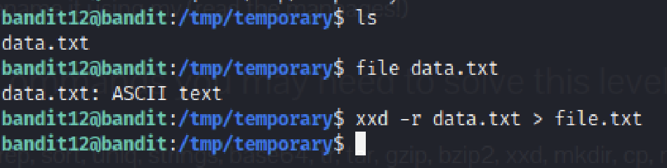

The file command is used to know the kind of file given. This file is a hexdump as mentioned. So The xxd -r command reverses the hexdump and the output of that is now stored in a file called file.txt

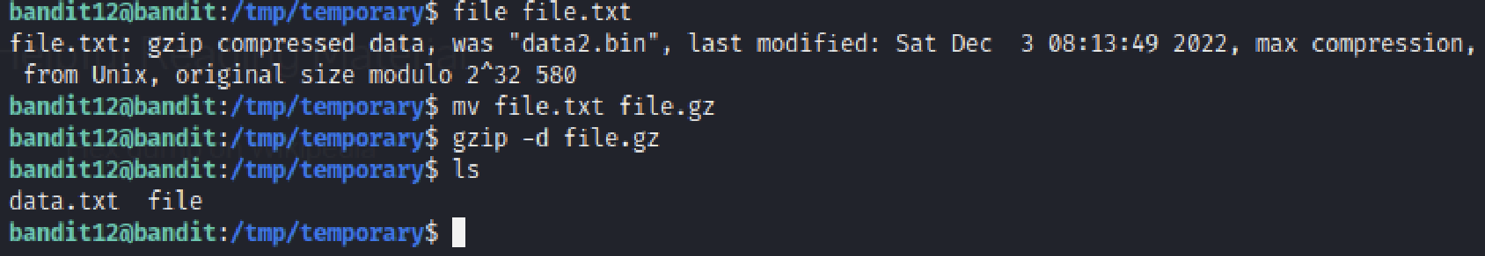

The file is now gzip compressed. So, the file has to be given a suitable extension which is done using the mv command. Then “gzip -d” decompresses the file.

This file is now bzip2 compressed. Which is then given a suitable extension and decompressed using “bzip2 -d” command.

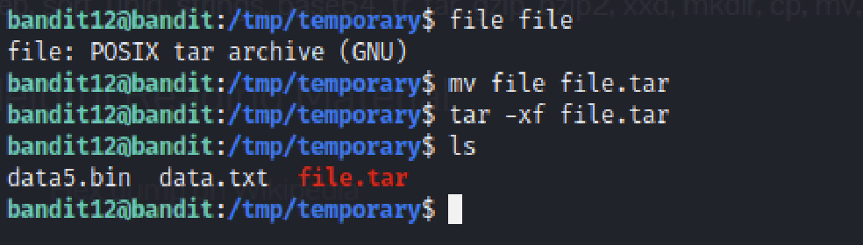

In a few such iterations, we come across a tar archive. Again, the file extension must be changed and the “tar -xf” command is used to extract the file.

After several iterations of decompressions, we come across a file of ASCII text containing our password for the next level.