**Cryptography**

1.

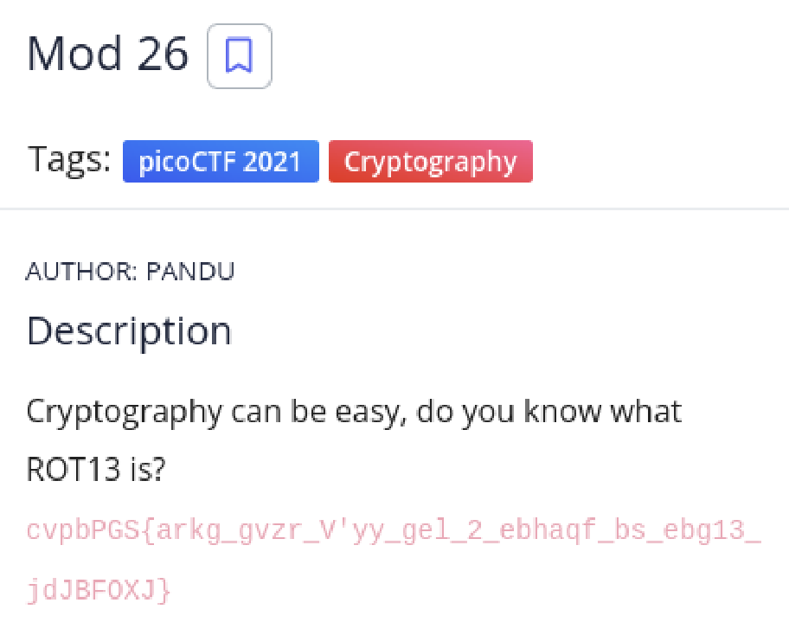

Solution

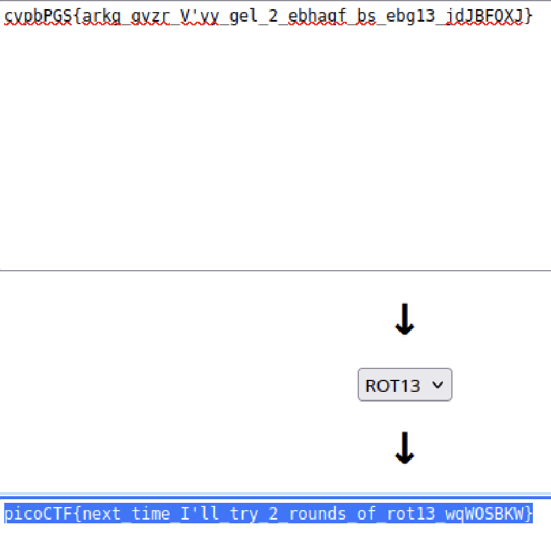

Using an online rot13 decoder, we find the flag.

2.

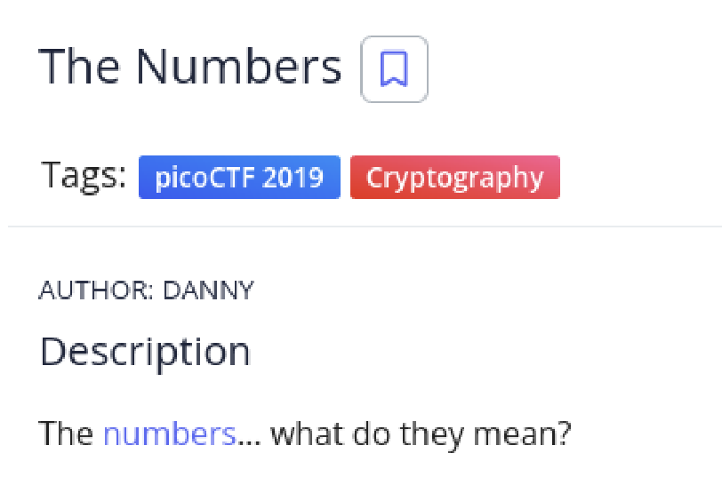

Solution

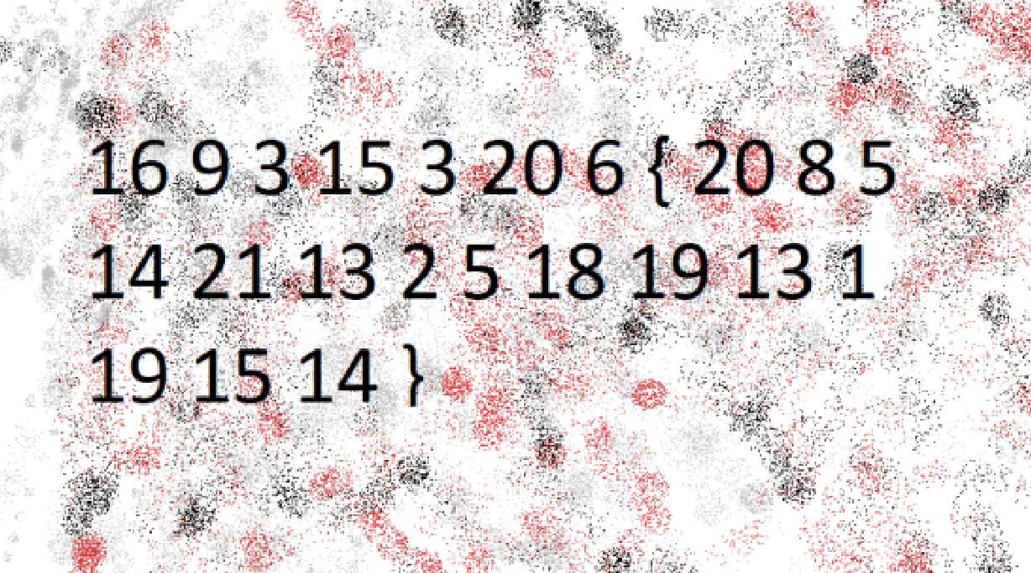

These are the numbers that are present in the image. Now observing the numbers, they correspond to the positions of the letters in the English alphabet. Hence, by writing the letters down, we have the flag.

3.

Solution

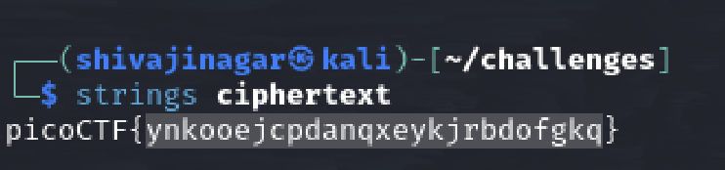

Using the strings command on the file gives a flag which is encoded using Caesar Cipher so trying out all keys possible, we have –

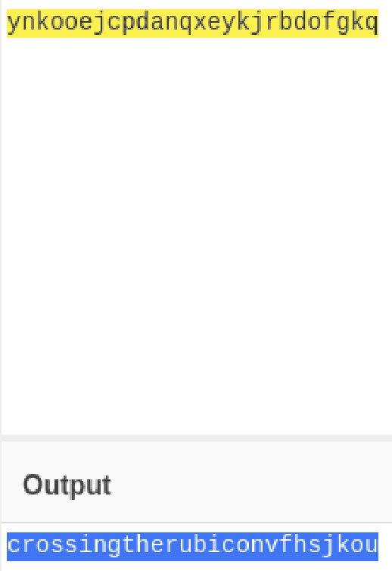

So key 4 reveals the right answer.

4.

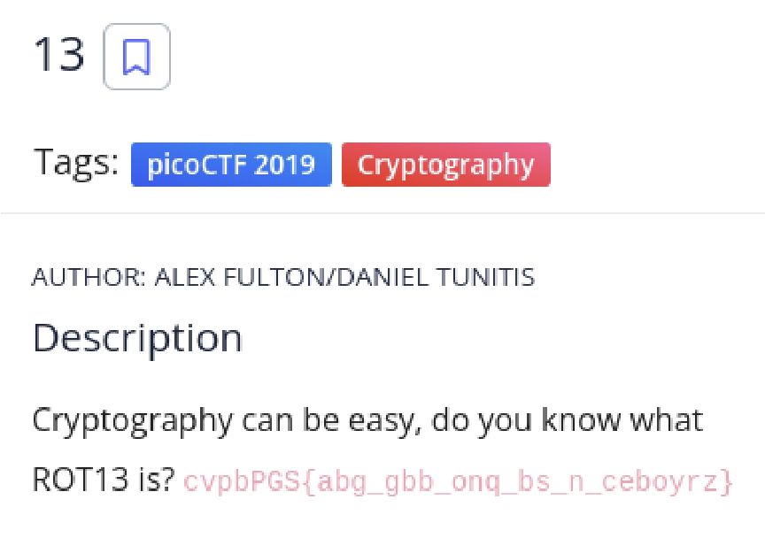

Solution

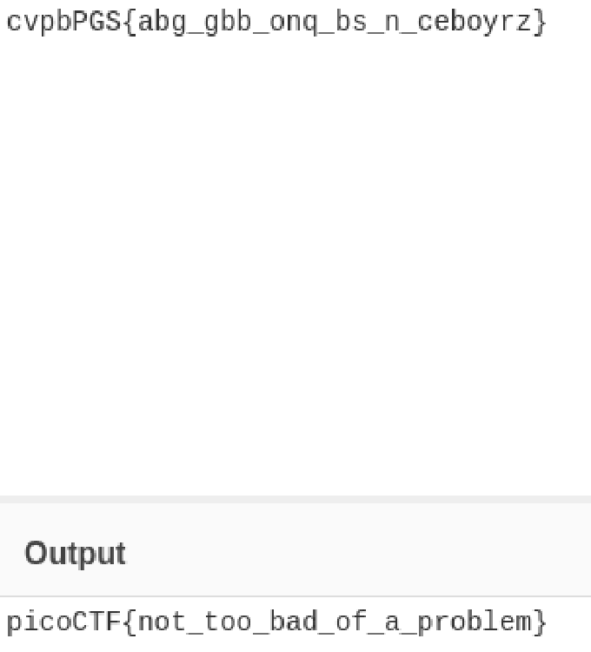

Using the online rot13 decoder, we have the flag.

5.

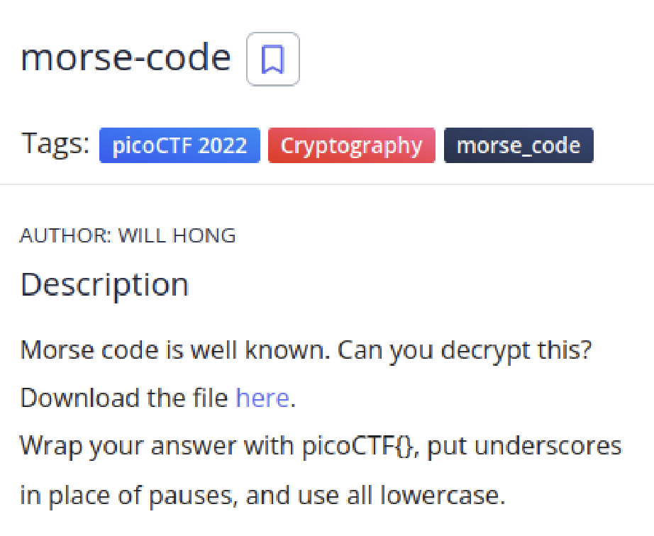

Solution

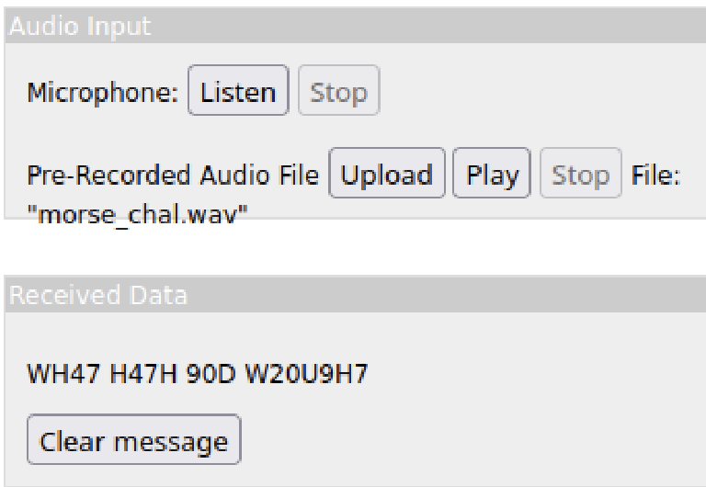

Using an online morse code decoder, we find the text. Replacing empty spaces with “_”, we get the flag.

6.

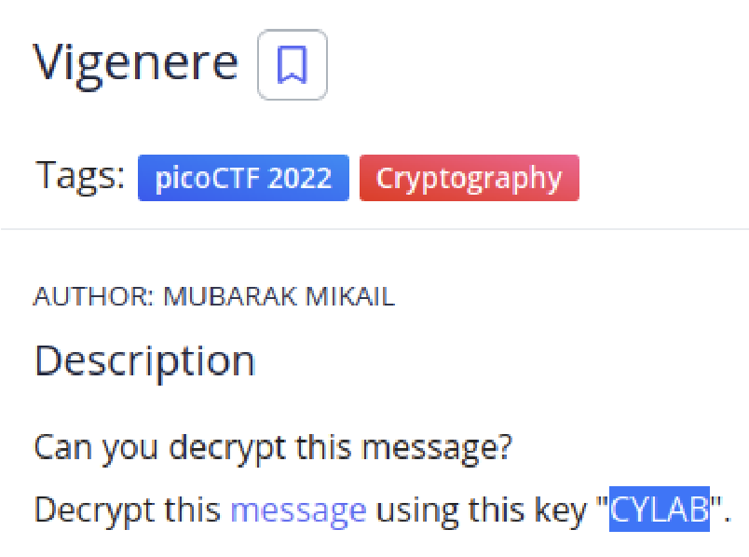

Solution

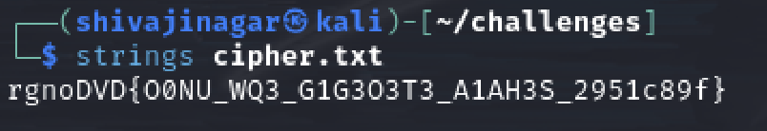

Looking for the strings in the file, we get the encrypted flag. Using an online decoder with the key given in the question, we have the flag.

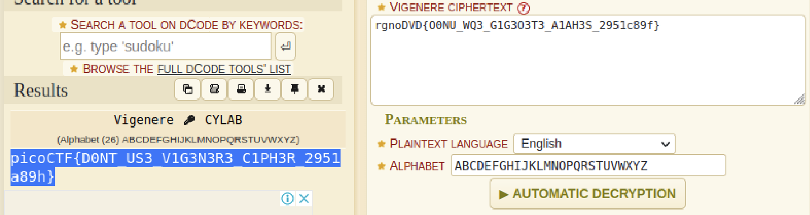

7.

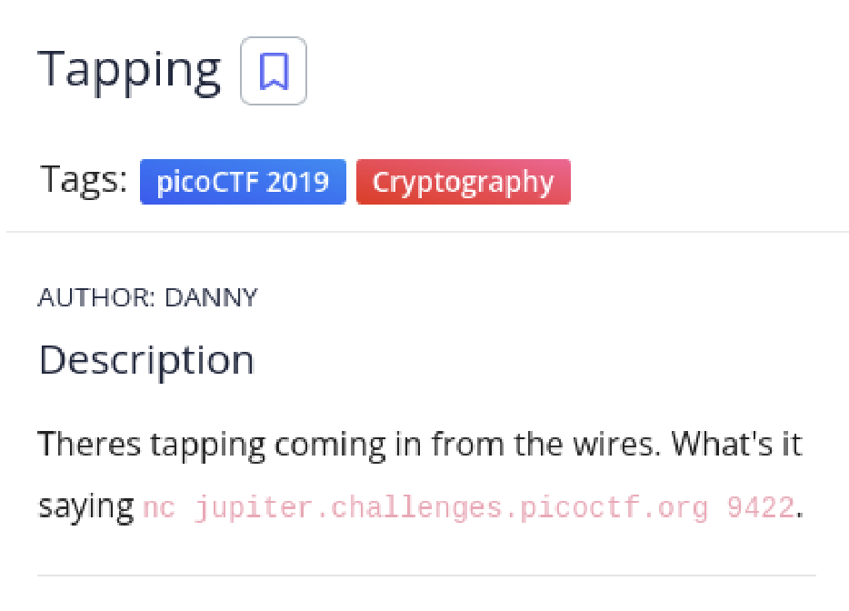

Solution

Using the command given in the question, we arrive at the following morse text.



Using an online Morse code decoder, we have the flag as follows

