# **Forensics**

Question

Solution

The license appears to be base64 encoded data

So using an online base64 decoder gives the flag.

Question

Solution

As the question says, the dolls are placed inside one another, the file carving tool binwalk comes to mind

Using binwalk once, reveals a directory called _dolls.jpg.extracted.

Moving into this directory, we find another directory base_images with another image 2_c.jpg. Continuing the use of binwalk on these images until the flag is found, we have

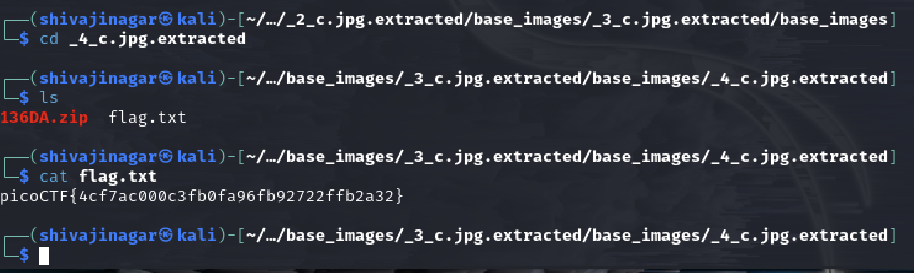After several such iterations of using binwalk, we finally come across flag.txt and using cat, we have the flag.

Question

Solution

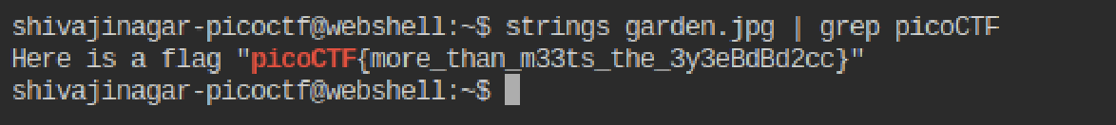

Using the strings command and using grep to look for picoCTF gives the flag.

Question

Solution

Using wireshark to trace the packets, we find a string which appears to be rot13 encoded. Using an online decoder for rot13, we get the flag.

Question

Solution

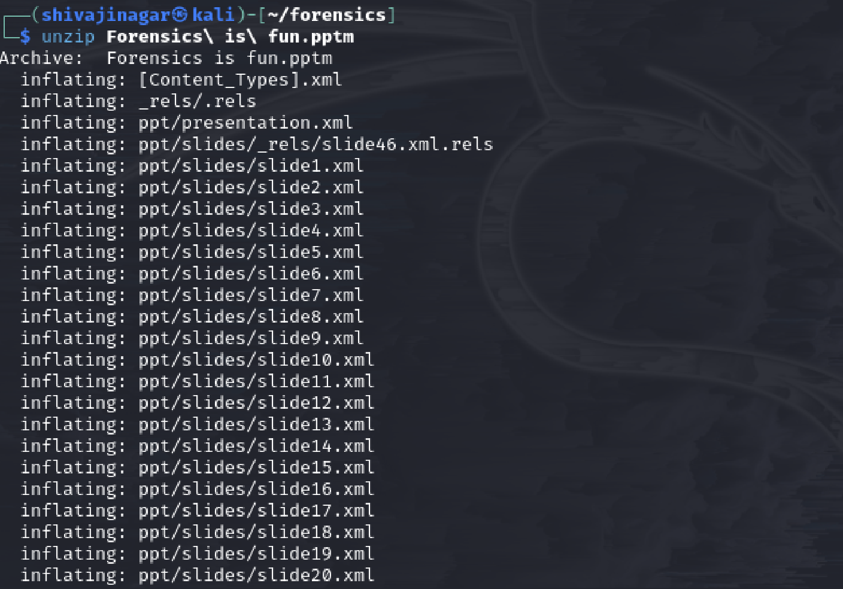

Using the unzip command to extract all files in the given archive, we have a list of files and directories. But one directory has a hidden file

We find a bunch of characters in the hidden file, which has uppercase, lowercase letters and numbers. So it could be base64 encoded.

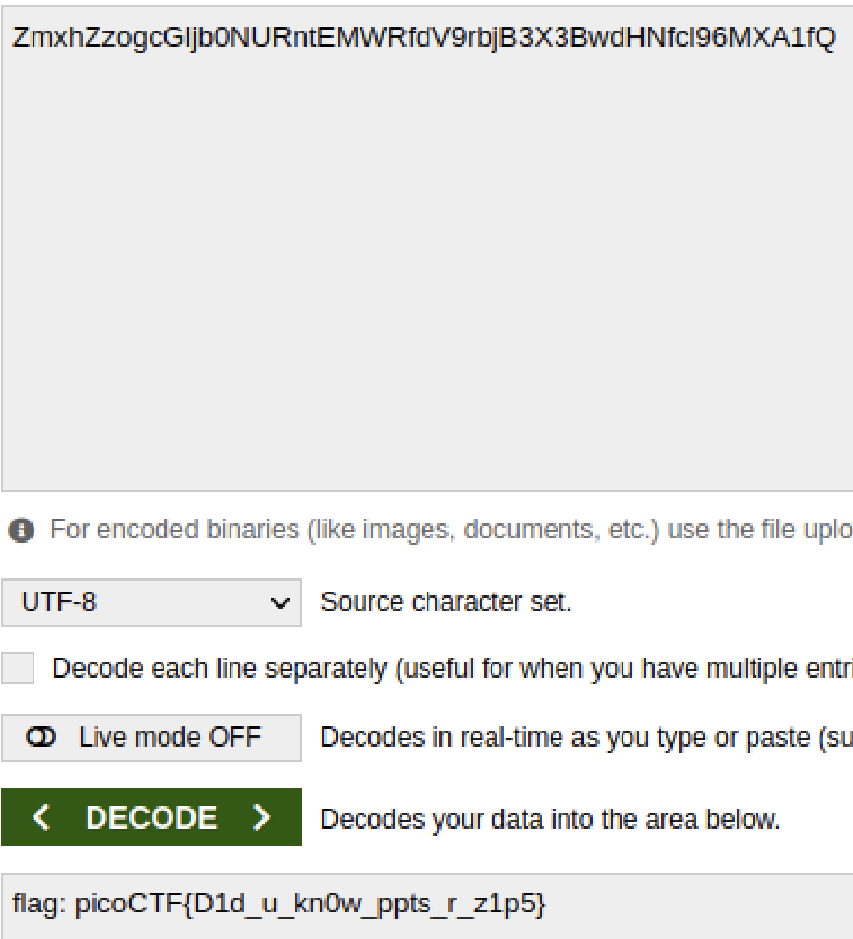

We find the flag using an online decoder.

Question

Solution



Using Wireshark and exporting objects of TFTP, we have the shown files in the directory.



The strings in the file look like rot13 encoded so by decoding it and following the steps, we have –

It hints towards checking the plan file.

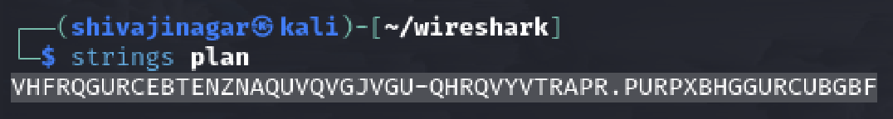

Using the rot13 decoder on the contents of the plan file,

We come across this, and DUEDILIGENCE looks like the passphrase for the steghide tool. Not using it on the 3 images, we have –

Looking at the flag.txt file, we come across the flag.

Question

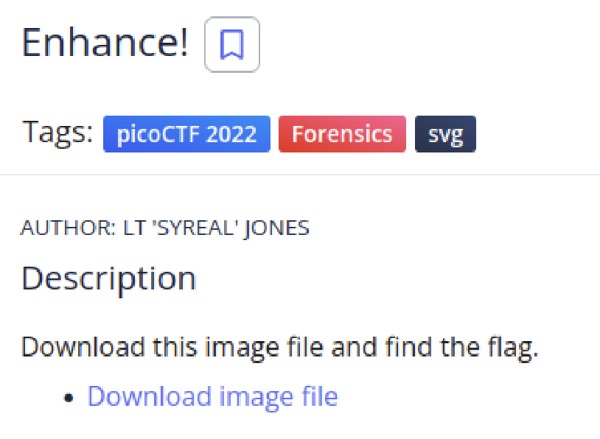

Solution

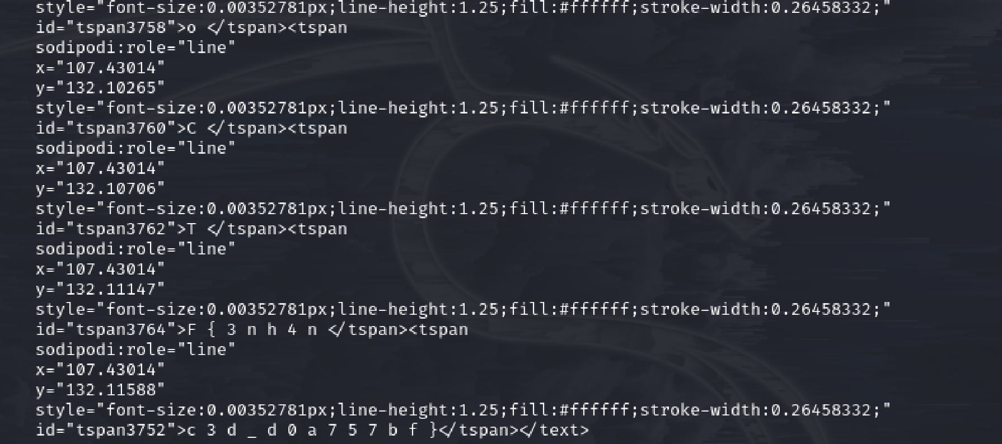

Running the strings command on the file, we get the above result, but the interesting thing is that the contents in the tspans look like flags

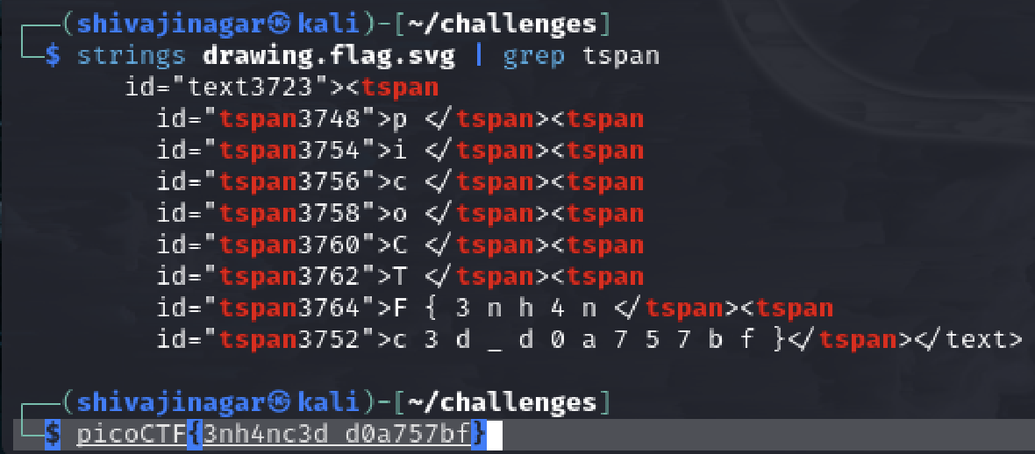

Using grep to find the tspans, we end up with the flag.