**YES I WILL DRAW MYSELF!**

**Learning outcomes**

• Self-awareness.

• Understand how identities and cultures form, are expressed, change and are connected.

• Value different perspectives.

**Summary**

An opportunity for us to get to know one another and identify what we care about and explore concepts of identity and community.

**STEPS:**

1. Draw a symbol of ourselves (I represent myself as a sun, or tree, or cloud, or flower…) **You need to state WHY.**
2. We will draw a picture representing ourselves with a heart in the centre.
3. Around the heart, we post words representing the things that are important to us. The closer to the heart, the more important it is.
4. Then we speak about a source of pain in our life (if we have any).

Example 1 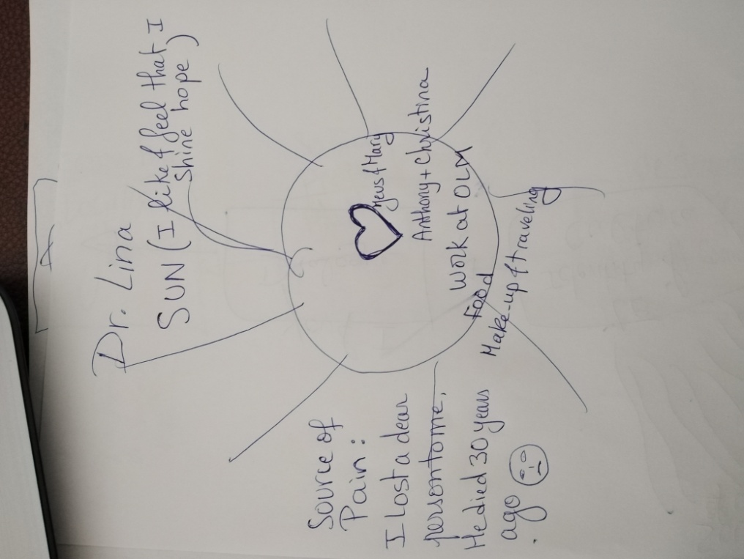

Example 2



1. Please check some of your classmates work so we get to know each other better.