Step1: Host a Ubuntu Virtual Machine using Oracle VM Virtual Box

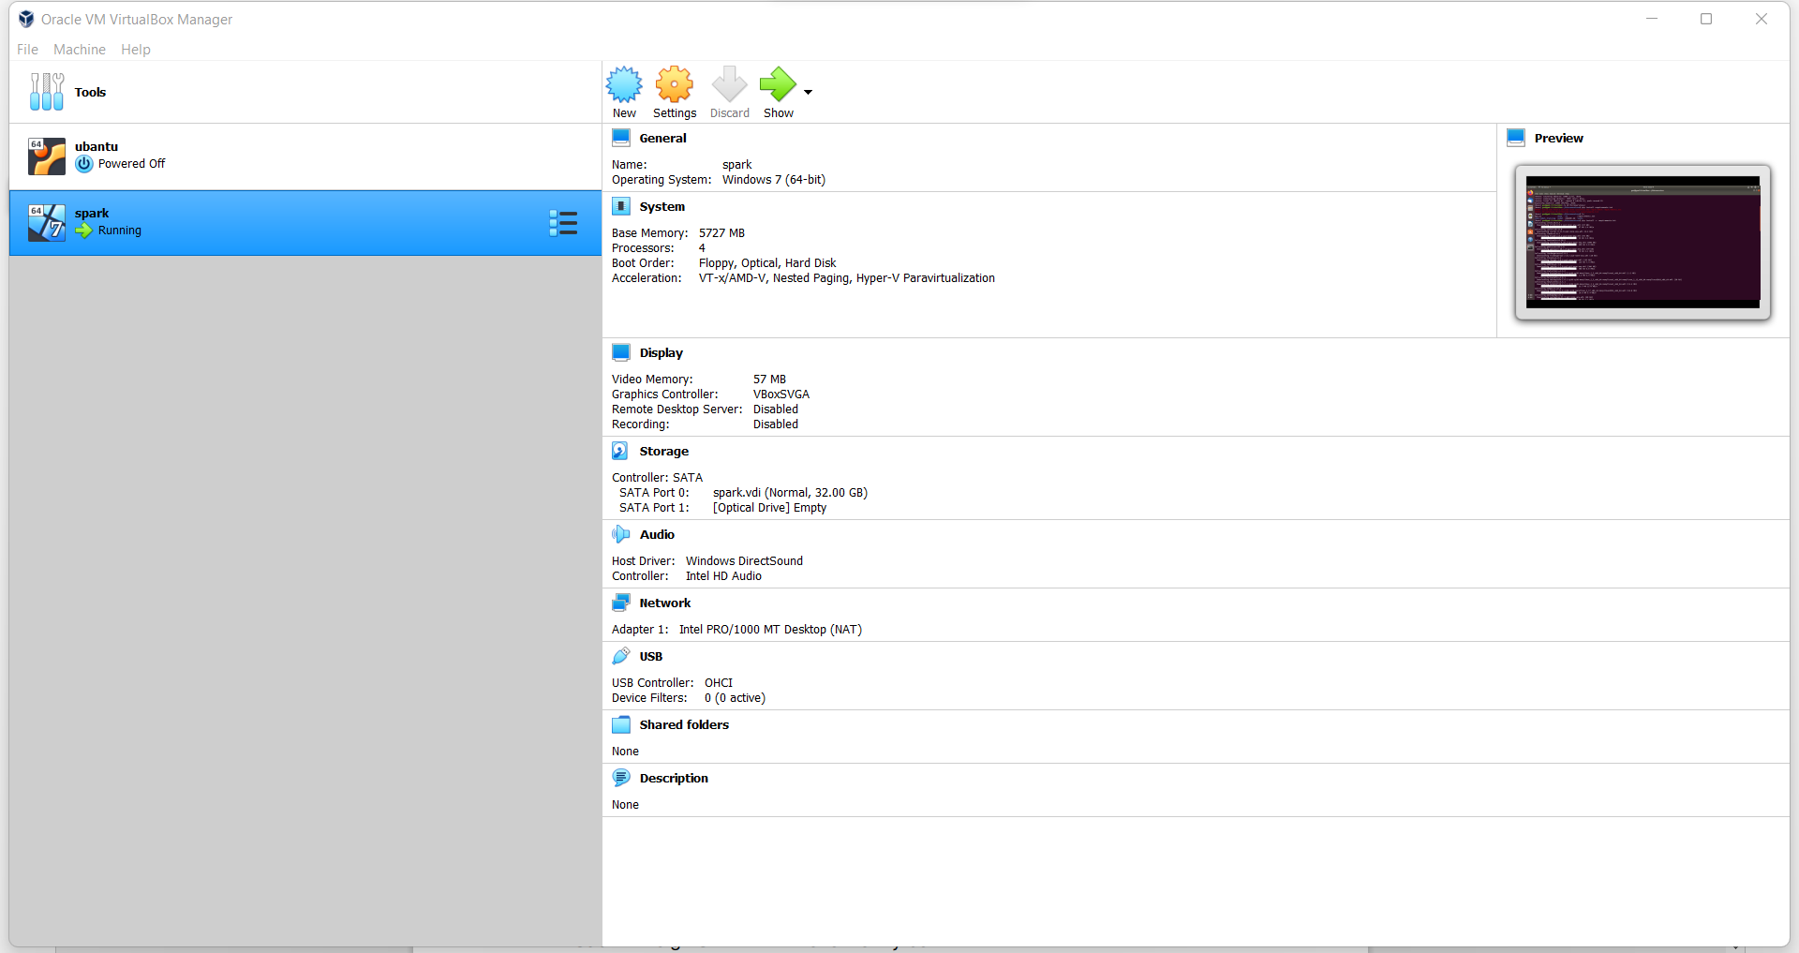

Step2: Set up Visual Studio code on Ubuntu VM.

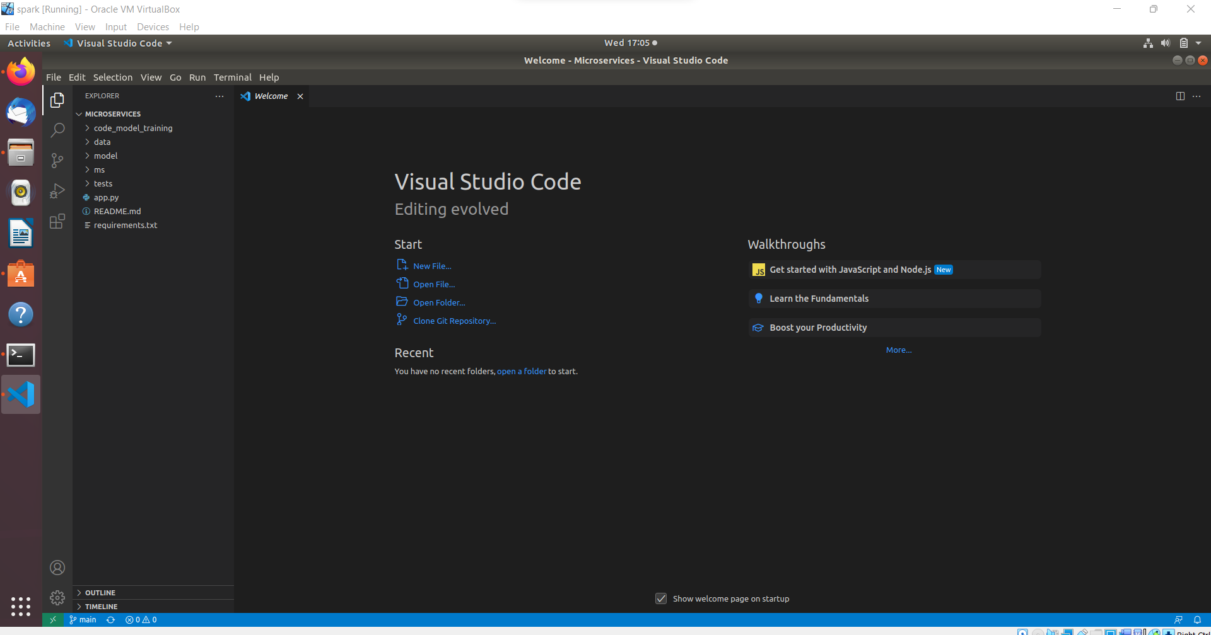

Step 3 4 5

Set up Python & Clone this Github repository <https://github.com/Vikas098766/Microservices.git>



Virtual env is base here.(anaconda) Command is git clone to clone a repo

Step6 :

Install the dependencies from requirements.txt file command is pip install –r requirments.txt

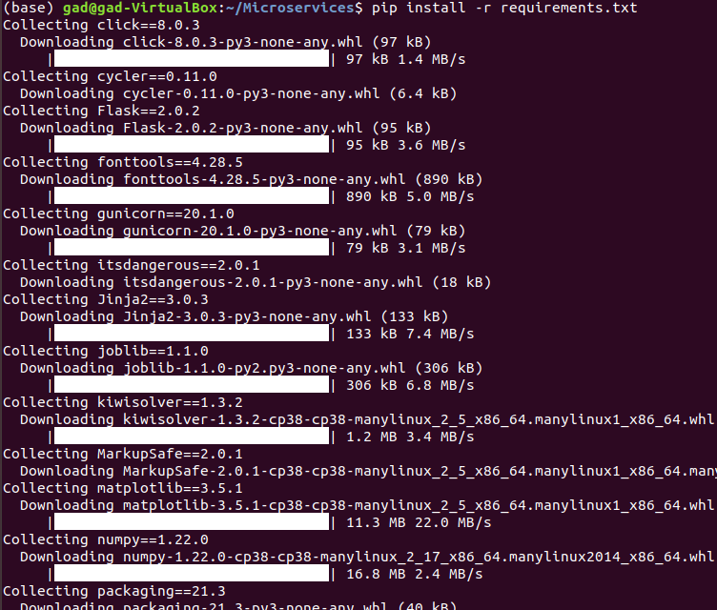

Step7 train and save the model

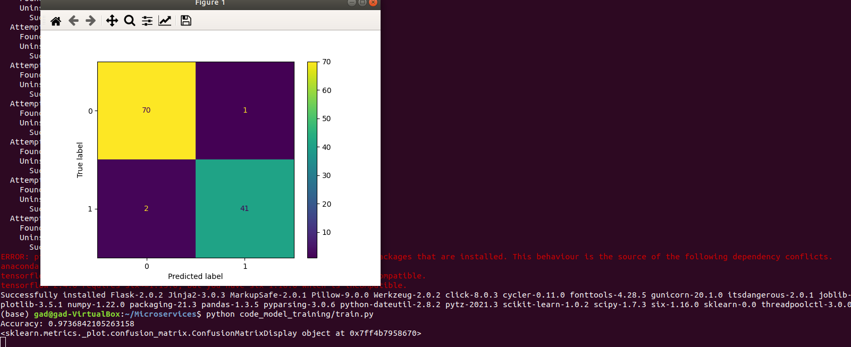

Command : python code_model_train.py

Step 8 Test the Flask web application

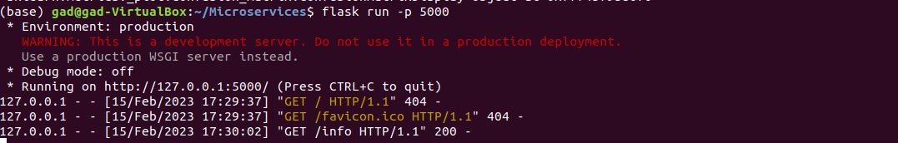

Command : flask run –p 5000

Step 9:Test the application and make predictions



Command : curl –d [{----}] 🡪data dictionary of data

Step 10: docker image

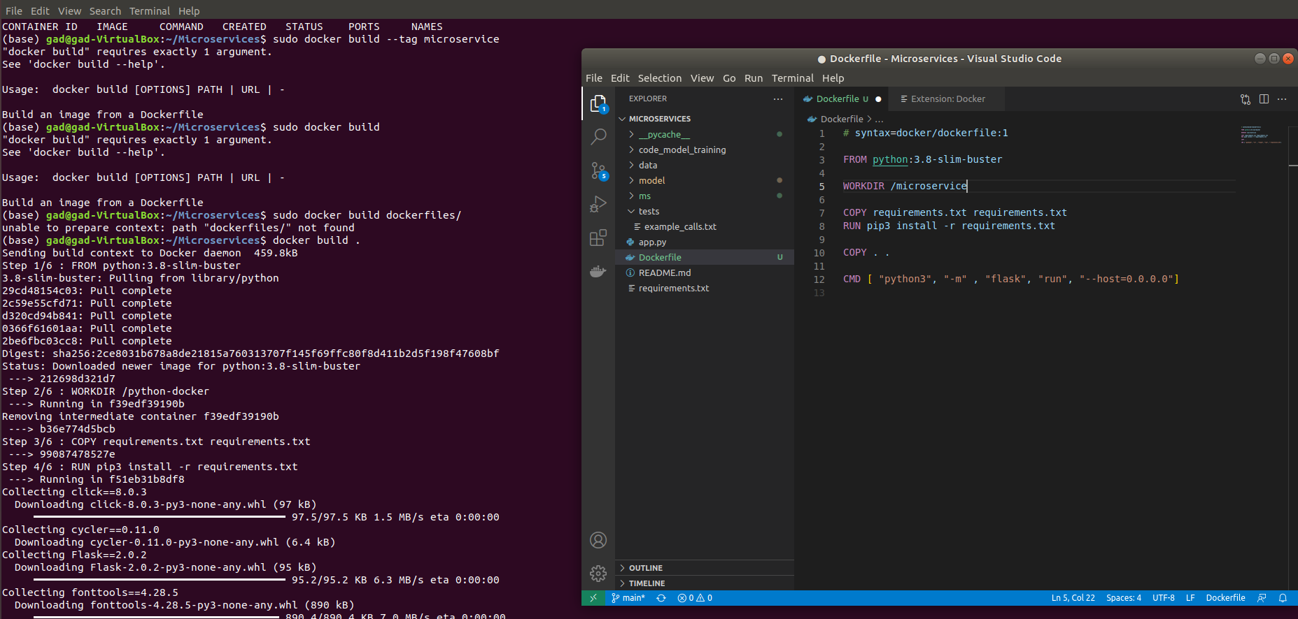

Command : docker build

Step 11: Run the containerized application as a prediction service and test it

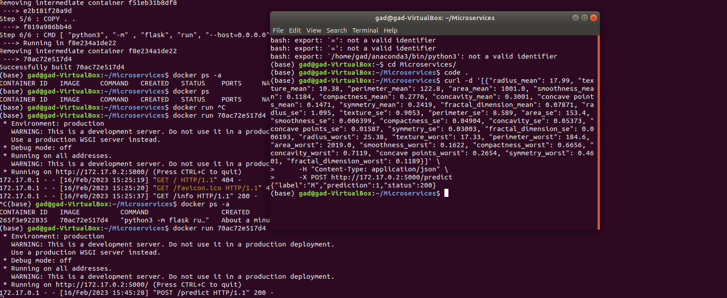

Commands : docker run [container id]

And open other terminal and test the running server by curl

Curl –d ‘[{ ---}]’