**EGGHOLDER FUNCTION**

GADADHAR .T

18519

EGG HOLDER

FUNCTION

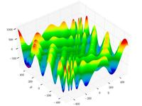

**50 GENERATIONS**

**CORRECT SOLUTION** : -959.6407

20 POPULATION

OPTIMAL VALUE : -931.522166993916

50 POPULATION

OPTIMAL VALUE : -898.8773986649531

100 POPULATION

OPTIMAL VALUE : -943.3199423706709

200 POPULATION

OPTIMAL VALUE : -953.4514353119739

**GRAPHS FOR 50 GENERATIONS AND POPULATIONS CASES**

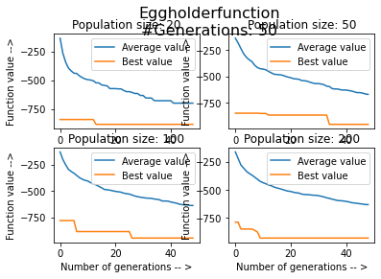

**100 GENERATIONS**

**CORRECT SOLUTION** : -959.6407

20 POPULATION

OPTIMAL VALUE : - 884.4899778591273

50 POPULATION

OPTIMAL VALUE : -934.4956318066297

100 POPULATION

OPTIMAL VALUE : -912.2462011265875

200 POPULATION

OPTIMAL VALUE : -955.4727955594356

**GRAPHS FOR 100 GENERATIONS AND POPULATIONS CASES**

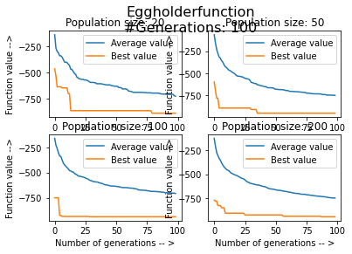

**200 GENERATIONS** (ASKED IN THE QUESTION)

**CORRECT SOLUTION** : -959.6407

20 POPULATION

OPTIMAL VALUE : -950.9122122192795

50 POPULATION

OPTIMAL VALUE : -956.6023906127247

100 POPULATION

OPTIMAL VALUE : -946.9461218169679

200 POPULATION

OPTIMAL VALUE : -952.1929448977054

**GRAPHS FOR 200 GENERATIONS AND POPULATIONS CASES**

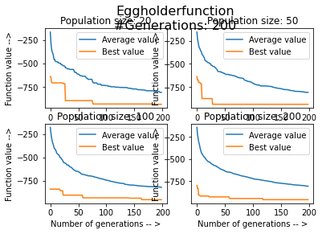

HOLDERTABE FUNCTION

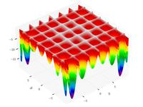

**HOLDERTABLE FUNCTION**

**50 GENERATIONS**

**CORRECT SOLUTION** : -19.2085

20 POPULATION

OPTIMAL VALUE : -19.17478344932741

50 POPULATION

OPTIMAL VALUE : -19.206437880544154

100 POPULATION

OPTIMAL VALUE : -19.204787384583447

200 POPULATION

OPTIMAL VALUE : -19.2051078786313

**GRAPHS FOR 50 GENERATIONS AND POPULATIONS CASES**

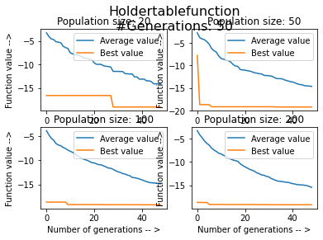

**100 GENERATIONS**

**CORRECT SOLUTION** : -19.2085

20 POPULATION

OPTIMAL VALUE : -19.20806136847195

50 POPULATION

OPTIMAL VALUE : -19.208452711927066

100 POPULATION

OPTIMAL VALUE : -19.20839624116994

200 POPULATION

OPTIMAL VALUE : -19.208499577023602

**GRAPHS FOR 100 GENERATIONS AND POPULATIONS CASES**

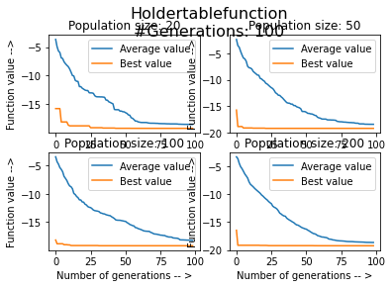

**200 GENERATIONS** (ASKED IN THE QUESTION)

**CORRECT SOLUTION** : -19.2085

OPTIMAL VALUE : -19.208502566988106

50 POPULATION

OPTIMAL VALUE : -19.208501237437485

100 POPULATION

OPTIMAL VALUE : -19.208502393517385

200 POPULATION

OPTIMAL VALUE : -19.2085023339878

**GRAPHS FOR 200 GENERATIONS AND POPULATIONS CASES**

