

Functional Safety Concept Lane Assistance

**Document Version: 1.0**

**Template Version 2.0, Released on 2017-10-17**



Document History

|  |  |  |  |
| --- | --- | --- | --- |
| Date | Version | Editor | Description |
| 2017-10-16 | 1.0 | Daniel Gattringer | Initial version |
|  |  |  |  |
|  |  |  |  |
|  |  |  |  |
|  |  |  |  |

Table of Contents

Document History 2

Table of Contents 2

1. Purpose of the Functional Safety Concept 3

2. Inputs to the Functional Safety Concept 3

2.1. Safety goals from the Hazard Analysis and Risk Assessment 3

2.2. Preliminary Architecture 3

Description of architecture elements 4

3. Functional Safety Concept 5

3.1. Functional Safety Analysis 5

3.2. Functional Safety Requirements 6

3.3. Refinement of the System Architecture 7

3.4. Allocation of Functional Safety Requirements to Architecture Elements 7

3.5. Warning and Degradation Concept 8

# Purpose of the Functional Safety Concept

The creation of a functional safety concept is part of the safety process of ISO 26262 for the treatment of potential malfunctions in electrical and electronic systems.

From the safety goals, functional safety requirements are derived on system level and assigned to the higher-level system diagrams.

# Inputs to the Functional Safety Concept

## Safety goals from the Hazard Analysis and Risk Assessment

|  |  |
| --- | --- |
| **ID** | **Safety Goal** |
| Safety_Goal_01 | The oscillating steering torque from the lane departure warning function shall be limited. |
| Safety_Goal_02 | The lane keeping assistance function shall be time limited and the additional steering torque shall end after a given time interval so that the driver cannot misuse the system for autonomous driving. |
| Safety_Goal_03 | The lane departure warning function is designed to prevent it from being activated independently if this is not the intention of the driver. |
| Safety_Goal_04 | The lane keeping assistance function shall deactivate itself and shall warn the driver if it is unable to reliably detect lane and road boundaries. |

## Preliminary Architecture

The following image shows the preliminary architecture, which will be refined within this document:

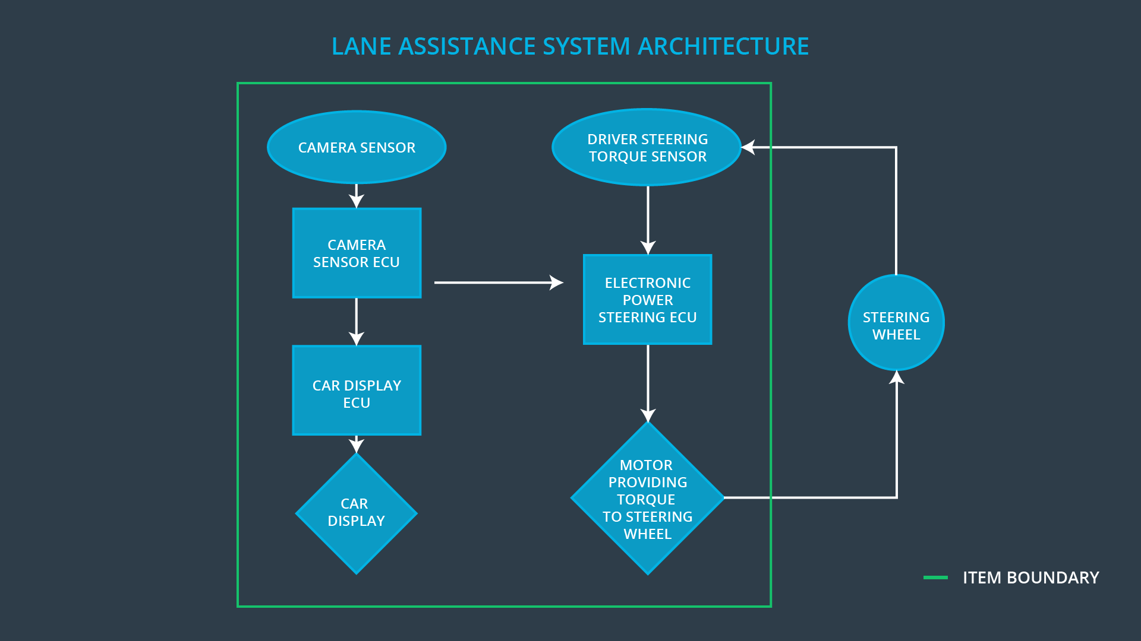

### Description of architecture elements

|  |  |
| --- | --- |
| **Element** | **Description** |
| Camera Sensor | Sensor for the optical detection of the front area of the vehicle, including detectable lane lines. |
| Camera Sensor ECU | Electronic Control Unit (ECU) responsible for detecting lane lines and determining when the vehicle leaves the lane by mistake. Responsible for triggering reactions to add extra torque for LDW and LKA functionality. |
| Car Display | Visual display which is, among other functionalities, responsible for displaying warning of lane departures and displaying LKA and LDW status. |
| Car Display ECU | Electronic Control Unit (ECU), which is responsible for creating and providing the data and information that the car display visualizes. |
| Driver Steering Torque Sensor | Sensor responsible for measuring the steering torque provided by the driver. |
| Electronic Power Steering ECU | Electronic Control Unit (ECU) responsible for evaluating the torque provided by the driver and for adding an additional torque based on the torque request of the lane assist system (LKA). Initializes the vibration of the steering wheel when the driver inadvertently drifts away from the center of the lane (LDW). |
| Motor | Mechatronic device which adds extra steering torque directly to the steering wheel. |

# Functional Safety Concept

The functional safety concept consists of:

* Functional safety analysis
* Functional safety requirements
* Functional safety architecture
* Warning and degradation concept

## Functional Safety Analysis

|  |  |  |  |
| --- | --- | --- | --- |
| **Malfunction ID** | **Main Function of the Item Related to Safety Goal Violations** | **Guidewords (NO, WRONG, EARLY, LATE, MORE, LESS)** | **Resulting Malfunction** |
| Malfunction_01 | Lane Departure Warning (LDW) function shall apply an oscillating steering torque to provide the driver a haptic feedback | MORE  DV04 - Actor effect is too much  (torque amplitude) | The lane departure warning function applies an oscillating torque with very high torque amplitude (above limit). |
| Malfunction_02 | Lane Departure Warning (LDW) function shall apply an oscillating steering torque to provide the driver a haptic feedback | MORE  DV04 - Actor effect is too much  (torque frequency) | The lane departure warning function applies an oscillating torque with very high torque frequency (above limit). |
| Malfunction_03 | Lane Keeping Assistance (LKA) function shall apply the steering torque when active in order to stay in ego lane | NO  DV03 - Function always activated | The lane keeping assistance function is not limited in time duration which leads to misuse as an autonomous driving function. |
| Malfunction_04 | Lane Departure Warning (LDW) function shall apply an oscillating steering torque to provide the driver a haptic feedback | WRONG  DV02 - Function unexpectedly activated | The lane departure warning function is activated independently. The steering wheel begins to oscillate during normal city driving even if the driver expects the system to be deactivated. |
| Malfunction_05 | Lane Keeping Assistance (LKA) function shall apply the steering torque when active in order to stay in ego lane | WRONG  DV19 - Sensor detection is wrong | The lane keeping assistance system is activated but the system can't detect the lane boundaries correctly because of snow. The systems interpret the lane boundaries wrong and tries to steer off the road. |

## Functional Safety Requirements

Lane Departure Warning (LDW) Requirements:

|  |  |  |  |  |
| --- | --- | --- | --- | --- |
| **ID** | **Functional Safety Requirement** | **ASIL** | **Fault Tolerant Time Interval** | **Safe State** |
| Functional  Safety  Requirement  01-01 | The lane keeping item shall ensure that the lane departure oscillating torque amplitude is below Max_Torque_Amplitude. | C | 50ms | Set the oscillating torque to zero. |
| Functional  Safety  Requirement  01-02 | The lane keeping item shall ensure that the lane departure oscillating torque frequency is below Max_Torque_Frequency. | C | 50ms | Set the oscillating torque to zero. |
| Functional  Safety  Requirement  03-01 | The lane keeping item shall ensure that the lane departure warning by means of vibration of the steering wheel is only possible when LDW_On is set. | A | 50ms | Set the oscillating torque to zero. |

Lane Departure Warning (LDW) Verification and Validation Acceptance Criteria:

|  |  |  |
| --- | --- | --- |
| **ID** | **Validation Acceptance**  **Criteria and Method** | **Verification Acceptance**  **Criteria and Method** |
| Functional  Safety  Requirement  01-01 | Validate that Max_Torque_Amplitude is chosen high enough that the driver notices it but low enough not to cause loss of steering. | Verify that the system really sets oscillating torque to zero if the lane departure warning ever causes a vibration above Max_Torque_Amplitude. |
| Functional  Safety  Requirement  01-02 | Validate that Max_Torque_Frequency is chosen high enough that the driver notices it but low enough not to cause loss of steering. | Verify that the system really sets oscillating torque to zero if the lane departure warning ever causes a vibration above Max_Torque_Frequency. |
| Functional  Safety  Requirement  03-01 | Validate that the lane departure warning functionality is never available when it is not activated by the driver. | Verify that the system really sets oscillating torque to zero LDW_On is not set. |

Lane Keeping Assistance (LKA) Requirements:

|  |  |  |  |  |
| --- | --- | --- | --- | --- |
| **ID** | **Functional Safety Requirement** | **ASIL** | **Fault Tolerant Time Interval** | **Safe State** |
| Functional  Safety  Requirement  02-01 | The electronic power steering ECU shall ensure that the lane keeping assistance torque is applied for only Max_Duration. | B | 500ms | Set the lane keeping add extra torque to zero. |
| Functional  Safety  Requirement  04-01 | The electronic power steering ECU shall ensure that the lane keeping assistance torque is set to zero when the camera sensor ECU can’t reliably detect the lane boundaries. | A | 50ms | Set the lane keeping add extra torque to zero. |
| Functional  Safety  Requirement  04-02 | The electronic power steering ECU shall ensure that the lane keeping assistance functionality is deactivated and signalized on the car display when the camera sensor ECU can’t reliably detect the lane boundaries. | A | 50ms | Set the lane keeping add extra torque to zero. |

Lane Keeping Assistance (LKA) Verification and Validation Acceptance Criteria:

|  |  |  |
| --- | --- | --- |
| **ID** | **Validation Acceptance**  **Criteria and Method** | **Verification Acceptance**  **Criteria and Method** |
| Functional  Safety  Requirement  02-01 | Validate that the chosen amount for Max_Duration really dissuades drivers from taking their hands off the wheel. | Verify that the system really sets the lane keeping add extra torque to zero if the lane keeping assistance ever exceeds Max_Duration. |
| Functional  Safety  Requirement  04-01 | Validate that the lane keeping assistance is not applying extra torque when the lane boundaries are not detected reliably. | Verify that the system really sets the lane keeping add extra torque to zero if the lane boundaries are not detected reliably. |
| Functional  Safety  Requirement  04-02 | Validate that the lane keeping assistance is warning via car display when the lane boundaries are not detected reliably while the system is active. | Verify that the system really warns the driver via the car display if the lane boundaries are not detected reliably. |

## Refinement of the System Architecture

The following image shows the refined system architecture:

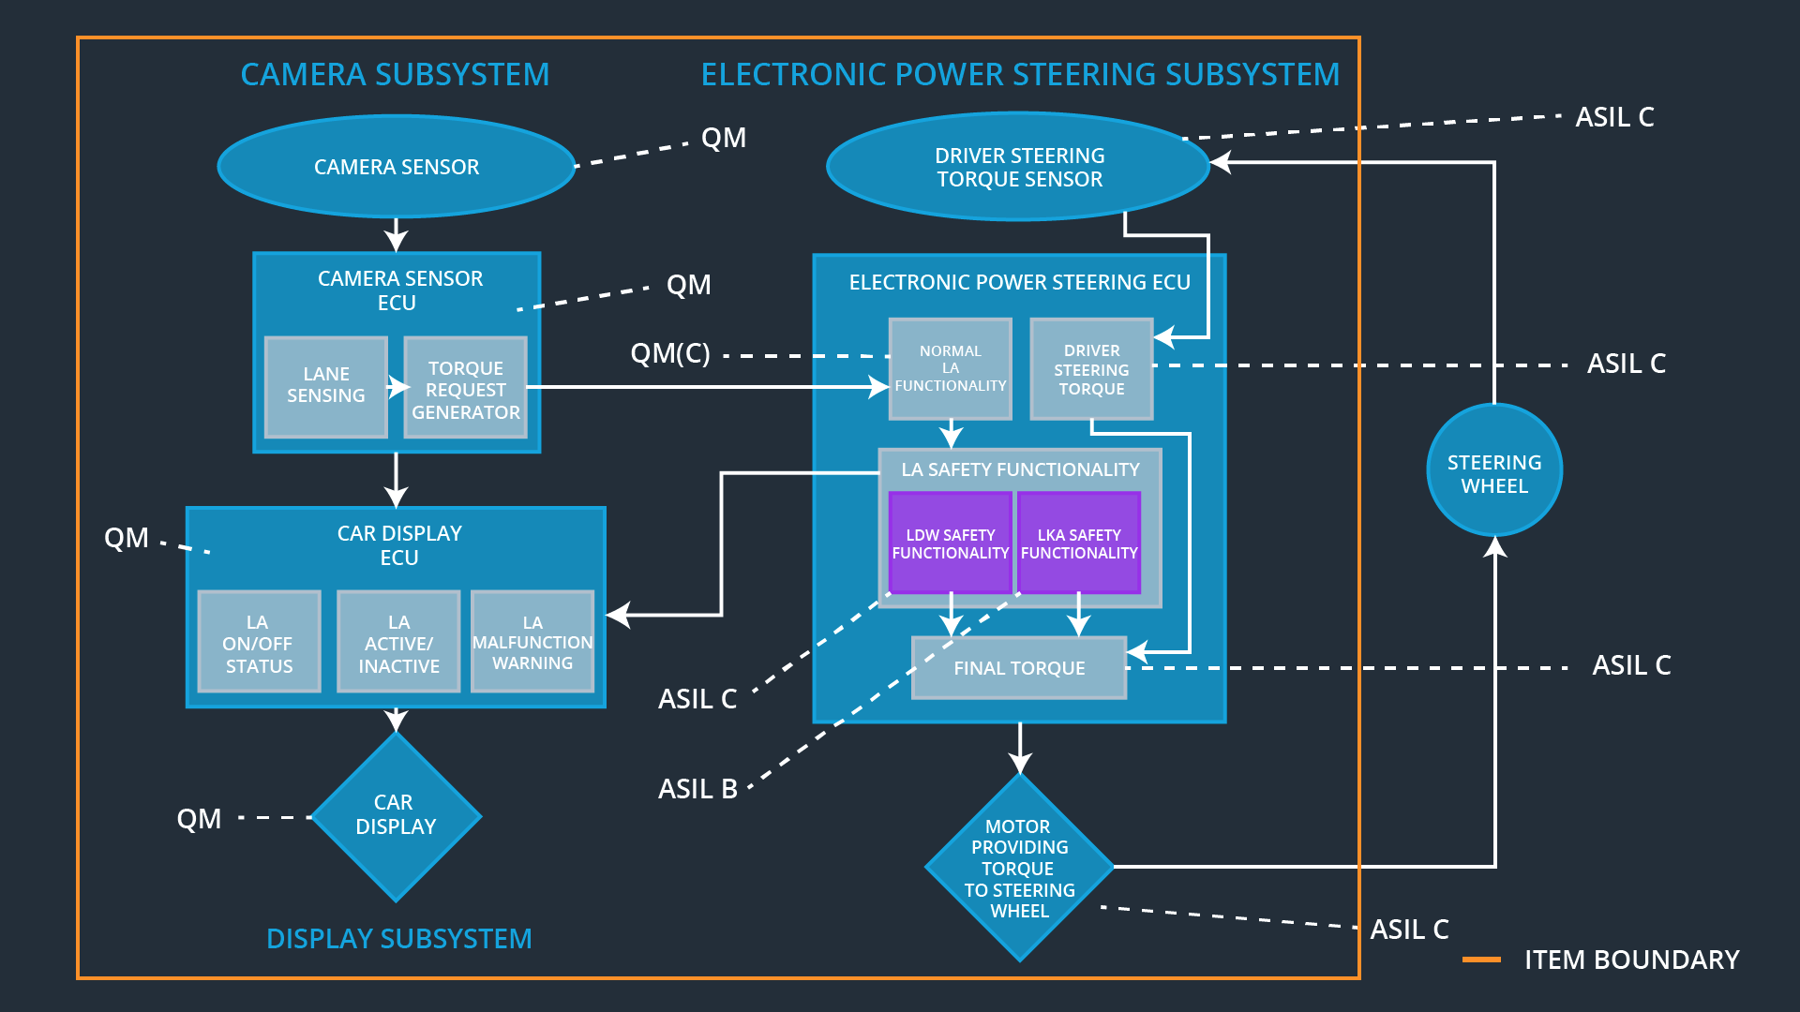

### Description of architecture elements TODO

|  |  |
| --- | --- |
| **Element** | **Description** |
| Camera Sensor | Sensor for the optical detection of the front area of the vehicle, including detectable lane lines. |
| Camera Sensor ECU | Electronic Control Unit responsible for detecting lane lines and determining when the vehicle leaves the lane by mistake. Responsible for triggering reactions to add extra torque for LDW and LKA functionality. |
| Camera Sensor ECU Lane Sensing | Component within the camera sensor ECU responsible for detecting lane lines and determining when the vehicle leaves the lane by mistake. |
| Camera Sensor ECU Torque Request Generator | Component within the camera sensor ECU responsible for calculating and sending an request for additional steering torque for the LDW and LKA functionality. |
| Car Display | Visual display which is, among other functionalities, responsible for displaying warning of lane departures and LKA and LDW activation-status. |
| Car Display ECU | Electronic control unit, which is responsible for creating and providing the data and information that the car display visualizes. |
| Car Display ECU  LA on/off status | Component within the car display ECU responsible for visualizing if the lane assistance functionality is switched on or off. |
| Car Display ECU  LA active/inactive | Component within the car display ECU responsible for visualizing if the lane assistance functionality is active at the moment. Active means the car is drifting away from the center of the lane and LKA is actively acting or the car is getting too narrow to a lane boundary and LDW is warning. |
| Car Display ECU  LA malfunction warning | Component within the car display ECU responsible for visualizing if there occurs any malfunction within the lane assistance system. |
| Driver Steering Torque Sensor | Sensor responsible for measuring the steering torque provided by the driver. |
| Electronic Power Steering (EPS) ECU | The electronic control unit is responsible for evaluating the torque provided by the driver and for adding an additional torque based on the torque request of the lane assist system (LKA). Initializes the vibration of the steering wheel when the driver inadvertently drifts away from the center of the lane (LDW). |
| EPS ECU – Normal Lane Assistance Functionality |  |
| EPS ECU – Driver Steering Torque |  |
| EPS ECU – LDW Safety Functionality |  |
| EPS ECU – LKA Safety Functionality |  |
| EPS ECU – Final Torque |  |
| Motor |  |

## Allocation of Functional Safety Requirements to Architecture Elements

|  |  |  |  |  |
| --- | --- | --- | --- | --- |
| **ID** | **Functional Safety Requirement** | **Electronic Power Steering ECU** | **Camera ECU** | **Car Display ECU** |
| Functional  Safety  Requirement  01-01 | The lane keeping item shall ensure that the lane departure oscillating torque amplitude is below Max_Torque_Amplitude. | **X** |  |  |
| Functional  Safety  Requirement  01-02 | The lane keeping item shall ensure that the lane departure oscillating torque frequency is below Max_Torque_Frequency. | **X** |  |  |
| Functional  Safety  Requirement  02-01 | The electronic power steering ECU shall ensure that the lane keeping assistance torque is applied for only Max_Duration. | **X** |  |  |
| Functional  Safety  Requirement  03-01 | The lane keeping item shall ensure that the lane departure warning by means of vibration of the steering wheel is only possible when LDW_On is set. | **X** |  |  |
| Functional  Safety  Requirement  04-01 | The electronic power steering ECU shall ensure that the lane keeping assistance torque is set to zero when the camera sensor ECU can’t reliably detect the lane boundaries. | **X** |  |  |
| Functional  Safety  Requirement  04-02 | The electronic power steering ECU shall ensure that the lane keeping assistance functionality is deactivated and signalized on the car display when the camera sensor ECU can’t reliably detect the lane boundaries. | **X** |  |  |

## Warning and Degradation Concept

|  |  |  |  |  |
| --- | --- | --- | --- | --- |
| **ID** | **Degradation Mode** | **Trigger for Degradation Mode** | **Safe State invoked?** | **Driver Warning** |
| WDC-01 | Turn off LDW functionality | Malfunction_01,  Malfunction_02,  Malfunction_04 | Yes, LDW oscillating torque shall be set to zero | Lane assistance functionality set inactive and malfunction warning to the driver via car display. |
| WDC-02 | Turn off LKA functionality | Malfunction_03,  Malfunction_05 | Yes, LKA added extra torque shall be set to zero | Lane assistance functionality set inactive and malfunction warning to the driver via car display. |

# 