VitaSi: A real-time contactless vital signs estimation system

In existing system heart and breath rate was calculating based on ECG and other signals but non-a-days due to increasing popularity of deep learning algorithms author has introduced contactless vital signs estimation based on person facial motion. In propose paper author is applying Phase Based Motion Processing to detect motion from faces and then this motions will be extracted as PPG (Photoplethysmography) signals. This signals will get trained with CNN algorithm and then this trained model can be applied on any human face motion signals to predict heart and breath rate.

In propose paper WEBCAM will read 10 frames which contains human face and then detect face and then extract ROI (region of interest) of face and then extract temporal (current time data) and spatial (current frame data) features and then input this features to Phase-based Video Motion Processing (PVMP) algorithm which will extract PPG signals and then this signals will be input to CNN model to predict heart and breath rate.

In this project we have used COHFACE dataset which contains 11 person videos and from this videos we extracted faces, heart and breathe rate and input to CNN algorithm to train model.

All this features will be calculated from WEBCAM and to implement this project we have designed following modules

1. Generate & Load VitaSi CNN Model: using this module we will load CNN model which will predict heart and breath rate
2. Contactless Vital Estimation: this module will open WEBCAM and then read 10 frames and then estimate heart and breathe rate by extracting PPG signal and employing CNN model
3. MSE Graph: using this module we will display MSE (mean square error) of CNN model for heart and breathe rate prediction. The lower the MSE the better is the prediction model

To run project double click on ‘run.bat’ file to get below screen



In above screen click on ‘Generate & Load VitaSi CNN Model’ button to generate and load CNN model and get below screen

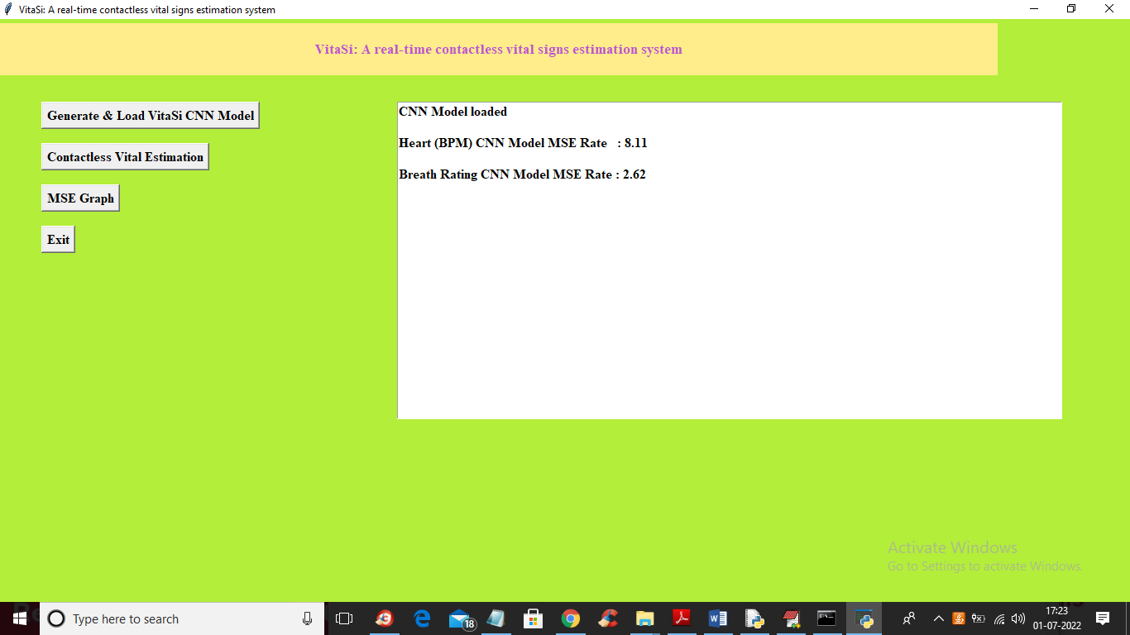

In above screen CNN model is loaded and we got Heart Rate MSE as 8.11 and Breathe Rate MSE as 2.62 and now click on ‘Contactless Vital Estimation’ button to start WEBCAM and predict Heart Rate and Breathe Rate

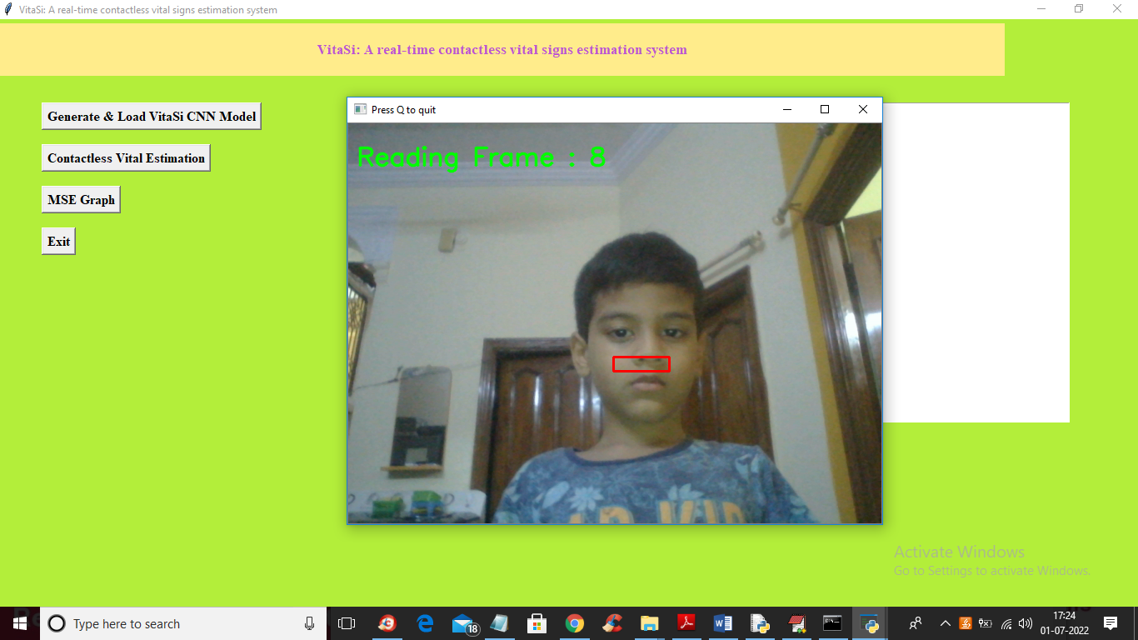

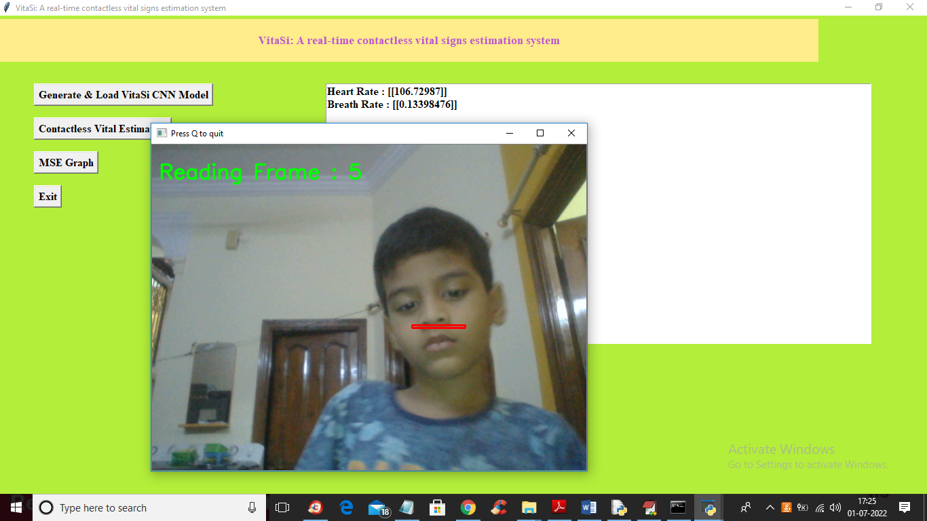

In above screen WEBCAM read 10 frames and then predict heart and breathe rate and this rate will be displayed and updated on TEXT AREA and in above screen we got heart rate as 106 and breathe rate as 0.13 and now click on ‘MSE Graph’ button to get below graph

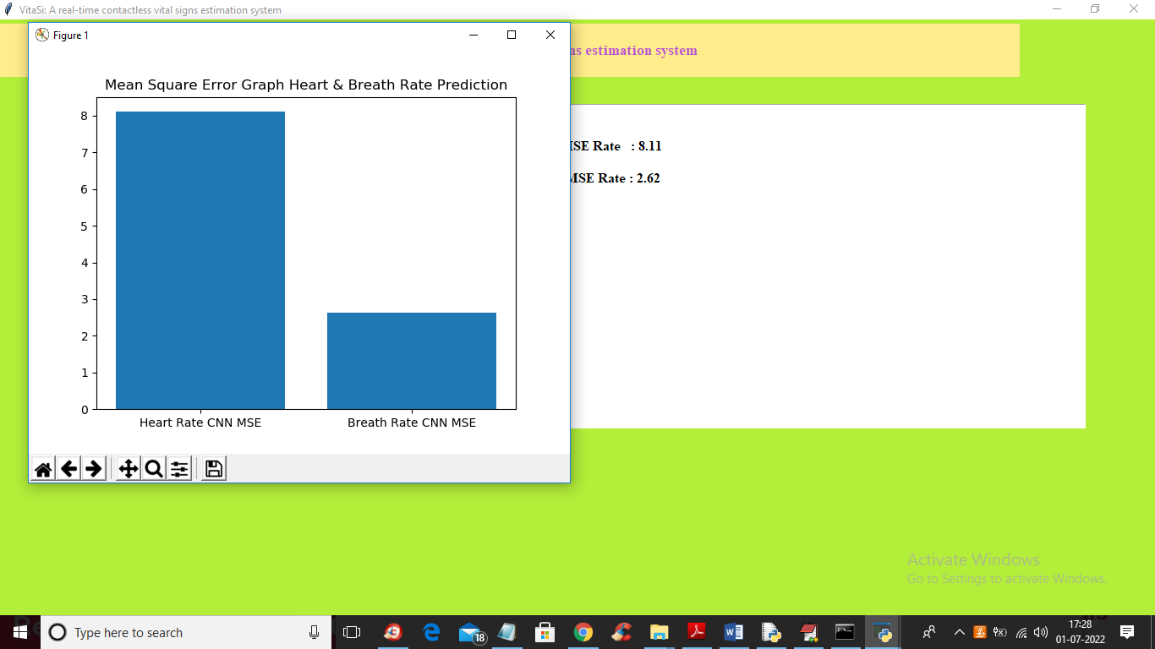

In above graph x-axis contains type of prediction and y-axis contains MSE error value of CNN prediction.

Note: if no face shown to WEBCAM then it will throw exception and stop executing