Before the rise of um

Tim Gadanidis and Derek Denis

# Introduction

One of the most dramatic discourse-pragmatic changes in twentieth-century English has progressed under the radar of laypeople and (until recently) linguists: the rise of *um* as the predominant variant of the ‘filled pause’ variable (UHM) at the expense of *uh* (Fruehwald, 2016; Tottie, 2011; Wieling et al., 2016). The variation is exemplified in (1):

1. **Uh** as a rule they harrowed it before they **um** drilled it. (NIA-22)

Fruehwald (2016, p. 43) documents this “textbook” change over 100+ years of apparent time: *um* increases incrementally between generations and the rise is led by women. Why *um*? Why did this change occur? In this chapter, we investigate (UHM) at an early stage of change to determine what triggered the rise of *um*. We take up the hypothesis that the rise of *um* was connected to the development of a new discourse function for the variable (UHM), that *um* came to be favoured with. We remain agnostic about what the function is, but follow Tottie (2016) and Fruehwald (2016) who suggest a correlation between utterance position and function; and specifically Fruehwald (2016: 46), who suggests that “turn-initial *um* may be the best candidate for a new discourse function coming into use.” We follow essentially a variationist approach, first treating *um* and *uh* as variants of a linguistic variable and using proportional analysis to assess the role of social and linguistic factors. We augment these results with a different quantitative perspective and examine the relative frequency of the variable itself in discourse to help in our interpretation. What we find is a need to look beyond the envelope of variation, as defined, to understand the results that we see.

# (UHM) as a pragmatic marker

The exact nature of (UHM) as a linguistic feature is not a trivial question. A great deal of ink has been spilled over whether they are produced consciously or unconsciously, and what their purpose is. For example, Maclay & Osgood (1959, pp. 41–42) characterize (UHM) as a floor-management device which speakers insert to indicate that they do not want to be interrupted when hesitating over what to say. Levelt (1983, 1989) describes (UHM) as an involuntary noise produced as a result of production problems: “[*uh*] apparently signals that at the moment when trouble is detected, the source of the trouble is still actual or quite recent. But otherwise, [*uh*] doesn’t seem to mean anything. It is a symptom, not a sign” (Levelt, 1989, p. 484).

One problem with the involuntary “symptom” view is that, as Clark & Fox Tree (2002) point out, speakers have some control over whether or not they produce (UHM)—for example, it can be suppressed in a public speaking context (and indeed speakers are often counselled to do so). They argue that (UHM) is an “interjection” used to signify a delay, with *um* signalling longer delays than *uh*.

Recently, Tottie (2016) has put forward the argument that (UHM) is a pragmatic marker that, in speech, indicates planning. This is on the basis that (UHM) is used more frequently in contexts requiring more speaker planning, such as narratives and responses to questions. Tottie (2017) describes (UHM) as being on a “cline of lexicalization”, where forms like *and-uh* and *but-uh* are not perceived as words, but *uh* and *um* alone are. Tottie (2017: 21–22) describes the former case, where the final consonant of a monosyllabic word such as *and* or *but* is immediately followed by (UHM), as cliticized forms. She goes on to argue that the use of (UHM) between words and silent pauses, rather than in these cliticized forms, causes (UHM) to be perceived as a word in the lexicon, making it available for conscious use in writing. Along the same lines, Gadanidis (2018) argues that (UHM) is consciously, agentively used in instant messaging, an interactive, text-based medium. On this hypothesis, (UHM) has transitioned from a purely interactional feature (indicating that a pause is incoming due to planning) to an interpersonal feature that indicate the speaker’s stance or point of view. For example, in (2), from Tottie (2017: (2)), the writer plays on the word-search-indicating function of *uh* to draw attention to their pun:

1. An ode to opera’s, **uh, operation**. As … Baroque-era composers become increasingly popular, more people wonder about the castrati — the emasculated singers … (*L.A. Times* 2005)

If this process was a factor in (UHM)’s diachronic development, we might expect to see an effect of cliticization at this early stage, with the variant that is more advanced in this functional change being used more outside of cliticized forms like *and-uh*.

As we note above, the rise of *um* has now been described extensively in the variationist and corpus-linguistic literature, across a number of corpora and speech communities. The typical finding is that women have a higher *um*–*uh* ratio than men, and that younger speakers have a higher *um*–*uh* ratio than older ones. This pattern has been demonstrated in various speech communities and contexts in the United States (Acton, 2011; Fruehwald, 2016; Laserna et al., 2014; Wieling et al., 2016), as well as in England and Scotland (Tottie, 2011; Wieling et al., 2016), both in real and apparent time. Wieling et al. (2016) also show that this pattern extends beyond English to five other Germanic languages: Dutch, German, Norwegian, Danish, and Faroese.

While these accounts demonstrate definitively that a change is underway, an explanation remains elusive. What was the trigger for this “textbook” change? Fruehwald (2016) and Wieling et al. (2016) both suggest that a new meaning or function for *um* may have emerged in English[1]. Although Fruehwald (2016) found that *um* and *uh* appeared to be trading frequencies, casting doubt on a functional expansion explanation, it is possible that the emergence of a new function at some earlier point may have played a role nearer to the beginning of the change. Accordingly, in this chapter, we investigate data from before the rise of *um* with the goal of evaluating the functional expansion hypothesis.

# Data and coding

The data for this study are from the *Farm Work and Farm Life Since 1890* oral history collection (Denis, 2016). The corpus consists of oral history interviews with 155 elderly farmers, recorded in 1984. The corpus covers five regions of Ontario, Canada: Temiskaming, Essex, Dufferin, Niagara Region, and Eastern Ontario; for this study, speakers from the latter two regions were considered. Speaker birth years range from 1891 to 1919, just before *um* began to take off per Fruehwald (2016).

The interviews in each region were conducted by university students local to the region: F-INT conducted the interviews in Niagara, and M-INT conducted the interviews in Eastern Ontario.

For the purposes of this study, we follow Fruehwald (2016), Wieling et al. (2016), and Tottie (2016), among others, in treating *uh* [ə] and *um* [əm] (also written as *er* and *erm*) as variants of one sociolinguistic variable, termed (UHM). It should be noted that this is not the only way that the variable context could be defined. For instance, Tottie (2018) includes (UHM) as one element of a set including *well*, *you know*, and *like*, on the basis that all of the elements are used to indicate speech planning. In principle, *unfilled* pauses, i.e., silence, could also be included in the variable context, and we will return to this below. However, we argue that treating *um* and *uh* as an individual variable captures the two words’ intuitive and structural similarity[2], both variants being phonologically and orthographically identical, modulo the coda. Both variants are also single-word constructions which, unlike *well*, *you know*, and *like*, do not appear to be derived from bleached lexical items, but from apparently non-lexical speech sounds. As Fruehwald (2016) notes, they have also traditionally been treated as a unique phenomenon in the psycholinguistic literature.

We extracted each instance of *uh* and *um* from the transcripts, excluding unrelated instances such as *uh-oh*. Tokens from the two much-younger interviewers were also extracted, and analyzed separately. The transcription protocol emphasized faithful reproduction of *uh* and *um*. All interviews were carefully second-passed by the second author, knowing that (UHM) was of potential analytical interest.

The data were coded for the following social factors: year of birth, gender, and region (Niagara or Eastern Ontario). Year of birth and gender were used to operationalize the change-in-progress hypothesis. Table 1 presents a table of speakers by gender, region, and year of birth.

Table 1: List of speakers.

|  |  |  |  |
| --- | --- | --- | --- |
| ID | Gender | Region | Year of birth |
| F-INT | F | Niagara | mid-late 1960s |
| M-INT | M | Eastern Ontario | mid-late 1960s |
| NIA-1 | M | Niagara | 1906 |
| NIA-9 | F | Niagara | 1912 |
| NIA-11 | M | Niagara | 1917 |
| NIA-12 | F | Niagara | 1916 |
| NIA-20 | F | Niagara | 1911 |
| NIA-22 | F | Niagara | 1899 |
| NIA-23 | M | Niagara | 1898 |
| NIA-24 | M | Niagara | 1902 |
| NIA-27 | M | Niagara | 1911 |
| NIA-28 | M | Niagara | 1907 |
| NIA-32 | F | Niagara | 1904 |
| NIA-35 | F | Niagara | 1902 |
| NIA-36 | F | Niagara | 1903 |
| EON-001 | M | Eastern Ontario | 1891 |
| EON-004 | F | Eastern Ontario | 1907 |
| EON-006 | M | Eastern Ontario | 1905 |
| EON-012 | M | Eastern Ontario | 1910 |
| EON-013 | F | Eastern Ontario | 1914 |
| EON-014 | F | Eastern Ontario | 1899 |
| EON-016 | M | Eastern Ontario | 1912 |
| EON-019 | M | Eastern Ontario | 1904 |
| EON-020 | F | Eastern Ontario | 1906 |
| EON-022 | F | Eastern Ontario | 1915 |
| EON-024 | M | Eastern Ontario | 1898 |
| EON-028 | F | Eastern Ontario | 1919 |

We also coded for two linguistic factors. To operationalize the functional expansion hypothesis, we coded for initial or non-initial utterance position. (UHM) was defined as “initial” if it was the first element in an utterance, as in (3), and “non-initial” if it was not the first element in an utterance, as in (4). The exception was in the case of *and-* or *but-* cliticization, where (UHM) was classed as “initial” if the containing utterance began with *and-uh* or *but-uh*.

1. **Um** spring time was a very busy time for everyone on the farm. (EON-28, F/1919)
2. The birthdays we’d **uh**- we’d try to- we’d **uh** remember them. (EON-001, F/1907)

To test for a potential effect of cliticization (per Tottie (2017)’s suggestion that this may have played a role in (UHM)’s lexicalization), we coded each token as “clitic” if it occurred immediately following *and* or *but*, as in (5), and as “non-clitic” otherwise, as in (6).

1. If it was in school time I couldn’t go unless it was Saturday **but-uh**, auction sales were usually on Saturday. (NIA-09, F/1912)
2. **Um** do you know how old you were when you started? (F-INT)

# Results

## Proportional frequency

Table 2 shows how our data compare with previous communities analyzed. The first block summarizes our data from Niagara and Eastern Ontario, as well as F-INT and M-INT, the two younger interviewers. The second block summarizes results from previous work on the Switchboard corpus (Godfrey et al., 1992), the Fisher corpus (Cieri et al., 2004), the Philadelphia Neighborhood Corpus (PNC) (Labov & Rosenfelder, 2011), and the British National Corpus (BNC) ((*The british national corpus*, 2007)). The numbers for all of these other corpora are drawn from Wieling et al. (2016). From left to right, the columns provide the raw number of *uh* tokens, the raw number of *um* tokens, the percentage of (UHM) tokens that were *um*, the mean frequency of *uh* per 1000 words (averaged across speakers), the mean frequency of *um* per 1000 words, and the mean frequency of (UHM) altogether per 1000 words.

Table 2: Cross-community comparison

|  |  |  |  |  |  |  |
| --- | --- | --- | --- | --- | --- | --- |
| Community | Raw N *uh* | Raw N *um* | % *um* | Mean *uh* /1000 | Mean *um*/1000 | Mean UHM/1000 |
| Niagara | 1864 | 357 | 16.1 | 21.3 | 4.1 | 25.4 |
| E. Ont. | 1563 | 168 | 9.7 | 22.6 | 2.4 | 25.0 |
| F-INT | 321 | 318 | 49.8 | 12.4 | 12.3 | 24.7 |
| M-INT | 255 | 51 | 16.7 | 13.2 | 2.6 | 15.8 |
| Switchboard | — | — | 28.3 | 22.1 | 7.5 | 29.6 |
| Fisher | — | — | 64.1 | 6.8 | 9.9 | 16.7 |
| PNC | — | — | 27.6 | 13.2 | 4.5 | 17.7 |
| BNC | — | — | 46.1 | 4.5 | 4.3 | 8.8 |

As can be seen in the table, *um* is less frequent in our farmer data compared to the more recent corpora. The female interviewer uses it around half the time, while the male interviewer’s rate is comparable to the farmers’. The median of number of (UHM) tokens per speaker is 140, with an interquartile range of 105.5. Relative frequency of (UHM) taken as a whole is on par with other corpora, but we are cautious about making such a comparison because each corpus was collected and transcribed differently (for related discussion, see Pichler, 2010).

Looking at individual speakers’ rates, we can see that all speakers use both *uh* and *um*, but there is little patterning by age or gender. Figures 1, 2 illustrate this by presenting each speaker’s *um* rate, with the bars coloured by region and gender, respectively. Figure 1 confirms a slight skew toward increased *um* rate in Niagara, but this is not driven by any one speaker. Figure 2 confirms a slight skew toward increased *um* rate among female speakers, which again is not driven by any one speaker. The numbers at the top of each bar indicate the number of (UHM) tokens for that speaker.

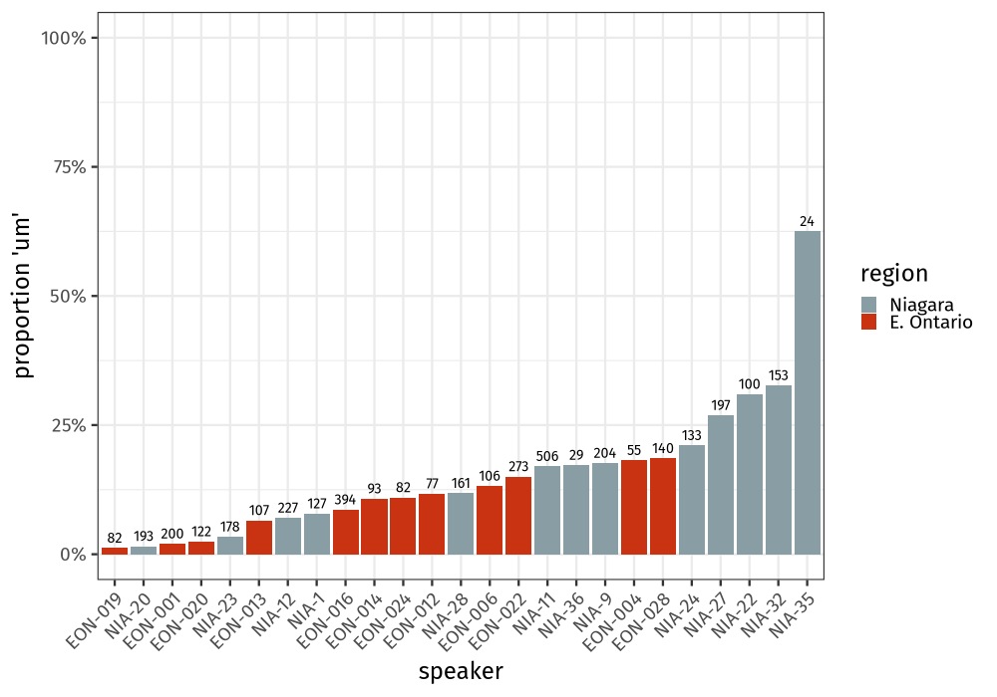

Figure 1: Proportion *um* per speaker by age.

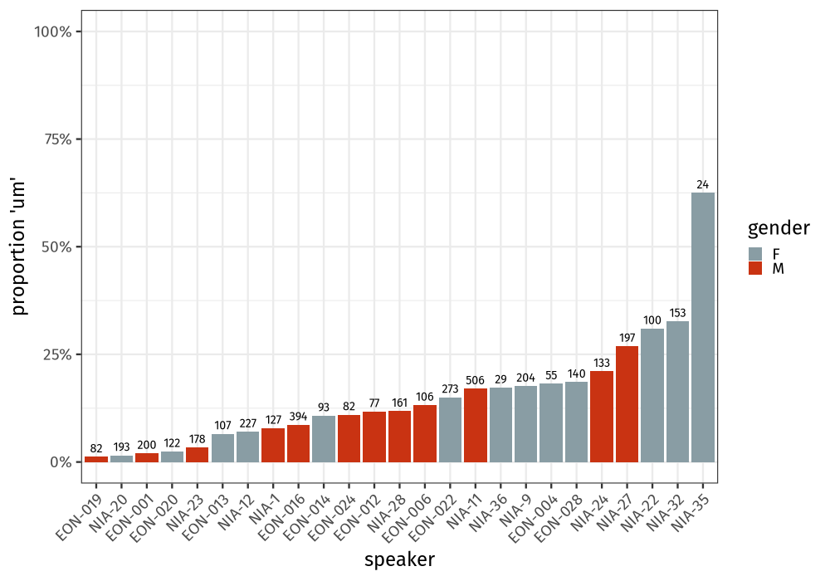

Figure 2: Proportion *um* per speaker by gender.

Figure 3 shows the proportion of *um* in apparent time, with year of birth on the x-axis and *um* rate on the y-axis. Each point represents one farmer (interviewers were excluded, other than where explicitly mentioned). In the plot to the left, year of birth is binned into five-year increments, which makes the patterns easier to see; in the plot to the right, year of birth is continuous, and the line is drawn using R’s LOESS (locally-estimated scatterplot smoothing) function. Because LOESS is a local regression technique, the fit at a given point is based on the data close to that point. The size of each point indicates the number of tokens in that point (but note that the number of tokens in each point was not taken into account by the LOESS fit). In both cases, there is a modest trend upward over time. To determine the possible predictors underlying this trend, in the following figures we split the data by gender, position and cliticization. Figure 4 shows the pattern when splitting speakers by gender. Starting around 1905, women use *um* slightly less often than men do, with both genders’ *um* rates trending slightly upward over time. Figure 5 shows the pattern when splitting tokens by position (initial vs. non-initial). Starting around 1905, *um* is used more frequently in initial position than in non-initial position. Figure 6 shows the pattern when splitting tokens by cliticization with *and* or *but* and position. *Um*’s proportional increase appears to be limited to non-cliticized initial tokens.

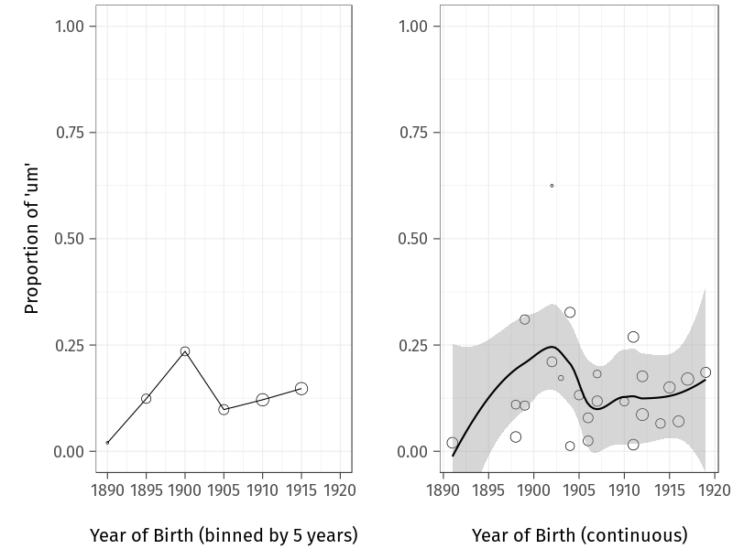

Figure 3: Proportion *um* in apparent time.

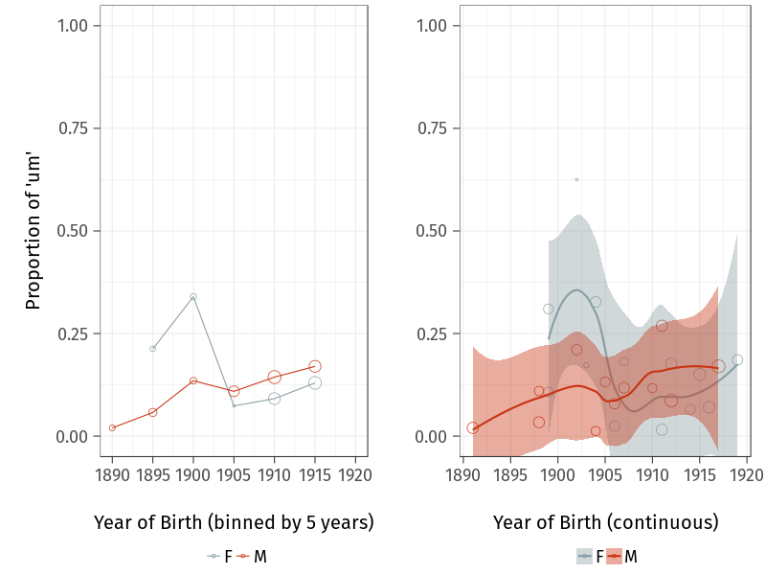

Figure 4: Proportion *um* in apparent time, by gender.

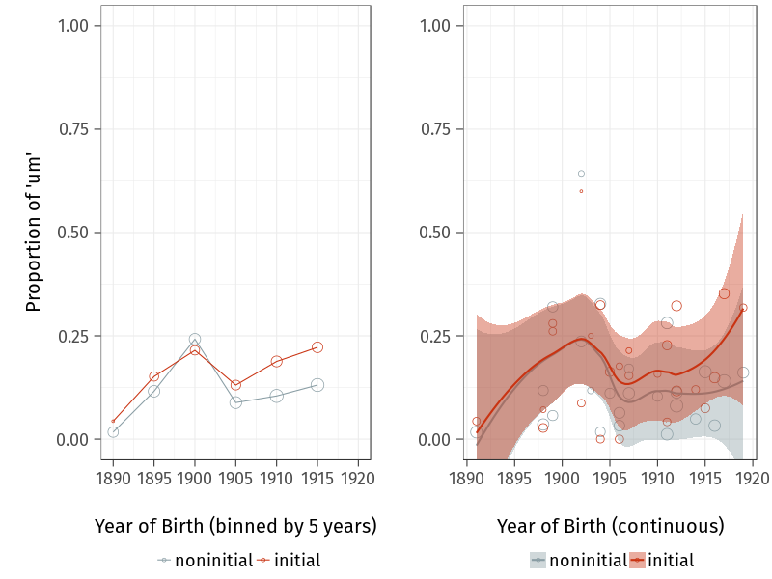

Figure 5: Proportion *um* in apparent time, by position.

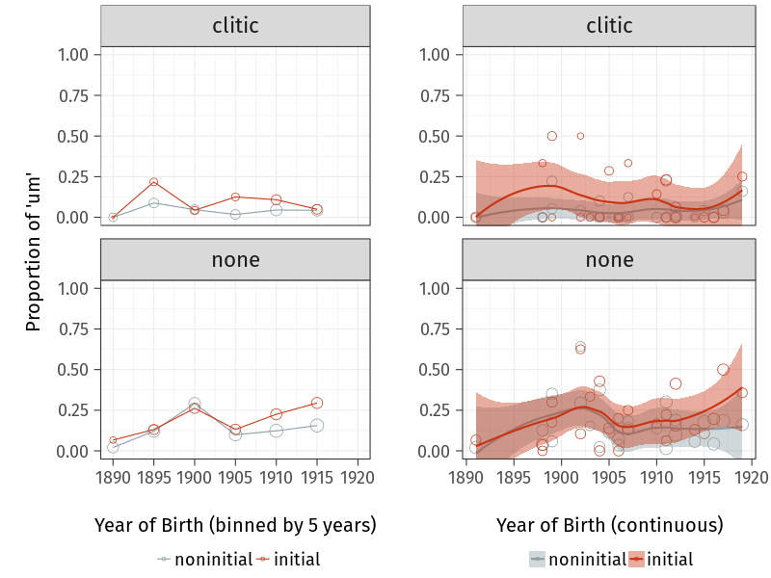

Figure 6: Proportion *um* in apparent time, by position and cliticization.

Figure 7 shows a conditional inference tree for all farmers. Conditional inference trees are statistical models built by repeatedly splitting the data based on a set of covariates, using a significance test procedure to select the variables to split by (Tagliamonte & Baayen, 2012). The model in Figure 7 contained the predictors position (“pos”), cliticization (“clitic”), gender (which was not selected for any splits), and year of birth. The model confirms several of the patterns indicated in Figures 3, 6. The tree splits first at cliticization, with cliticized (UHM) having a low overall *um* rate. Within the cliticized tokens, there is a slight difference between noninitial and initial (UHM), with initial tokens having a higher *um* rate (9.39%) than noninitial ones (4.35%). Within the noncliticized tokens, there is an effect of year of birth: speakers born after 1898 have a much higher *um* rate in noncliticized tokens than that of speakers born in 1898 or earlier (4.65%). This is especially true in initial position: noninitial cliticized tokens have a lower *um* rate (16.10%) than initial ones (21.90%).

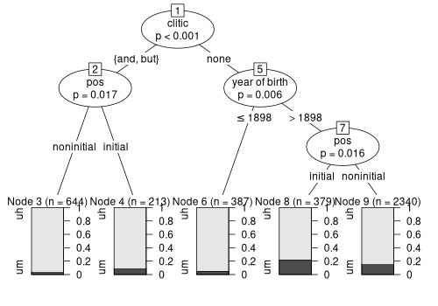

Figure 7: Conditional inference tree for farmers.

Figure 8 shows a conditional inference tree for the two interviewers. The model contained position and cliticization (the interviewers’ years of birth are not known, and there are only two speakers in any case). As shown in the tree, the internal constraints are much the same, but the baseline *um* rate is much higher (due in large part to the female interviewer). *Um* is the least common in the cliticized forms (13.90%). In non-cliticized forms, there is a split by position, where initial tokens favour *um* (53.20%) compared to non-initial tokens (40.90%).

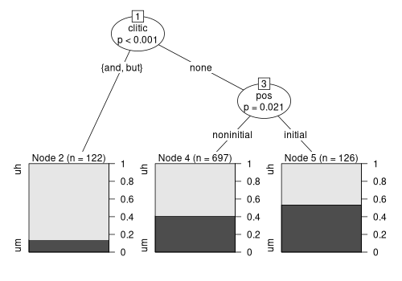

Figure 8: Conditional inference tree for interviewers.

Taken together, the results presented in this section appear to show the beginning of the change toward *um* that has been observed by other researchers. While other work has shown that women lead this change, we do not find this pattern in our data. In fact, older woman actually use (slightly) more *um* than do younger women. What we are likely seeing here is a stage of change before gender specialization/split (Labov, 2001: 308), similar to quotative *be like* in earlier generations (Tagliamonte & D’Arcy, 2007: 208–209).

Looking at internal factors, we can see that cliticized forms, like *and-uh*, favour *uh*. There is some evidence for positional divergence, possibly consistent with a new utterance-initial discourse function that favours *um* (cf. Fruehwald, 2016, who found no turn-positional difference). Conditional inference trees confirm that the internal constraints persist with the younger speakers, while their baseline *um* rate is higher. These patterns suggest that in these early data, *um* may indeed be specializing to initial position, potentially due to the emergence of a new utterance-initial discourse/pragmatic function. In the following section, we test this hypothesis using relative frequency data.

## Relative frequency

Fruehwald (2016) tests the hypothesis that functional expansion triggered the rise of um by considering changes to the relative frequency of variants over time (e.g., frequency of *um* or *uh* per 1000 words). When a new discourse-pragmatic function emerges, we expect that these functions would add to the relative frequency of the feature; it is being used overall more frequently because it appears additionally in a new context. If the new function is restricted to one variant, the relative frequency of that variant should rise, with little change to the relative frequency of the other variant. In other words, we expect a fishtail pattern as with the lexical frequency of *computer* and *typewriter* over time: once *computer* gained its contemporary meaning, its relative frequency took off as that meaning became more frequent. This is illustrated in Figure 9, (Figure 3 from Fruehwald, 2016): looking at the proportion of *computer* over *typewriter* (left graph), *computer* appears to replace *typewriter* over time; but looking at the relative frequency of each word (right graph), it’s clear that *typewriter* remained stable as *computer* took off, being used in contexts that *typewriter* had never been used before.

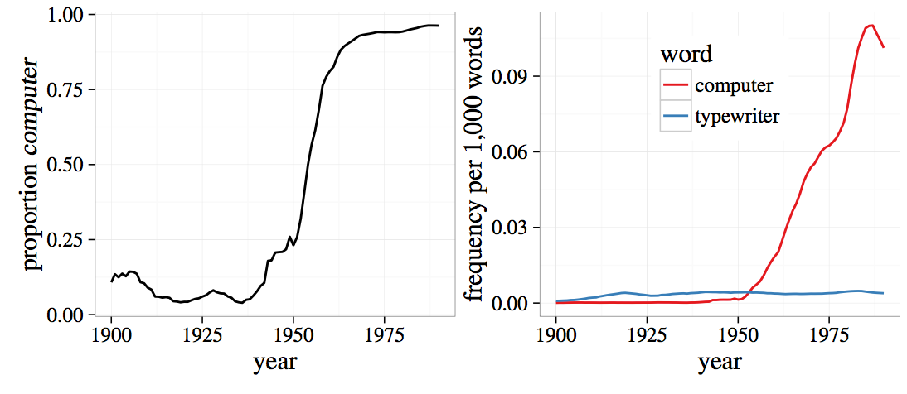

Figure 9: Proportional frequency and relative frequency of *computer* and *typewriter* (Figure 3 from Fruehwald, 2016)

If a new discourse function is what led to the rise of *um*, we should expect to see a similar fishtail pattern, with *um* rising and *uh* remaining stable. Conversely, if *um* were straightforwardly replacing *uh*, we should expect *uh* to fall concurrently with *um*’s rise.

Figure 10 shows the frequency of *um* and *uh* per 1000 words for each of the farmers, with year of birth on the x-axis and frequency on the y-axis. Each point represents one farmer. There is some evidence of a fishtail pattern, but in the opposite direction as expected: *uh* is increasing as *um* remains relatively stable. The pattern is more extreme when we split the data by position, as in Figure 11. In initial position, both *um* and *uh* are largely stable, whereas in noninitial position, *uh* alone is increasing. Splitting the data again by gender, we can see that the increase can be attributed to the female speakers—there is no apparent increase over apparent time for male speakers, but the older female speakers have a relatively lower *uh* rate, rising to match the male speakers by the 1910s.

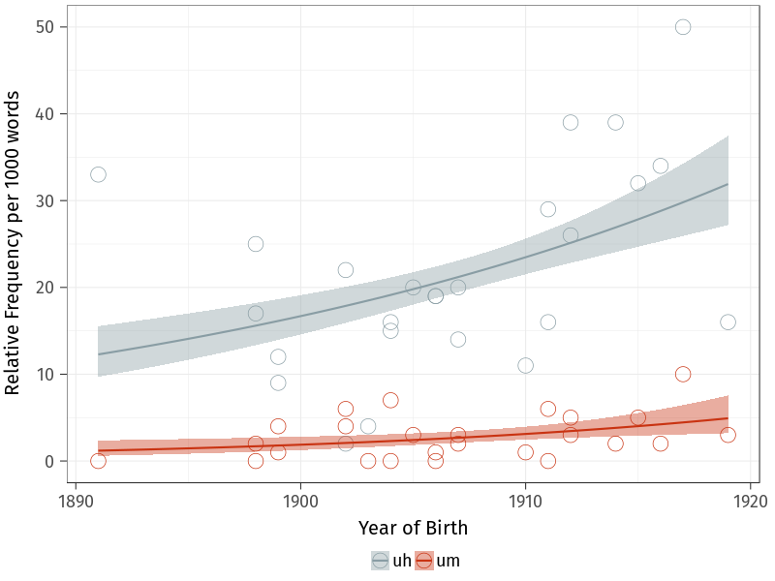

Figure 10: Frequency of *uh* and *um* per 1000 words

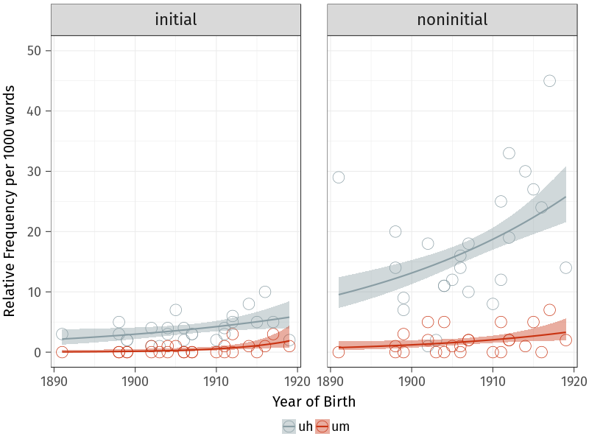

Figure 11: Frequency of *uh* and *um* per 1000 words, by position

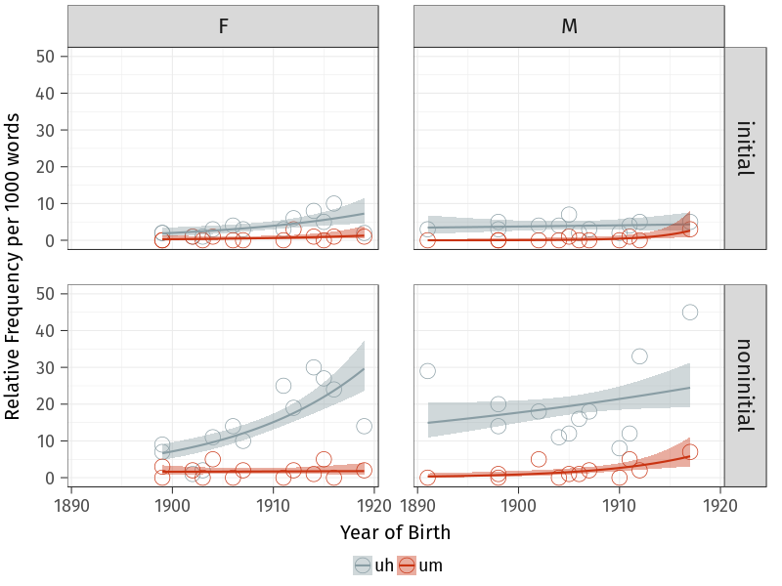

Figure 12: Frequency of *uh* and *um* per 1000 words, by position and gender

We ran a mixed-effects Poisson regression model to confirm these interactions, the results of which are shown in Table 3. The dataset fed to the model included each speaker’s *um* and *uh* counts in non-initial position, which was the dependent variable; year of birth, gender, and variant (*uh* or *um*) were the predictors, along with a random intercept for speaker and a random slope for variant by speaker. The reference level for gender was male, and the reference level for variant was *um*. Poisson regressions are well-suited for count data, because the range of possible values is limited to zero and above, and the assumption of normality is not required. Because our data are rates, not raw count data, the logarithm of each speaker’s word count was used as an offset in order to normalize across speakers.

Table 3: Mixed-effects Poisson regression model on non-initial (UHM) counts.

|  |  |  |  |  |
| --- | --- | --- | --- | --- |
| Predictor | Estimate | Std. Error | *z* | *p* |
| (Intercept) | -6.22331 | 0.24692 | -25.204 | 0 |
| year of birth | 0.08301 | 0.03608 | 2.300 | 0.0214 |
| variant (*uh*) | 2.22094 | 0.27482 | 8.081 | 0 |
| gender (male) | -0.23516 | 0.34576 | -0.680 | 0.4964 |
| year of birth : variant | -0.07520 | 0.03987 | -1.886 | 0.0593 |
| year of birth : gender | -0.06622 | 0.05106 | -1.297 | 0.1946 |
| variant : gender | -0.30181 | 0.38587 | -0.782 | 0.4341 |
| year of birth : variant : gender | 0.14482 | 0.05678 | 2.550 | 0.0108 |

Table 3 shows that there is an interaction between year of birth, variant, and gender. The relevant coefficient, 0.14482, indicates that in non-initial position, the slope for year of birth for *uh* is predicted to be greater for men than for women. In other words, women’s non-initial *uh* frequency (compared to *um*) is increasing over time to a greater extent than men’s is. This confirms the fishtail pattern shown in the bottom-left and bottom-right facets of Figure 12.

# Discussion

Exploring data from before the rise of *um* has not yielded a definitive explanation for the change. Looking at the proportional frequency, we do find that for the younger farmers, *um* appears more frequent than *uh* in initial position, and the same is the case for the two (much younger) interviewers. Alone, this could be taken as suggestive evidence in favour of a new, initial-position function for *um*. Looking at the relative frequency, however, we see that the pattern does not appear to be driven by an increase of *um* in initial position— like Fruehwald (2016), we do not find strong evidence that a new, utterance-initial function for *um* is behind the rise of *um*. The question as to what the trigger for the rise of *um* was remains. However, we find evidence of a different change: *uh* seems to have expanded its functional range in this time period. We tentatively suggest that this may be because *uh* was recruited by speakers to fill erstwhile unfilled pauses, particularly in non-initial position.

We illustrate this explanation using (7) and (8): two passages of about the same length from NIA-11, a younger woman in the dataset (born 1917), and NIA-36, an older woman (born 1903). In the transcriptions, (UHM) is bolded, and unfilled pauses are indicated using (.) or (…), depending on the length of the pause. In her extract, NIA-11 uses (UHM) eight times— all but one of which are *uh*. In sharp contrast, NIA-36 does not use (UHM) once, opting instead for lengthy, unfilled pauses. With respect to (UHM), the two speakers employ fundamentally different discourse strategies.

1. INT: And what types of fruit (.) did you grow?  
   NIA-11: Well the **uh** (.) originally **uh** when they came- **uh** grandfather bought the property in nineteen hundred and **uh** (.) **um** (.) to begin with there was very- there were very few fruit trees on it and they planted (.) **uh** (.) our orchard of **uh** (.) peaches. And **uh** waiting- while they waited for the peaches to come into bearing, they planted raspberries between the rows, so it started out as principally a raspberry farm I suppose but (.) it evolved into a farm that **uh** principally grew peaches and cherries, mainly sweet cherries.  
   INT: Okay. And how much (.) older was the very oldest?  
   NIA-11: The oldest was born (…) in eighteen ninety two (…) and then my sister Lianne, eighteen ninety four (…) Greg, eighteen ninety eight (.) Sally nineteen hundred and one (…) I was born nineteen hundred and three (.) and that’s it.
2. INT: Okay, and how old was your dad when you were born? At-  
   NIA-36: (…) I- (…) how old was my dad when I was born? Oh.  
   INT: I think we had figured out that he was probably somewhere around forty five.  
   NIA-36: Oh yes.  
   INT: And your mom was?  
   NIA-36: Thirty (.) five?  
   INT: Thirty- oh-  
   NIA-36: Is that it?  
   INT: Yup. Good.

While our data are too early to shed much light on the rise of *um*, and it is important to be careful when generalizing across corpora and speech communities, it is possible that the *uh*-led shift from unfilled to filled pauses played a role in the competition between *um* and *uh* in the years to come. For example, if *uh* became specialized to non-initial position, which often appears to indicate word-search (Tottie, 2016, 2017), it may have become a less desirable variant (frequent word-search potentially giving the impression of disfluency). (9) provides an example of this word-search usage from Tottie (2016):[3]

1. Oh, that one goes with –  
   .. That’s **um**=,  
   …**u=m**  
   .. $⟨$ P God XXXXX P $⟩$,  
   … Isis and Osiris.

This mid-utterance word-search function may previously have been linked with unfilled pauses. Notice that in (7), (UHM) tends to appear when the speaker is recalling information, such as what was planted (the family’s orchard) and what grew in the family’s orchard (peaches) in the following snippet: “they planted (.) **uh** (.) our orchard of **uh** (.) peaches”. This is the same sort of context in which lengthy unfilled pauses, marked by “(…)”, are used in (8), when the speaker is recalling years of birth for her family members. Our data thus provide tentative support for the idea that *uh* may have become associated with this function, explaining its rise in overall frequency among women in our data. However, we have to stress that more work would be needed for us to be able to go beyond this kind of speculation.

# Conclusion

This study analyzed both proportional and relative frequency data, with the goal of identifying potential triggers for the rise of *um* that has been described over the last decade by Fruehwald (2016), Tottie (2016) and several others. Our result highlights the importance of viewing discourse-pragmatic variation and change from multiple angles: the two quantitative perspectives we employ here provide complementary information about the functional expansion hypothesis. Considering only the proportional data might suggest that a new function for *um* is emerging, but the relative frequency data indicate that the relevant change is actually one that we hadn’t considered, and one that falls outside our original envelope of variation: a change from unfilled pauses to *uh* in non-initial position.

Acton, E. K. (2011). On gender differences in the distribution of um and uh. *University of Pennsylvania Working Papers in Linguistics*, *17*(2), 2.

Cieri, C., Miller, D., & Walker, K. (2004). The fisher corpus: A resource for the next generations of speech-to-text. *LREC*, *4*, 69–71.

Clark, H. H., & Fox Tree, J. E. (2002). Using uh and um in spontaneous speaking. *Cognition*, *84*(1), 73–111.

Denis, D. (2016). Oral histories as a window to sociolinguistic history and language history: Exploring earlier Ontario English with the Farm Work and Farm Life Since 1890 oral history collection. *American Speech*, *91*(4), 513–516.

Fruehwald, J. (2016). Filled pause choice as a sociolinguistic variable. *University of Pennsylvania Working Papers in Linguistics*, *22*(2), 6.

Gadanidis, T. (2018). *Um, about that, uh, variable*. M.A. forum paper, University of Toronto.

Godfrey, J. J., Holliman, E. C., & McDaniel, J. (1992). SWITCHBOARD: Telephone speech corpus for research and development. *[Proceedings] Icassp-92: 1992 Ieee International Conference on Acoustics, Speech, and Signal Processing*, *1*, 517–520.

Labov, W. (2001). *Principles of linguistic change, vol. 2: Social factors*. Oxford: Blackwell.

Labov, W., & Rosenfelder, I. (2011). *The Philadelphia Neighborhood Corpus*.

Laserna, C. M., Seih, Y.-T., & Pennebaker, J. W. (2014). Um… who like says you know: Filler word use as a function of age, gender, and personality. *Journal of Language and Social Psychology*, *33*(3), 328–338.

Levelt, W. J. (1983). Monitoring and self-repair in speech. *Cognition*, *14*(1), 41–104.

Levelt, W. J. (1989). *Speaking: From intention to articulation*. MIT Press Series in Natural-Language Processing. MIT Press, Cambridge, Massachusetts.

Maclay, H., & Osgood, C. E. (1959). Hesitation phenomena in spontaneous English speech. *Word*, *15*(1), 19–44.

Pichler, H. (2010). Methods in discourse variation analysis: Reflections on the way forward. *Journal of Sociolinguistics*, *14*(5), 581–608.

Tagliamonte, S. A., & Baayen, R. H. (2012). Models, forests, and trees of York English: Was/were variation as a case study for statistical practice. *Language Variation and Change*, *24*(2), 135–178.

Tagliamonte, S. A., & D’Arcy, A. (2007). Frequency and variation in the community grammar: Tracking a new change through the generations. *Language Variation and Change*, *19*(2), 199–217.

Tagliamonte, S. A., & Denis, D. (2010). The stuff of change: General extenders in Toronto, Canada. *Journal of English Linguistics*, *38*(4), 335–368.

*The british national corpus* (Version 3, BNC XML Edition). (2007). Bodleian Libraries, University of Oxford, on behalf of the BNC Consortium.

Tottie, G. (2011). Uh and um as sociolinguistic markers in British English. *International Journal of Corpus Linguistics*, *16*(2), 173–197.

Tottie, G. (2016). Planning what to say: Uh and um among the pragmatic markers. In G. Kaltenböck, E. Keizer, & A. Lohmann (Eds.), *Outside the clause: Form and function of extra-clausal constituents* (pp. 97–122). John Benjamins Publishing Company.

Tottie, G. (2017). From pause to word: *Uh*, *um* and *er* in written American English. *English Language & Linguistics*, 1–26.

Tottie, G. (2018). *Variation and change among pragmatic markers as planners in American English*.

Wieling, M., Grieve, J., Bouma, G., Fruehwald, J., Coleman, J., & Liberman, M. (2016). Variation and change in the use of hesitation markers in Germanic languages. *Language Dynamics and Change*, *6*(2), 199–234.

1. For Wieling et al. (2016), this is a possible explanation for the crosslinguistic nature of the change: a function could have emerged in English and then spread through contact to the other Germanic languages.
2. This is an (in our view justified) extension of the notion of “structural equivalence” (Pichler, 2010; Tagliamonte & Denis, 2010) to phonological/orthographic structure.
3. In Tottie’s transcription protocol, full stops indicate pauses, text between $⟨$ P P $⟩$ indicates soft (piano) voice, and Xs indicate incomprehensible speech.