

**Dharmsinh Desai University, Nadiad**

Faculty of Technology, Department of Computer Engineering

B. Tech. CE Semester – VI

Subject: **Software Development Project**

Project Title:

**Spam SMS Detection**

By:

Hetul Bhatt CE015 (17CEUOS)

Jainik Gadara CE047 (17CEUON116)

**Guided By:**

|  |
| --- |
| **Prof. Hariom Pandya** |
|  |



**Dharmsinh Desai University, Nadiad**

Faculty of Technology, Department of Computer Engineering

**CERTIFICATE**

This is to certify that Software Development Project entitled “**Spam SMS Detection**” is the bonafied report of work carried out by

**1)Hetul Bhatt (17CEUOS)**

**2)Jainik Gadara (17CEUON116)**

Of Department of Computer Engineering ,Semester VI , academic year 2019-2020, under our supervision and guidance.

|  |  |
| --- | --- |
|  |  |
| **Guide** | **HOD** |
| **Prof. Hariom Pandya**  Associate Professor of Department of Computer Engineering, Dharmsinh Desai University, Nadiad | **Dr. C. K. Bhensdadia**  Head of Department of Computer Engineering, Dharmsinh Desai University, Nadiad |
|  |  |

**Content**

1. **Abstract …………………….……………………………………………………………………. 1**
2. **Introduction …………..……………………………………………………………………….. 1**
3. **Software Specification Requirement .………………………………………………. 2**
   1. **Functional Requirement**
   2. **Non-Functional Requirement**
4. **Design .…………………………………………………………………………………………… 8**
   1. **Use Case diagrams**
   2. **Sequence diagrams**
   3. **Activity diagrams**
5. **Implementation Detail …………………………………………………………………… 17**
6. **Screenshots ……………………………………………………………………………………. 18**
7. **Conclusion …………………………………………………………………………………….. 21**
8. **Limitation ……………………………………………………………………………………… 21**
9. **Abstract**

Many times, we get messages from an unknown about the winning lottery, gift vouchers and many more fake advertisements. We make mistake by giving our confidential information to those anonymous people and that might be a fraud.

So, Spam SMS detection system detects whether the SMS we have received is a Spam or a Ham message. This system will help individuals to automatically recognize messages as SPAM and categorize them from Ham SMS. Spam SMS detection system will caution you about spam messages so that you don’t get mistaken by those messages.

We have used Bayes Theorem for calculating probability. And a Naïve Bayes Classifier to develop our predicting model.

1. **Introduction**

We all might have received many SMS from an unknowns congratulating your victory in any contest or lottery and requesting you to share our bank account details to avail benefit. Here Spam SMS Detection comes into picture, which helps us by labeling such messages as spam so that we are not mistaken.

Spam SMS Detection is a android application for detecting spam messages from your message inbox.

Application reads all your inbox messages and checks whether message is spam or not. Application send message body to API and API in turn returns response whether message is spam or ham.

Application also preserves privacy of your before read messages from inbox. User must permit application to read message inbox after which application can do its work.

We have used Bayes Theorem for calculating probability. And a Naïve Bayes Classifier to develop our predicting model.

* 1. **Technology/Platform/Tools**

Technology used:

* Flutter Framework
* Python
* Flask

Platform:

* Xyz

Tools:

* Google Colabs
* Visual Studio Code
* Android Studio

1. **Software Requirement Specification**
   1. **Functional Requirement**

**R1** Display Spam messages

**Description:** User can see list of all spam messages.

**Input:** User selection

**Output:** List of Spam messages

**R1.1** Delete message(s)

**Description:** After identifying message as spam, user has option to delete

spam messages.

**R1.1.1** Delete single message

**Description:** User delete a Spam message.

**Input:** User selection.

**Output:** Updated list of Spam messages.

**R1.1.2** Delete multiple messages

**Description:** User can delete multiple spam messages by selecting

them.

**Input:** User selected messages.

**Output:** Updated list of spam messages.

**R1.2** Block sender

**Description:** User can block a sender who has send spam message.

**Input:** User selects the sender.

**Output:** Success or failure message.

**R2** Check message as SPAM/HAM

**Description:** When user receives a message , system automatically checks

whether the received message is SPAM or HAM.

**Input:** Received message

**\*Output:** Informing whether message is HAM or SPAM.

* 1. **Non-Functional Requirement**
     1. System should always be available.
     2. System should be architected in such a way that future expansions is easy.
     3. System should be easy to access.
     4. System should be highly secured so that no can intercept messages in between.

1. **Design**
   1. **Use Case Diagram**

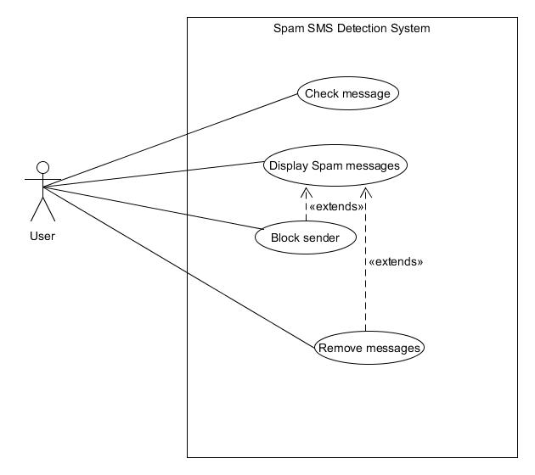

* 1. **Sequence Diagram**

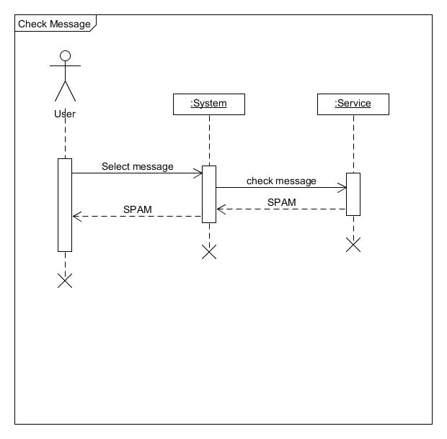

* 1. **Activity Diagram**

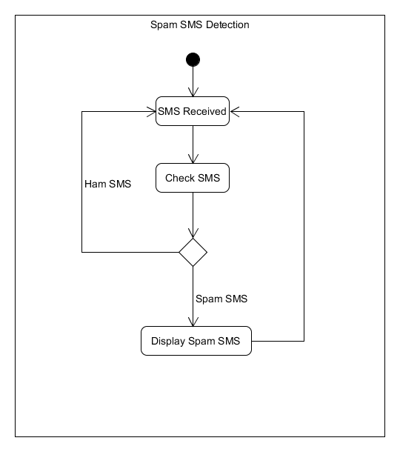

1. **Implementation Detail**
   1. **Prediction Module**

This module is the key feature of the system. Prediction module

Predicts whether a message is spam or ham. Module takes SMS body as an input and outputs string “Spam” or “Ham”.

System is a machine learning model where we have used concept of Bayes probability theorem to predict output.

We have