TASK 1: PYTHON FILE HANDLING & AUTOMATION
Name
Gaddala Sathwik
Internship Domain
Python Developer
Objective
The objective of this task is to demonstrate Python file handling and automation operations such as reading data from a file, writing data to another file, renaming files, and handling exceptions.
Tools Used
- Python
- Visual Studio Code (VS Code)
- Windows Operating System
Program Description
This program performs the following operations:
- Reads data from an input text file.
- Displays the file content.
- Writes the content into another file.
- Renames the output file.
- Handles possible errors using exception handling.

Source Code
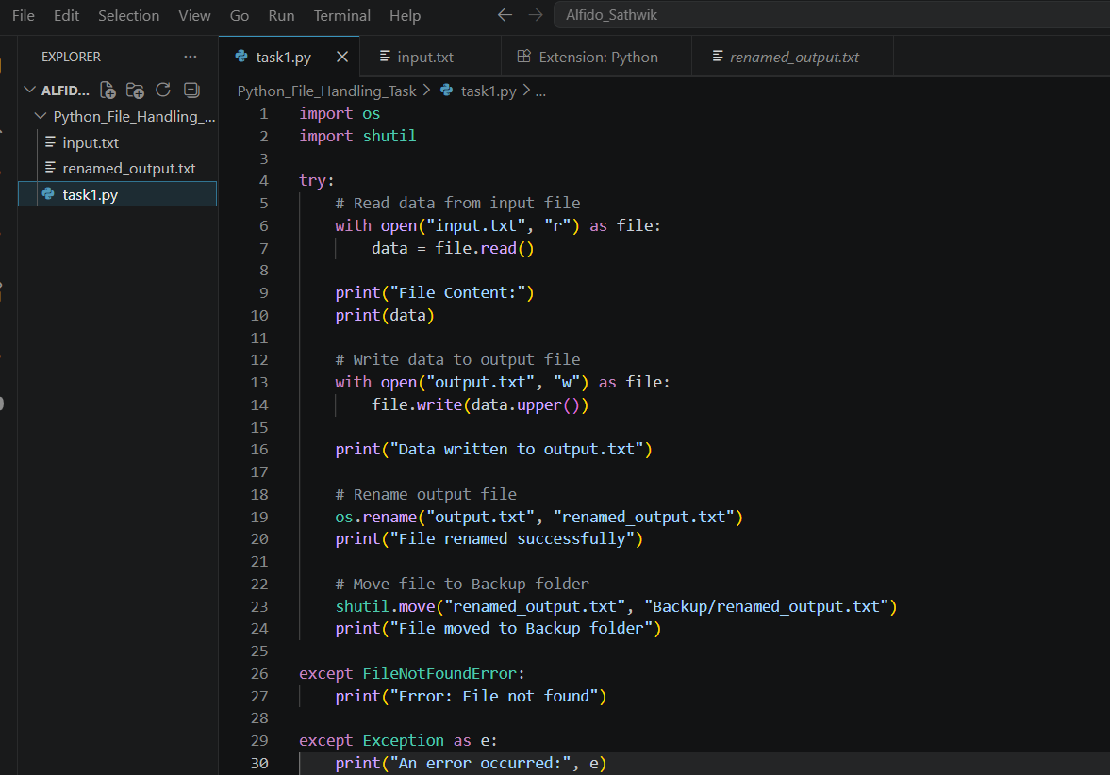

Output Screenshots
Screenshot 1: Input File
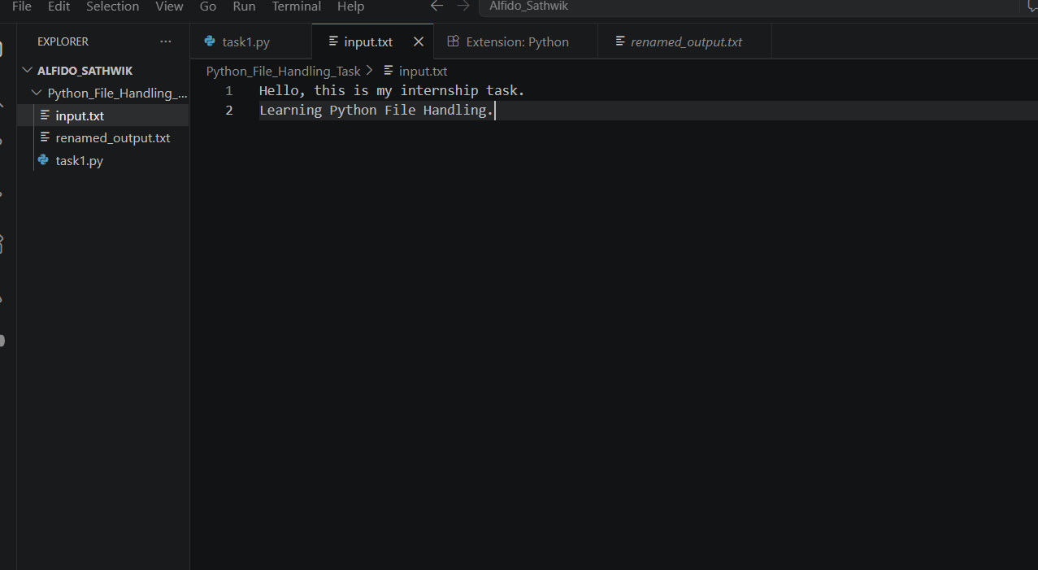

Screenshot 3: Terminal Output
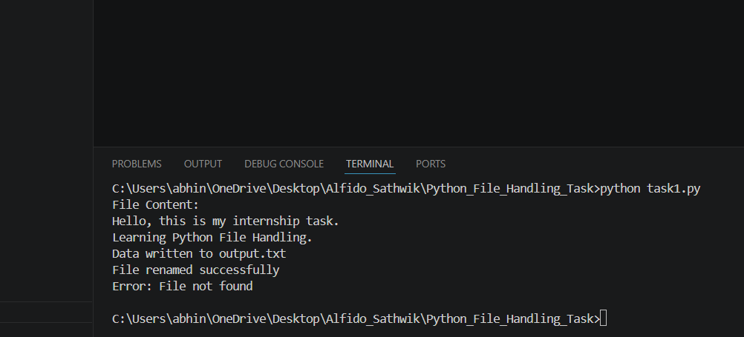

Screenshot 4: Renamed Output File
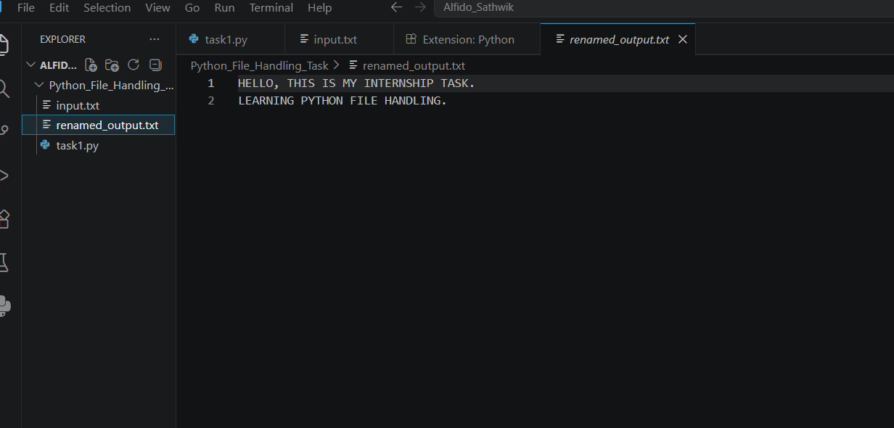

Result
The Python File Handling and Automation task was successfully implemented. The program correctly read data from the input file, wrote the processed data to another file, renamed the output file, and handled exceptions effectively.

Conclusion
This task helped in understanding Python file operations and exception handling. It provided practical experience in automating basic file management tasks using Python.

