FinanceGov Architecture & API Specification
Comprehensive Microservice Endpoint Blueprint & Full Technology Stack Reference
I. System Technology Stack & Architecture 💻
The FinanceGov platform leverages a production-grade enterprise software architecture built on top of decoupled microservices. The absolute technology layers are verified below:
• Frontend Layer: React.js (Vite Tooling Tier), Tailwind CSS, Axios REST Client Client (Base URL: http://localhost:5173)
• Microservice Backend Framework: Java 17+, Spring Boot 3.x, Spring Cloud (Gateway, Discovery, Configuration)
• Security Ecosystem: Spring Security 6.x Filters, JWT (JSON Web Tokens) Stateless Access Assertions
• Orchestration & Registry: Spring Cloud Netflix Eureka Server Discovery Instance Node (Port 8761)
• Application Gateway: Spring Cloud Gateway Routing perimeter engine featuring CORS interceptors (Port 9091)
• Inter-Service Transport: Spring Cloud OpenFeign Declarative Synch Clients
• Database Management Tier: Relational MySQL 8.0 Engine (Isolated Schema-Per-Service Topology Mapping)
Architectural Integration Flowchart Diagram
The visual topology outlining perimeter checking, Eureka endpoint lookups, and transactional data writes is mapped below:
┌─────────────────────────────────────────────────────────┐
│ REACT FRONTEND UI │
│ (Running on Port: 5173) │
└─────────────────────────┬───────────────────────────────┘
│
│ 1. User action triggers event
│ 2. Axios compiles payload
│ 3. Appends Bearer token header
▼
┌─────────────────────────────────────────────────────────┐
│ API GATEWAY (MASTER) │
│ (Listening on Port: 9091) │
└─────────────────────────┬───────────────────────────────┘
│
├─► Intercepts path: /api/{service-path}
├─► Validates stateless JWT signature
├─► Enforces global CORS filters
│
│ A. Queries registry leases
▼
┌─────────────────────────────────────────────────────────┐
│ EUREKA SERVER (SERVICE DISCOVERY) │
│ (Listening on Port: 8761) │
└─────────────────────────┬───────────────────────────────┘
│
│ B. Resolves target microservice URL
▼
┌─────────────────────────────────────────────────────────┐
│ API GATEWAY (MASTER) │
│ (Forwards request with extracted security context) │
└─────────────────────────┬───────────────────────────────┘
│
▼ Routes downstream via /api/**
===========================================================================
CORE TARGET MICROSERVICES LAYER
===========================================================================
│
├──► [ Identity Access Service ] ───► Port: 8081 ───► DB: [ identityaccessservice ]
│ └─ Handles: /api/auth/**, /api/users/**, /api/admin/**
│
├──► [ Citizen Business Service ] ──► Port: 8082 ───► DB: [ citizenbusiness ]
│ └─ Handles: /entities/**, /documents/**
│
├──► [ Financial Program Subsidy ] ─► Port: 8083 ───► DB: [ subsidy ]
│ └─ Handles: /programs/**, /applications/**, /subsidies/**
│
├──► [ Taxation Disclosure Service ]► Port: 8084 ───► DB: [ taxation ]
│ └─ Handles: /api/taxation/**, /api/disclosure/**
│
├──► [ Budget Resource Service ] ───► Port: 8085 ───► DB: [ budgetresource ]
│ └─ Handles: /api/budget/**, /api/resources/**
│
├──► [ Compliance Audit Service ] ──► Port: 8086 ───► DB: [ complianceaudit ]
│ └─ Handles: /compliance/**, /audit/**
│
├──► [ Report Generation Service ] ─► Port: 8087 ───► DB: [ reports ]
│ └─ Handles: /reports/**
│
└──► [ Notification Service ] ──────► Port: 8088 ───► DB: [ notifications ]
└─ Handles: /api/notification/**
│
▼
┌─────────────────────────────────────────────────────────┐
│ ISOLATED MYSQL 8.0 SCHEMAS │
│ (Executes isolated CRUD transactions) │
└─────────────────────────┬───────────────────────────────┘
│
▼ [Return Lifecycle Path]
┌─────────────────────────────────────────────────────────┐
│ TARGET MICROSERVICE CONTAINER │
│ (Compiles and yields JSON payload) │
└─────────────────────────┬───────────────────────────────┘
│
▼ Passes back through perimeter
┌─────────────────────────────────────────────────────────┐
│ API GATEWAY (MASTER) │
│ (Appends final outbound response headers) │
└─────────────────────────┬───────────────────────────────┘
│
▼ HTTP Response delivered
┌─────────────────────────────────────────────────────────┐
│ REACT FRONTEND UI │
│ (Hooks refresh state and updates data views) │
└─────────────────────────────────────────────────────────┘
Figure 1.1: FinanceGov Distributed Microservices Communication Topology Chart

II. Centralized Microservice Endpoints Blueprint Registry 📊
1. Authentication Module (Identity Access Service - Port 8081)
Method | Target HTTP Endpoint Path | Payload Structure | Expected JSON Response | Role Level Required | Functional Logic Purpose
POST | /api/auth/register | {username, email, password, phone} | {id, token, user} | PUBLIC | Citizen self-registration
POST | /api/auth/login | {email, password} | {token, user: {id, role, email}} | PUBLIC | User login authentication
GET | /api/auth/me | - | {id, email, role, isVerified} | AUTHENTICATED | Retrieve active authenticated payload
POST | /api/users/create | {email, username, password, phone, roleId} | {id, email, token} | ROLE_ADMIN | Provision system operators manually
GET | /api/users/all | - | [{id, email, username, phone, role}] | ROLE_ADMIN | Enumerate registered user records
PUT | /api/users/{id} | {email, phone, status} | {id, email, phone} | ROLE_ADMIN | Modify tracking profile records
DELETE | /api/users/{id} | - | {message: 'User deleted'} | ROLE_ADMIN | De-provision user profile metadata
2. Citizen Profile Module (Citizen Business Service - Port 8082)
Method | Target HTTP Endpoint Path | Payload Structure | Expected JSON Response | Role Level Required | Functional Logic Purpose
POST | /entities/createCitizen | {userId, name, type, address, contactInfo} | {entityId, userId, name, type} | ROLE_CITIZEN | Initialize citizen tracking profile
GET | /entities/getCitizenById/{id} | - | {entityId, userId, name, type, address, documents} | ROLE_CITIZEN/ROLE_ADMIN | Get target profile records
PUT | /entities/updateCitizenById/{id} | {name, type, address, contactInfo} | {entityId, name, type, address} | ROLE_CITIZEN | Modify background profile details
GET | /entities/getAllEntity | - | [{entityId, userId, name, type, status}] | ROLE_ADMIN | Enumerate all tracking profiles
DELETE | /entities/deleteById/{id} | - | {message: 'Citizen deleted'} | ROLE_ADMIN | Purge citizen profile database context
POST | /entities/approveCitizen/{id} | - | {entityId, status: 'APPROVED'} | ROLE_ADMIN | Update verification workflows state
POST | /documents/upload | FormData multipart with file | {documentId, entityId, fileUrl} | ROLE_CITIZEN | Upload compliance credentials file
GET | /documents/getAllDocument | - | [{documentId, entityId, docType, status}] | ROLE_ADMIN | Review all document stream assets
3. Budget & Resource Micro-Allocations Module (Budget Resource Service - Port 8085)
Method | Target HTTP Endpoint Path | Payload Structure | Expected JSON Response | Role Level Required | Functional Logic Purpose
POST | /api/budget/create | {amount, year, description} | {budgetId, amount, year, status} | ROLE_PROGRAM_MANAGER | Commit new fiscal year budget program
GET | /api/budget/all | - | [{budgetId, amount, year, allocatedAmount}] | ROLE_PROGRAM_MANAGER | Review all state budget pools
POST | /api/resources/allocate | {budgetId, amount, departmentId} | {resourceId, budgetId, amount} | ROLE_PROGRAM_MANAGER | Disburse funds down to departments
GET | /api/resources/all | - | [{resourceId, budgetId, departmentId, amount}] | ROLE_PROGRAM_MANAGER | Review allocations log
GET | /api/budget/summary/{programId} | - | Aggregated financial breakdown analytics | ROLE_PROGRAM_MANAGER | Compile summaries of budgets utilized
4. Compliance Tracking & Forensic Audit Module (Compliance Audit Service - Port 8086)
Method | Target HTTP Endpoint Path | Payload Structure | Expected JSON Response | Role Level Required | Functional Logic Purpose
POST | /compliance | {entityId, complianceType, result} | {recordId, entityId, status} | ROLE_COMPLIANCE_OFFICER | Commit verification evaluation profile record
GET | /compliance | - | [{recordId, entityId, status, timestamp}] | ROLE_COMPLIANCE_OFFICER/ROLE_ADMIN | Enumerate compliance ledger checks
GET | /compliance/{id} | - | {recordId, entityId, details, status} | ROLE_COMPLIANCE_OFFICER/ROLE_ADMIN | Get target record metrics
POST | /audit | {auditType, scope, targetId} | {auditId, type, status, createdDate} | ROLE_GOVERNMENT_AUDITOR | Initialize independent target investigation profile
GET | /audit | - | [{auditId, type, status, date}] | ROLE_GOVERNMENT_AUDITOR | Review forensics timeline stream
GET | /audit/summary | - | {totalAudits, completedAudits, pendingAudits} | ROLE_GOVERNMENT_AUDITOR/ROLE_ADMIN | Compile comprehensive audit stats summary
5. Welfare Programs & Subsidy Management Module (Financial Program Subsidy Service - Port 8083)
Method | Target HTTP Endpoint Path | Payload Structure | Expected JSON Response | Role Level Required | Functional Logic Purpose
POST | /programs/create | {name, description, budget, eligibility} | {programId, name, status} | ROLE_PROGRAM_MANAGER | Initialize state assistance initiative profile
GET | /programs/all | - | [{programId, name, status, budget}] | AUTHENTICATED | Enumerate active initiatives registry
POST | /applications/save | {citizenId, programId, applicationData} | {applicationId, programId, status} | ROLE_CITIZEN | Submit eligibility forms payload stream
GET | /applications/all | - | [{applicationId, citizenId, programId, status}] | ROLE_FINANCIAL_OFFICER | Review incoming request pipelines
PUT | /applications/{id}/status | {status: 'APPROVED'} | {applicationId, status} | ROLE_FINANCIAL_OFFICER | Update evaluation workflows criteria state
POST | /subsidies/create | {applicationId, amount, type} | {subsidyId, applicationId, amount} | ROLE_FINANCIAL_OFFICER | Execute disbursement tracking record line item
PUT | /subsidies/{id}/verify | {status: 'VERIFIED'} | {subsidyId, status, verifiedDate} | ROLE_FINANCIAL_OFFICER | Sign off on disbursement parameters
6. Taxation Logs & Asset Disclosures Module (Taxation Disclosure Service - Port 8084)
Method | Target HTTP Endpoint Path | Payload Structure | Expected JSON Response | Role Level Required | Functional Logic Purpose
POST | /api/taxation/enter_taxrecord | {citizenId, amount, year} | {taxId, citizenId, amount} | ROLE_CITIZEN | File official fiscal year filing logs statement
GET | /api/taxation/all_taxrecords | - | [{taxId, citizenId, amount, year}] | ROLE_ADMIN/ROLE_FINANCIAL_OFFICER | Review comprehensive historical tax filings ledger
POST | /api/disclosure/enter_disclosure | {citizenId, amount, type} | {disclosureId, citizenId, type} | ROLE_CITIZEN | Submit financial assets asset self-declaration statements
GET | /api/disclosure/all_disclosures | - | [{disclosureId, citizenId, amount}] | ROLE_ADMIN/ROLE_FINANCIAL_OFFICER | Enumerate asset self-declarations statements for review
POST | /api/disclosure/validate/{id} | {status: 'VERIFIED'} | {disclosureId, status} | ROLE_FINANCIAL_OFFICER | Execute compliance checking signatures updates

III. User Interface Screen Index & Verification Mapping 🖼️
This section presents the real runtime interface screenshots mapped against structural database tables to complete verification testing pipelines.
📌 Fig 2.1: Admin Core Dashboard View & Metrics Grid Layout Panel
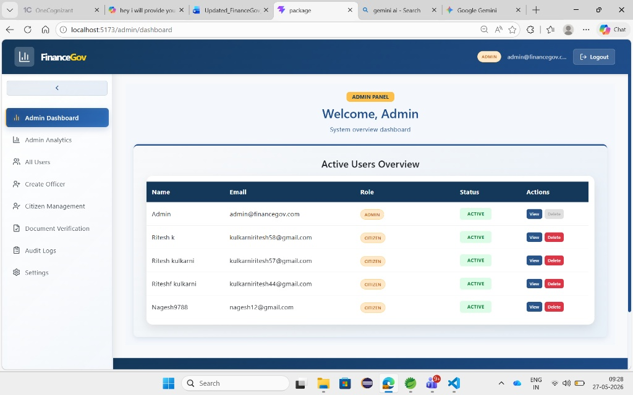

📌 Fig 2.2: Interactive Systems Allocation Visual Charts
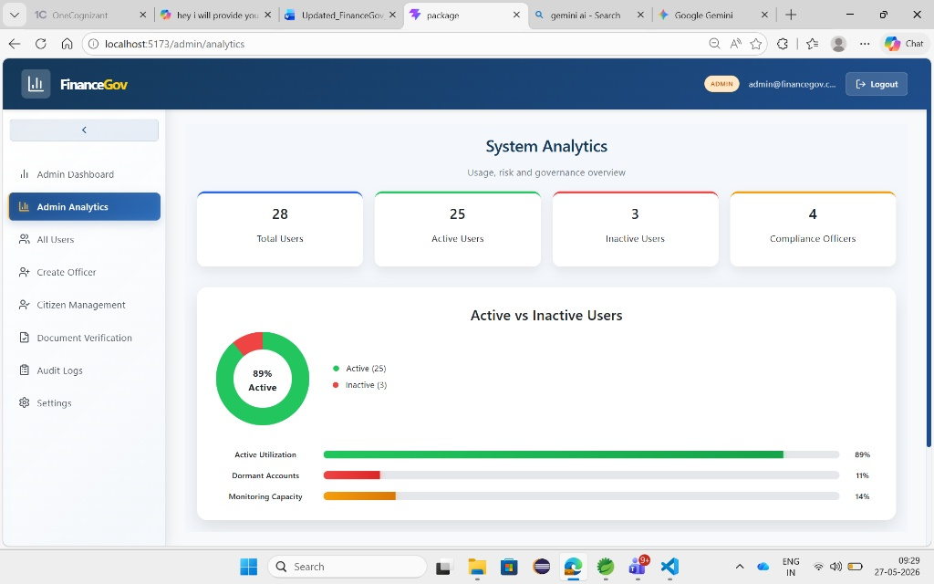
📌 Fig 2.3: Advanced Security Profiles Grid List & Operations Board
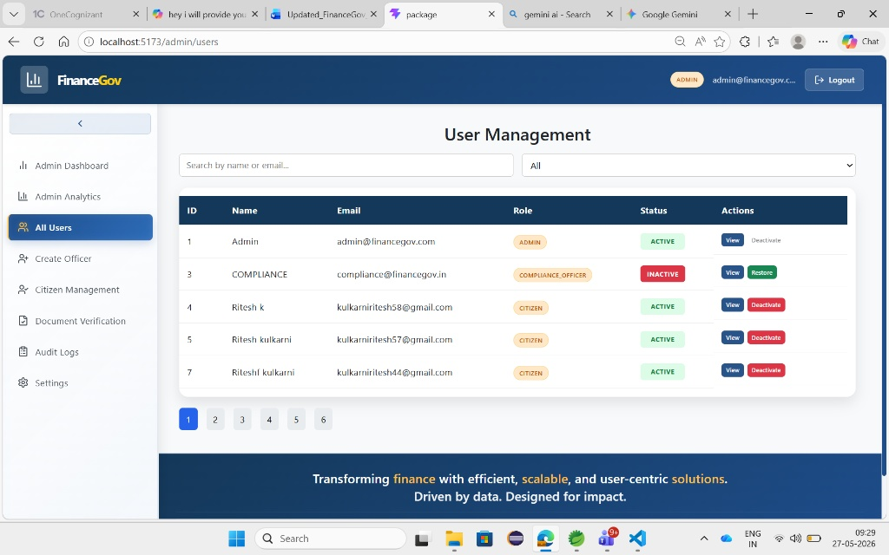

📌 Fig 2.4: State Initiative Programs Workspace Entry Form Deck
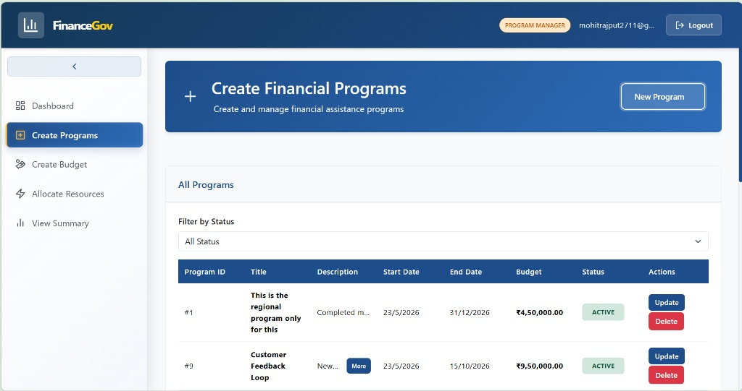
📌 Fig 2.5: Welfare Requests Intake Control Pipeline Status Matrix
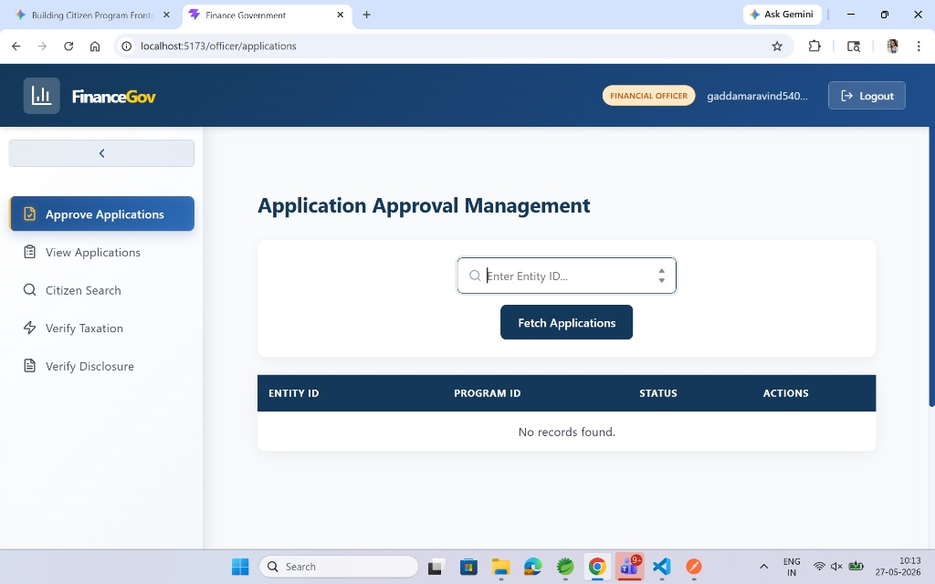

📌 Fig 2.6: Individual Account Taxation Overview Records Grid Table
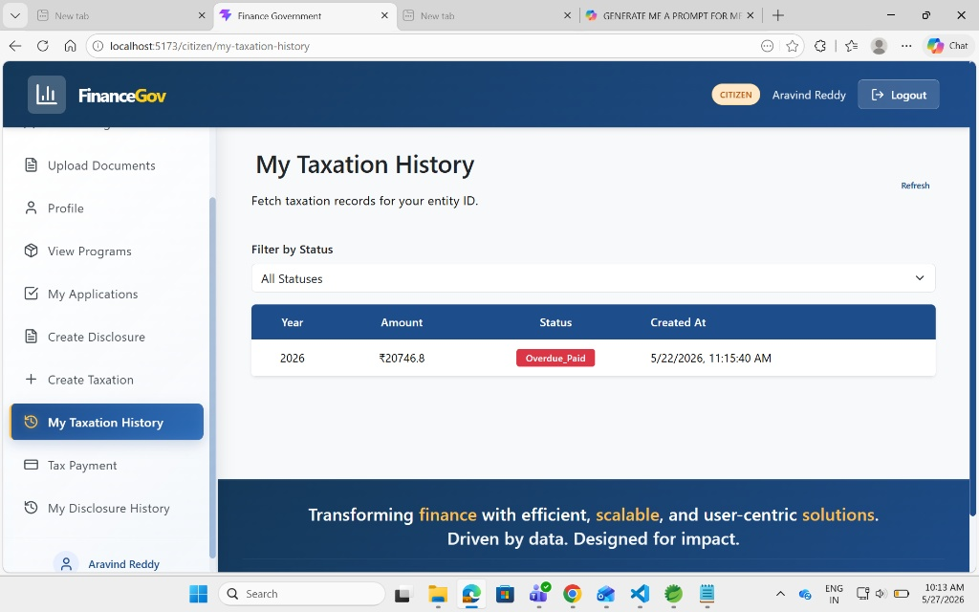
📌 Fig 2.7: Policy Compliance Operations Auditing Central Control Board
