LAB-2
1.Accuracy – “0.931”
2. MLP Architectures
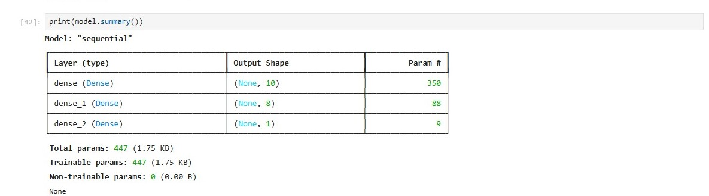
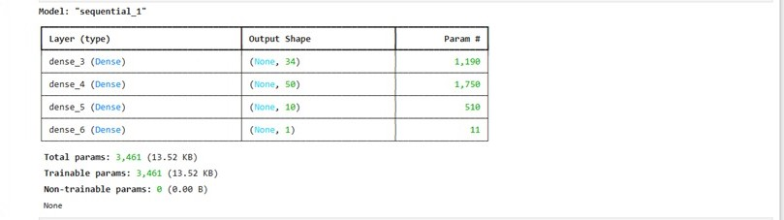
dddss

3. The output of the neural network as provided in Task 2 is – “0.732”

