SAAS API SECURITY ASSESSMENT
Postman-Based Security Testing Report
Prepared by: Gaddam Manicharan
Cyber Security | API Security Assessment
Testing Tool: Postman
Test API: JSONPlaceholder (public demo/testing API)
Assessment Type: Authorized educational testing
Evidence Count: 10 screenshots

1. Executive Summary
This report documents a structured API security assessment performed using Postman against the JSONPlaceholder public demo API. The objective was to practice common SaaS/API security testing techniques including authentication review, object-level access checks, response-data review, HTTP status-code validation, security-header inspection, rate-limit observation, and POST request testing.
The assessment identified several security-relevant observations that would be important in a real production SaaS API. However, JSONPlaceholder is intentionally a public testing service, so the observations below are not presented as confirmed vulnerabilities in a production system. Instead, they demonstrate what a tester should verify in a real application and how the corresponding controls could be implemented.

2. Scope and Test Environment
Application/API | JSONPlaceholder public demo API
Base URL | https://jsonplaceholder.typicode.com
Testing Tool | Postman
Primary Endpoints Tested | GET /users, GET /users/1, GET /users/2, GET /users/99999, GET /posts/1, POST /posts
Authentication Observed | No Auth
Evidence | 10 Postman screenshots
Assessment Nature | Educational / authorized testing of a public demo API

3. Testing Methodology
- Sent baseline GET requests and verified HTTP response status and JSON response structure.
- Reviewed the Authorization tab to determine whether authentication was configured.
- Compared object-specific requests such as /users/1 and /users/2.
- Tested an invalid object identifier (/users/99999) to verify error handling.
- Inspected response headers for security-related controls and rate-limit information.
- Reviewed returned JSON for potentially excessive user information.
- Tested a POST request to verify creation behavior and HTTP 201 Created handling.
- Captured screenshots as evidence for each significant test result.

4. Test Results Summary
Test | Endpoint / Area | Observed Result | Assessment
Authentication review | GET /users/1 | No Auth; 200 OK | Security design observation
User data exposure review | GET /users/1 | Multiple user fields returned | Review minimization in production
Object access comparison | GET /users/1 and /users/2 | Both return 200 OK | Not proof of IDOR on demo API
Invalid object handling | GET /users/99999 | 404 Not Found | Expected behavior
Header review | GET responses | Security/rate-limit headers observed | Positive control indicators
POST behavior | POST /posts | 201 Created | Expected behavior

5. Security Observations and Recommendations

5.1 Authentication — No Auth Observed
The tested requests were configured with 'No Auth' in Postman and still received successful responses. For a public demo API this is expected. In a real SaaS application, endpoints containing private customer or account information should normally require authentication.
Potential production risk: unauthorized users could access protected resources if authentication is missing.
Recommended controls:
- Require authentication on protected endpoints.
- Use secure token-based authentication such as OAuth 2.0/OpenID Connect where appropriate.
- Validate token expiry, issuer, audience, and signature.
- Return appropriate 401/403 responses when authentication or authorization fails.

5.2 Excessive Data Exposure — Response Contains Multiple User Fields
The user response contains several fields such as name, username, email, address, phone and other profile-related information. JSONPlaceholder is a mock API, so this is not treated as a confirmed vulnerability. In a production SaaS API, responses should expose only the fields required by the client and the user's authorization level.
Recommended controls:
- Define response schemas for every endpoint.
- Return only data required for the business function.
- Apply field-level authorization to sensitive attributes.
- Avoid returning internal or unnecessary personal information.

5.3 Object-Level Authorization / IDOR Check
The assessment compared object-specific requests for /users/1 and /users/2 and confirmed that different objects could be requested without authentication. This demonstrates the testing technique used to identify Broken Object Level Authorization (BOLA/IDOR). Because JSONPlaceholder is a public demo API and does not represent private user accounts, the evidence does not establish a production IDOR vulnerability.
Recommended production verification:
- Authenticate as User A and request User B's object identifier.
- Confirm that the server checks ownership/tenant authorization server-side.
- Return 403 Forbidden (or an appropriate non-disclosing response) when access is not permitted.
- Use authorization middleware consistently across every object-level endpoint.

5.4 Invalid Object Handling
A request to /users/99999 returned HTTP 404 Not Found. This indicates that the API handles a nonexistent object with a standard not-found response. Consistent error handling should be maintained in production without revealing unnecessary internal implementation details.

5.5 Security Headers and Rate Limiting
The captured response headers include controls such as X-Content-Type-Options: nosniff and rate-limit-related headers including X-Ratelimit-Limit and X-Ratelimit-Remaining. These are useful indicators of defensive controls.
In a production SaaS API, rate limiting should be applied according to endpoint sensitivity, user identity, IP reputation, and business requirements, with appropriate monitoring and alerting.

5.6 POST Request and Status-Code Validation
The POST /posts request returned HTTP 201 Created. The Postman test was updated to validate the expected 201 status. This demonstrates correct success-status validation for a resource-creation operation.
Recommended controls for real write endpoints:
- Require authentication and authorization before creating resources.
- Validate and sanitize all input fields server-side.
- Apply request-size limits and content-type validation.
- Prevent mass assignment by allowing only explicitly approved fields.
- Log security-relevant creation events without storing secrets.

6. Evidence Appendix
The following screenshots were captured during the Postman assessment. They are included as evidence of the observed requests, responses, headers, authentication configuration, and status codes.
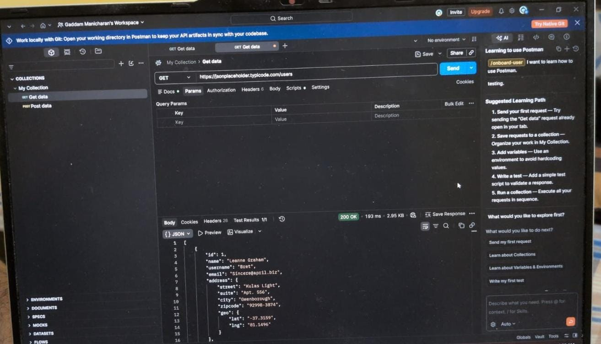
Evidence 01 — GET /users response (200 OK)
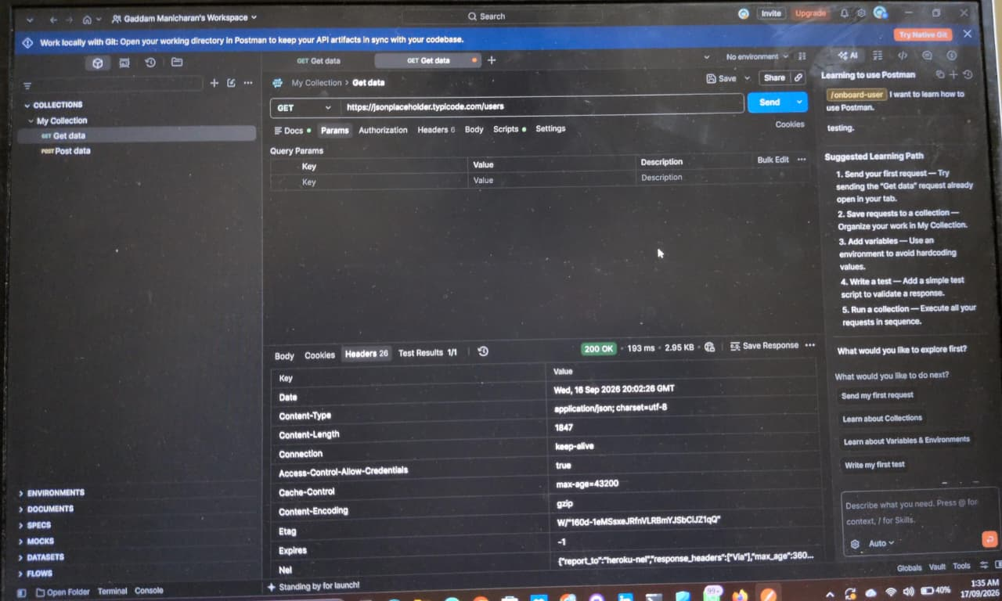
Evidence 02 — Response headers
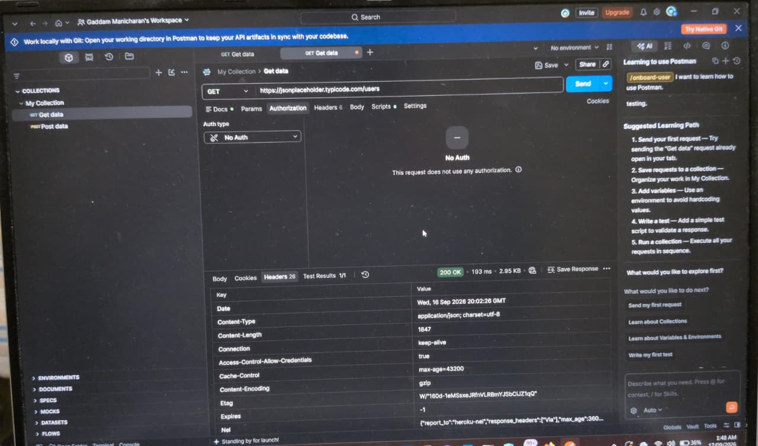
Evidence 03 — Authorization set to No Auth
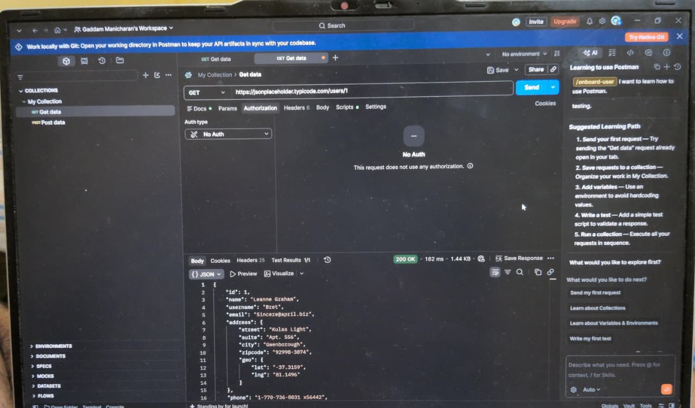
Evidence 04 — GET /users/1 user data response
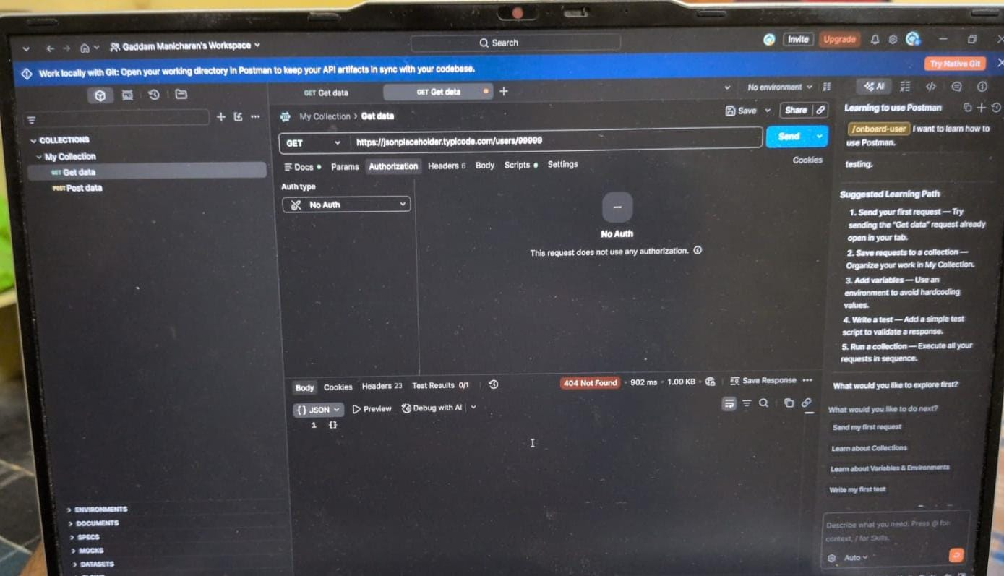
Evidence 05 — Invalid user ID returns 404 Not Found
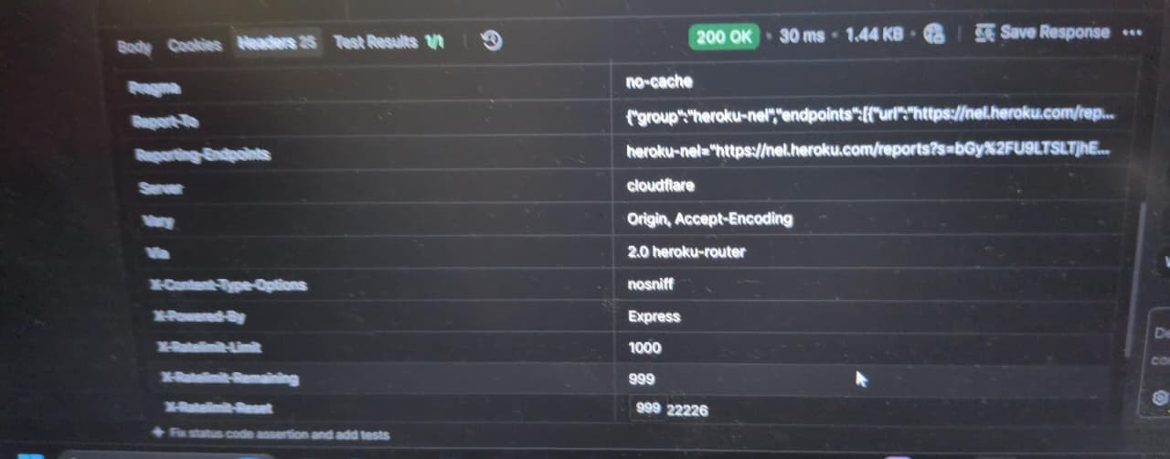
Evidence 06 — Security headers and rate-limit response headers
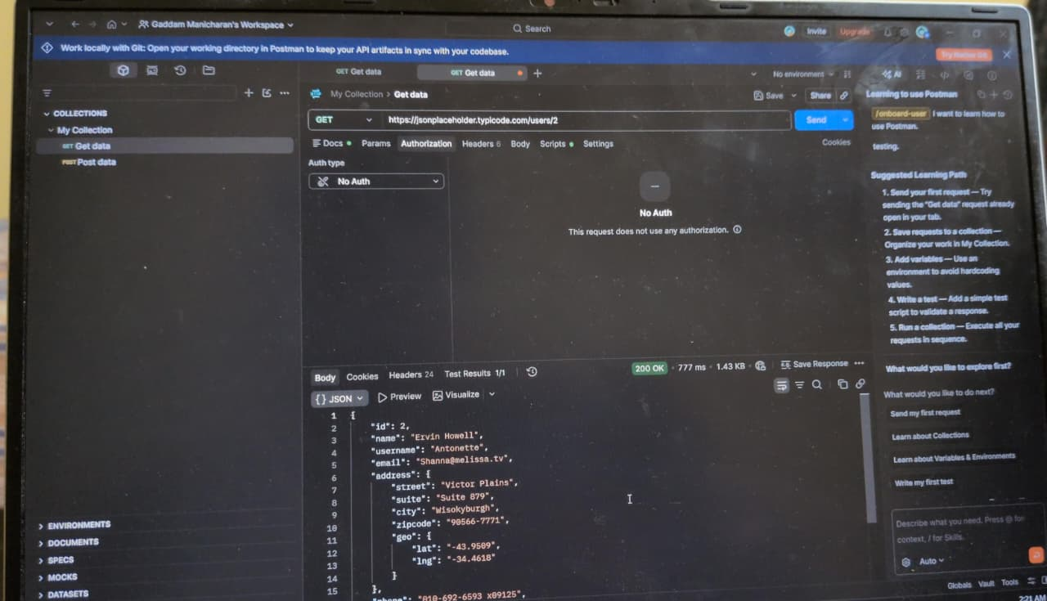
Evidence 07 — Object access check for /users/1
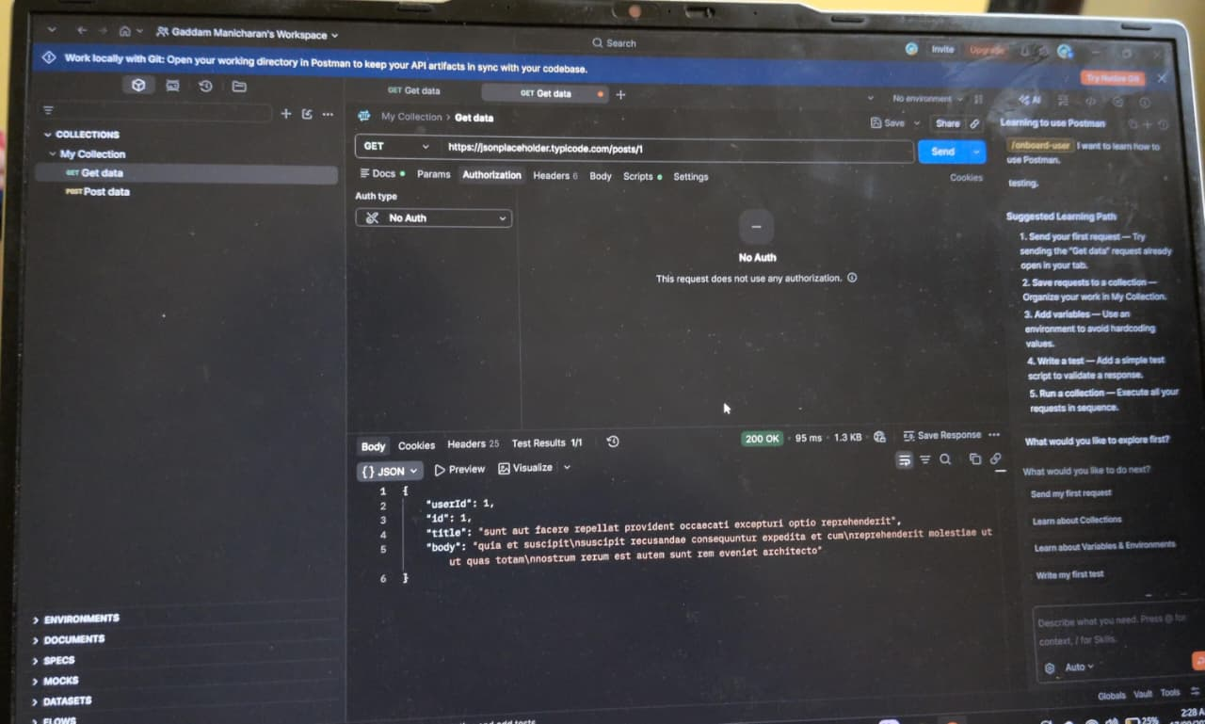
Evidence 08 — POST /posts response
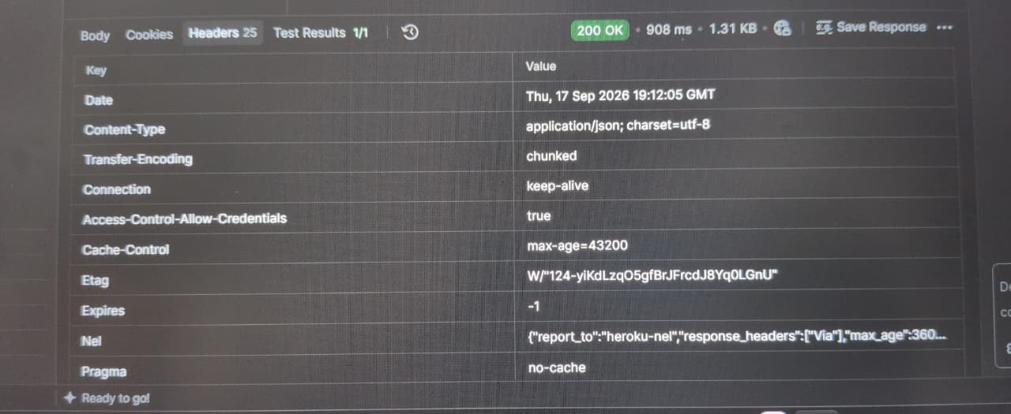
Evidence 09 — Additional response headers
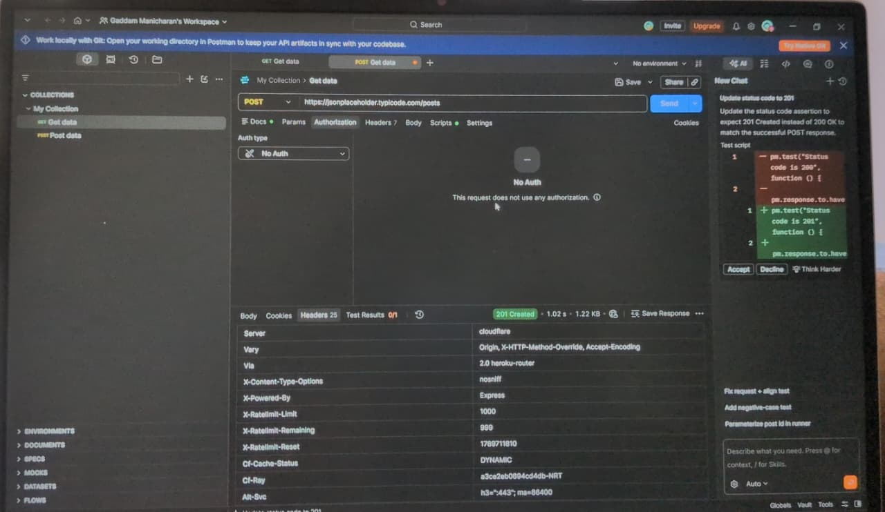
Evidence 10 — Successful POST returning 201 Created

7. Risk Assessment Summary
The following risk assessment maps the observed API behavior to practical security considerations. Because JSONPlaceholder is a public educational/demo API and the assessment was non-destructive, these items are documented as risk observations or control considerations rather than confirmed production vulnerabilities.
Risk / Observation | Severity | Business Impact | Remediation
Public / unauthenticated endpoint exposure | Low | For this demo API, public access is expected. In a production SaaS API, unintended public access to private resources could expose data. | Require authentication for non-public resources and enforce access controls server-side.
Excessive data exposure potential | Medium | User responses contain multiple fields such as contact and address information. If unnecessary fields were exposed by a real application, privacy and data-minimization risks could result. | Return only fields required by the client; apply field-level response filtering and review sensitive-data exposure.
Object-level authorization (BOLA/IDOR) requires authenticated validation | Not confirmed | If a production API allowed one user to access another user's objects, unauthorized data disclosure could occur. The demo API does not provide the authenticated multi-user context needed to confirm this. | For authenticated APIs, enforce server-side authorization on every object and test cross-user access with authorized test accounts.
Rate-limiting control observed | Low | Rate-limit headers were present in the observed responses, indicating a control exists in the demo environment. Incorrect limits in a production API could still permit abuse or resource exhaustion. | Tune limits by endpoint, identity and risk; monitor abnormal request patterns and return consistent rate-limit responses.
Server / technology information disclosure | Low | Headers exposed implementation/proxy information such as X-Powered-By and Server/Via details. This can assist basic technology fingerprinting but does not demonstrate compromise. | Minimize unnecessary technology disclosure and apply an appropriate API security header policy.
Error handling for invalid resource | Low | An invalid user ID returned HTTP 404, which is predictable and does not expose an internal stack trace in the observed response. | Standardize error responses and ensure internal details, stack traces and sensitive diagnostics are not returned.
Input validation | Not assessed | No intrusive validation or injection testing was performed. In production APIs, weak validation could affect data integrity and application security. | Validate type, format, length and allowed values on all client-supplied input, especially write operations.
Severity note: 'Low', 'Medium', and 'Not confirmed/Not assessed' reflect the limited evidence and scope of this educational assessment. They should not be interpreted as proof of exploitability in a production system.

8. Conclusion
The assessment successfully demonstrated a practical API security testing workflow using Postman. The tests covered authentication configuration, object-level access checks, data exposure review, error handling, security headers, rate limiting, and write-operation status validation.
The most important takeaway for a production SaaS environment is that successful API responses alone do not demonstrate secure authorization. Every protected object and sensitive field should be controlled by server-side authentication and authorization checks. The JSONPlaceholder results in this report are therefore treated as educational observations rather than confirmed production vulnerabilities.

9. Recommended Production Security Checklist
- Authentication required for all non-public resources.
- Server-side authorization for every object/resource.
- Least-privilege access to response fields.
- Consistent 401/403/404 error handling.
- Input validation and output schema enforcement.
- Rate limiting and abuse monitoring.
- Security headers appropriate to the API and deployment architecture.
- Centralized security logging and alerting.
- Automated API security tests in CI/CD.
- Regular penetration testing against authorized staging/production environments.

End of Report
Evidence note: The Postman screenshots already embedded in this report provide the evidence for the tested requests, responses, headers, authentication configuration, invalid-object handling, and POST operation.

