**Jenkins**

**Jenkins** is a software that allows **continuous integration**. Jenkins will be installed on a server where the central build will take place. The following flowchart demonstrates a very simple workflow of how Jenkins works

**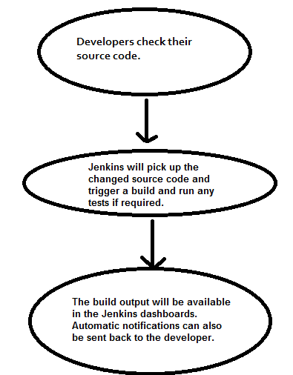**

Continuous Integration is a development practice that requires developers to integrate code into a shared repository at regular intervals. This concept was meant to remove the problem of finding later occurrence of issues in the build lifecycle. Continuous integration requires the developers to have frequent builds. The common practice is that whenever a code commit occurs, a build should be triggered.

**Installing Junkins**

Download junkins war file from the <https://jenkins-ci.org/>. Open the command prompt. From the command prompt, browse to the directory where the jenkins.war file is present. Run the following command

D:\>Java –jar Jenkins.war

After the command is run, various tasks will run, one of which is the extraction of the war file which is done by an embedded webserver called winstone.

Login into the jankins with the generated password

**Creating New Item**

Click on Add “New Item” link Enter the Item name, select “Freestyle project” and click on “OK” button

In Configure select the Git option, give the Git Repository URL & Git Credentials.

Select “GitHub hook trigger for GITScm polling” option

In build select “Execute windows batch command” option and add the command that run the project.

So whenever a code commit occurs, the build get triggered.

In Build Triggers select the option “Build periodically” and in schedule text box schedule the time based in the requirement.

What Jenkins used is a [cron expression](https://en.wikipedia.org/wiki/Cron" \l "CRON_expression), the different fields are:

1. MINUTES Minutes in one hour (0-59)
2. HOURS Hours in one day (0-23)
3. DAYMONTH Day in a month (1-31)
4. MONTH Month in a year (1-12)
5. DAYWEEK Day of the week (0-7) where 0 and 7 are sunday

If you want to schedule your build every 5 minutes, this will do the job: \*/5 \* \* \* \*

If you want to schedule your build every day at 8h00, this will do the job: 0 8 \* \* \*