#1 Created K8 cluster in GCP named as kubernetd-test.

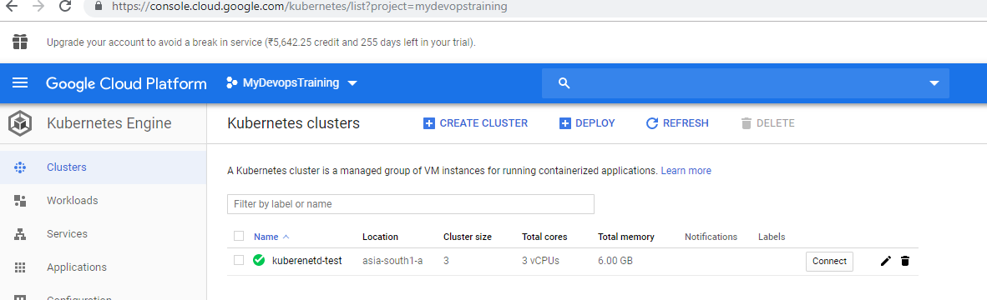

Cluster information

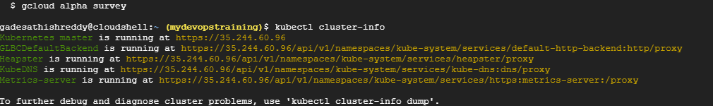

#2 Created tomcat deployment

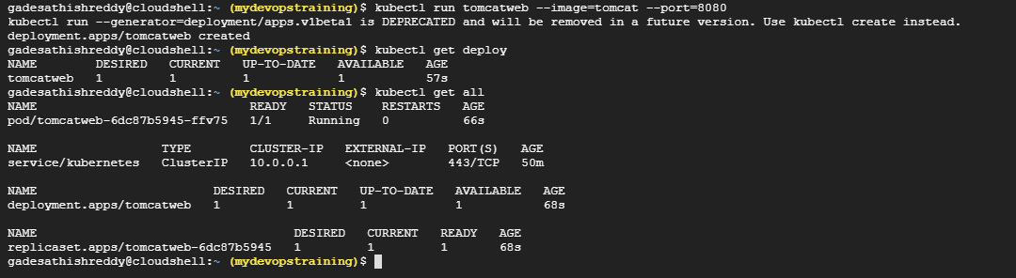

#3 Scaled up the tomcat deployment

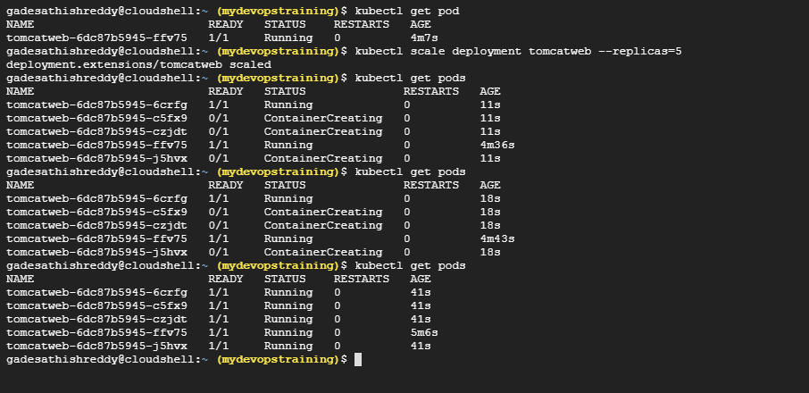

#4 expose the tomcat web to outside world using LoadBalancer

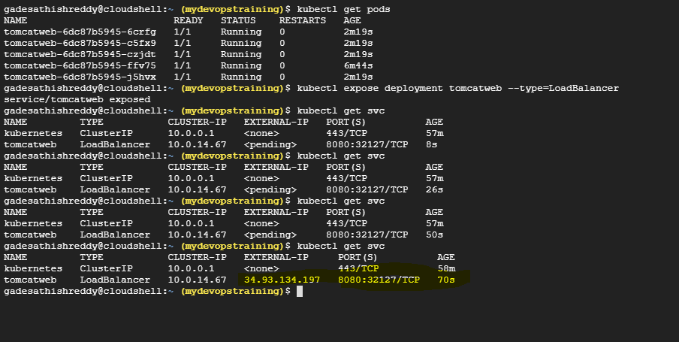

#5 accessing the tomcat from outside url

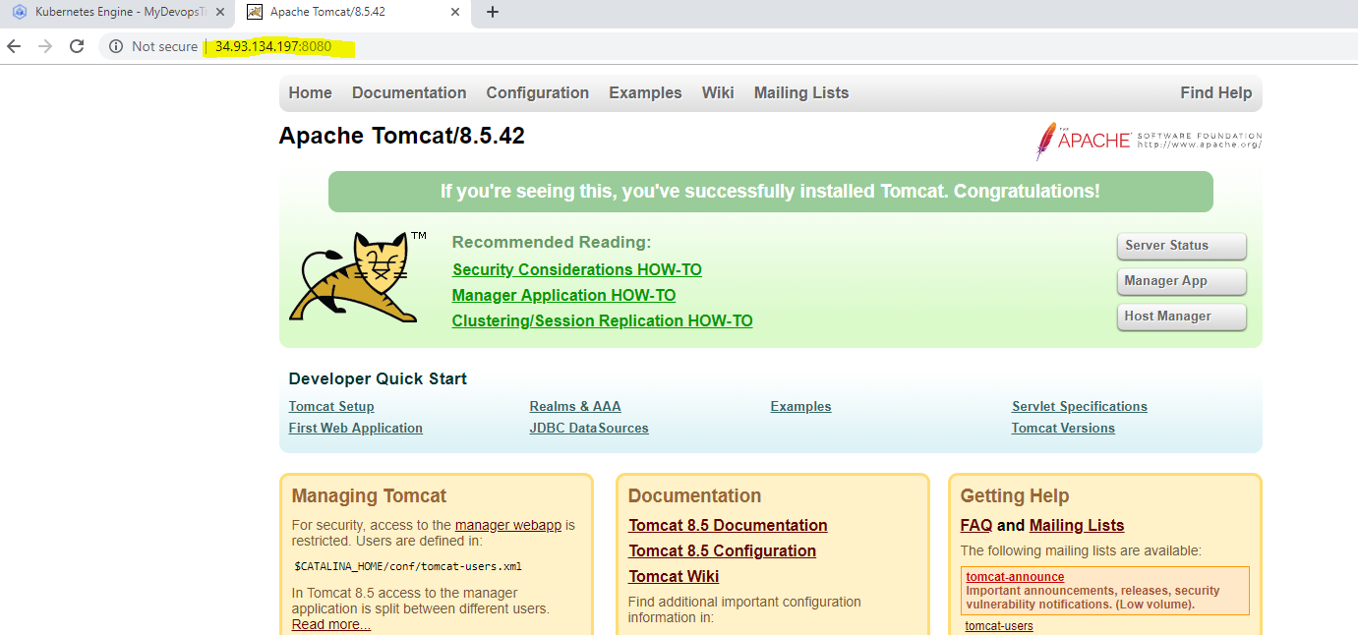

#6 Created Mongo DB deployment named as mongodb

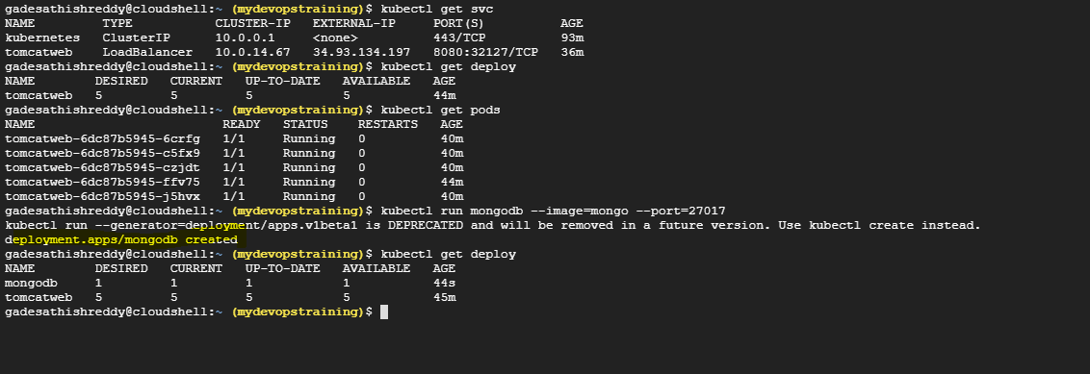

#7 Scale up the mongodb

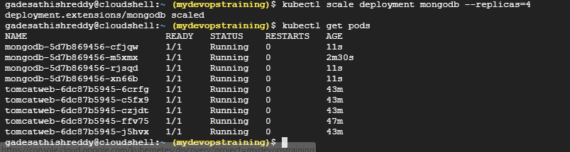

#8 Expose monogdb to outside world

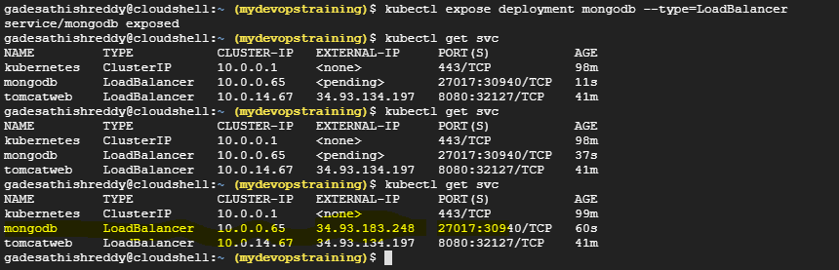

#9 accessing mango db from outside world

