Sommario

1 GES - Master data 3

1.1 F-GES-01: Room management 3

1.1.1 F-GES-01.1: Search for rooms 4

1.1.2 F-GES-01.2: View room details 4

1.1.3 F-GES-01.3: Edit room details 5

1.1.4 F-GES-01.4: Insert a new room 6

1.2 F-GES-02: Services management 7

1.2.1 F-GES-02.1: Search for services 8

1.2.2 F-GES-02.2: View service details 8

1.2.3 F-GES-02.3: Edit service details 9

1.2.4 F-GES-02.4: Insert a new service 10

1.3 F-GES-03: Customers management 11

1.3.1 F-GES-03.1: Search for customers 11

1.3.2 F-GES-03.2: View customer details 12

1.3.3 F-GES-03.3: Edit customer details 13

1.3.4 F-GES-03.4: Insert a new customer 14

1.3.5 F-GES-03.4.1: Create a new customer 14

1.4 F-GES-04: System configuration 15

1.4.1 F-GES-04.1: Search for Seasons configuration 16

1.4.2 F-GES-04.2: View season configuration details 17

1.4.3 F-GES-04.3: Edit season configuration 17

1.4.4 F-GES-04.4.a: Remove season configuration 18

1.4.5 F-GES-04.5.a: Insert a new season configuration 19

1.4.6 F-GES-04.4: View Rooms and services configuration 20

1.4.7 F-GES-04.5: Edit Rooms and services configuration 21

1.5 F-GES-05: Room services management 22

1.5.1 F-GES-05.1: View room services 22

1.5.2 F-GES-05.2: Insert new room service 23

1.5.3 F-GES-05.3: Delete room service 24

2 PRE – Booking 25

2.1 F-PRE-00: Book a room 25

2.1.1 F-PRE-01: Search for available rooms 26

2.1.2 F-PRE-02: Reserve rooms 27

2.1.3 F-PRE-02.1: Select customer 29

2.2 F-PRE-03: Blocked rooms management 29

2.2.1 F-PRE-03.0: Blocked rooms check 29

2.2.2 F-PRE-03.1: Search for blocked rooms 30

2.2.3 F-PRE-03.2: Change reservation status 31

2.3 F-PRE-07, 05, 06: Reservation Management 32

2.3.1 F-PRE-07: View reservation details 32

2.3.2 F-PRE-05: Cancel reservation 33

2.3.3 F-PRE-06.1: Edit reservation 34

2.3.4 F-PRE-06.2: Change reservation services 35

2.3.5 F-PRE-08: List customer’s reservations 36

2.4 F-PRE-04: Commissioned rooms management 37

2.4.1 F-PRE-04.1: Search for Agencies 38

2.4.2 F-PRE-04.2: View Agency details 38

2.4.3 F-PRE-04.3: Edit Agency Detail 39

2.4.4 F-PRE-04.4: Insert agency 40

2.4.5 F-PRE-04.5: Add commissioned room 41

2.4.6 F-PRE-04.6: Remove commissioned room 42

3 RIS – Restaurant 43

3.1 F-RIS-01: Management of the restaurant service for external customers 44

3.1.1 F-RIS-01.1: Search for orders 44

3.1.2 F-RIS-01.2: View order details 45

3.1.3 F-RIS-01.3: Place order 46

3.1.4 F-RIS-01.4: Add food to meal 47

3.1.5 F-RIS-01.5: Remove food from meal 48

3.1.6 F-RIS-01.6: Cancel order 49

3.1.7 F-RIS-01.7: Prepare bill 49

3.1.8 F-RIS-01.8: Print bill 50

3.1.9 F-RIS-01.9: Pay bill 51

3.2 F-RIS-02: Menu management 52

3.2.1 F-RIS-02.1: Search for menu category 52

3.2.2 F-RIS-02.2: View menu category details 53

3.2.3 F-RIS-02.3: Edit menu category details 53

3.2.4 F-RIS-02.4: Insert menu category 54

3.2.5 F-RIS-02.5: Remove menu category 55

3.2.6 F-RIS-02.6: Edit food 56

3.2.7 F-RIS-02.7: Remove food 57

3.2.8 F-RIS-02.8: Insert food 58

4 SOG – Hotel stay 59

4.1 F-SOG-01: Check-in management 59

4.1.1 F-SOG-01.1: Check-in 60

4.1.2 F-SOG-01.2: Add room guest 61

4.2 F-SOG-02: Charge for services and extra expenses per room 62

4.2.1 F-SOG-02.1: View current room services 62

4.2.2 F-SOG-02.2: Add services to current room 63

4.3 F-SOG-03: Telephone bill 64

4.4 F-SOG-04: Calculate total bill 65

4.5 F-SOG-05: Print total bill 66

4.6 F-SOG-06: Room change 67

4.7 F-SOG-07: Checkout 68

# GES - Master data

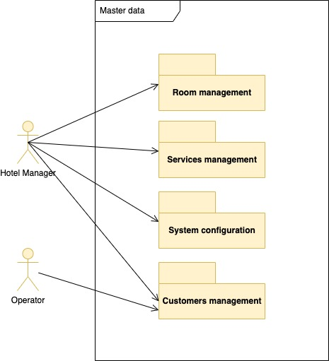

## F-GES-01: Room management

The system shall make available to the user the functions necessary to manage the rooms. It must be possible to view the rooms list, make changes to room data and insert new rooms. For each room, it must be possible to establish its base price. The hotel manager must set this price whenever he deems it appropriate. Suppose you want to change the base price of an occupied room at that moment. In that case, the system will have to notify the hotel manager with a message to prevent the customer from complaining that he/she has not paid the agreed amount.

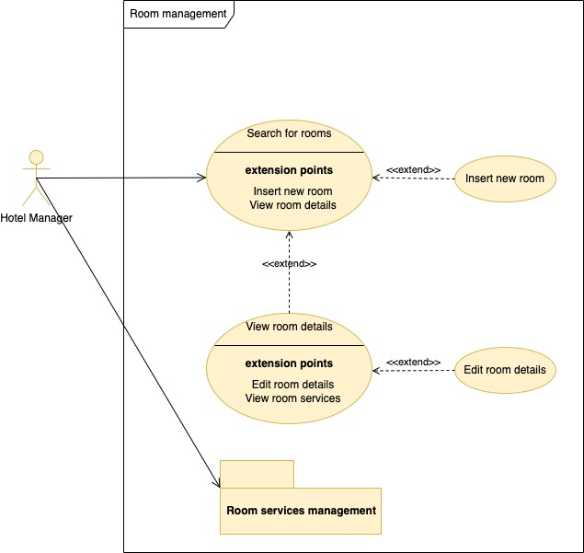

### F-GES-01.1: Search for rooms

|  |  |  |
| --- | --- | --- |
| **ID**  *UC-GES-01.1* | | *Search for rooms* |
| **Description** | | This function allows the hotel manager to view the rooms list. |
| **Primary actor** | | **Hotel manager** |
| **Supporting actors** | | **N/A** |
| **Entry Condition** | | The hotel manager is logged in |
| **Exit condition**  On success | | The rooms list is shown to the user |
| **Exit condition**  On failure | | There are no rooms that meet the search criteria |
| **Priority** | | High |
| **Extension points** | | Step No. 3 - Insert new room  Step No. 6 - View room details |
| **Generalization of** | | N/A |
| **MAIN SCENARIO** | | |
| **1** | **Hotel manager** | The hotel manager selects the sub-option "Rooms" |
| **2** | **System** | The system shows a form to search rooms by code |
| **3** | **Hotel manager** | The user optionally fills in the room code to filter the results and executes the search |
| **4** | **System** | The system searches for rooms that meet the search criteria |
| **5** | **System** | The system displays the list of rooms that meet the search criteria |
| **6** | **Hotel Manager** | The Hotel Manager browses the results. |
| **Exceptions** | | |
| **5.a1** | **System** | The system shows an error message stating that no results match the search criteria. |

### F-GES-01.2: View room details

|  |  |  |
| --- | --- | --- |
| **ID**  *UC-GES-01.2* | | *View room details* |
| **Description** | | This function allows the hotel manager to view the given room details. |
| **Primary actor** | | **Hotel manager** |
| **Supporting actors** | | **N/A** |
| **Entry Condition** | | The main scenario of UC-GES-01.1 has been executed successfully |
| **Exit condition**  On success | | The room details are shown to the Hotel Manager |
| **Exit condition**  On failure | | No room with the given code is available in persistent storage |
| **Priority** | | High |
| **Extension points** | | Step No. 3 - Edit room details  Step No. 3 – View room services |
| **Generalization of** | | N/A |
| **MAIN SCENARIO** | | |
| **1** | **Hotel manager** | The hotel manager clicks the "View room details" button relating to the room of his (or her) interest |
| **2** | **System** | The system searches for the room with the given code |
| **3** | **System** | The system shows a page with the room details: code, description, type, notes, status, view, additional beds and last valid price. |
| **Exceptions** | | |
| **3.a1** | **System** | The system shows an error message stating that no room with the given code is available in persistent storage |

### F-GES-01.3: Edit room details

|  |  |  |
| --- | --- | --- |
| **ID**  *UC-GES-01.3* | | *Edit room details* |
| **Description** | | This function allows the hotel manager to edit the given room details |
| **Primary actor** | | **Hotel manager** |
| **Supporting actors** | | **N/A** |
| **Entry Condition** | | The main scenario of UC-GES-01.2 has been successfully executed. |
| **Exit condition**  On success | | The new room details are recorded in persistent storage |
| **Exit condition**  On failure | | The new room details are not recorded in persistent storage |
| **Priority** | | High |
| **Extension points** | | N/A |
| **Generalization of** | | N/A |
| **MAIN SCENARIO** | | |
| **1** | **Hotel manager** | The hotel manager clicks the "Edit room details" button relating to the room of his (or her) interest |
| **2** | **System** | The system checks if the room is already occupied, looking up the Booked Room File. |
| **3** | **System** | The system displays a page with the Room's description and other details. |
| **4** | **Hotel manager** | The hotel manager modifies the room details fields and presses “Save”. |
| **5** | **System** | The system checks that the room description contains at least three characters and that the room price and additional beds are greater or equal to 0 and records the new room details. |
| **6** | **System** | The system displays a message indicating that the operation was successful. |
| **Alternative flow no. 1** | | |
| **3.a1** | **System** | The system shows a warning message stating that the given room is already occupied and asks the user whether to continue. |
| **4.a1** | **Hotel manager** | The hotel manager clicks the “Cancel” button. The flow of events ends. |
| **Alternative flow no. 2** | | |
| **3.b1** | **System** | The system shows a warning message stating that the given room is already occupied and asks the user whether to continue. |
| **4.b1** | **Hotel manager** | The hotel manager clicks the “Continue” button. The flow of events resumes at step no. 3 of the MAIN SCENARIO. |
| **Exceptions** | | |
| **5.a1** | **System** | The system shows an error message stating that the provided data are not valid. |
| **6.a1** | **System** | The system shows a system error message. |

### F-GES-01.4: Insert a new room

|  |  |  |
| --- | --- | --- |
| **ID**  *UC-GES-01.4* | | *Insert a new room* |
| **Description** | | This function allows the hotel manager to insert a new room. |
| **Primary actor** | | **Hotel manager** |
| **Supporting actors** | | **N/A** |
| **Entry Condition** | | The main scenario of UC-GES-01.1 has been executed successfully. |
| **Exit condition**  On success | | The new room is recorded in persistent storage |
| **Exit condition**  On failure | | The new room is not recorded in persistent storage |
| **Priority** | | High |
| **Extension points** | | N/A |
| **Generalization of** | | N/A |
| **MAIN SCENARIO** | | |
| **1** | **Hotel manager** | The hotel manager clicks the "New room" button |
| **2** | **System** | The system shows a form with the following editable fields: code, description, view, notes, type, additional beds and active price. |
| **3** | **Hotel manager** | The hotel manager fills in the code, description, type, view, additional beds, and notes fields. |
| **4** | **Hotel manager** | The hotel manager submits the form. |
| **5** | **System** | The system checks that the room code contains at least one character, the room description contains at least three characters and that the room price and additional beds are greater or equal to 0 and records the new room details. |
| **6** | **System** | The system shows a confirmation message. |
| **Exceptions** | | |
| **6.a1** | **System** | The system shows an error message stating that the provided data are not valid. |
| **6.b1** | **System** | The system shows an error message stating that the provided code already exists in persistent storage |
| **6.c1** | **System** | The system shows a system error message. |

## F-GES-02: Services management

The system shall make available to the user the functions necessary to manage the price list of the extra services. It must be possible to view the price list, make changes to the prices and insert new items. The system shall provide a particular field to manage any rare items for which it is not convenient to provide specific management.

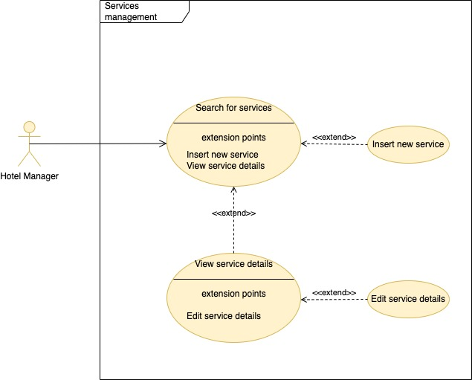

### F-GES-02.1: Search for services

|  |  |  |
| --- | --- | --- |
| **ID**  *UC-GES-02.1* | | *Search for services* |
| **Description** | | This function allows the hotel manager to view the services list. |
| **Primary actor** | | **Hotel manager** |
| **Supporting actors** | | **N/A** |
| **Entry Condition** | | The hotel manager is logged in |
| **Exit condition**  On success | | The services list is shown to the user |
| **Exit condition**  On failure | | There are no services available |
| **Priority** | | High |
| **Extension points** | | Step No. 3 - Insert new service  Step No. 6 - View service details  Step No. 6 – Select service |
| **Generalization of** | | N/A |
| **MAIN SCENARIO** | | |
| **1** | **Hotel manager** | The hotel manager clicks the sub-option "Services" |
| **2** | **System** | The system shows a form to search services by code |
| **3** | **Hotel manager** | The user optionally fills in the service code to filter the results and executes the search |
| **4** | **System** | The system searches for services that meet the search criteria |
| **5** | **System** | The system displays the list of available services |
| **6** | **System** | The Hotel Manager browses the results. |
| **Exceptions** | | |
| **5.a1** | **System** | The system shows an error message stating that no results match the search criteria. |

### F-GES-02.2: View service details

|  |  |  |
| --- | --- | --- |
| **ID**  *UC-GES-02.2* | | *View service details* |
| **Description** | | This function allows the hotel manager to view the given service details. |
| **Primary actor** | | **Hotel manager** |
| **Supporting actors** | | **N/A** |
| **Entry Condition** | | The main scenario of UC-GES-02.1 has been executed successfully. |
| **Exit condition**  On success | | The service details are shown to the Hotel Manager |
| **Exit condition**  On failure | | No service with the given code is available in persistent storage |
| **Priority** | | High |
| **Extension points** | | Step No. 3 - Edit service details |
| **Generalization of** | | N/A |
| **MAIN SCENARIO** | | |
| **1** | **Hotel manager** | The hotel manager presses ‘View service details’ relating to the service of his (or her) interest |
| **2** | **System** | The system searches for the service with the given code |
| **3** | **System** | The system shows a page with the service details: code, description, notes, and last valid price. |
| **Exceptions** | | |
| **3.a1** | **System** | The system shows an error message stating that no service with the given code is available in persistent storage |

### F-GES-02.3: Edit service details

|  |  |  |
| --- | --- | --- |
| **ID**  *UC-GES-02.3* | | *Edit service details* |
| **Description** | | This function allows the hotel manager to edit the given service details |
| **Primary actor** | | **Hotel manager** |
| **Supporting actors** | | **N/A** |
| **Entry Condition** | | The main scenario of UC-GES-02.2 has been executed successfully. |
| **Exit condition**  On success | | The new service details are recorded in persistent storage |
| **Exit condition**  On failure | | The new service details are not recorded in persistent storage |
| **Priority** | | High |
| **Extension points** | | N/A |
| **Generalization of** | | N/A |
| **MAIN SCENARIO** | | |
| **1** | **Hotel manager** | The hotel manager clicks the sub-option "Edit service details" |
| **2** | **System** | The system shows a form with the following editable fields: description, notes and active price. |
| **3** | **Hotel manager** | The hotel manager modifies the fields of his interest and presses the Save button. |
| **4** | **System** | The system checks that the service description contains at least three characters, and the service price is greater or equal to 0 and records the new service details. |
| **5** | **System** | The system shows a confirmation message. |
| **Exceptions** | | |
| **5.a1** | **System** | The system shows an error message stating that the provided data are not valid. |
| **5.b1** | **System** | The system shows a system error message. |

### F-GES-02.4: Insert a new service

|  |  |  |
| --- | --- | --- |
| **ID**  *UC-GES-02.4* | | *Insert a new service* |
| **Description** | | This function allows the hotel manager to insert a new service. |
| **Primary actor** | | **Hotel manager** |
| **Supporting actors** | | **N/A** |
| **Entry Condition** | | The main scenario of UC-GES-02.1 has been executed successfully. |
| **Exit condition**  On success | | The new service is recorded in persistent storage |
| **Exit condition**  On failure | | The new service is not recorded in persistent storage |
| **Priority** | | High |
| **Extension points** | | N/A |
| **Generalization of** | | N/A |
| **MAIN SCENARIO** | | |
| **1** | **Hotel manager** | The hotel manager clicks the "New service" button |
| **2** | **System** | The system shows a form with the following editable fields: code, description, notes and active price. |
| **3** | **Hotel manager** | The hotel manager fills in the code, description, and price fields. He (or She) optionally fills in the notes field and submits the form. |
| **4** | **System** | The system checks that the service code contains at least one character, the service description contains at least three characters, and the service price is greater or equal to 0 and records the new service details. |
| **5** | **System** | The system shows a confirmation message. |
| **Exceptions** | | |
| **5.a1** | **System** | The system shows an error message stating that the provided data are not valid. |
| **5.b1** | **System** | The system shows an error message stating that the provided code already exists in persistent storage |
| **5.c1** | **System** | The system shows a system error message. |

## F-GES-03: Customers management

The system must keep some customer data. It is also possible to search for and view the data contained in persistent storage so that the hotel manager can have helpful information whenever he (or she) needs it. The following information about customers will be in persistent storage: name, surname, and address of the customer and the number of the last room he occupied in the hotel. If a customer is already on the list, their details may be updated.

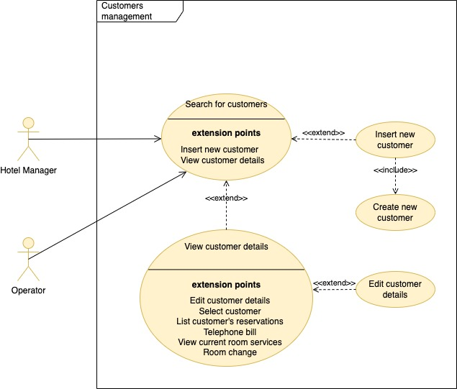

### F-GES-03.1: Search for customers

|  |  |  |
| --- | --- | --- |
| **ID**  *UC-GES-03.1* | | *Search for customers* |
| **Description** | | This function allows the user to view the customers list. |
| **Primary actor** | | **Hotel manager, Operator** |
| **Supporting actors** | | **N/A** |
| **Entry Condition** | | The user is logged in |
| **Exit condition**  On success | | The customers list is shown to the user |
| **Exit condition**  On failure | | There are no customers available |
| **Priority** | | High |
| **Extension points** | | Step No. 3 - Insert new customer  Step No. 6 - View customer details |
| **Generalization of** | | N/A |
| **MAIN SCENARIO** | | |
| **1** | **Hotel manager, Operator** | The user clicks the sub-option " Customers" |
| **2** | **System** | The system shows a form to search customers containing the following filters: surname, name, fiscal code |
| **3** | **Hotel manager, Operator** | The user optionally fills in the filters and executes the search |
| **4** | **System** | The system searches for customers that meet the search criteria |
| **5** | **System** | The system displays the list of available customers |
| **6** | **System** | The Hotel Manager browses the results. |
| **Exceptions** | | |
| **5.a1** | **System** | The system shows an error message stating that no results match the search criteria. |

### F-GES-03.2: View customer details

|  |  |  |
| --- | --- | --- |
| **ID**  *UC-GES-03.2* | | *View customer details* |
| **Description** | | This function allows the user to view the given customer details. |
| **Primary actor** | | **Hotel manager, Operator** |
| **Supporting actors** | | **N/A** |
| **Entry Condition** | | The main scenario of UC-GES-03.1 has been executed successfully. |
| **Exit condition**  On success | | The customer details are shown to the user |
| **Exit condition**  On failure | | No customer with the fiscal code is available in persistent storage |
| **Priority** | | High |
| **Extension points** | | Step No. 3 - Edit customer details  Step No. 3 - Select customer  Step No. 3 – List customer’s reservations  Step No. 3 – Telephone bill  Step No. 3 - View current room services  Step No. 3 – Room change |
| **Generalization of** | | N/A |
| **MAIN SCENARIO** | | |
| **1** | **Hotel manager, Operator** | The user clicks the "View customer details" button relating to the customer of his (or her) interest |
| **2** | **System** | The system searches for the customer with the given fiscal code |
| **3** | **System** | The system displays the customer details: surname, name, date of birth, fiscal code, address, city, email address, notes, currently occupied room and last occupied room. |
| **Exceptions** | | |
| **3.a1** | **System** | The system shows an error message stating that no customer with the given fiscal code is available in persistent storage |
| **3.b1** | **System** | The system shows a system error message. |

### F-GES-03.3: Edit customer details

|  |  |  |
| --- | --- | --- |
| **ID**  *UC-GES-03.3* | | *Edit customer details* |
| **Description** | | This function allows the user to edit the given customer details |
| **Primary actor** | | **Hotel manager, Operator** |
| **Supporting actors** | | **N/A** |
| **Entry Condition** | | The main scenario of UC-GES-03.2 has been executed successfully. |
| **Exit condition**  On success | | The new customer details are recorded in persistent storage |
| **Exit condition**  On failure | | The new customer details are not recorded in persistent storage |
| **Priority** | | High |
| **Extension points** | | N/A |
| **Generalization of** | | N/A |
| **MAIN SCENARIO** | | |
| **1** | **Hotel manager, Operator** | The user clicks the sub-option "Edit customer details" |
| **2** | **System** | The system shows a form with the following editable fields: surname, name, date of birth, fiscal code, address, city, and notes. |
| **3** | **Hotel manager, Operator** | The user modifies the fields of his interest and presses the Save button. |
| **4** | **System** | The system checks that: the surname and name fields contain at least two characters, the fiscal code field is valid, the date of birth is correct, and records the new customer details. |
| **5** | **System** | The system shows a confirmation message. |
| **Exceptions** | | |
| **5.a1** | **System** | The system shows an error message stating that the provided data are not valid. |
| **5.b1** | **System** | The system shows a system error message. |

### F-GES-03.4: Insert a new customer

|  |  |  |
| --- | --- | --- |
| **ID**  *UC-GES-03.4* | | *Insert a new customer* |
| **Description** | | This function allows the user to insert a new customer. |
| **Primary actor** | | **Hotel manager, Operator** |
| **Supporting actors** | | **N/A** |
| **Entry Condition** | | The main scenario of UC-GES-03.1 has been executed successfully. |
| **Exit condition**  On success | | The new customer is recorded in persistent storage |
| **Exit condition**  On failure | | The new customer is not recorded in persistent storage |
| **Priority** | | High |
| **Extension points** | | N/A |
| **Generalization of** | | N/A |
| **MAIN SCENARIO** | | |
| **1** | **Hotel manager, Operator** | The user clicks the "New customer" button |
| **2** | **System** | The system shows a form with the following editable fields: surname, name, date of birth, fiscal code, address, city, and notes. |
| **3** | **Hotel manager, Operator** | Include UC-GES-03.4.1. (Insertion of the new customer details in the persistent storage) |
| **4** | **System** | The system shows a confirmation message. |
| **Exceptions** | | |
| **4.a1** | **System** | The system shows an error message stating that the provided data are not valid. |
| **4.b1** | **System** | The system shows an error message stating that the provided fiscal code already exists in persistent storage |
| **4.c1** | **System** | The system shows a system error message. |

### F-GES-03.4.1: Create a new customer

|  |  |  |
| --- | --- | --- |
| **ID**  *UC-GES-03.4.1* | | *Create a new customer* |
| **Description** | | This function allows the user to insert a new customer. |
| **Primary actor** | | **Hotel manager, Operator** |
| **Supporting actors** | | **N/A** |
| **Entry Condition** | | The main scenario of UC-GES-03.1 has been executed successfully  OR  The alternative scenario no. 1 of UC-PRE- 01 is executing |
| **Exit condition**  On success | | The new customer is recorded in persistent storage |
| **Exit condition**  On failure | | The new customer is not recorded in persistent storage |
| **Priority** | | High |
| **Extension points** | | N/A |
| **Generalization of** | | N/A |
| **MAIN SCENARIO** | | |
| **1** | **Hotel manager, Operator** | The user fills in the surname, name, date of birth, address, city, email address, fiscal code fields, and optionally the notes field and submits the form. |
| **2** | **System** | The system checks that: the surname and name fields contain at least two characters, the fiscal code field is valid, the date of birth is correct, the email address is valid and records the new customer in persistent storage. |

## F-GES-04: System configuration

Some parameters and data that the system uses to carry out the activities for which it will be developed must able to be set by the hotel manager. Therefore, the system shall be configured according to the user's needs.

The following settings shall be required:

* start and end dates of the various seasons;
* discounts and reductions for infants and children;
* maximum duration for which a room can remain blocked;
* supplement for the various seasons;
* the cost of a phone call.

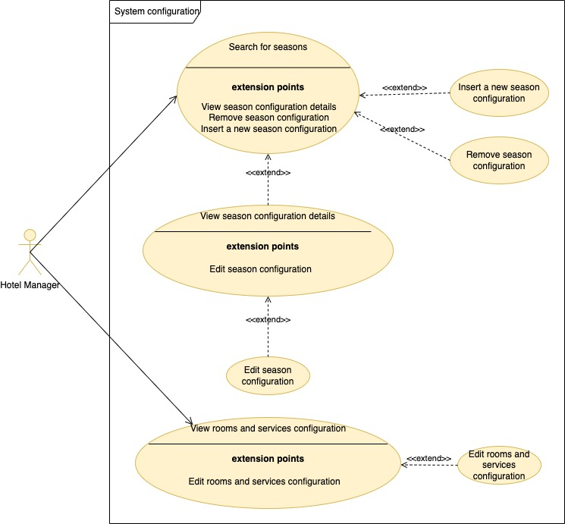

### F-GES-04.1: Search for Seasons configuration

|  |  |  |
| --- | --- | --- |
| **ID**  *UC-GES-04.1* | | *Search for Seasons configuration* |
| **Description** | | This function allows the user to view the seasons configuration. |
| **Primary actor** | | **Hotel manager** |
| **Supporting actors** | | **N/A** |
| **Entry Condition** | | The hotel manager is logged in |
| **Exit condition**  On success | | The configuration is shown to the user. |
| **Exit condition**  On failure | | There are no seasons configured in the persistent storage |
| **Priority** | | Low |
| **Extension points** | | Step no. 4 – View season configuration details  Step no. 4 – Remove season configuration  Step no. 4 – Insert a new season configuration |
| **Generalization of** | | N/A |
| **MAIN SCENARIO** | | |
| **1** | **Hotel manager** | The actor clicks “Seasons Configuration” to view all configured seasons. |
| **2** | **System** | The system searches for the configured seasons in persistent storage. |
| **3** | **System** | The system displays the list of configured seasons. |
| **4** | **Hotel manager** | The user browses the result |
| **Exceptions** | | |
| **5.a1** | **System** | The system shows an error message stating that no results were found. |

### F-GES-04.2: View season configuration details

|  |  |  |
| --- | --- | --- |
| **ID**  *UC-GES-04.2* | | *View season configuration details* |
| **Description** | | This function allows the hotel manager to view the given season configuration details. |
| **Primary actor** | | **Hotel manager** |
| **Supporting actors** | | **N/A** |
| **Entry Condition** | | The main scenario of UC-GES-04.1 has been executed successfully. |
| **Exit condition**  On success | | The configured season details are shown to the user |
| **Exit condition**  On failure | | No configured season with the given ID is available in persistent storage |
| **Priority** | | Low |
| **Extension points** | | Step No. 3 – Edit season configuration |
| **Generalization of** | | N/A |
| **MAIN SCENARIO** | | |
| **1** | **Hotel manager** | The hotel manager clicks ‘View season configuration details’ relating to the configuration of his (or her) interest |
| **2** | **System** | The system searches for the season configuration with the given ID |
| **3** | **System** | The system shows a page with the season configuration details: ID, description, start date, end date, supplement. |
| **Exceptions** | | |
| **3.a1** | **System** | The system shows an error message stating that no configuration with the given ID is available in persistent storage |
| **3.b1** | **System** | The system shows a system error message. |

### F-GES-04.3: Edit season configuration

|  |  |  |
| --- | --- | --- |
| **ID**  *UC-GES-04.3* | | *Edit season configuration* |
| **Description** | | This function allows the hotel manager to edit the given season configuration |
| **Primary actor** | | **Hotel manager** |
| **Supporting actors** | | **N/A** |
| **Entry Condition** | | The main scenario of UC-GES-04.2 has been executed successfully. |
| **Exit condition**  On success | | The new season configuration details are recorded in persistent storage |
| **Exit condition**  On failure | | The new season configuration details are not recorded in persistent storage |
| **Priority** | | Low |
| **Extension points** | | N/A |
| **Generalization of** | | N/A |
| **MAIN SCENARIO** | | |
| **1** | **Hotel manager** | The hotel manager clicks the sub-option "Edit configuration" |
| **2** | **System** | The system shows a form with the following editable fields: description, start date, end date and supplement. |
| **3** | **Hotel manager** | The hotel manager modifies the fields of his interest and presses the Save button. |
| **4** | **System** | The system checks that the season description contains at least three characters, the supplement is greater or equal to 0, the date interval is valid and records the new season configuration details. |
| **5** | **System** | The system shows a confirmation message. |
| **Exceptions** | | |
| **5.a1** | **System** | The system shows an error message stating that the provided data are not valid. |
| **5.b1** | **System** | The system shows a system error message. |

### F-GES-04.4.a: Remove season configuration

|  |  |  |
| --- | --- | --- |
| **ID**  *UC-GES-04.4.a* | | *Remove season configuration* |
| **Description** | | This function allows the hotel manager to remove the given season configuration |
| **Primary actor** | | **Hotel manager** |
| **Supporting actors** | | **N/A** |
| **Entry Condition** | | The main scenario of UC-GES-04.1 has been executed successfully. |
| **Exit condition**  On success | | The given season configuration has been removed from persistent storage |
| **Exit condition**  On failure | | The given season configuration has not been removed from persistent storage |
| **Priority** | | Low |
| **Extension points** | | N/A |
| **Generalization of** | | N/A |
| **MAIN SCENARIO** | | |
| **1** | **Hotel manager** | The hotel manager clicks the "Delete configuration" button relating to the configuration of his (or her) interest |
| **2** | **System** | The system asks the user to confirm the operation. |
| **3** | **Hotel manager** | The hotel manager clicks the “Confirm” button. |
| **4** | **System** | The system removes the given season configuration from the persistent storage |
| **5** | **System** | The system shows a confirmation message. |
| **Alternative flow no. 1** | | |
| **3** | **Hotel manager** | The hotel manager clicks the “Undo” button. The flow of events ends. |
| **Exceptions** | | |
| **5.a1** | **System** | The system shows a system error message. |

### F-GES-04.5.a: Insert a new season configuration

|  |  |  |
| --- | --- | --- |
| **ID**  *UC-GES-04.5.a* | | *Insert a new season configuration* |
| **Description** | | This function allows the hotel manager to insert a new season configuration. |
| **Primary actor** | | **Hotel manager** |
| **Supporting actors** | | **N/A** |
| **Entry Condition** | | The main scenario of UC-GES-04.1 has been executed successfully. |
| **Exit condition**  On success | | The new season configuration is recorded in persistent storage |
| **Exit condition**  On failure | | The new season configuration is not recorded in persistent storage |
| **Priority** | | Low |
| **Extension points** | | N/A |
| **Generalization of** | | N/A |
| **MAIN SCENARIO** | | |
| **1** | **Hotel manager** | The hotel manager clicks the sub-option "New configuration" |
| **2** | **System** | The system shows a form with the following editable fields: ID, description, start date, end date and supplement. |
| **3** | **Hotel manager** | The hotel manager fills in the ID, description, start date, end date, and supplement fields and submits the form. |
| **4** | **System** | The system checks that the configuration ID contains at least one character, the configuration description contains at least three characters, the date interval is valid, and the supplement is greater or equal to 0 and records the new season configuration. |
| **5** | **System** | The system shows a confirmation message. |
| **Exceptions** | | |
| **5.a1** | **System** | The system shows an error message stating that the provided data are not valid. |
| **5.b1** | **System** | The system shows an error message stating that the provided ID already exists in persistent storage |
| **5.c1** | **System** | The system shows a system error message. |

### F-GES-04.4: View Rooms and services configuration

|  |  |  |
| --- | --- | --- |
| **ID**  *UC-GES-04.4* | | *View Rooms and services configuration* |
| **Description** | | This function allows the user to view the rooms and services configuration. |
| **Primary actor** | | **Hotel manager** |
| **Supporting actors** | | **N/A** |
| **Entry Condition** | | The hotel manager is logged in |
| **Exit condition**  On success | | The configuration is shown to the user. |
| **Exit condition**  On failure | | There are no configured parameters in the persistent storage |
| **Priority** | | Low |
| **Extension points** | | Step no. 4 – Edit rooms and services configuration |
| **Generalization of** | | N/A |
| **MAIN SCENARIO** | | |
| **1** | **Hotel manager** | The actor clicks “Rooms and Services Configuration” to list “rooms and services” configuration. |
| **2** | **System** | The system searches for the Rooms and Services configuration in persistent storage. |
| **3** | **System** | The system displays the configuration details |
| **4** | **Hotel manager** | The user reviews the result |
| **Exceptions** | | |
| **3.a1** | **System** | The system shows an error message stating that no results were found. |

### F-GES-04.5: Edit Rooms and services configuration

|  |  |  |
| --- | --- | --- |
| **ID**  *UC-GES-04.5* | | *Edit rooms and services configuration* |
| **Description** | | This function allows the hotel manager to edit the rooms and services configuration |
| **Primary actor** | | **Hotel manager** |
| **Supporting actors** | | **N/A** |
| **Entry Condition** | | The main scenario of UC-GES-04.4 has been executed successfully. |
| **Exit condition**  On success | | The new details are recorded in persistent storage |
| **Exit condition**  On failure | | The new details are not recorded in persistent storage |
| **Priority** | | Low |
| **Extension points** | | N/A |
| **Generalization of** | | N/A |
| **MAIN SCENARIO** | | |
| **1** | **Hotel manager** | The hotel manager clicks the sub-option "Edit configuration" |
| **2** | **System** | The system shows a form with the following editable fields: maximum duration for blocked rooms, infants discount, children discount, and cost of a phone call. |
| **3** | **Hotel manager** | The hotel manager modifies the fields of his interest and presses the Save button. |
| **4** | **System** | The system checks that the infants discount, children discounts, and phone call cost are greater or equal to 0, the maximum duration is greater than 0, and records the new rooms and services configuration. |
| **5** | **System** | The system shows a confirmation message. |
| **Exceptions** | | |
| **5.a1** | **System** | The system shows an error message stating that the provided data are not valid. |
| **5.b1** | **System** | The system shows a system error message. |

## F-GES-05: Room services management

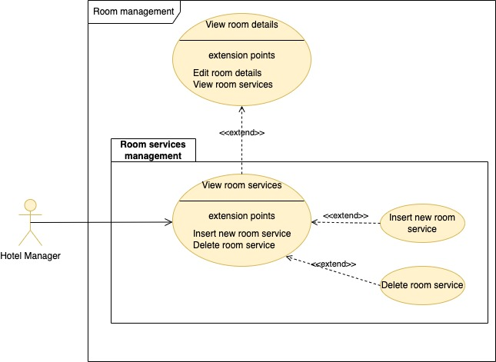

### F-GES-05.1: View room services

|  |  |  |
| --- | --- | --- |
| **ID**  *UC-GES-05.1* | | *View room services* |
| **Description** | | This function allows the hotel manager to view the services assigned to a given room. |
| **Primary actor** | | **Hotel manager** |
| **Supporting actors** | | **N/A** |
| **Entry Condition** | | The main scenario of UC-GES-01.2 has been successful executed |
| **Exit condition**  On success | | The services assigned to the given room are shown to the user |
| **Exit condition**  On failure | | There are no services assigned to the given room |
| **Priority** | | High |
| **Extension points** | | Step No. 4 - Insert new room service  Step No. 4 - Delete room service |
| **Generalization of** | | N/A |
| **MAIN SCENARIO** | | |
| **1** | **Hotel manager** | The hotel manager clicks the "View services" link for the given room |
| **2** | **System** | The system searches for the assigned services of the given room. |
| **3** | **System** | The system displays the list of assigned services of the given room |
| **4** | **Hotel Manager** | The Hotel Manager browses the results. |
| **Exceptions** | | |
| **3.a1** | **System** | The system shows an error message stating that no results match the search criteria. |

### F-GES-05.2: Insert new room service

|  |  |  |
| --- | --- | --- |
| **ID**  *UC-GES-05.2* | | *Insert new room service* |
| **Description** | | This function allows the hotel manager to assign a new service to the room |
| **Primary actor** | | **Hotel manager** |
| **Supporting actors** | | **N/A** |
| **Entry Condition** | | The main scenario of UC-GES-05.1 has been successful executed |
| **Exit condition**  On success | | The new service is assigned to the given room |
| **Exit condition**  On failure | | The new service is not saved in the persistent storage |
| **Priority** | | High |
| **Extension points** | | N/A |
| **Generalization of** | | N/A |
| **MAIN SCENARIO** | | |
| **1** | **Hotel manager** | Include UC-GES-02.1 (The hotel manager searches for available services). |
| **2** | **Hotel manager** | The hotel manager fills in the service of his (or her) interest to send to the system. |
| **3** | **System** | The system refreshes the list. |
| **3** | **Hotel Manager** | The hotel manager clicks the “Save” button |
| **4** | **System** | The system saves the changes to the Room Services file. |
| **5** | **System** | The system displays a confirmation message. |
| **Alternative flow no. 1** | | |
| **3.a1** | **Hotel Manager** | The user clicks the “Undo” button |
| **4.a1** | **System** | The system refreshes the list. The flow of events ends. |
| **Alternative Flow no. 2** | | |
| **2.a1** | **Hotel manager** | There are no available services, therefore the Hotel manager clicks the close button. The flow of events ends. |
| **Exceptions** | | |
| **5.a1** | **System** | The system shows an error message. |

### F-GES-05.3: Delete room service

|  |  |  |
| --- | --- | --- |
| **ID**  *UC-GES-05.3* | | *Delete room service* |
| **Description** | | This function allows the hotel manager to delete a service assigned to the given room |
| **Primary actor** | | **Hotel manager** |
| **Supporting actors** | | **N/A** |
| **Entry Condition** | | The main scenario of UC-GES-05.1 has been successful executed |
| **Exit condition**  On success | | The service is removed from the persistent storage |
| **Exit condition**  On failure | | The service is not removed in the persistent storage |
| **Priority** | | High |
| **Extension points** | | N/A |
| **Generalization of** | | N/A |
| **MAIN SCENARIO** | | |
| **1** | **Hotel manager** | The hotel manager clicks the “Delete” button regarding the service of his(or her) interest |
| **2** | **System** | The system asks the user to confirm or not the operation |
| **3** | **Hotel Manager** | The hotel manager confirms the operation |
| **4** | **System** | The system removes the selected service from the list of assigned services to the given room |
| **5** | **System** | The system displays a confirmation message. |
| **Alternative flow no. 1** | | |
| **3.a1** | **Hotel Manager** | The user does not confirm the operation. The flow of events ends. |
| **Exceptions** | | |
| **5.a1** | **System** | The system shows an error message. |

# PRE – Booking

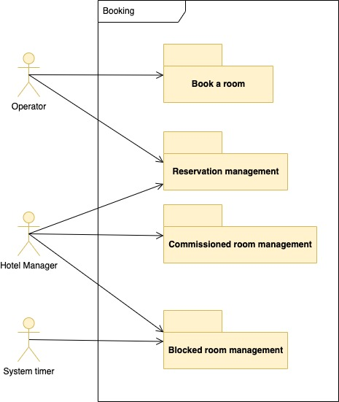

## F-PRE-00: Book a room

The system shall allow listing all the rooms available in the period requested by the customer. Suppose there are no rooms available precisely in that period. In that case, the system shall show other availabilities so that the operator can suggest to the customer how to change the period of stay. This period is a time interval expressed as days between two dates. For example, from 05/07/1998 to 11/07/1998, there is a 7-day stay, having the room vacated on 12/07/1998 in the morning; therefore, starting from that day, the room will be available for any other reservations. In the event of no exact availability, the system shall show a table highlighting the requested availability of the hotel.

Searching for available rooms must consider the constraints imposed, such as blocked, assigned, or commissioned rooms to travel agencies.

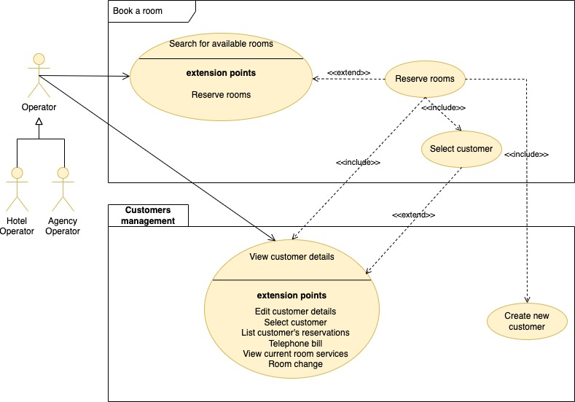

|  |  |  |
| --- | --- | --- |
| **ID**  *UC-PRE-01* | | *Book a room* |
| **Description** | | This function allows the operator (hotel operator or agency operator) to book a room |
| **Primary actor** | | **Operator (Hotel operator or Agency operator)** |
| **Supporting actors** | | **N/A** |
| **Entry Condition** | | The operator is logged in |
| **Exit condition**  On success | | The new reservation is saved in persistent storage |
| **Exit condition**  On failure | | The reservation is not saved in persistent storage |
| **Priority** | | High |
| **Extension points** | | N/A |
| **Generalization of** | | N/A |
| **MAIN SCENARIO** | | |
| **1** | **Operator** | The user selects the “Book a room” Link |
| **2** | **System** | The system displays a form containing the room filters. |
| **3** | **Operator** | The user fills in the filters. |
| **4** | **Operator** | Include UC-PRE-01 (Search for available rooms) |
| **5** | **Operator** | Include UC-PRE-02 (Reserve rooms) |
| **Alternative flow no. 1** | | |
| **4.a1** | **Operator** | The user selects one or more children. |
| **5.a1** | **System** | The system presents drop-down lists to specify every child’s age. The flow of events resumes at step no. 5 of the main scenario. |

### F-PRE-01: Search for available rooms

|  |  |  |
| --- | --- | --- |
| **ID**  *UC-PRE-01* | | *Search for available rooms* |
| **Description** | | This function allows the operator (hotel operator or agency operator) to view the available rooms list in a specific date interval. |
| **Primary actor** | | **Operator (Hotel operator or Agency operator)** |
| **Supporting actors** | | **N/A** |
| **Entry Condition** | | The operator is logged in |
| **Exit condition**  On success | | The available rooms list is shown to the user |
| **Exit condition**  On failure | | There are no rooms available |
| **Priority** | | High |
| **Extension points** | | Step no. 7 – Reserve rooms |
| **Generalization of** | | N/A |
| **MAIN SCENARIO** | | |
| **1** | **Operator** | The user clicks the “Search Availability” button. |
| **2** | **System** | The system validates the given filters. |
| **3** | **System** | The system searches for all rooms of the given type to accommodate the guests. |
| **4** | **System** | For each room, the system checks if it is in the Commission file in the given date interval. |
| **5** | **System** | For each room, the system searches for the unbooked dates in the Booked rooms file. |
| **6** | **System** | The system lists the available rooms |
| **7** | **Operator** | The user browses the results. |
| **Exceptions** | | |
| **6.a1** | **System** | The system shows an error message stating that no results have been found. |
| **6.b1** | **System** | The system shows a system error message. |

### F-PRE-02: Reserve rooms

|  |  |  |
| --- | --- | --- |
| **ID**  *UC-PRE-02* | | *Reserve rooms* |
| **Description** | | This function allows the operator (hotel operator or agency operator) to reserve rooms. |
| **Primary actor** | | **Operator (hotel operator, agency operator)** |
| **Supporting actors** | | **N/A** |
| **Entry Condition** | | The main scenario of UC-PRE-01 has been executed successfully |
| **Exit condition**  On success | | The reservation is recorded in persistent storage |
| **Exit condition**  On failure | | The reservation is not recorded in persistent storage |
| **Priority** | | High |
| **Extension points** | | N/A |
| **Generalization of** | | N/A |
| **MAIN SCENARIO** | | |
| **1** | **Operator** | The actor clicks the “Reserve rooms” relating to the rooms of his interest. |
| **2** | **System** | The system reads from persistent storage the room details and searches for the requestable room services for the selected rooms. |
| **3** | **System** | The system lists the selected rooms. For each room, the system lists the requestable services. |
| **4** | **Operator** | The user presses “Reservation” relating to the reservation details of his interest. |
| **5** | **System** | The system searches for supplements in Configured season file.  The system lists the reservation details and shows a blank formatted screen to insert the customer's details. |
| **6** | **Operator** | The user fills in the fiscal code field and executes the main scenario of UC-GES-03.2. |
| **7** | **Operator** | Include UC-PRE-02.1 (Select customer) |
| **8** | **Operator** | The user optionally enters the customer’s details and fills in the selection for the reservation details. |
| **9** | **System** | The system updates the customer’s details if needed. |
| **10** | **System** | The system searches for the season configuration in the given interval. The system stores the reservation header.  In addition, the system stores the booked rooms for the given date interval, then saves the requested services for the booked rooms and saves the children's ages for the reservation. |
| **11** | **System** | The system shows a confirmation message |
| **Alternative flow no. 1: no customers found with the given fiscal code** | | |
| **7.a1** | **Operator** | Include UC-GES-03.4.1 (Since no customers with the given fiscal code have been found, the user inserts the new customer details). The flow of events resumes at step no. 9 of the main scenario. |
| **Alternative flow no. 2: the customer requests to cancel the reservation** | | |
| **3.a1** | **Operator** | The user presses the Close button. The flow of events ends. |
| **Alternative flow no. 3: the customer requests to cancel the reservation after confirming the room** | | |
| **6.a1** | **Operator** | The user presses the Close button. |
| **7.a2** | **System** | The flow of events ends. |
| **Exceptions** | | |
| **5.a1** | **System** | The system shows an error message stating that the selected room(s) is (are) already occupied. |
| **5.b1** | **System** | The system shows a system error message. |
| **9.c1** | **System** | The system shows a system error message. |
| **10.d1** | **System** | The system shows a system error message. |

### F-PRE-02.1: Select customer

|  |  |  |
| --- | --- | --- |
| **ID**  *UC-PRE-02.1* | | *Select customer* |
| **Description** | | This function allows the user to select the given customer details. |
| **Primary actor** | | **Hotel manager, Operator** |
| **Supporting actors** | | **N/A** |
| **Entry Condition** | | The main scenario of UC-GES-02.2 has been executed successfully AND  The user is executing the main scenario of UC-PRE-02 |
| **Exit condition**  On success | | The user selects the customer details  OR  the user cancels the operation. |
| **Exit condition**  On failure | | N/A |
| **Priority** | | High |
| **Extension points** | | N/A |
| **Generalization of** | | N/A |
| **MAIN SCENARIO** | | |
| **1** | **Hotel manager, Operator** | The user clicks the "Select" sub-option |
| **2** | **System** | The system displays a formatted screen for the customer’s details. |

## F-PRE-03: Blocked rooms management

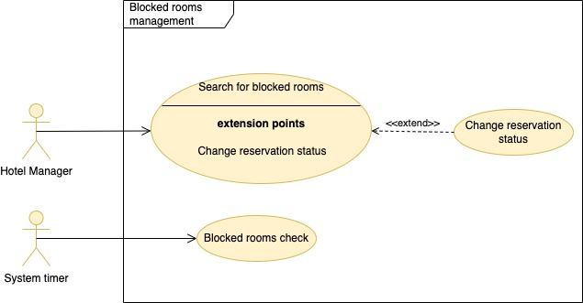

### F-PRE-03.0: Blocked rooms check

|  |  |  |
| --- | --- | --- |
| **ID**  *UC-PRE-03.0* | | *Blocked rooms management* |
| **Description** | | Rooms are blocked at the time of booking and will remain in that state for a certain period set by the hotel manager. After this period, the system shall inform the user that the room has been blocked for too long. Therefore, the user can find out if the delay is due to a customer's mishap or if he (or she) no longer intends to stay in the hotel. Once the customer's deposit has arrived, it must be possible to switch the room from blocked to assigned. In the first case, the blocking of the room will be renewed, while in the second case, the reservation will be canceled. This function inserts in the Blocked Rooms Warnings file the reservations that have to be processed by the Hotel Manager. |
| **Primary actor** | | **System timer** |
| **Supporting actors** | | **N/A** |
| **Entry Condition** | | At 00:00 every day |
| **Exit condition**  On success | | The warnings for the blocked rooms are saved. |
| **Exit condition**  On failure | | N/A |
| **Priority** | | High |
| **Extension points** | | N/A |
| **Generalization of** | | N/A |
| **MAIN SCENARIO** | | |
| **1** | **System timer** | The system timer ticks and requests the system to check if there are blocked rooms to process. |
| **2** | **System** | The system searches for the maximum amount of time rooms may be blocked in Rooms and Services configuration file.  The system looks for reservations with the status "Reserved" or "In progress" booked for more than the maximum length of time. |
| **3** | **System** | The system empties the Blocked Rooms Warnings file. |
| **4** | **System** | The system saves the reservations' IDs in the Blocked Rooms Warnings file. |
| **Alternative flow no. 1** | | |
| **4** | **System** | No reservations have been found for the search criteria. The flow of events ends. |

### F-PRE-03.1: Search for blocked rooms

|  |  |  |
| --- | --- | --- |
| **ID**  *UC-PRE-03.1* | | *Search for blocked rooms* |
| **Description** | | This function lets the user know when rooms are blocked over the configured amount of time. |
| **Primary actor** | | **Hotel Manager** |
| **Supporting actors** | | **N/A** |
| **Entry Condition** | | The user is logged in |
| **Exit condition**  On success | | No blocked rooms need to be processed |
| **Exit condition**  On failure | | N/A |
| **Priority** | | High |
| **Extension points** | | Step no. 4 – Change reservation status |
| **Generalization of** | | N/A |
| **MAIN SCENARIO** | | |
| **1** | **Hotel Manager** | The hotel manager clicks "Blocked rooms warnings" to list all the “blocked rooms” |
| **2** | **System** | The system searches for the reservations whose IDs are in the Blocked Rooms Warnings file. |
| **3** | **System** | The system shows a list of reservations to be processed. |
| **4** | **Hotel Manager** | The user browses the results. |
| **Exceptions** | | |
| **3** | **System** | The system shows an error message stating that no results match the search criteria. |

### F-PRE-03.2: Change reservation status

|  |  |  |
| --- | --- | --- |
| **ID**  *UC-PRE-03.2* | | *Change reservation status* |
| **Description** | | This function allows the user to change the given reservation status from “Reserved” to “Assigned” or extend the blocking period. |
| **Primary actor** | | **Hotel manager, Operator** |
| **Supporting actors** | | **N/A** |
| **Entry Condition** | | The main scenario of UC-PRE-03.1 has been successful executed |
| **Exit condition**  On success | | The new reservation status is recorded |
| **Exit condition**  On failure | | The reservation status does not change. |
| **Priority** | | High |
| **Extension points** | | N/A |
| **Generalization of** | | N/A |
| **MAIN SCENARIO** | | |
| **1** | **Hotel manager, Operator** | The user clicks the "Change status" button for the given reservation ID |
| **2** | **System** | The system shows a form containing the new status field having the following items: “Assigned,” “Extended.” |
| **3** | **Hotel manager, Operator** | The user selects the new status and submits the form. |
| **4** | **System** | The system updates the given reservation header with the new status. |
| **5** | **System** | The system displays a confirmation message. |
| **Exceptions** | | |
| **5.a1** | **System** | The system shows an error message stating that no reservation with the given ID is available in persistent storage or that the status of the given reservation is inconsistent. |
| **5.b1** | **System** | The system shows a system error message. |

## F-PRE-07, 05, 06: Reservation Management

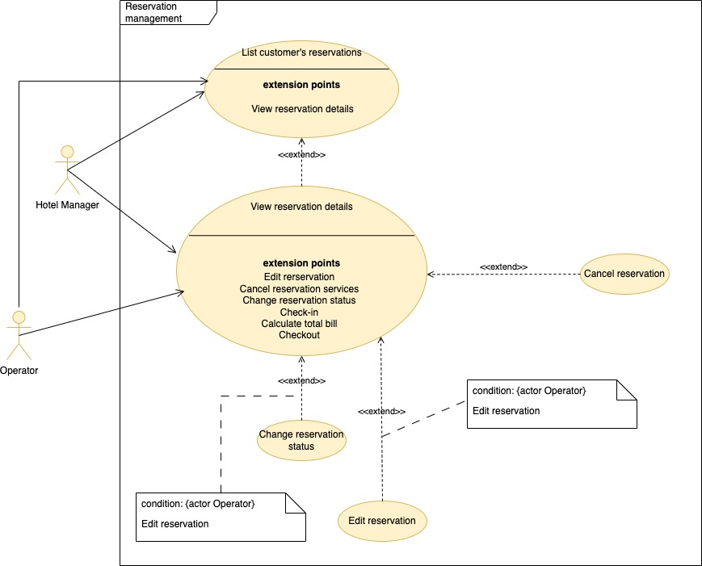

### F-PRE-07: View reservation details

|  |  |  |
| --- | --- | --- |
| **ID**  *UC-PRE-07* | | *View reservation details* |
| **Description** | | This function allows the user to view the given reservation details. |
| **Primary actor** | | **Hotel manager, Operator** |
| **Supporting actors** | | **N/A** |
| **Entry Condition** | | The main scenario of UC-PRE-08 has been successful executed |
| **Exit condition**  On success | | The reservation details are shown to the user |
| **Exit condition**  On failure | | No reservation for the given ID is available in persistent storage |
| **Priority** | | High |
| **Extension points** | | Step No. 3 - Edit reservation  Step No. 3 – Cancel reservation services  Step No. 3 – Change reservation status  Step No. 3 – Check-in  Step No. 3 - Calculate total bill  Step No. 3 - Checkout |
| **Generalization of** | | N/A |
| **MAIN SCENARIO** | | |
| **1** | **Hotel manager, Operator** | The user clicks the "Details" button regarding the reservation of his (or her) interest |
| **2** | **System** | The system searches for the reservation header with the given ID, the booked rooms, the requested services for every booked room, and the children’s ages. |
| **3** | **System** | The system shows a page with the reservation details, booked rooms, requested services, and children’s ages. |
| **Exceptions** | | |
| **3.a1** | **System** | The system shows an error message stating that no reservation with the given ID is available in persistent storage |
| **3.b1** | **System** | The system shows a system error message. |

### F-PRE-05: Cancel reservation

|  |  |  |
| --- | --- | --- |
| **ID**  *UC-PRE-05* | | *Cancel reservation* |
| **Description** | | This function allows the user to cancel a given reservation. |
| **Primary actor** | | **Hotel manager, Operator** |
| **Supporting actors** | | **N/A** |
| **Entry Condition** | | The main scenario of UC-PRE-07 has been successfully executed. |
| **Exit condition**  On success | | The reservation details are removed from persistent storage |
| **Exit condition**  On failure | | The reservation has the status "Stayed" or "Finished" and has not been removed. |
| **Priority** | | High |
| **Extension points** | | N/A |
| **Generalization of** | | N/A |
| **MAIN SCENARIO** | | |
| **1** | **Hotel manager, Operator** | The user clicks the "Cancel" button for the given reservation ID |
| **2** | **System** | The system asks the user to confirm |
| **3** | **Hotel manager, operator** | The user confirms the operation |
| **4** | **System** | The system removes the Requested Services, the Children’s Ages, and the Booked Rooms and deletes the Reservation header with the given reservation ID. |
| **5** | **System** | The system shows a confirmation message. |
| **Alternative flow no. 1** | | |
| **3.a1** | **Hotel manager, operator** | The user does not confirm the operation. The flow of events ends. |
| **Exceptions** | | |
| **5.a1** | **System** | The system shows an error message stating that no reservation with the given ID is available in persistent storage |
| **5.b1** | **System** | The system shows a system error message. |

### F-PRE-06.1: Edit reservation

|  |  |  |
| --- | --- | --- |
| **ID**  *UC-PRE-06.1* | | *Edit reservation* |
| **Description** | | This function allows the operator (hotel operator or agency operator) to change the given reservation. |
| **Primary actor** | | **Operator (Hotel operator or Agency operator)** |
| **Supporting actors** | | **N/A** |
| **Entry Condition** | | The main scenario of UC-PRE-07 has been executed  AND  The given reservation status must be “Reserved”. |
| **Exit condition**  On success | | The new reservation services are saved in persistent storage |
| **Exit condition**  On failure | | There new reservation services are not saved in persistent storage |
| **Priority** | | Low |
| **Extension points** | | N/A |
| **Generalization of** | | N/A |
| **MAIN SCENARIO** | | |
| **1** | **Operator** | The user selects the “Edit reservation details”. |
| **2** | **System** | The system displays a form containing the reservation filters. |
| **3** | **Operator** | The user fills in the filters. |
| **4** | **Operator** | Include UC-PRE-01 (Search for available rooms) |
| **5** | **Operator** | The actor presses “Reserve rooms” relating to the rooms of his interest. |
| **6** | **System** | The system reads from persistent storage the room details and searches for the requestable room services for the selected rooms. |
| **7** | **System** | The system lists the selected rooms. For each room, the system lists the requestable services. |
| **8** | **Operator** | The user presses "Reservation" relating to the reservation details of his interest and confirms. |
| **9** | **System** | The system updates the customer’s details if needed.  The system removes the previously Requested Services, the previously Booked Rooms, the previous Children's Ages, and the Reservation header for the previous reservation.  The system searches for the season configuration in the given interval.  The system stores the Reservation header. In addition, the system stores the Booked Rooms, for each room saves the Requested Services, and stores the Children's Ages for the reservation. |
| **10** | **System** | The system displays a confirmation message |
| **Alternative flow no. 1** | | |
| **5.a1** | **Operator** | The user specifies the number of children. |
| **6.a1** | **System** | The system presents static drop-down lists to specify every child’s age. The flow of events resumes at step no. 5 of the main scenario. |
| **Exceptions** | | |
| **11.a1** | **System** | The system shows a system error message. |

### F-PRE-06.2: Change reservation services

|  |  |  |
| --- | --- | --- |
| **ID**  *UC-PRE-06.2* | | *Change reservation services* |
| **Description** | | This function allows the operator (hotel operator or agency operator) to change the room services for the given reservation. |
| **Primary actor** | | **Operator (Hotel operator or Agency operator)** |
| **Supporting actors** | | **N/A** |
| **Entry Condition** | | The main scenario of UC-PRE-07 has been executed  AND  The given reservation status must be “Reserved”. |
| **Exit condition**  On success | | The new reservation services are saved in persistent storage |
| **Exit condition**  On failure | | There new reservation services are not saved in persistent storage |
| **Priority** | | Low |
| **Extension points** | | N/A |
| **Generalization of** | | N/A |
| **MAIN SCENARIO** | | |
| **1** | **Operator** | The user clicks the "Change reservation details" button regarding the reservation of his (or her) interest. |
| **2** | **System** | The system searches for the room details, available services for the booked rooms, the already selected services for the booked rooms and the extra services for the booked rooms.  The system lists the details of the room(s), the already selected services, the requestable services and the booked rooms extra services. |
| **3** | **Operator** | The user chooses the services and the rooms of his interest to send to the system and presses the Confirm button. |
| **4** | **System** | The system stores the newly requested services for the reservation, removing the previous room services.  In addition, the system updates the reservation header (special requests and total amount). |
| **5** | **System** | The system displays a confirmation message. |
| **Exceptions** | | |
| **5.a1** | **System** | The system shows a system error message. |

### F-PRE-08: List customer’s reservations

|  |  |  |
| --- | --- | --- |
| **ID**  *UC-PRE-08* | | *List customer’s reservations* |
| **Description** | | This function allows the user to list the customer’s reservations. |
| **Primary actor** | | **Hotel Manager, Operator** |
| **Supporting actors** | | **N/A** |
| **Entry Condition** | | The main scenario of UC-GES-03.2 has been successful executed |
| **Exit condition**  On success | | There are no reservations available for the given customer |
| **Exit condition**  On failure | | N/A |
| **Priority** | | Medium |
| **Extension points** | | Step no. 6 – View reservation details |
| **Generalization of** | | N/A |
| **MAIN SCENARIO** | | |
| **1** | **Hotel Manager, Operator** | The user clicks the "Reservations" link. |
| **2** | **System** | The system shows a form to filter the reservations by ID and/or date interval and/or status |
| **3** | **Hotel Manager, Operator** | The user optionally fills in the filter details and presses the “Search” button. |
| **4** | **System** | The system searches for the Reservation details for the customer’s fiscal code. |
| **5** | **System** | The system lists the customer’s reservation details. |
| **6** | **Hotel Manager, Operator** | The user browses the results. |
| **Exceptions** | | |
| **5.a1** | **System** | The system shows an error message stating that no results match the search criteria. |

## F-PRE-04: Commissioned rooms management

The hotel manager shall be able to enter information relating to the agreements with the agency (commission start and end date of the rooms) and verify their effective commissioning.

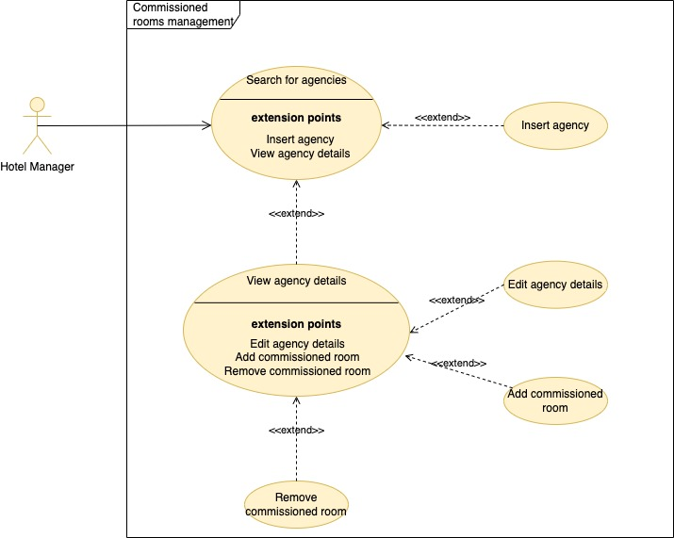

### F-PRE-04.1: Search for Agencies

|  |  |  |
| --- | --- | --- |
| **ID**  *UC-PRE-04.1* | | *Search for agencies* |
| **Description** | | This function allows the hotel manager to view the agency list. |
| **Primary actor** | | **Hotel manager** |
| **Supporting actors** | | **N/A** |
| **Entry Condition** | | The hotel manager is logged in |
| **Exit condition**  On success | | The agency list is shown to the user |
| **Exit condition**  On failure | | There is no agency that meet the search criteria |
| **Priority** | | High |
| **Extension points** | | Step No. 3 - Insert agency  Step No. 6 - View agency details |
| **Generalization of** | | N/A |
| **MAIN SCENARIO** | | |
| **1** | **Hotel manager** | The hotel manager clicks the "Agencies" link |
| **2** | **System** | The system shows a form to search for agencies by business name or VAT number. |
| **3** | **Hotel manager** | The user optionally fills in the search fields to filter the results and executes the search. |
| **4** | **System** | The system searches for agencies that meet the search criteria |
| **5** | **System** | The system displays the list of agencies that meet the search criteria |
| **6** | **Hotel Manager** | The Hotel Manager browses the results. |
| **Exceptions** | | |
| **5.a1** | **System** | The system shows an error message stating that no results match the search criteria. |

### F-PRE-04.2: View Agency details

|  |  |  |
| --- | --- | --- |
| **ID**  *UC-PRE-04.2* | | *View Agency details* |
| **Description** | | This function allows the hotel manager to view the given agency details. |
| **Primary actor** | | **Hotel manager** |
| **Supporting actors** | | **N/A** |
| **Entry Condition** | | The main scenario of UC-PRE-04.1 has been executed successfully |
| **Exit condition**  On success | | The agency details are shown to the Hotel Manager |
| **Exit condition**  On failure | | No agency with the given ID is available in persistent storage |
| **Priority** | | High |
| **Extension points** | | Step No. 3 - Edit agency details  Step No. 3 – Add commissioned room  Step No. 3 – Remove commissioned room |
| **Generalization of** | | N/A |
| **MAIN SCENARIO** | | |
| **1** | **Hotel manager** | The hotel manager clicks the "View agency details" button regarding the agency of his (or her) interest |
| **2** | **System** | The system searches for the agency with the given ID. The system searches for the rooms commissioned to the agency. |
| **3** | **System** | The system shows the agency details contains uneditable items: ID, business name, email, contact name, address, city, and VAT number.  The system lists the rooms commissioned by the agency. It has the following column headers: room, start date, and end date. |
| **Exceptions** | | |
| **3.a1** | **System** | The system shows an error message stating that no agency with the given ID is available in persistent storage |

### F-PRE-04.3: Edit Agency Detail

|  |  |  |
| --- | --- | --- |
| **ID**  *UC-PRE-04.3* | | *Edit Agency details* |
| **Description** | | This function allows the hotel manager to edit the given agency details |
| **Primary actor** | | **Hotel manager** |
| **Supporting actors** | | **N/A** |
| **Entry Condition** | | The main scenario of UC-PRE-04.2 has been successful executed. |
| **Exit condition**  On success | | The new agency details are recorded in persistent storage |
| **Exit condition**  On failure | | The new agency details are not recorded in persistent storage |
| **Priority** | | High |
| **Extension points** | | N/A |
| **Generalization of** | | N/A |
| **MAIN SCENARIO** | | |
| **1** | **Hotel manager** | The hotel manager clicks the "Edit Agency details" button |
| **2** | **System** | The system shows a form with the following editable fields: business name, email, contact name, address, city, and VAT number. |
| **3** | **Hotel manager** | The hotel manager updates the field of his (or her) interest and presses the "Save" button. |
| **4** | **System** | The system checks that all the field values are not null.  The system checks that the business and contact names contain at least three characters. The system validates the VAT number and email values. Finally, the system records the new agency details. |
| **5** | **System** | The system displays a message indicating that the operation was successful. |
| **Exceptions** | | |
| **5.a1** | **System** | The system shows an error message. |

### F-PRE-04.4: Insert agency

|  |  |  |
| --- | --- | --- |
| **ID**  *UC-PRE-04.4* | | *Insert agency* |
| **Description** | | This function allows the hotel manager to insert a new agency. |
| **Primary actor** | | **Hotel manager** |
| **Supporting actors** | | **N/A** |
| **Entry Condition** | | The main scenario of UC-PRE-04.1 has been executed successfully. |
| **Exit condition**  On success | | The new agency is recorded in persistent storage |
| **Exit condition**  On failure | | The new agency is not recorded in persistent storage |
| **Priority** | | High |
| **Extension points** | | N/A |
| **Generalization of** | | N/A |
| **MAIN SCENARIO** | | |
| **1** | **Hotel manager** | The hotel manager clicks the "New agency" button |
| **2** | **System** | The system shows a form with editable fields: business name, email, contact name, address, city, and VAT number. |
| **3** | **Hotel manager** | The hotel manager fills in all the fields. |
| **4** | **Hotel manager** | The hotel manager submits the form. |
| **5** | **System** | The system checks that all the field values are not null.  The system checks that the business and contact names contain at least three characters. The system validates the VAT number and email values. Finally, the system calculates the new ID and records the new agency details. |
| **6** | **System** | The system shows a confirmation message. |
| **Exceptions** | | |
| **6.a1** | **System** | The system shows an error message stating that the provided data are not valid. |
| **7.b1** | **System** | The system shows an error message stating that the provided business name already exists in persistent storage |
| **7.c1** | **System** | The system shows a system error message. |

### F-PRE-04.5: Add commissioned room

|  |  |  |
| --- | --- | --- |
| **ID**  *UC-PRE-04.5* | | *Add commissioned room* |
| **Description** | | This function allows the hotel manager to add a new commissioned room to the agency. |
| **Primary actor** | | **Hotel manager** |
| **Supporting actors** | | **N/A** |
| **Entry Condition** | | The main scenario of UC-PRE-04.2 has been executed successfully. |
| **Exit condition**  On success | | The new commissioned room is recorded in persistent storage |
| **Exit condition**  On failure | | The new commissioned room is not recorded in persistent storage |
| **Priority** | | High |
| **Extension points** | | N/A |
| **Generalization of** | | N/A |
| **MAIN SCENARIO** | | |
| **1** | **Hotel Manager** | The hotel manager selects the sub-option "Search Room". |
| **2** | **System** | The system shows a form with the following editable fields: start date and end date. |
| **3** | **Hotel Manager** | The user fills in the date interval and presses the “Search” button. |
| **4** | **System** | The system verifies that the date interval is valid and searches for the “uncommissioned rooms” in the Commission file and the “unbooked rooms” in the Booked Room files. For each available room, the system searches for its details in the Room file. |
| **5** | **System** | The system displays the list of uncommissioned rooms (with their details) that meet the search criteria. The rooms are selectable. |
| **6** | **Hotel manager** | The hotel manager selects one or more rooms and presses the “Confirm” button. |
| **7** | **System** | The system adds the selected rooms to the Commission file for the given agency. |
| **8** | **System** | The system shows a confirmation message. |
| **Alternative flow no. 1** | | |
| **6.a1** | **Hotel manager** | The user has no room to select. The flow of events resumes from step no. 1 of the main scenario. |
| **Alternative flow no. 2** | | |
| **6.b1** | **Hotel manager** | The user decides to leave the feature. The flow of events ends. |
| **Exceptions** | | |
| **5.a1** | **System** | The system shows an error message. |
| **8.b1** | **System** | The system shows an error message. |

### F-PRE-04.6: Remove commissioned room

|  |  |  |
| --- | --- | --- |
| **ID**  *UC-PRE-04.6* | | *Remove commissioned room* |
| **Description** | | This function allows the hotel manager to remove a commissioned room by a given agency. |
| **Primary actor** | | **Hotel manager** |
| **Supporting actors** | | **N/A** |
| **Entry Condition** | | The main scenario of UC-PRE-04.2 has been executed successfully. |
| **Exit condition**  On success | | The commissioned room is removed from the persistent storage |
| **Exit condition**  On failure | | The commissioned room is not removed from the persistent storage |
| **Priority** | | High |
| **Extension points** | | N/A |
| **Generalization of** | | N/A |
| **MAIN SCENARIO** | | |
| **1** | **Hotel manager** | The hotel manager clicks the "Delete room" button on the chosen record |
| **2** | **System** | The system asks the user to confirm the operation. |
| **3** | **Hotel manager** | The hotel manager confirms by clicking the “Confirm” button |
| **4** | **System** | The system removes the commissioned room from persistent storage. |
| **5** | **System** | The system shows a confirmation message. |
| **Alternative flow no. 1** | | |
| **3.a1** | **Hotel manager** | The hotel manager does not confirm the operation. The flow of events ends. |
| **Exceptions** | | |
| **5.a1** | **System** | The system shows an error message |

# RIS – Restaurant

The system shall allow to manage the immediate accounting of a typical restaurant whose customers are not necessarily staying in the hotel.

The system shall therefore be able to:

* provide the prices of the single courses so that the external customer is not bound by choice of the fixed menu provided for the residents;
* accept the various courses consumed at the entrance;
* print the bill.

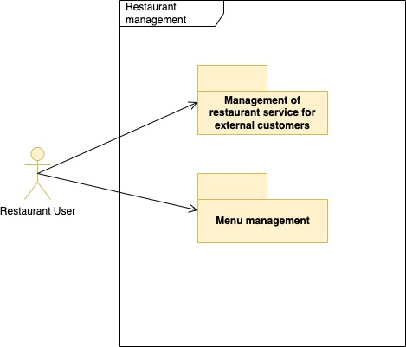

## F-RIS-01: Management of the restaurant service for external customers

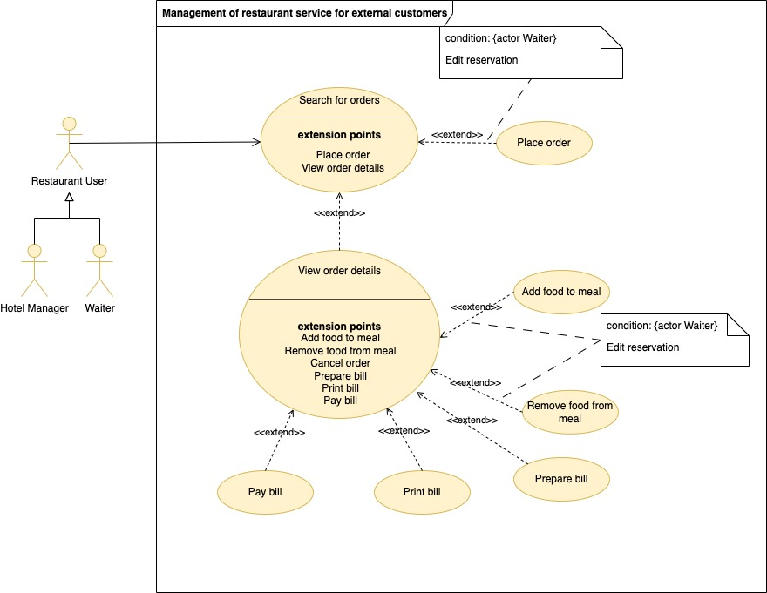

### F-RIS-01.1: Search for orders

|  |  |  |
| --- | --- | --- |
| **ID**  *UC-RIS-01.1* | | *Search for orders* |
| **Description** | | This function allows the hotel manager and the waiter to view the order list. |
| **Primary actor** | | **Hotel manager, Waiter** |
| **Supporting actors** | | **N/A** |
| **Entry Condition** | | The user is logged in |
| **Exit condition**  On success | | The order list is shown to the user |
| **Exit condition**  On failure | | There is no order that meet the search criteria |
| **Priority** | | High |
| **Extension points** | | Step No. 3 – Place order  Step No. 6 - View order details |
| **Generalization of** | | N/A |
| **MAIN SCENARIO** | | |
| **1** | **User** | The user clicks the "View orders" link |
| **2** | **System** | The system shows a form to search for orders containing the following fields: table, start date, end date, and status. |
| **3** | **User** | The user optionally fills in the search fields to filter the results and presses the search button. |
| **4** | **System** | The system searches for orders that meet the search criteria. |
| **5** | **System** | The system displays the list of orders that meet the search criteria. The list contains the following columns: order number, number of guests, date, and status. |
| **6** | **User** | The Hotel Manager browses the results. |
| **Exceptions** | | |
| **5.a1** | **System** | The system shows an error message stating that no results match the search criteria. |

### F-RIS-01.2: View order details

|  |  |  |
| --- | --- | --- |
| **ID**  *UC-RIS-01.2* | | *View order details* |
| **Description** | | This function allows the hotel manager or waiter to view the order details. |
| **Primary actor** | | **Hotel manager, Waiter** |
| **Supporting actors** | | **N/A** |
| **Entry Condition** | | The main scenario of UC-RIS-01.1 has been executed successfully |
| **Exit condition**  On success | | The order details are shown to the user. |
| **Exit condition**  On failure | | No order with the given ID is available in persistent storage |
| **Priority** | | High |
| **Extension points** | | Step No. 3 – Add food to meal  Step No. 3 – Remove food from meal  Step No. 3 – Cancel order  Step No. 3 – Prepare bill  Step No. 3 – Print bill  Step No. 3 – Pay bill |
| **Generalization of** | | N/A |
| **MAIN SCENARIO** | | |
| **1** | **User** | The user clicks the "View order details" button for the order of his (or her) interest |
| **2** | **System** | The system queries the Order file to search for the order with the given ID. The system looks up the ordered foods. |
| **3** | **System** | The system displays a page with the order details containing the following uneditable items: Number, date, number of guests, and status.  The system lists the ordered foods (food, quantity, and price). The list is uneditable. |
| **Exceptions** | | |
| **3.a1** | **System** | The system shows an error message stating that no order with the given ID is available in persistent storage |

### F-RIS-01.3: Place order

|  |  |  |
| --- | --- | --- |
| **ID**  *UC-RIS-01.3* | | *Place order* |
| **Description** | | This function allows the waiter to place a new order. |
| **Primary actor** | | **Waiter** |
| **Supporting actors** | | **N/A** |
| **Entry Condition** | | The main scenario of UC-RIS-01.1 has been executed successfully. |
| **Exit condition**  On success | | The new order is recorded in persistent storage |
| **Exit condition**  On failure | | The new order is not recorded in persistent storage |
| **Priority** | | High |
| **Extension points** | | N/A |
| **Generalization of** | | N/A |
| **MAIN SCENARIO** | | |
| **1** | **Waiter** | The waiter clicks the "New order" button |
| **2** | **System** | The system shows a form with the following editable fields: number of guests and table. |
| **3** | **System** | The system looks for the free tables in the Tables file and displays the list of the free tables. |
| **4** | **Waiter** | The waiter selects the table of his interest from the list, fills in the order details fields and submits the form. |
| **5** | **System** | The system checks that the number of guests is greater than 0 and that the table number is not empty. The system verifies that the selected table is not occupied and updates the table status to “Occupied” in the Tables File. The system inserts the new order with the status “In progress.” |
| **6** | **System** | The system shows a confirmation message. |
| **Exceptions** | | |
| **6.a1** | **System** | The system shows an error message stating that the provided data are not valid. |
| **6.b1** | **System** | The system shows an error message stating that the table number is already occupied. |
| **6.c1** | **System** | The system shows a system error message. |

### F-RIS-01.4: Add food to meal

|  |  |  |
| --- | --- | --- |
| **ID**  *UC-RIS-01.4* | | *Add food to meal* |
| **Description** | | This function allows the waiter to add new food to the given meal. |
| **Primary actor** | | **Waiter** |
| **Supporting actors** | | **N/A** |
| **Entry Condition** | | The main scenario of UC-RIS-01.2 has been executed successfully  AND  The order status is not “Paid” |
| **Exit condition**  On success | | The new food is recorded in persistent storage |
| **Exit condition**  On failure | | The new food is not recorded in persistent storage |
| **Priority** | | High |
| **Extension points** | | N/A |
| **Generalization of** | | N/A |
| **MAIN SCENARIO** | | |
| **1** | **Waiter** | The waiter clicks the sub-option "Add food". |
| **2** | **System** | The system shows a search form with the following fields: category and food. |
| **3** | **Waiter** | The waiter fills in the search fields and presses the “Search” button. |
| **4** | **System** | The system searches for foods and the associated categories that meet the search criteria. |
| **5** | **System** | The system lists the categories and, for each category, lists the associated food. |
| **6** | **Waiter** | The waiter selects the food. |
| **7** | **Waiter** | The waiter submits the form. |
| **8** | **System** | The system adds the ordered food. The system updates the order. |
| **9** | **System** | The system shows a confirmation message. |
| **Exceptions** | | |
| **8.a1** | **System** | The system shows an error message |

### F-RIS-01.5: Remove food from meal

|  |  |  |
| --- | --- | --- |
| **ID**  *UC-RIS-01.5* | | *Remove food from meal* |
| **Description** | | This function allows the user to remove an ordered food from a given order. |
| **Primary actor** | | **Waiter** |
| **Supporting actors** | | **N/A** |
| **Entry Condition** | | The main scenario of UC-RIS-01.2 has been executed successfully  AND  The order status is not “Paid” |
| **Exit condition**  On success | | The food is removed from the persistent storage |
| **Exit condition**  On failure | | The food is not removed from the persistent storage |
| **Priority** | | High |
| **Extension points** | | N/A |
| **Generalization of** | | N/A |
| **MAIN SCENARIO** | | |
| **1** | **Waiter** | The waiter clicks the "Delete food" button for the given ordered food |
| **2** | **System** | The system asks the user to confirm the operation. |
| **3** | **Waiter** | The waiter confirms by clicking the “Confirm” button |
| **4** | **System** | The system removes the ordered food. The system updates the given order's total price. |
| **5** | **System** | The system shows a confirmation message. |
| **Alternative flow no. 1** | | |
| **3.a1** | **waiter** | The waiter does not confirm the operation. The flow of events ends. |
| **Exceptions** | | |
| **5.a1** | **System** | The system shows an error message stating that the provided food ID does not exist in persistent storage |
| **5.b1** | **System** | The system shows a system error message. |

### F-RIS-01.6: Cancel order

|  |  |  |
| --- | --- | --- |
| **ID**  *UC-RIS-01.6* | | *Cancel order* |
| **Description** | | This function allows the hotel manager or the waiter to cancel an order. |
| **Primary actor** | | **Hotel manager, Waiter** |
| **Supporting actors** | | **N/A** |
| **Entry Condition** | | The main scenario of UC-RIS-01.2 has been executed successfully AND  Order status is not “Paid”. |
| **Exit condition**  On success | | The order is removed from the persistent storage |
| **Exit condition**  On failure | | The order is not removed from the persistent storage |
| **Priority** | | High |
| **Extension points** | | N/A |
| **Generalization of** | | N/A |
| **MAIN SCENARIO** | | |
| **1** | **User** | The actor clicks the "Cancel order" button for the current order |
| **2** | **System** | The system asks the user to confirm the operation. |
| **3** | **User** | The actor confirms by clicking the “Confirm” button |
| **4** | **System** | The system deletes the ordered food and removes the given order. The system updates the table status to “Free” in the Tables File. |
| **5** | **System** | The system shows a confirmation message. |
| **Alternative flow no. 1** | | |
| **3.a1** | **User** | The user does not confirm the operation. The flow of events ends. |
| **Exceptions** | | |
| **5.a1** | **System** | The system shows an error message stating that the provided order number does not exist in persistent storage |
| **5.b1** | **System** | The system shows a system error message. |

### F-RIS-01.7: Prepare bill

|  |  |  |
| --- | --- | --- |
| **ID**  *UC-RIS-01.7* | | *Prepare bill* |
| **Description** | | The function allows the waiter to calculate the total price and apply a discount for the given order. |
| **Primary actor** | | **Waiter** |
| **Supporting actors** | | **N/A** |
| **Entry Condition** | | The main scenario of UC-RIS-01.2 has been executed successfully  AND  The order status is not “Paid” |
| **Exit condition**  On success | | The order is updated with the new total in persistent storage |
| **Exit condition**  On failure | | The order is not updated in persistent storage |
| **Priority** | | High |
| **Extension points** | | N/A |
| **Generalization of** | | N/A |
| **MAIN SCENARIO** | | |
| **1** | **Waiter** | The waiter selects the sub-option "billing" |
| **2** | **System** | The system shows a summary form with the following fields: total price, discount%, and discounted price. |
| **3** | **Waiter** | The waiter optionally fills in the discount for the order and presses the "Save" button. |
| **4** | **System** | The system updates the given order. |
| **8** | **System** | The system shows a confirmation message. |
| **Exceptions** | | |
| **8.a1** | **System** | The system shows an error message |

### F-RIS-01.8: Print bill

|  |  |  |
| --- | --- | --- |
| **ID**  *UC-RIS-01.8* | | *Print bill* |
| **Description** | | This function allows the waiter to print the bill for the given order. |
| **Primary actor** | | **Waiter** |
| **Supporting actors** | | **N/A** |
| **Entry Condition** | | The main scenario of UC-RIS-01.2 has been executed successfully AND  The order status is “Prepared” |
| **Exit condition**  On success | | The bill is printed |
| **Exit condition**  On failure | | The bill is not printed |
| **Priority** | | High |
| **Extension points** | | N/A |
| **Generalization of** | | N/A |
| **MAIN SCENARIO** | | |
| **1** | **Waiter** | The waiter clicks the "Print bill" button for the current order |
| **2** | **System** | The system searches the order details and searches for the ordered food. |
| **3** | **System** | The system prints the order details and the ordered food details. |
| **Exceptions** | | |
| **3.a1** | **System** | The system shows an error message |

### F-RIS-01.9: Pay bill

|  |  |  |
| --- | --- | --- |
| **ID**  *UC-RIS-01.9* | | *Pay bill* |
| **Description** | | This function allows the Hotel manager or the waiter to close the bill for the given order. |
| **Primary actor** | | **Hotel Manager, Waiter** |
| **Supporting actors** | | **N/A** |
| **Entry Condition** | | The main scenario of UC-RIS-01.2 has been executed successfully AND  The order status is “Prepared” |
| **Exit condition**  On success | | The order status is updated to “Paid” |
| **Exit condition**  On failure | | The order status is not updated |
| **Priority** | | High |
| **Extension points** | | N/A |
| **Generalization of** | | N/A |
| **MAIN SCENARIO** | | |
| **1** | **User** | The actor clicks the "Pay bill" button for the current order |
| **2** | **System** | The system asks the user to confirm the operation. |
| **3** | **User** | The actor confirms by clicking the “Confirm” button |
| **4** | **System** | The system updates the order status to “Paid.” The system updates the table status to “Free” in the Tables File. |
| **5** | **System** | The system shows a confirmation message. |
| **Alternative flow no. 1** | | |
| **3.a1** | **User** | The user does not confirm the operation. The Flow of events ends. |
| **Exceptions** | | |
| **5.a1** | **System** | The system shows an error message stating that the provided order number does not exist in persistent storage |
| **5.b1** | **System** | The system shows a system error message. |

## F-RIS-02: Menu management

### F-RIS-02.1: Search for menu category

|  |  |  |
| --- | --- | --- |
| **ID**  *UC-RIS-02.1* | | *Search for menu category* |
| **Description** | | This function allows the hotel manager to view the menu category list. |
| **Primary actor** | | **Hotel manager** |
| **Supporting actors** | | **N/A** |
| **Entry Condition** | | The hotel manager is logged in |
| **Exit condition**  On success | | The menu category list is shown to the user |
| **Exit condition**  On failure | | There is no menu category that meet the search criteria |
| **Priority** | | High |
| **Extension points** | | Step No. 3 - Insert menu category  Step No. 6 - View menu category details  Step No. 6 – Delete menu category |
| **Generalization of** | | N/A |
| **MAIN SCENARIO** | | |
| **1** | **Hotel manager** | The hotel manager selects the sub-option "Menu categories" |
| **2** | **System** | The system shows a form to search for menu categories by description |
| **3** | **Hotel manager** | The user optionally fills in the menu category description to filter the results and executes the search. |
| **4** | **System** | The system searches for menu categories that meet the search criteria |
| **5** | **System** | The system displays the list of menu categories that meet the search criteria |
| **6** | **Hotel Manager** | The Hotel Manager browses the results. |
| **Exceptions** | | |
| **5.a1** | **System** | The system shows an error message stating that no results match the search criteria. |

### F-RIS-02.2: View menu category details

|  |  |  |
| --- | --- | --- |
| **ID**  *UC-RIS-02.2* | | *View menu category details* |
| **Description** | | This function allows the hotel manager to view the given menu category details. |
| **Primary actor** | | **Hotel manager** |
| **Supporting actors** | | **N/A** |
| **Entry Condition** | | The main scenario of UC-RIS-02.1 has been executed successfully |
| **Exit condition**  On success | | The menu category details are shown to the Hotel Manager |
| **Exit condition**  On failure | | No menu category with the given ID is available in persistent storage |
| **Priority** | | High |
| **Extension points** | | Step No. 3 - Edit menu category details  Step No. 3 – Edit food  Step No. 3 – Delete food  Step No. 3 – Add food |
| **Generalization of** | | N/A |
| **MAIN SCENARIO** | | |
| **1** | **Hotel manager** | The hotel manager clicks the "View menu category details" button regarding the category of his (or her) interest |
| **2** | **System** | The system searches for the menu category with the given ID. The system searches for foods associated with the menu category. |
| **3** | **System** | The system shows the category details: ID, description, and note.  The system lists foods associated with the given menu category. The list is uneditable. |
| **Exceptions** | | |
| **3.a1** | **System** | The system shows an error message stating that no menu category with the given ID is available in persistent storage |

### F-RIS-02.3: Edit menu category details

|  |  |  |
| --- | --- | --- |
| **ID**  *UC-RIS-02.3* | | *Edit menu category details* |
| **Description** | | This function allows the hotel manager to edit the given menu category details |
| **Primary actor** | | **Hotel manager** |
| **Supporting actors** | | **N/A** |
| **Entry Condition** | | The main scenario of UC-RIS-02.2 has been successfully executed. |
| **Exit condition**  On success | | The new menu category details are recorded in persistent storage |
| **Exit condition**  On failure | | The new menu category details are not recorded in persistent storage |
| **Priority** | | High |
| **Extension points** | | N/A |
| **Generalization of** | | N/A |
| **MAIN SCENARIO** | | |
| **1** | **Hotel manager** | The hotel manager clicks the "Edit menu category details" option |
| **2** | **System** | The system makes editable the following fields: description and note. |
| **3** | **Hotel manager** | The hotel manager updates the description and (or) the note fields and presses the "Save" button. |
| **4** | **System** | The system checks that the menu category description contains at least three characters and records the new menu category details. |
| **5** | **System** | The system displays a message indicating that the operation was successful. |
| **Exceptions** | | |
| **5.a1** | **System** | The system shows an error message. |

### F-RIS-02.4: Insert menu category

|  |  |  |
| --- | --- | --- |
| **ID**  *UC-RIS-02.4* | | *Insert menu category* |
| **Description** | | This function allows the hotel manager to insert a new menu category. |
| **Primary actor** | | **Hotel manager** |
| **Supporting actors** | | **N/A** |
| **Entry Condition** | | The main scenario of UC-RIS-02.1 has been executed successfully. |
| **Exit condition**  On success | | The new menu category is recorded in persistent storage |
| **Exit condition**  On failure | | The new menu category is not recorded in persistent storage |
| **Priority** | | High |
| **Extension points** | | N/A |
| **Generalization of** | | N/A |
| **MAIN SCENARIO** | | |
| **1** | **Hotel manager** | The hotel manager clicks the "New menu category" option |
| **2** | **System** | The system shows a form with the following editable fields: description and note. |
| **3** | **Hotel manager** | The hotel manager fills in the menu category details. |
| **4** | **Hotel manager** | The hotel manager submits the form. |
| **5** | **System** | The system checks that the menu category description contains at least three characters, and records the new menu category details. |
| **6** | **System** | The system shows a confirmation message. |
| **Exceptions** | | |
| **6.a1** | **System** | The system shows an error message stating that the provided data are not valid. |
| **7.b1** | **System** | The system shows an error message stating that the provided description already exists in persistent storage |
| **7.c1** | **System** | The system shows a system error message. |

### F-RIS-02.5: Remove menu category

|  |  |  |
| --- | --- | --- |
| **ID**  *UC-RIS-02.5* | | *Remove menu category* |
| **Description** | | This function allows the hotel manager to remove a menu category. |
| **Primary actor** | | **Hotel manager** |
| **Supporting actors** | | **N/A** |
| **Entry Condition** | | The main scenario of UC-RIS-02.1 has been executed successfully. |
| **Exit condition**  On success | | The menu category is removed from the persistent storage |
| **Exit condition**  On failure | | The menu category is not removed from the persistent storage |
| **Priority** | | High |
| **Extension points** | | N/A |
| **Generalization of** | | N/A |
| **MAIN SCENARIO** | | |
| **1** | **Hotel manager** | The hotel manager clicks the "Delete menu category" button regarding the category of his (or her) interest |
| **2** | **System** | The system asks the user to confirm the operation. |
| **3** | **Hotel manager** | The hotel manager confirms by clicking the “Confirm” button |
| **4** | **System** | The system removes the given menu category and its associated foods. |
| **5** | **System** | The system shows a confirmation message. |
| **Alternative flow no. 1** | | |
| **3.a1** | **Hotel manager** | The hotel manager does not confirm the operation. The flow of events ends. |
| **Exceptions** | | |
| **5.a1** | **System** | The system shows an error message stating that there is one or more associated food to the given category. |
| **5.b1** | **System** | The system shows an error message stating that the provided menu category ID does not exist in persistent storage |
| **5.c1** | **System** | The system shows a system error message. |

### F-RIS-02.6: Edit food

|  |  |  |
| --- | --- | --- |
| **ID**  *UC-RIS-02.6* | | *Edit food* |
| **Description** | | This function allows the hotel manager to edit the given food details |
| **Primary actor** | | **Hotel manager** |
| **Supporting actors** | | **N/A** |
| **Entry Condition** | | The main scenario of UC-RIS-02.2 has been successful executed  AND  The food list contains one or more rows |
| **Exit condition**  On success | | The new food details are recorded in persistent storage |
| **Exit condition**  On failure | | The new food details are not recorded in persistent storage |
| **Priority** | | High |
| **Extension points** | | N/A |
| **Generalization of** | | N/A |
| **MAIN SCENARIO** | | |
| **1** | **Hotel manager** | The hotel manager selects the option "Edit food details". |
| **2** | **System** | The system makes editable the following fields: food, description, note, price, and available. |
| **3** | **Hotel manager** | The hotel manager changes the fields of his (or her) interest and presses the “Save” button. |
| **4** | **System** | The system checks that the food and description contain at least three characters and that price is greater than or equal to 0 and records the new details of the food associated with the given category in persistent storage. |
| **5** | **System** | The system displays a message indicating that the operation was successful. |
| **Exceptions** | | |
| **5.a1** | **System** | The system shows an error message. |

### F-RIS-02.7: Remove food

|  |  |  |
| --- | --- | --- |
| **ID**  *UC-RIS-02.7* | | *Remove food* |
| **Description** | | This function allows the hotel manager to remove food from a given menu category. |
| **Primary actor** | | **Hotel manager** |
| **Supporting actors** | | **N/A** |
| **Entry Condition** | | The main scenario of UC-RIS-02.2 has been successful executed  AND  The food list contains one or more rows |
| **Exit condition**  On success | | The food is removed from the persistent storage |
| **Exit condition**  On failure | | The food is not removed from the persistent storage |
| **Priority** | | High |
| **Extension points** | | N/A |
| **Generalization of** | | N/A |
| **MAIN SCENARIO** | | |
| **1** | **Hotel manager** | The hotel manager clicks the "Delete food" button regarding the record of his (or her) interest |
| **2** | **System** | The system asks the user to confirm the operation. |
| **3** | **Hotel manager** | The hotel manager confirms by clicking the “Confirm” button |
| **4** | **System** | The system removes the food associated with the given category from persistent storage. |
| **5** | **System** | The system shows a confirmation message. |
| **Alternative flow no. 1** | | |
| **3.a1** | **Hotel manager** | The hotel manager does not confirm the operation. The flow of events ends. |
| **Exceptions** | | |
| **5.a1** | **System** | The system shows an error message stating that the provided food ID does not exist in persistent storage |
| **5.b1** | **System** | The system shows a system error message. |

### F-RIS-02.8: Insert food

|  |  |  |
| --- | --- | --- |
| **ID**  *UC-RIS-02.8* | | *Insert food* |
| **Description** | | This function allows the hotel manager to add new food to the given category. |
| **Primary actor** | | **Hotel manager** |
| **Supporting actors** | | **N/A** |
| **Entry Condition** | | The main scenario of UC-RIS-02.2 has been executed successfully. |
| **Exit condition**  On success | | The new food is recorded in persistent storage |
| **Exit condition**  On failure | | The new food is not recorded in persistent storage |
| **Priority** | | High |
| **Extension points** | | N/A |
| **Generalization of** | | N/A |
| **MAIN SCENARIO** | | |
| **1** | **Hotel manager** | The hotel manager clicks the "Add food" button |
| **2** | **System** | The system shows a form with the following editable fields: food, description, price, and available. |
| **3** | **Hotel manager** | The hotel manager fills in the food, description, price fields, and optionally the available field. |
| **4** | **Hotel manager** | The hotel manager submits the form. |
| **5** | **System** | The system checks that the food and description contain at least three characters and that price is greater than or equal to 0, and records the new details of the food associated with the given category in persistent storage. |
| **6** | **System** | The system shows a confirmation message. |
| **Exceptions** | | |
| **6.a1** | **System** | The system shows an error message stating that the provided data are not valid. |
| **7.b1** | **System** | The system shows an error message stating that the provided food already exists in persistent storage |
| **7.c1** | **System** | The system shows a system error message. |

# SOG – Hotel stay

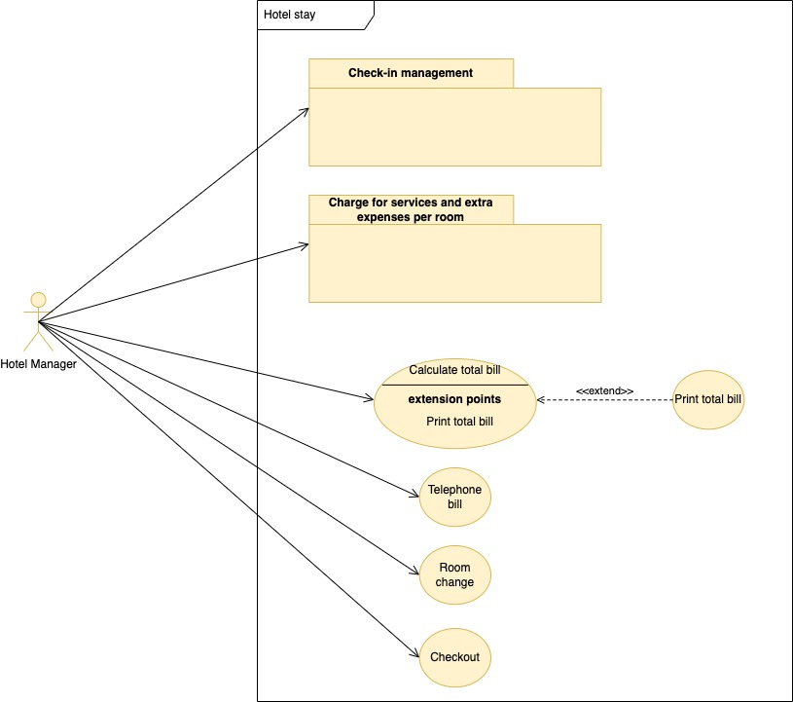

## F-SOG-01: Check-in management

When a customer arrives, the following events may occur:

1. if the customer has a reservation, then the room numbers that he (she) will occupy are figured out from the reservation. Then, the hotel manager will cancel the reservation from the list of reservations;
2. if the customer has not previously booked, we will proceed as if a booking were in progress, i.e.:
   1. you are looking for an available room;
   2. if the outcome is favorable, it is assigned to the customer for the specified period.
3. if the new guest requests to join those already occupying a specific room. In this case,

Starting from the rooms assigned, the hotel manager will enter the information of the people who will stay in the guest archive, room by room.

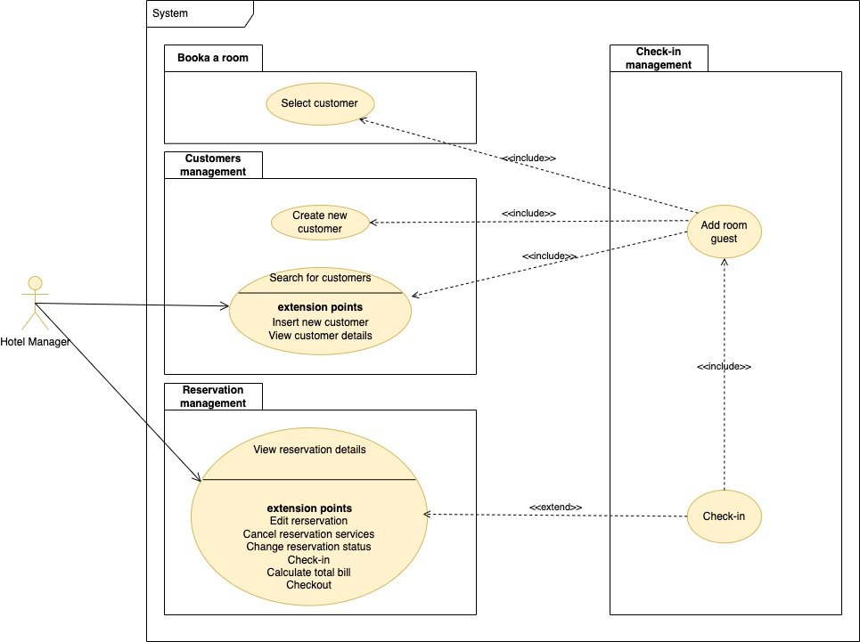

### F-SOG-01.1: Check-in

|  |  |  |
| --- | --- | --- |
| **ID**  *UC-SOG-01.1* | | *Check-in* |
| **Description** | | This function allows the user to execute guest check-in. |
| **Primary actor** | | **Hotel manager** |
| **Supporting actors** | | **N/A** |
| **Entry Condition** | | The main scenario of UC-PRE-7 has been successful executed |
| **Exit condition**  On success | | Rooms are assigned to the right guests |
| **Exit condition**  On failure | | Rooms are not assigned to guests |
| **Priority** | | High |
| **Extension points** | | N/A |
| **Generalization of** | | N/A |
| **MAIN SCENARIO** | | |
| **1** | **Hotel manager** | The user selects the sub-option “check-in”. |
| **2** | **System** | The system displays a form containing the reservation details. |
| **3** | **Hotel manager** | The user selects the room of his interest and executes the search. |
| **4** | **System** | The system searches for the room guests and for each guest the relative details |
| **5** | **System** | The system lists the guests in the selected room. |
| **6** | **Hotel Manager** | Include UC-SOG-01.2 (add a new guest to the given room) |
| **7** | **Hotel Manager** | The user presses the “Close” button |
| **Alternative flow no. 1** | | |
| **7.a1** | **Hotel manager** | The flow of events resumes at step no. 6 of the main scenario to allow the user to add all guests. |
| **Exceptions** | | |
| **5.a1** | **System** | The system shows an error message |

### F-SOG-01.2: Add room guest

|  |  |  |
| --- | --- | --- |
| **ID**  *UC-SOG-01.2* | | *Add room guest* |
| **Description** | | This function allows the user to add a new guest to the room. |
| **Primary actor** | | **Hotel manager** |
| **Supporting actors** | | **N/A** |
| **Entry Condition** | | The main scenario of UC-SOG-01.1 has been successful executed |
| **Exit condition**  On success | | A new guest is added to the given room |
| **Exit condition**  On failure | | No new guest is added to the given room  OR  There are not enough beds in the room |
| **Priority** | | High |
| **Extension points** | | N/A |
| **Generalization of** | | N/A |
| **MAIN SCENARIO** | | |
| **1** | **Hotel manager** | The user clicks “Add guest” |
| **3** | **Hotel manager** | Include UC-GES-03.1 (search for the customer’s personal information) |
| **4** | **Hotel manager** | Include UC-PRE-02.1 (select the customer from the list) |
| **5** | **Hotel manager** | The user optionally enters new values for the customer’s details and selects the room to assign to the customer. |
| **6** | **System** | The system asks the user to confirm |
| **7** | **Hotel manager** | The user confirms the assignment |
| **8** | **System** | The system checks the provided of the customer’s details. |
| **9** | **System** | The system updates the new customer’s details. |
| **10** | **System** | The system updates the booked room details, increasing the number of guests by one. Then, it inserts the new guest for the given room and changes the reservation status to “Checked-in.” |
| **11** | **System** | The system shows a confirmation message |
| **Alternative flow no. 1** | | |
| **4.a1** | **Hotel manager** | Include UC-GES-03.4.1 (Create a new customer, since no customers have been found) |
| **5.a1** | **System** | The flow of events resumes at step no. 5 of the main scenario. |
| **Alternative flow no. 2** | | |
| **7.a1** | **Hotel manager** | The user does not confirm. The flow of events resumes at step no. 3 of the main scenario |
| **Exceptions** | | |
| **9.a1** | **System** | The system shows an error message (i.e., the selected customer already has an assigned room, the information provided is not valid, Etc.) |
| **2.b1** | **System** | The system shows an error message indicating that there are not enough beds in the room. |
| **11.c1** | **System** | The system shows an error message |

## F-SOG-02: Charge for services and extra expenses per room

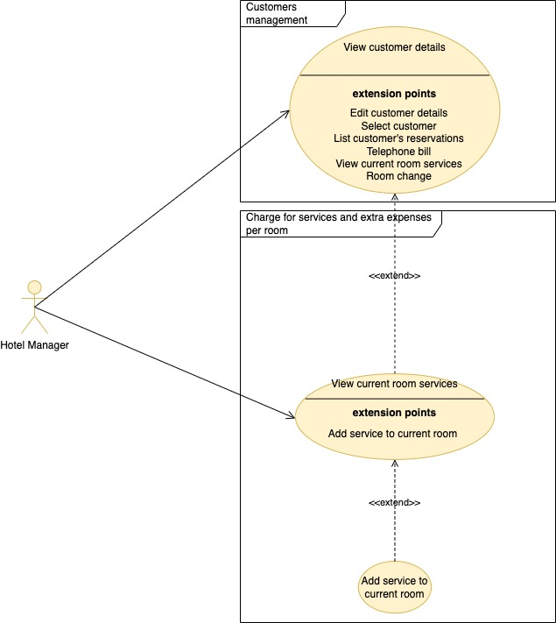

### F-SOG-02.1: View current room services

|  |  |  |
| --- | --- | --- |
| **ID**  *UC-SOG-02.1* | | *View current room services* |
| **Description** | | This function allows the user to list the customer’s current room services. |
| **Primary actor** | | **Hotel Manager** |
| **Supporting actors** | | **N/A** |
| **Entry Condition** | | The main scenario of UC-GES-03.2 has been successful executed |
| **Exit condition**  On success | | The requested room services are shown to the user |
| **Exit condition**  On failure | | The given customer has not an assigned room |
| **Priority** | | High |
| **Extension points** | | Step no. 6 – Add services to current room |
| **Generalization of** | | N/A |
| **MAIN SCENARIO** | | |
| **1** | **User** | The user selects the sub-option "List room services". |
| **2** | **System** | The system shows a form to filter the room services by description |
| **3** | **User** | The user optionally fills in the filter fields and presses the “Search” button. |
| **4** | **System** | The system searches for the requested services for the given customer’s room. For each requested service the system looks up the service details. |
| **5** | **System** | The system lists the currently requested services for the given customer’s room and lists the services details. |
| **6** | **User** | The user browses the results. |
| **Exceptions** | | |
| **5.a1** | **System** | The system shows an error message stating that no results match the search criteria. |

### F-SOG-02.2: Add services to current room

|  |  |  |
| --- | --- | --- |
| **ID**  *UC-SOG-02.2* | | *Add services to current room* |
| **Description** | | This function allows the user to add services to the current customer’s room |
| **Primary actor** | | **Hotel Manager** |
| **Supporting actors** | | **N/A** |
| **Entry Condition** | | The main scenario of UC-SOG-02.1 has been successful executed |
| **Exit condition**  On success | | The new services are added to the current customer’s room |
| **Exit condition**  On failure | | The new services are not added to the current customer’s room |
| **Priority** | | High |
| **Extension points** | | N/A |
| **Generalization of** | | N/A |
| **MAIN SCENARIO** | | |
| **1** | **User** | The user clicks the "Room services" button for the current room code. |
| **2** | **System** | The system searches for the assigned services of the given room and looks up service details in the Services file. |
| **3** | **System** | The system displays the details of each service and displays the list of assigned services. |
| **4** | **User** | The user enters the services to add to the given reservation and presses the “Confirm” button. |
| **5** | **System** | The system adds the selected services to the requested services file. It updates the Reservation file, setting the new total amount. |
| **6** | **System** | The system shows a confirmation message |
| **Exceptions** | | |
| **6.a1** | **System** | The system shows an error message. |

## F-SOG-03: Telephone bill

|  |  |  |
| --- | --- | --- |
| **ID**  *UC-SOG-03* | | *Telephone bill* |
| **Description** | | This function allows the user to update the current telephone billing for the given customer |
| **Primary actor** | | **Hotel Manager** |
| **Supporting actors** | | **N/A** |
| **Entry Condition** | | The main scenario of UC-GES-03.2 has been successful executed |
| **Exit condition**  On success | | The new telephone billing is recorded in persistent storage |
| **Exit condition**  On failure | | The given customer has not an assigned room  OR  The new telephone billing is not recorded in persistent storage |
| **Priority** | | High |
| **Extension points** | | N/A |
| **Generalization of** | | N/A |
| **MAIN SCENARIO** | | |
| **1** | **User** | The user clicks the "Telephone bill" button for the current room code. |
| **2** | **System** | The system looks up the telephone bill for the given room. |
| **2** | **System** | The system shows a form containing the Telephone bill details: number of phone calls and total cost. |
| **3** | **User** | The user fills in the number of phone calls field and submits the form. |
| **4** | **System** | The system checks that the number of phone calls is greater than or equal to zero. |
| **5** | **System** | The system searches for rooms and services configuration to get the phone call cost, calculates the new total cost, and then inserts (or updates) the new telephone bill containing the following attributes: ID, number of phone calls, room code, reservation ID, total cost, date. Finally, the system updates the reservation total amount: new total amount = previous total amount – previous total phone calls cost + new total phone calls cost). |
| **6** | **System** | The system shows a confirmation message. |
| **Exceptions** | | |
| **5.a1** | **System** | The system shows an error message. |
| **6.b1** | **System** | The system shows an error message. |

## F-SOG-04: Calculate total bill

|  |  |  |
| --- | --- | --- |
| **ID**  *UC-SOG-04* | | *Calculate total bill* |
| **Description** | | This function allows the user to calculate and view the current total bill for the given reservation |
| **Primary actor** | | **Hotel Manager** |
| **Supporting actors** | | **N/A** |
| **Entry Condition** | | The main scenario of UC-PRE-07 has been successful executed  AND  The reservation status is “Checked-in” |
| **Exit condition**  On success | | The total bill is shown to the user |
| **Exit condition**  On failure | | The total bill is not shown to the user |
| **Priority** | | High |
| **Extension points** | | Step no. 4 – Print bill |
| **Generalization of** | | N/A |
| **MAIN SCENARIO** | | |
| **1** | **User** | The user clicks the "View bill" link for the given reservation |
| **2** | **System** | The system looks up the customer’s reservation details and its requested services, and searches for the Telephone bill. |
| **3** | **System** | The system shows the total amount of the given reservation, the list of requested services and the telephone bill of each room |
| **4** | **User** | The user looks at the results and presses the close button |
| **Exceptions** | | |
| **3.a1** | **System** | The system shows an error message. |
| **6.b1** | **System** | The system shows an error message. |

## F-SOG-05: Print total bill

|  |  |  |
| --- | --- | --- |
| **ID**  *UC-SOG-05* | | *Print total bill* |
| **Description** | | This function allows the user to print the total bill. |
| **Primary actor** | | **Hotel Manager** |
| **Supporting actors** | | **N/A** |
| **Entry Condition** | | The main scenario of UC-SOG-4 has been successful executed  AND  The reservation status is “Checked-in” |
| **Exit condition**  On success | | The printed bill is given to the customer |
| **Exit condition**  On failure | | The bill has not been printed |
| **Priority** | | High |
| **Extension points** | | N/A |
| **Generalization of** | | N/A |
| **MAIN SCENARIO** | | |
| **1** | **User** | The user clicks the "Print bill" button regarding the given reservation |
| **2** | **System** | The system displays the bill (using the information already present on the screen but properly formatting them). |
| **3** | **User** | The user gives the printed bill to the customer |
| **Exceptions** | | |
| **2.a1** | **System** | The system shows an error message. |

## F-SOG-06: Room change

|  |  |  |
| --- | --- | --- |
| **ID**  *UC-SOG-06* | | *Room change* |
| **Description** | | This function allows the user to change the current customer’s room. |
| **Primary actor** | | **Hotel Manager, Hotel operator** |
| **Supporting actors** | | **N/A** |
| **Entry Condition** | | The main scenario of UC-GES-03.2 has been successful executed  AND  The current room reservation status is not “Paid” |
| **Exit condition**  On success | | A new room is assigned to the given customer |
| **Exit condition**  On failure | | The current customer’s room does not change |
| **Priority** | | High |
| **Extension points** | | N/A |
| **Generalization of** | | N/A |
| **MAIN SCENARIO** | | |
| **1** | **User** | The user clicks the "Change room" link for the given customer |
| **2** | **System** | The system searches for all rooms of the given type to accommodate the number of guests. |
| **3** | **System** | For each room, the system checks if it is in the Commission file or if it is in the Booked Room file in the given date interval. |
| **4** | **System** | The system lists the available rooms. |
| **5** | **User** | The user selects a new room code for the customer and clicks the “search services” button. |
| **6** | **System** | The system searches for the assigned services of the new room and looks up the requested services for the old customer’s room. |
| **7** | **System** | The system shows the selected room details and lists the requested services for the old customer’s room.  The system lists the assigned services of the new room |
| **8** | **User** | The user optionally enters the requestable services for the new room |
| **9** | **System** | The system searches for the customer’s details, changes the currently occupied room code to the selected room code in the Customers file, updates the booked rooms for the given reservation, deletes the requested services for the old booked room, inserts the newly requested services, changes the room code in the Telephone Bill file to the new selected room code. The system updates the total amount for the reservation and the room code in the Room Guest file. |
| **10** | **System** | The system shows a confirmation message. |
| **Alternative flow no. 1** | | |
| **5.a1** | **User** | The user presses the “Close” button. The flow of events ends. |
| **Exceptions** | | |
| **3.a1** | **System** | The system shows an error message. |
| **4.b1** | **System** | The system shows an error message. |
| **7.c1** | **System** | The system shows an error message. |
| **10.d1** | **System** | The system shows an error message. |

## F-SOG-07: Checkout

|  |  |  |
| --- | --- | --- |
| **ID**  *UC-SOG-07* | | *Checkout* |
| **Description** | | This function allows the user to complete the checkout process. |
| **Primary actor** | | **Hotel Manager** |
| **Supporting actors** | | **N/A** |
| **Entry Condition** | | The main scenario of UC-SOG-4 has been successful executed  AND  The reservation status is “Checked-in” |
| **Exit condition**  On success | | The new reservation status is “Paid”. |
| **Exit condition**  On failure | | The reservation status does not change. |
| **Priority** | | High |
| **Extension points** | | N/A |
| **Generalization of** | | N/A |
| **MAIN SCENARIO** | | |
| **1** | **User** | The user clicks the "Checkout" button regarding the given reservation |
| **2** | **System** | The system changes the reservation status and the room reference in the Customer file. |
| **3** | **System** | The system shows a confirmation message |
| **Exceptions** | | |
| **3.a1** | **System** | The system shows an error message. |