Programmer: Gadfrey Balacy

**Typical Scene:**

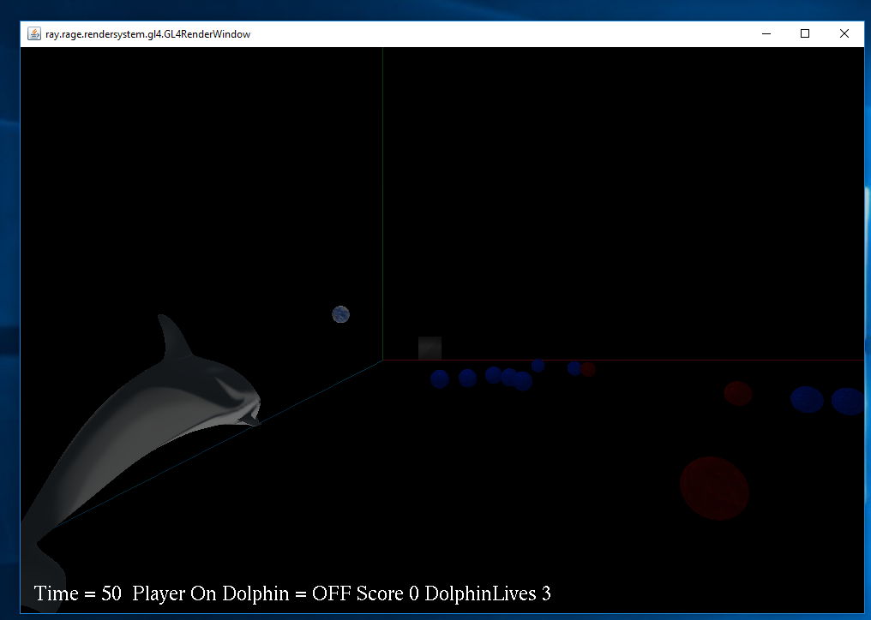

**How to compile and Run program in the Command Line:**

Compile:

First Command: javac myGameEngine\*.java

Second Command: javac a1\*.java

Run:

Java –Dsun.java2d.d3d=false a1.MyGame

Bat Files:

Instead of running the game from the command line.

First Double Click: compile.bat

Then Double Click: run.bat

**How Game is Played:**

The game is played by collecting the prizes ( Blue Spheres ) by positioning the camera near the blue sphere. Then the prize gets attach to the dolphin. Then you have to position the dolphin near the box to score. (Note. The prizes does get attach to the dolphin node but for some reason the image of the attach node gets position at 0,0,0. I have tried to position the blue sphere in front of the dolphin but for some reason if keeps getting position at the 0,0,0 or slightly outside the view of the camera.) Once the sphere is attach to the dolphin node. You have to toggle to the dolphin node then position the dolphin near the box to receive a score.

Inputs: Space Bar – toggle off and on dolphin.

If (toggle = Off)

Camera Inputs Keyboard : W – move camera forward. S – move camera backward. A – move camera left. D – move camera right. Right Arrow Key – yaw the camera right. Left Arrow Key – yaw the camera left. Up-Arrow Key- Pitch the camera up. Down-Arrow Key – pitch the camera down. Space Bar- toggle of and one of the dolphin.

Camera Inputs Controller: X-axis – move camera left and right, Y-axis move camera forward/ backward, RX-axis: yaw camera around V axis, RY-axis- pitch the camera in the U axis.

If(toggle = On)

Dolphin Node Inputs Keyboard : W – move dolphin node forward. S – move dolphin node backward. A – move dolphin node left. D – move dolphin node right. Right Arrow Key – yaw the dolphin node right. Left Arrow Key – yaw the dolphin node left. Up-Arrow Key- Pitch the dolphin node up. Down-Arrow Key – pitch the dolphin node down. Space Bar- toggle off and one of the dolphin.

Dolphin Node Inputs Controller: X-axis – move dolphin node left and right, Y-axis move dolphin node forward/ backward, RX-axis: yaw dolphin node around V axis, RY-axis- pitch the dolphin node in the U axis.

**Additional Game Activity**:

Bring the blue sphere prize near the box to score a point. By positioning the dolphin node near the box. If the dolphin loses all its lives by hitting the red sphere the game ends.

**Additional Game Object:**

The red sphere. If a dolphin hits a red sphere it loses one life.

**Requirements not able to get working**: None, all requirements done.

Special Added Beyond the requirement: The game ending once the dolphin loses all its lives. It closes the game window.

**Lac Machine:**

Classroom 5029

Computer: SNEEZYMUD

**Assets**:

Objects: dolphinHighPoly.obj from the java gaming assets folder.

Objects: sphere.obj from the java gaming assets folder.

Objects: earth.obj from the java gaming assets folder.

Manual Made Object: X, Y, Z axis are made by me.

Manual Made Object: Box object is made by me.

Textures: X_Axis.png, Y_Axis.png, Z_Axis.png is made by me.

Textures: red.jpeg from the java gaming assets folder. Blue.jpeg from the java gaming assets folder.