SSLCertManager4Java

# USER GUIDE

Version: release-b1

Preparedby: Gaurav-sjsu

Date: 04/25/2017

## STEPS

1. First go to JDK_HOME/bin Directory
   1. OR

#### If you already have it set in classpath then just type this command

Java -jar SSLCertManager4Java.jar



1. You will see the main page if the SSLCErtManager4Java like this

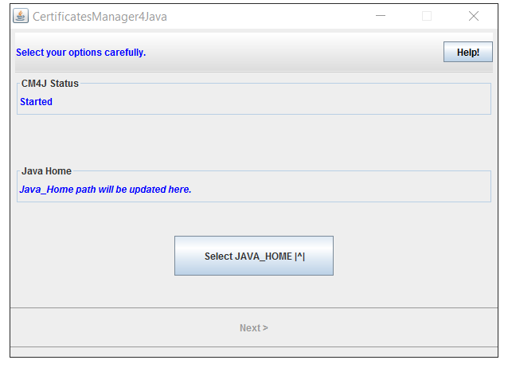

1. Different important parts of this screen are as follows:

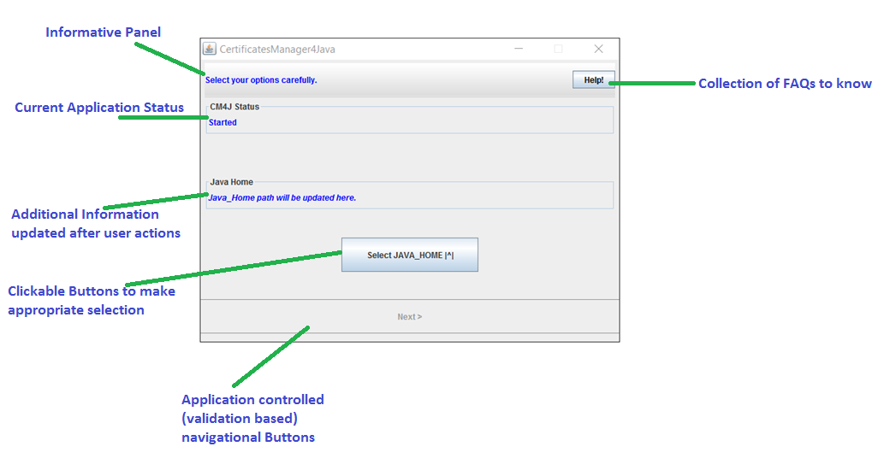

1. Once you will click “Select JAVA_HOME” you will see a directory selection screen something like this, Please navigate yourself to home directory (root folder) of JDK installation,

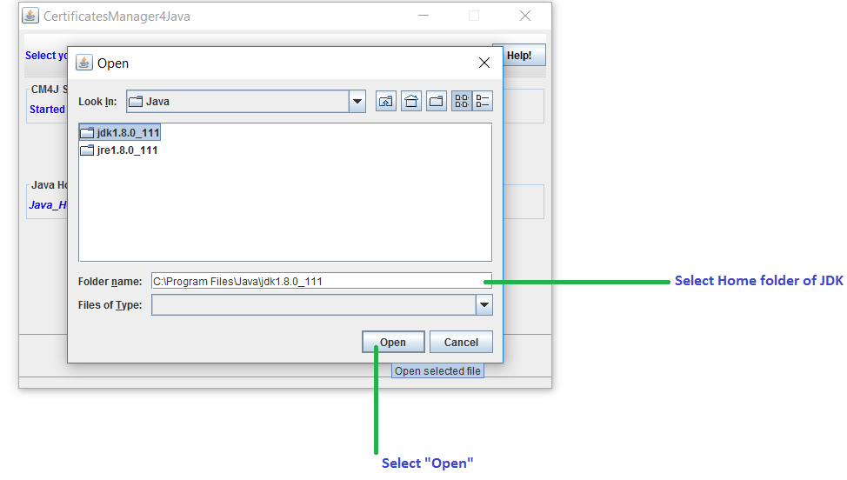

1. You must now see the Java home verified and next button as *“enabled”*.

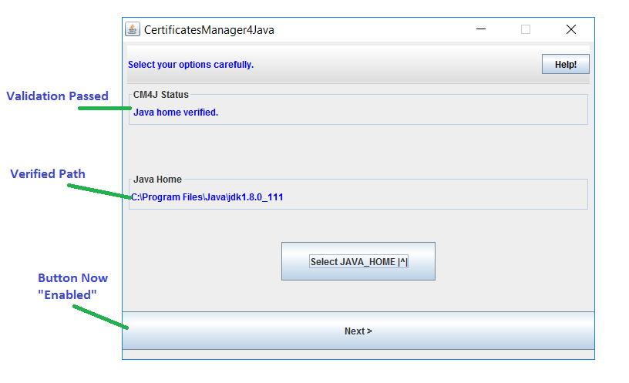

1. Now you will need to select the keystore which you want to perform all operations,

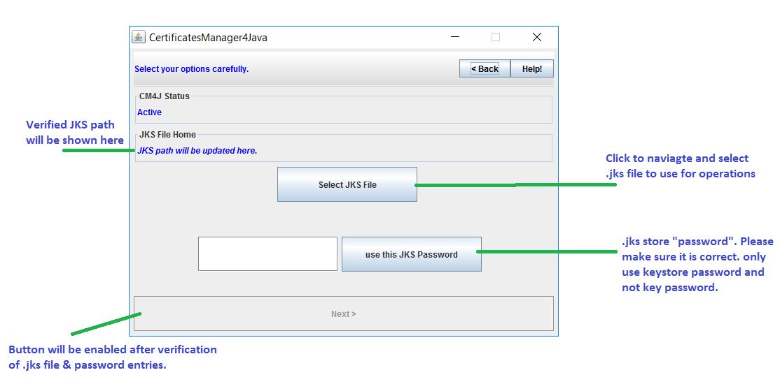

1. In this example, we will select our JKS

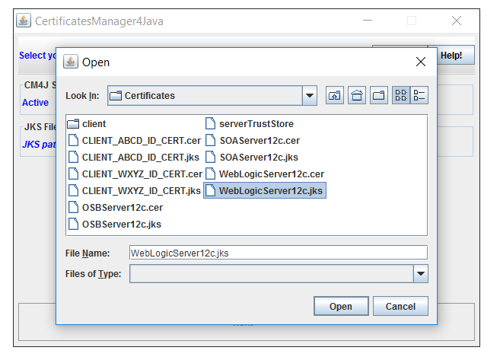

1. Once you have entered all information you will see something like this,

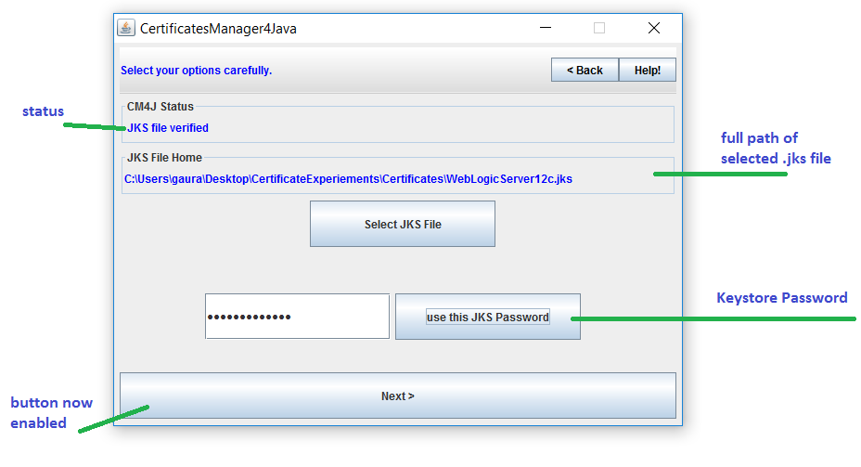

1. Now you will be presented will some of the operations that are currently supported by SSLCertManager4Java in its home screen as shown below,
2. View all certificates
3. Import new certificate into the JKS
4. Export existing certificate from JKS
5. Remove existing certificate from JKS

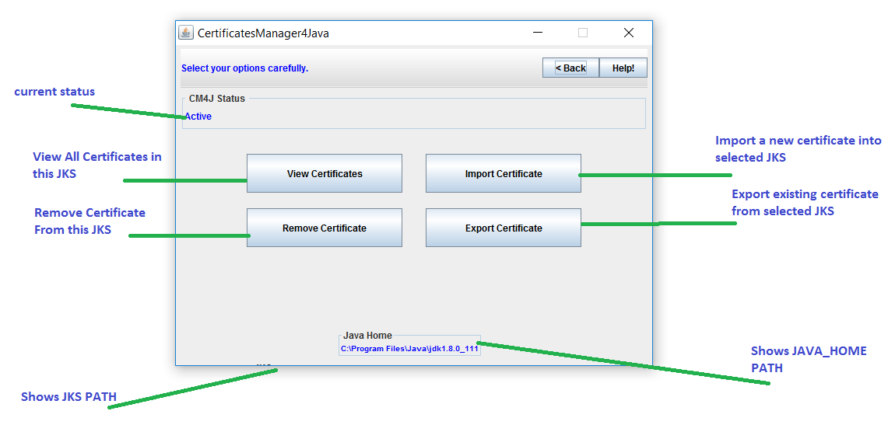

1. View Certificate

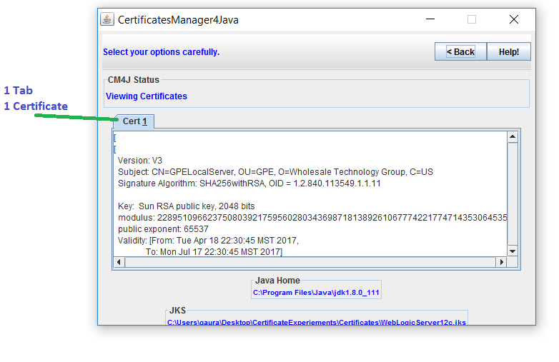

1. Import Certificate

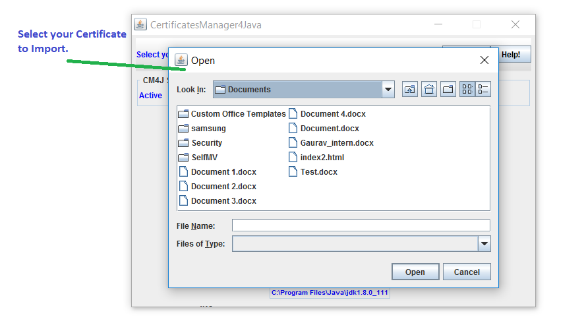

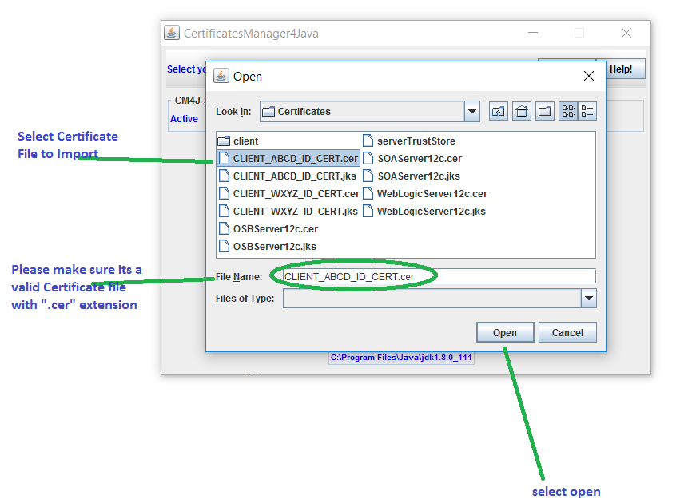

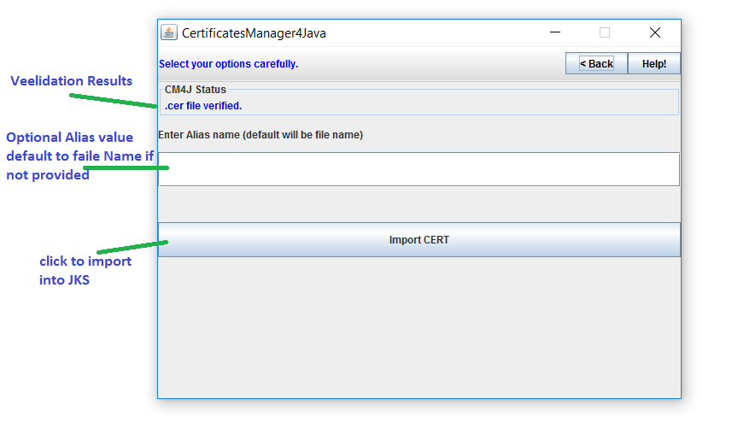

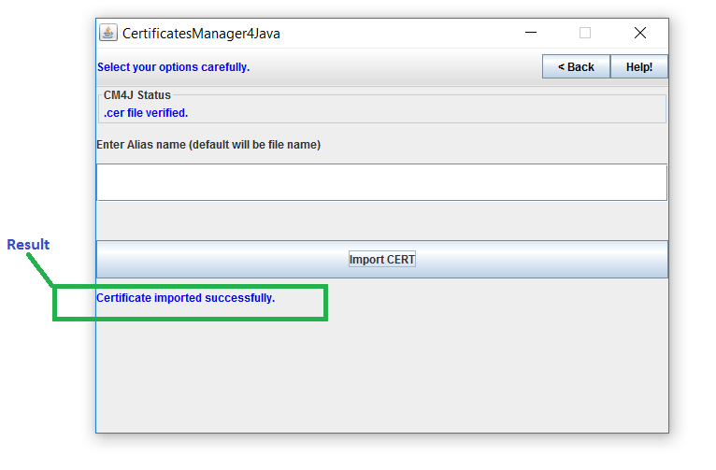

1. Export Operation

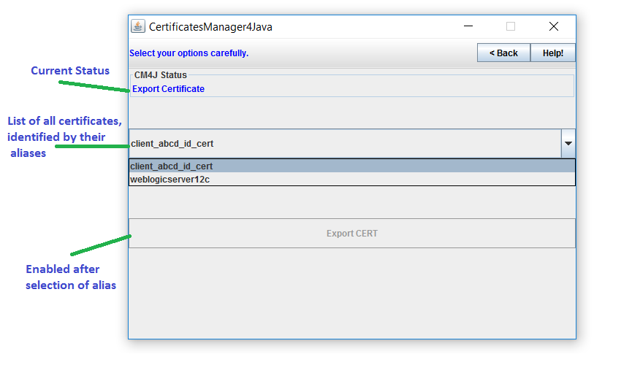

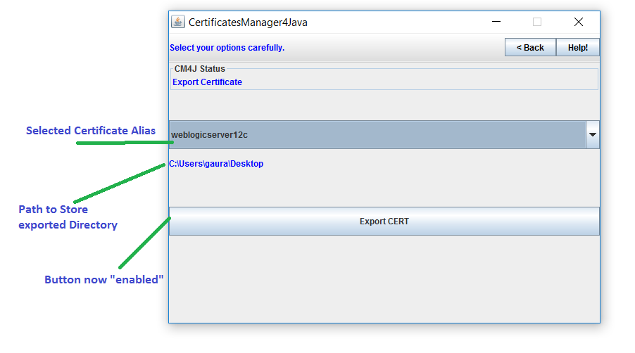

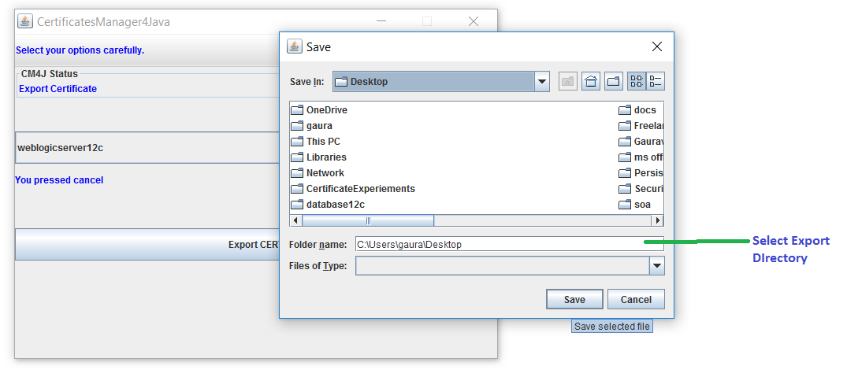

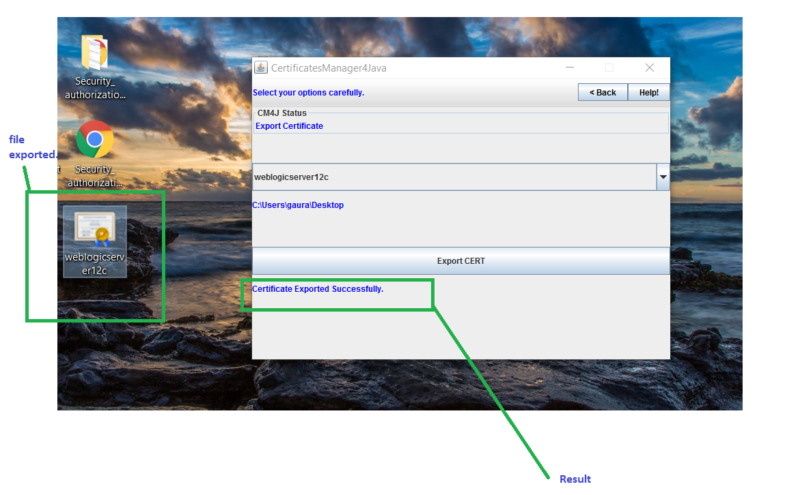

1. Remove Certificate

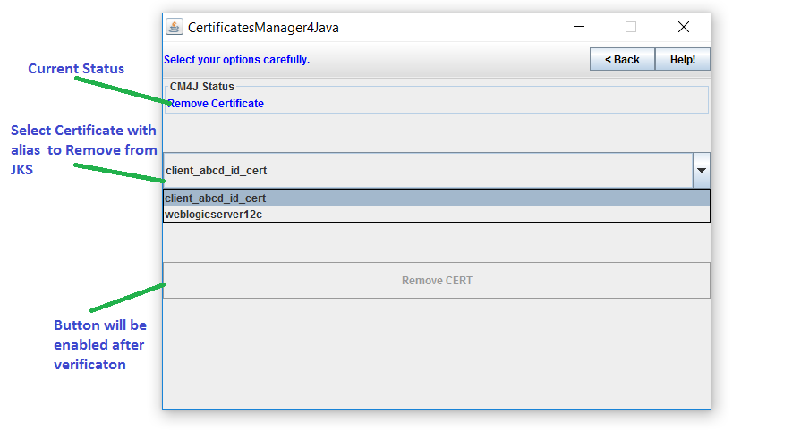

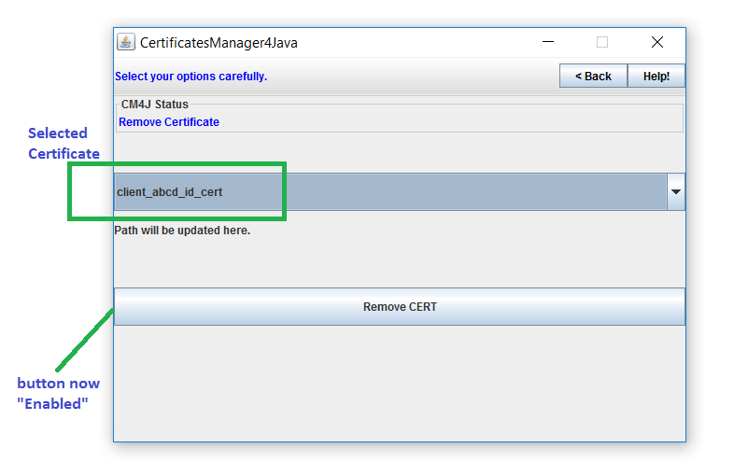

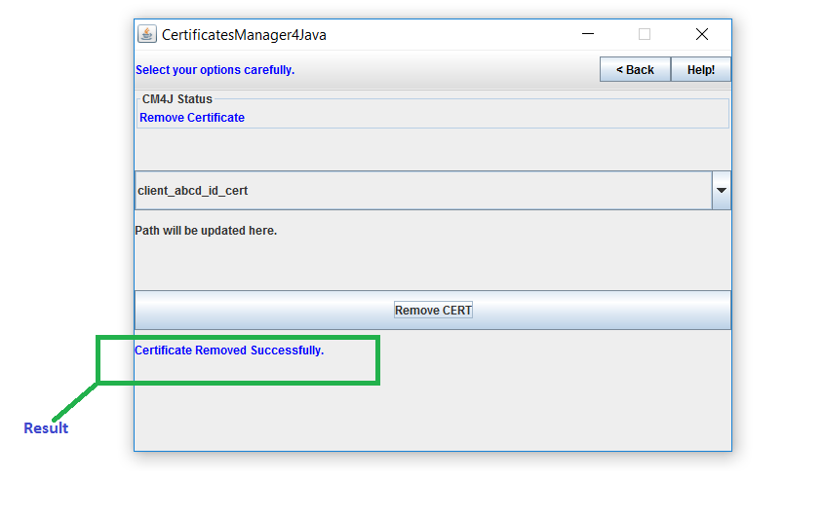

1. Help page and common FAQ, Credits.

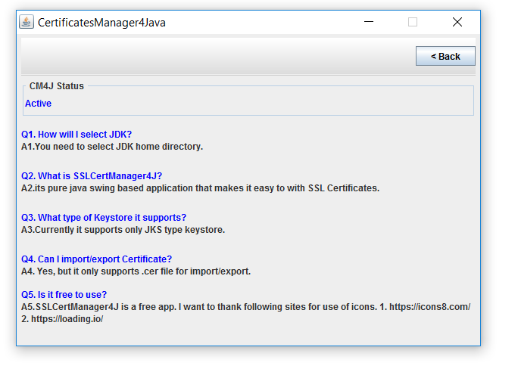

1. Close SSLCerManager4Java

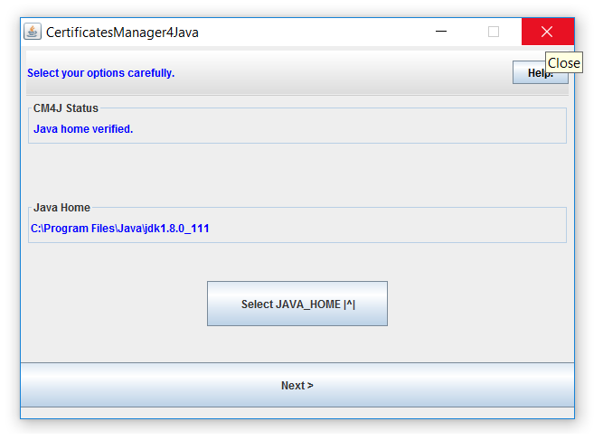

References & Credits:

1. <https://docs.oracle.com/javase/6/docs/technotes/tools/windows/keytool.html>
2. ICONS Used from these sites under open source license
   1. <https://icons8.com/>
   2. <https://loading.io/>