**MODULE:1**

**SE- Overview of IT Industry**

**1.What is software? What is software engineering?**

**-Software:** Software is a set of instructions, data or programs used to operate computers and execute specific tasks.it is the opposite of hardware, which describes the physical aspects of a computer. Software is a generic term used to refer to application, scripts and programs that run on a device.

**-software engineering:** Software engineering is a detailed study of engineering to the design, development and maintenance of software. Software engineering was introduced to address the issues of low-quality software project. Problems arise when a software generally exceeds timelines, budgets, and reduced levels of quality.

**2.Explain types of Software**

**Types of software:**

1. Application Software

2. System Software

3. Middleware Software

4. Driver Software

5. Programming Software

**1.Application Software:**

The most common type of software, application software is a computer software package that performs a specific function for a user, or in some cases, for another application. An application can be self-contained, or can be a group of programs that run the application for the user.

Example of Modern Application include office suites, graphics software, databases and database management programs, web browsers, word processors, software development tools, image editors and communication platforms.

**2.System Software:**

These software programs are designed to run a computers application programs and hardware. Systems software coordinates the activities and functions of the hardware and software.

It controls the operations of the computer hardware and provides an environment or platform for all the other types of software to work in.

**3.Middleware:**

The term middleware describes software that mediates between application and system software or between two different kinds of application software. For example, middleware enables Microsoft Windows to talk to Excel and word.

It is also used to send a remote work request from an application in a computer that has one kind of OS, to an application in a computer with a different OS. It also enables newer application to work with legacy ones.

**4.Driver Software:**

Also Known as device drivers, this software is often considered a type of system software.

Device drivers control the devices and peripherals connected to a computer, enabling them to perform their specific tasks.

Every device that is connected to a computer needs at least one device driver to function.

Example include software that comes with any nonstandard hardware, including special game controllers, as well as the software that enables standard hardware, such as USB storage devices, keyboards, headphones and printers.

**5.Programming Software:**

Computer programmers use programming software to write code. Programming software and programming tools enable developers to develop, write, test and debug other software programs.

Examples of programming software include assemblers, compilers, debuggers and interpreters.

**3.What is SDLC? Explain each phase of SDLC**

**SDLC:** The software development life cycle (SDLC) is the cost-effective and time-efficient process that development terms use to design and build high-quality software. The goal of SDLC is to minimize project risks through forward planning so that software meets customer expectations during production and beyond. This methodology outlines a series of steps that divide the software development process into tasks you can assign, complete, and measure.

**Phase of SDLC:**

1. Requirements gathering

2. Analysis

3. Designing

4. implementation

5. Testing

6. Maintenance

**1.Requirement gathering:**

SDLC is an acronym for SDLC and is the process used as the framework for software development. Project managers and business organizations use the SDLC as a blueprint for completing each step of the SDLC is called a phase. The requirements gathering and analysis phase is the first phase of the SDLC.

**2. Analysis:**

The analysis phase also gathers business requirement and identifies any potential risks. This step in SDLC also includes a feasibility study, which defines all fortes and weak points of the project to assess the overall project viability.

**3. Design:**

In this phase, the software design is created, which includes the overall architecture of the software, date structures, and interfaces. It has two steps:

**- High-level design (HLD):** It gives the architecture of software products.

**- Low-level design (LLD):** It describes how each and every feature in the product should work and every component.

**4. Implementation:**

The design is then implemented in code, usually in several iterations, and this phase is also called as Development.

Things you need to know about this phase:

-This is the longest phase in SDLC model.

-This phase consists of front end + Middleware + Back-end.

**-In front-end:** Development of coding is done even SEO setting are done.

**-In Middleware:** They connect both the front end and back end.

**-In the back-end:** A database is created.

**5. Testing:**

The software is thoroughly tested to ensure that it meets the requirement and works correctly.

**6.Maintenance:**

This phase includes ongoing support, bug fixes, and updates to the software.

**4. What is DFD? Create a DFD diagram on Flipkart**

**-DFD:** A data flow diagram (DFD) is a graphical or visual representation using a standardized set of symbols and notations to describe a business Operations through data movement. They are often elements of a formal methodology such as structured systems analysis and design method. superficially, DFDs can resemble flow charts or unified modeling language, but they are not meant to represent details of software logic.

**Create a DFD diagram on Flipkart**

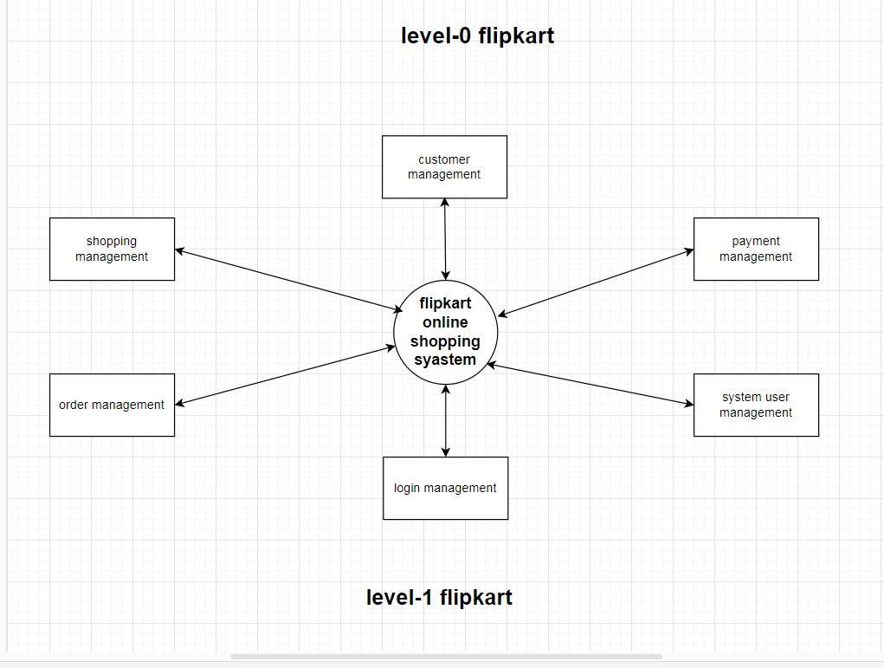

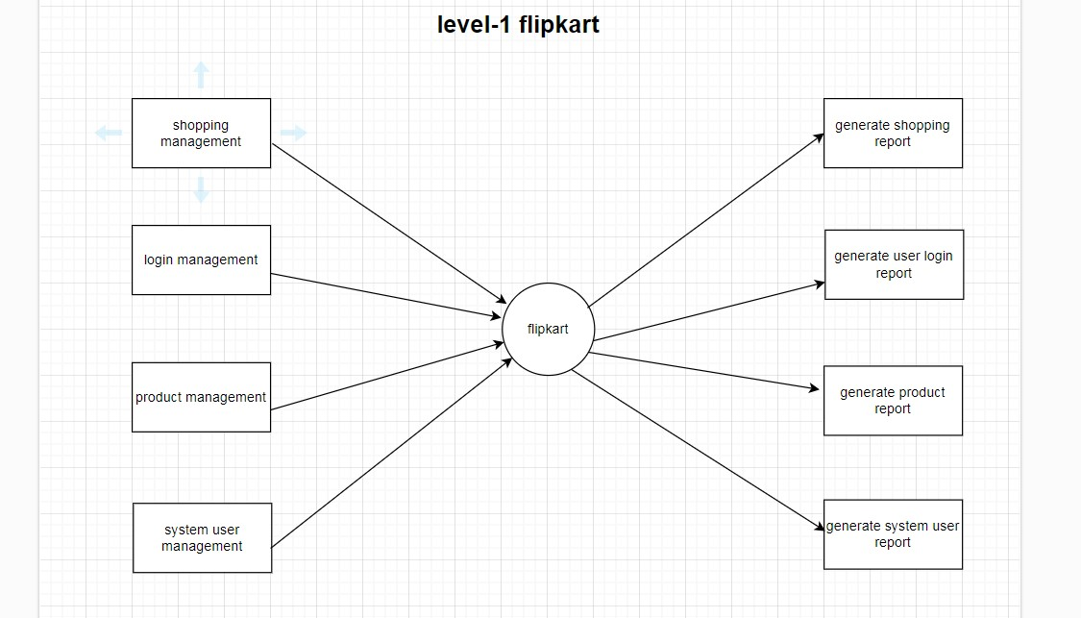

**5. What is Flow charts? Create a Flowchart to make addition of two numbers**

**-Flow charts:**  A flowcharts is a picture of the separate steps of a process in sequential order. It is a generic tool that can be adapted for a wide variety of purposes, and can be used to describe various processes, such as a manufacturing process, an administrative or service process, or a project plan.

**Create a Flowchart to make addition of two numbers**

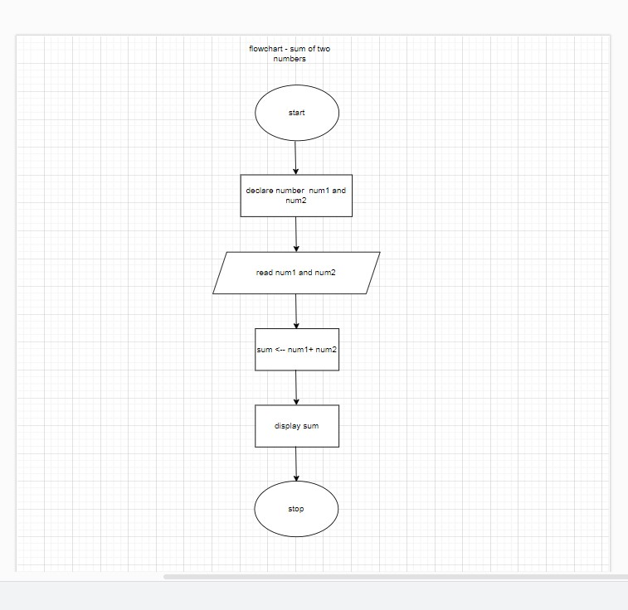

**6. What is Use-case Diagram? Create a use-case on bill payment on Paytm**

**-Use-case Diagram:** A use case diagram is a graphical depiction of a user possible interactions with a system. A use case diagram shows various use cases and different types of users the system has and will often be accompanied by other types of diagrams as well. The use cases are represented by either circles or ellipses.

**Create a use-case on bill payment on Paytm**

