I got selected, Yay !

Rushiraj Gadhvi

2024-05-16

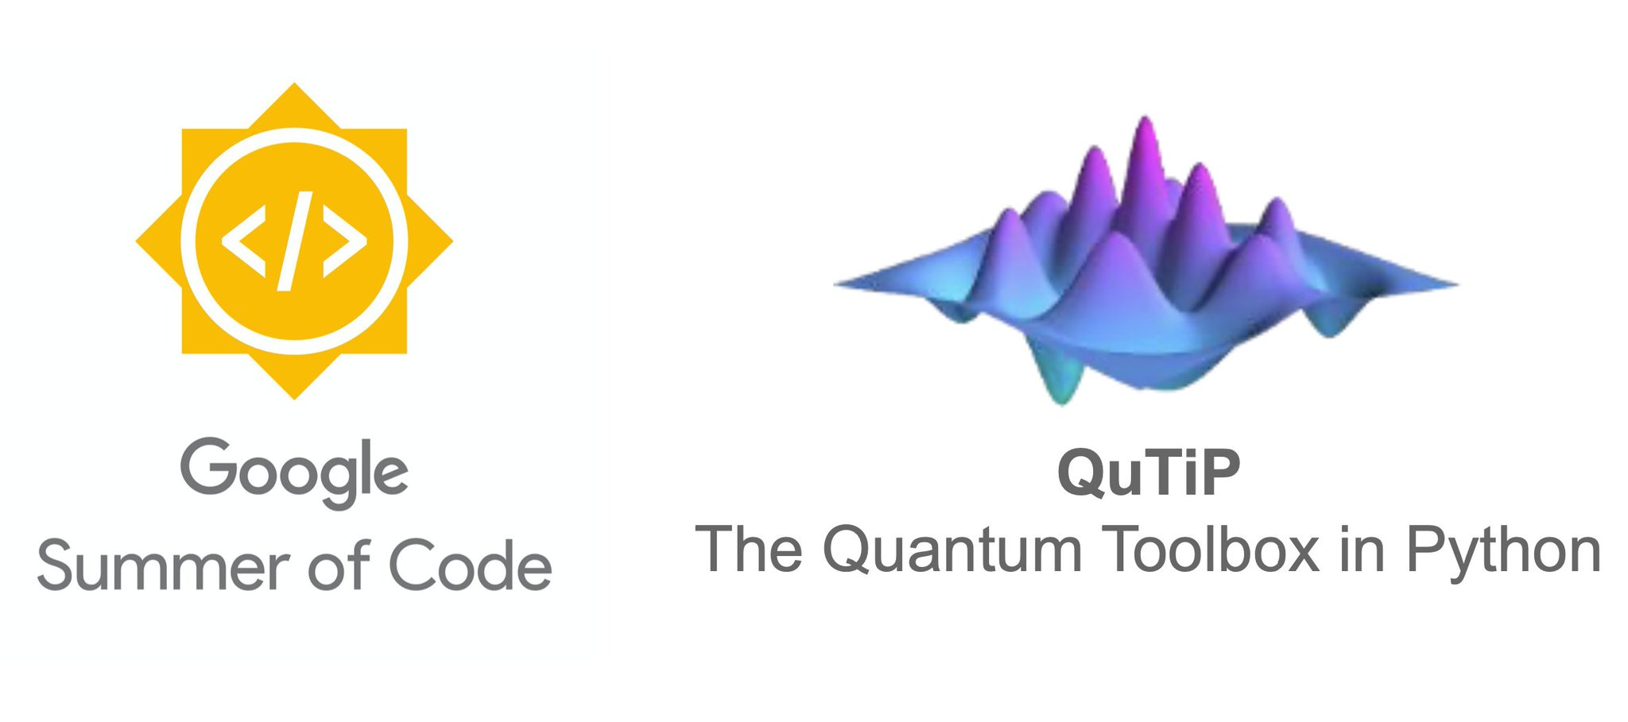

I am thrilled to share that I have been selected for Google Summer of Code (GSoC) 2024 @ QuTiP ! This opportunity is a dream come true, and I am excited to dive into this enriching experience full of learning. This series of blogs will consist of my weekly progress on the project, the hiccups I encounter along the way, how I solve them, and my plans for the upcoming week. In this introductory blog, I will go through the details of the project and objectives.

## Project

The project I will be working on is titled “QuTiP: Enhancing Quantum Circuit Visualization”.

* **Problem Statement** QuTiP offers a wide range of tools and functions for constructing and manipulating quantum states and operators, including a module for constructing quantum circuits and simulation using basic and custom gates, known as QuTiP-QIP. However, while QuTiP’s circuit visualization capabilities currently rely on LaTeX and ImageMagick to display the circuits, which can be cumbersome for users and require additional dependencies. This project seeks to generate an eye-appealing and accurate circuit rendering module without using external dependency.
* **Objectives**
  + Develop Matplotlib based Renderer
  + Develop an ASCII text-based rendering module for command-line interactions
  + Implementing a Circuit Renderer Selector between multiple rendering options
* **Mentors**
  + Boxi Li
  + Neill Lambert
  + Alex Pitchford
  + Simon Cross

## Why the project matters ?

This project is important because it addresses the usability challenges faced by QuTiP users when visualizing quantum circuits. By eliminating the need for external dependencies such as LaTeX and ImageMagick, the new rendering modules will simplify the installation and setup process for users. This will make QuTiP more accessible and user-friendly, particularly for those who may not be familiar with setting up these additional tools.

Additionally, the introduction of a Matplotlib-based renderer will enhance the visual appeal of quantum circuit diagrams, making it easier for researchers and developers to interpret and share their work. The ASCII text-based renderer will provide a lightweight and efficient option for command-line interactions, ensuring that users have a versatile set of tools to suit their different working environments.

By providing a Circuit Renderer Selector, users will have the flexibility to choose the most suitable rendering method for their needs, enhancing their overall experience with QuTiP. Ultimately, this project will enable users to visualize quantum circuits more efficiently and effectively, facilitating better understanding and communication of quantum algorithms and operations.