import matplotlib.pyplot as plt  
from matplotlib.patches import Rectangle, FancyBboxPatch, Circle  
  
import qutip  
from qutip_qip.circuit import QubitCircuit  
from qutip_qip.operations import Gate

WIRE_SEP = 0.7  
LAYER_SEP = 0.6  
PAD_LABEL = 0.3  
GATE_HEIGHT = 0.2  
GATE_WIDTH = 0.2  
GATE_PAD = (LAYER_SEP - GATE_WIDTH)/2  
FONT_SIZE = 10

def draw_wire(ax, n_wires):  
  
 n_layers=2  
 wires = [[(0, n_layers*LAYER_SEP) , (i*WIRE_SEP, i*WIRE_SEP) ] for i in range(n_wires)]  
  
 for wire in wires:  
 line = plt.Line2D(xdata=wire[0], ydata=wire[1], color='black', zorder=1)  
 ax.add_line(line)

def extend_wire(ax, n_wires, old_layers, add_layers):  
   
 wires = [[(old_layers * LAYER_SEP, (old_layers + add_layers) * LAYER_SEP), (i * WIRE_SEP, i * WIRE_SEP)] for i in range(n_wires)]  
  
 for wire in wires:  
 line = plt.Line2D(xdata=wire[0], ydata=wire[1], color='black', zorder=1)  
 ax.add_line(line)

def add_labels(ax, n_wires, wire_labels=[]):  
  
 if wire_labels == []:  
 wire_labels = [f"$q_{{{i}}}$" for i in range(n_wires)]  
   
 for i, label in enumerate(wire_labels):  
 ax.text(-PAD_LABEL, i * WIRE_SEP, label, fontsize=FONT_SIZE, verticalalignment='center')

def draw_control_node(ax, layer, target):  
  
 # make a circle patch  
 node = Circle((layer * LAYER_SEP + LAYER_SEP / 2, target * WIRE_SEP), 0.05, facecolor='blue', zorder=2)  
 ax.add_patch(node)

def draw_target_node(ax, layer, target):  
 TARGET_RADIUS = 0.12  
   
 # Draw the target node as a circle  
 node = Circle((layer * LAYER_SEP + LAYER_SEP / 2, target * WIRE_SEP), TARGET_RADIUS, facecolor='blue', zorder=2)  
 ax.add_patch(node)  
   
 # Draw plus sign  
 vertical = plt.Line2D((layer * LAYER_SEP + LAYER_SEP / 2, layer * LAYER_SEP + LAYER_SEP / 2),  
 (target * WIRE_SEP - TARGET_RADIUS/2, target * WIRE_SEP + TARGET_RADIUS/2),  
 linewidth=1.5, color='white', zorder=3)  
   
 horizontal = plt.Line2D((layer * LAYER_SEP + LAYER_SEP / 2 - TARGET_RADIUS/2, layer * LAYER_SEP + LAYER_SEP / 2 + TARGET_RADIUS/2),  
 (target * WIRE_SEP, target * WIRE_SEP),  
 linewidth=1.5, color='white', zorder=3)  
   
 ax.add_line(vertical)  
 ax.add_line(horizontal)

# add SWAP GATE mark "X"" on the target qubit  
def draw_swap_mark(ax, layer, wire):  
  
 # Draw the diagonal lines to form an "X"   
 dia_left = plt.Line2D(  
 [layer * LAYER_SEP + LAYER_SEP / 2 - GATE_WIDTH / 3, layer * LAYER_SEP + LAYER_SEP / 2 + GATE_WIDTH / 3],  
 [wire * WIRE_SEP - GATE_HEIGHT / 2, wire * WIRE_SEP + GATE_HEIGHT / 2],  
 color="blue", linewidth=1.5, zorder=3  
 )  
 dia_right = plt.Line2D(  
 [layer * LAYER_SEP + LAYER_SEP / 2 + GATE_WIDTH / 3, layer * LAYER_SEP + LAYER_SEP / 2 - GATE_WIDTH / 3],  
 [wire * WIRE_SEP - GATE_HEIGHT / 2, wire * WIRE_SEP + GATE_HEIGHT / 2],  
 color="blue", linewidth=1.5, zorder=3  
 )  
   
 ax.add_line(dia_left)  
 ax.add_line(dia_right)

def draw_bridge(ax, layer, wire1, wire2):  
  
 bridge = plt.Line2D(  
 [layer*LAYER_SEP + LAYER_SEP/2, layer*LAYER_SEP + LAYER_SEP/2],  
 [wire1*WIRE_SEP, wire2*WIRE_SEP],  
 color='blue', linewidth=1, zorder=2  
 )  
  
 ax.add_line(bridge)

def multiq_add_gate(ax, layer, gate):  
  
 # check if gate is a qutip Gate  
 if not isinstance(gate, Gate):  
 print("Gate is not a qutip Gate")  
 return  
   
 # check if gate has multiple targets  
 if gate.name == "CNOT":  
 draw_control_node(ax, layer, gate.controls[0],)  
 draw_target_node(ax, layer, gate.targets[0])  
 draw_bridge(ax, layer, gate.targets[0], gate.controls[0])  
  
 if gate.name == "SWAP":  
 draw_swap_mark(ax, layer, gate.targets[0])  
 draw_swap_mark(ax, layer, gate.targets[1])  
 draw_bridge(ax, layer, gate.targets[0], gate.targets[1])

# adding gate, currently only works for qutip Gates  
def add_gate(ax, layer, gate):  
   
 if isinstance(gate, Gate):  
 pass  
 # print("Gate is a qutip Gate")  
 else:  
 pass  
 # print("Gate is not a qutip Gate")  
  
   
 gate_label = f"${gate.name}$"  
 gate_wire = gate.targets[0]  
  
 gate_patch = FancyBboxPatch(  
 (layer * LAYER_SEP + GATE_PAD, gate_wire * WIRE_SEP - GATE_HEIGHT / 2),   
 GATE_WIDTH,   
 GATE_HEIGHT,   
 boxstyle="round4",   
 mutation_scale=0.3,   
 facecolor="aqua",   
 edgecolor="aqua",  
 zorder=2  
 )   
   
 # gate_patch = Rectangle((layer*LAYER_SEP + GATE_PAD, gate_wire*WIRE_SEP - GATE_HEIGHT/2), GATE_WIDTH, GATE_HEIGHT, facecolor='aqua', zorder=2)  
 ax.add_patch(gate_patch)  
  
 # add gate label  
 ax.text(layer*LAYER_SEP + GATE_PAD + GATE_WIDTH/2, gate_wire*WIRE_SEP, gate_label, fontsize=FONT_SIZE, verticalalignment='center', horizontalalignment='center')

def canvas_plot(qc, height, width):  
   
 fig, ax = plt.subplots(figsize=(width, height))  
  
 nwire = qc.N  
 display_layers = 2  
 draw_wire(ax, nwire) # generalize TODO   
 add_labels(ax, nwire)  
  
 # make a dict with wire_labels as keys and zero values  
 gate_maintain = {f"q{i}": 0 for i in range(nwire)}  
  
 for gate in qc.gates:  
  
 if len(gate.targets) == 1 and gate.controls == None:  
 add_gate(ax, gate_maintain[f"q{gate.targets[0]}"], gate)  
 gate_maintain[f"q{gate.targets[0]}"] += 1  
 else:  
 multiq_add_gate(ax, gate_maintain[f"q{gate.targets[0]}"], gate)  
 # update all values to multiqubot target  
 temp = gate_maintain[f"q{gate.targets[0]}"] + 1  
 gate_maintain = {key:temp for key in gate_maintain.keys()}  
   
 if max(gate_maintain.values()) >= display_layers:  
 extend_wire(ax, nwire, display_layers, add_layers=1)  
  
 display_layers += 1  
   
   
 ax.set_ylim(-WIRE_SEP, nwire*WIRE_SEP)  
 ax.set_xlim(-LAYER_SEP, (display_layers + 1)*LAYER_SEP)  
 ax.set_aspect('equal')  
 ax.axis('off')  
 fig.set_dpi(200)

def calsize(qc):  
  
 n_wires = qc.N   
 height = n_wires * 0.393701 * WIRE_SEP * 3  
 width = 10  
  
 return height, width

qc = QubitCircuit(3)  
qc.add_gate("H", targets=[0])  
qc.add_gate("H", targets=[1])  
qc.add_gate("X", targets=[2])  
qc.gates[0].targets, qc.png  
  
h, w = calsize(qc)  
canvas_plot(qc, h, w)

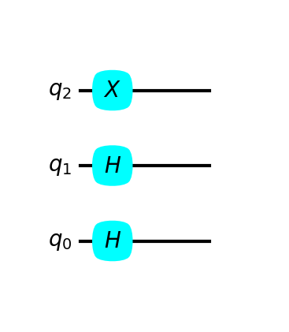

qc

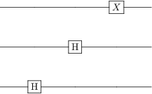

qc = QubitCircuit(2)  
qc.add_gate("H", targets=[0])  
qc.add_gate("H", targets=[1])  
qc.add_gate("X", targets=[1])  
qc.gates[0].targets, qc.png  
  
h, w = calsize(qc)  
canvas_plot(qc, h, w)

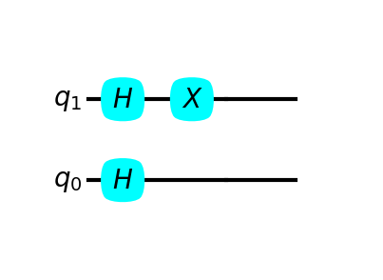

qc = QubitCircuit(2)  
qc.add_gate("H", targets=[0])  
qc.add_gate("H", targets=[1])  
qc.add_gate("X", targets=[1])  
qc.add_gate("CNOT", controls=[0], targets=[1])  
qc.add_gate("CNOT", controls=[1], targets=[0])  
qc.add_gate("CNOT", controls=[0], targets=[1])  
qc

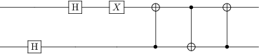

h, w = calsize(qc)  
canvas_plot(qc, h, w)

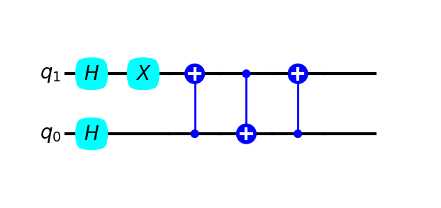

qc.add_1q_gate("X")  
canvas_plot(qc, h, w)

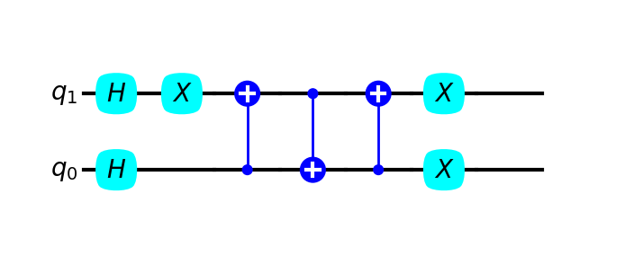

qc = QubitCircuit(3)  
qc.add_gate("H", targets=[0])  
qc.add_gate("CNOT", targets=[1], controls=[2])  
qc.add_gate("H", targets=[1])  
qc.add_gate("X", targets=[1])  
qc.add_gate("CNOT", controls=[0], targets=[1])  
qc.add_gate("CNOT", controls=[1], targets=[0])  
qc.add_gate("CNOT", controls=[0], targets=[2])

qc

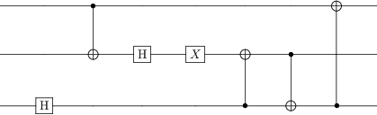

h, w = calsize(qc)  
canvas_plot(qc, h, w)

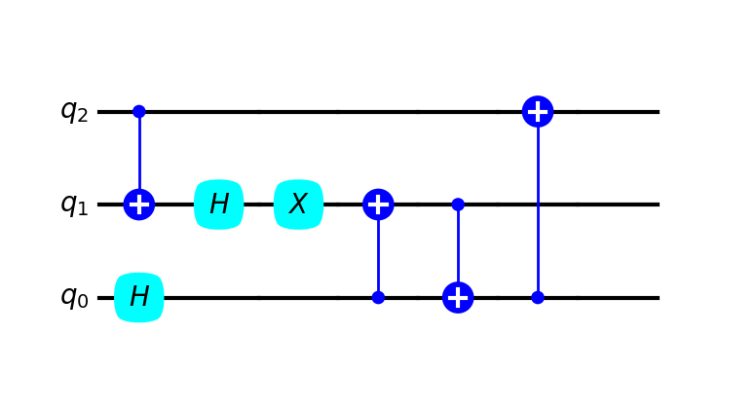

qc = QubitCircuit(3)  
qc.add_gate("H", targets=[0])  
qc.add_gate("CNOT", targets=[1], controls=[2])  
qc.add_gate("H", targets=[1])  
qc.add_gate("Y", targets=[1])  
qc.add_1q_gate("X")  
qc.add_gate("CNOT", controls=[0], targets=[1])  
qc.add_gate("CNOT", controls=[1], targets=[0])  
qc.add_gate("CNOT", controls=[0], targets=[2])  
qc.add_gate("CNOT", controls=[0], targets=[2])  
qc

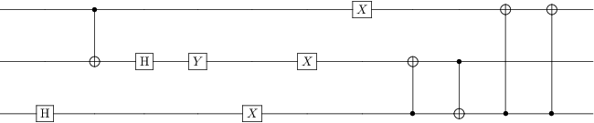

h, w = calsize(qc)  
canvas_plot(qc, h, w)

