How to add a hive service using cloudera?

Before adding hive service, RDBMS should be installed and configured.

With the help of hive service

Below components will be installed.

Hive server2

Hive metastore

Hive webH catalog

Hive

Since I am using mysql database.

I created hive database, hive user and password has been set for the hive user.

mysql –u root –p welcome1

mysql> show databases;

mysql>show tables;

mysql>create database hive;

mysql>use hive;

mysql> create user ‘hive’@’%’ identified by ‘hive’;

mysql>grant all on hive.\* to ‘hive’@’%’ identified by ‘hive’;

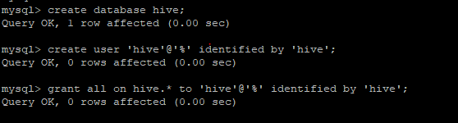

Created some sample table:



insert into fruits values (‘apple’,100);

show tables;

select \* from fruits;

hive press enter

you can connect to like below



