Kerberos errors:

When we run below command

sudo su - hdfs

In Kerberos cluster we are getting below error,



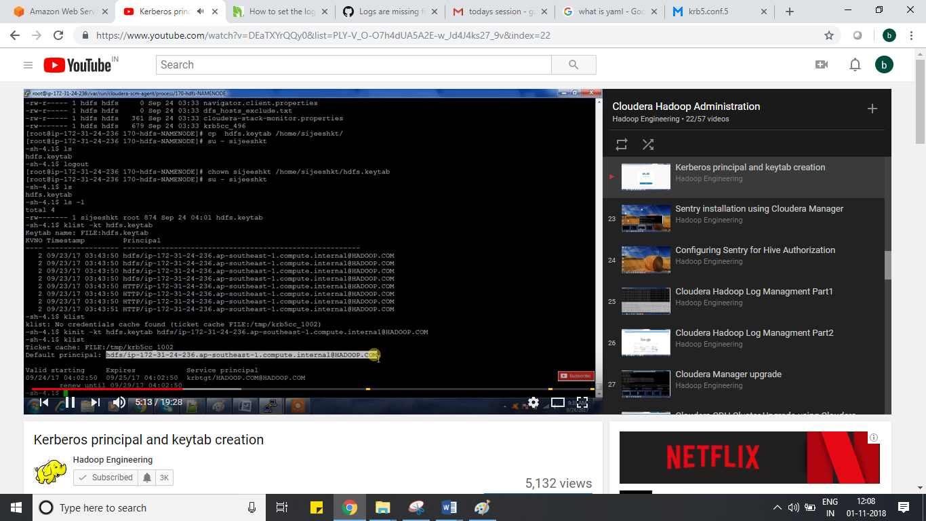

Basic commands:

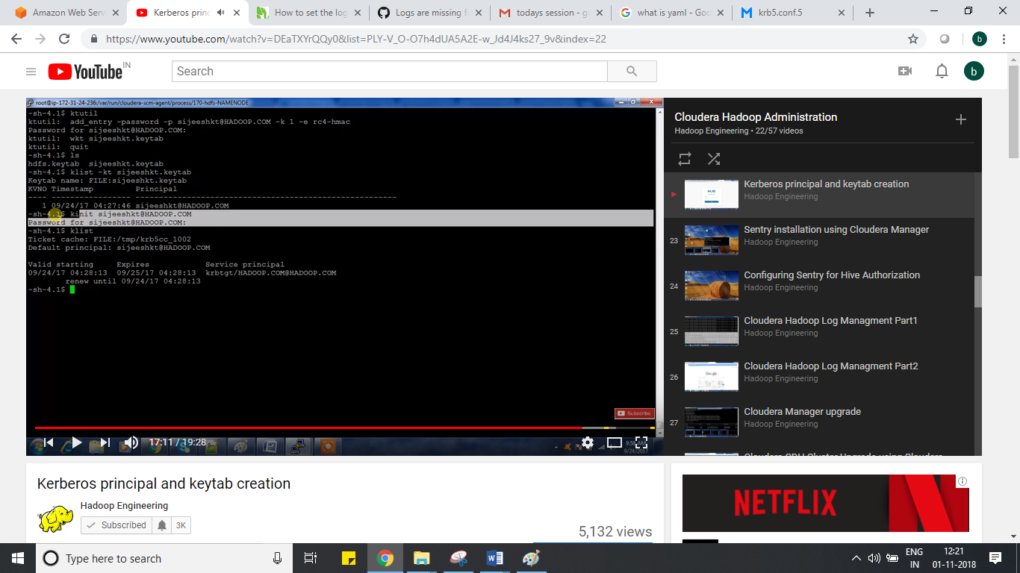

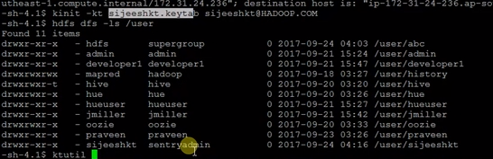

To Solve the issue:

Common Error:

hdfs dfs –ls /

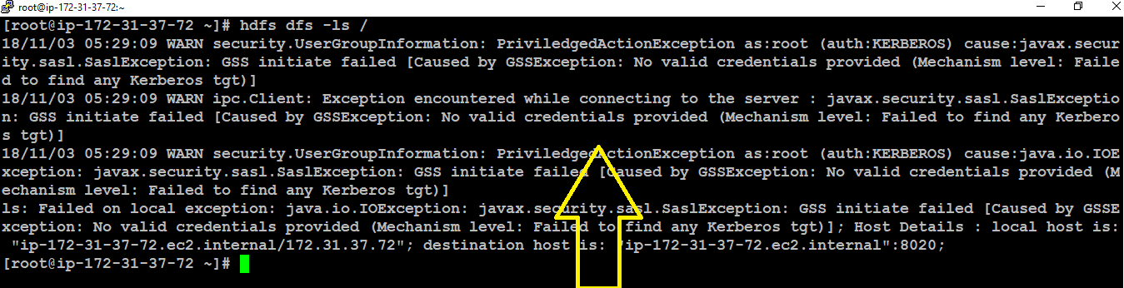

Solution:

We require keytab for this to solve this.

I enabled cloudera using ad.

In cloudera manager , I can get hdfs.keytab or in CLI like below way.

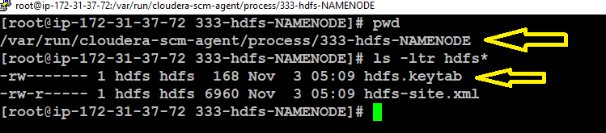

Or

In cloudera manager you can get principal name for HDFS.

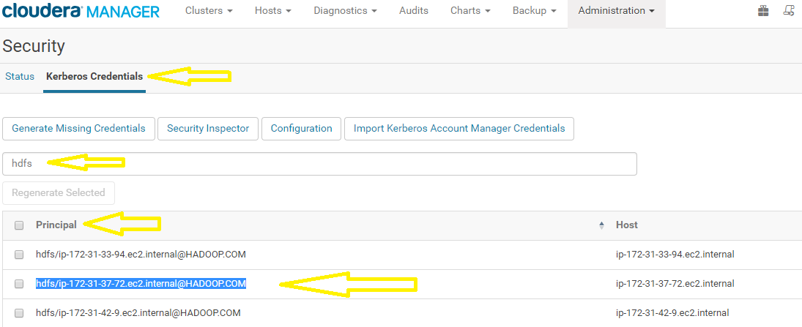

After that copy above hdfs.keytab in /root

And then initialize using below way

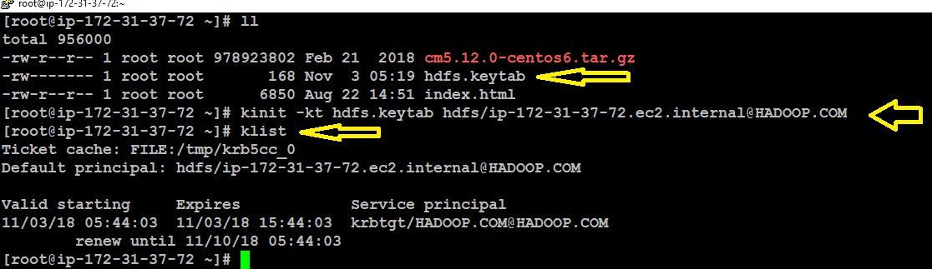

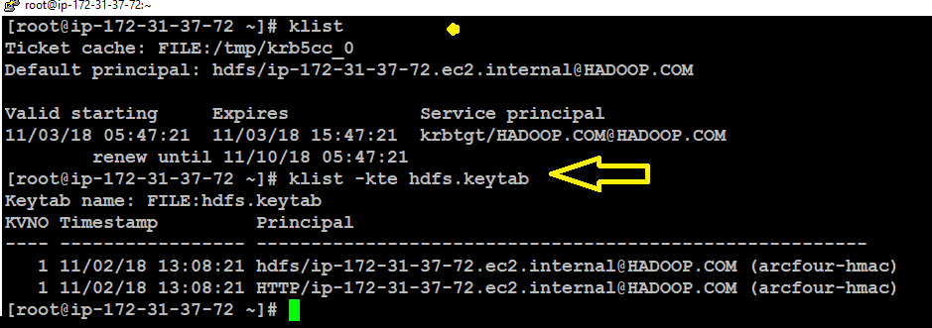

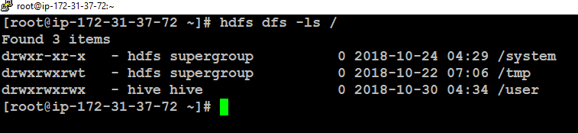

See above now hdfs command working fine now.

How to create keytab?

I have done some steps.

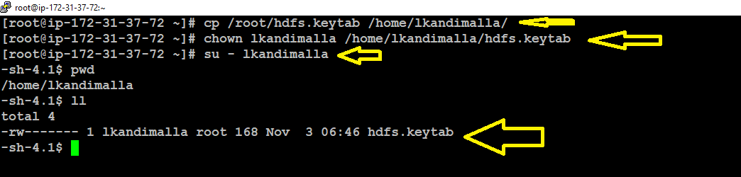

Actual steps for creating keytab.

Lets start.

Logged in with lkandimalla user

1.su – lkandimalla

2.after that run ktutil command you will get below screenshot.

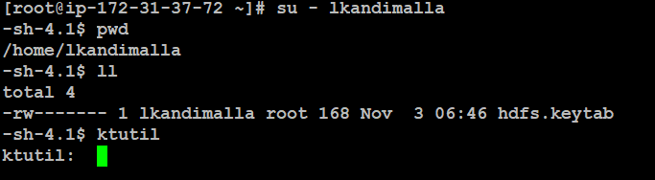

3. after that created principal for lkandimalla user

Using below command

add_entry –password –p [lkandimalla@HADOOP.COM](mailto:lkandimalla@HADOOP.COM) –k 1 –e rc4-hmac

above is lkandimalla prinical name

-k first key

-e encryption type

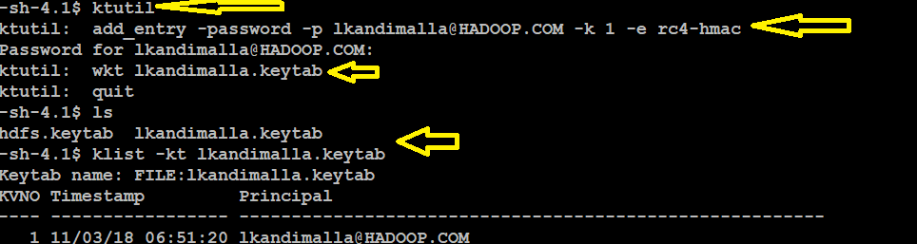

Wkt is download the keytab file.

4. now I have keytab and principal present I can initialize using kinit

Let me do it

Kinit –kt lkandimalla.keytab [lkandimalla@HADOOp.COM](mailto:lkandimalla@HADOOp.COM)

