Sentry:

Sentry is mainly used for authorization.

How to install sentry?

Prerequisites:

First for sentry backend database required, like mysql postgresql or oracle.

Then

To install mysql database

sudo yum -y install mysql-server mysql-connector-java

after that

/usr/bin/mysql-secure-lib-instalation

Use this and set the password for the root user

And then

mysql -u root –p

provide password

mysql>create database sentry;

mysql>create user ‘sentry’@’%’ identified by ‘sentry’;

mysql>grant all privileges on sentry.* to ‘sentry’@’%’;

mysql>flush privileges;

then after go to cloudera manager

go to cluster – add service – sentry

it will aks on which machine sentry server to be configured and sentry gateway to be used.

it will ask DB name and user name and password.

Provide and click continue and conitue and finish.

Check whether sentry service is up and running fine or not.

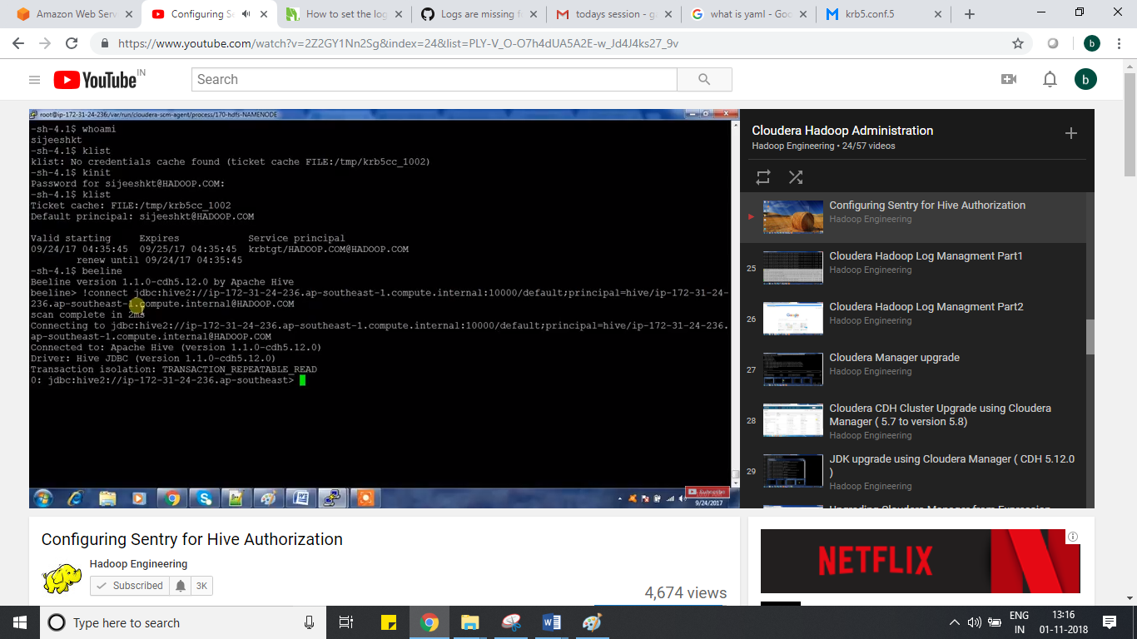

What he did is

He logged in with two different users.

He connected beeline

As usual we need to get ticket before performing beeline things.

klist

kinit -kt keytabname principal name

It will be initialized

klist

It will show information principal name of with tgt

Beeline

Beeline> !connect jdbc:hive2://hiveserver2_ipaddress:10000/default;principal=hiveserver2prinicaplanmae;

We can get hive server2 princiap name from cloudera manager

Administration – security – keberos credentials – there search for hive server2 principal

We can get it.

Once you connected beeline

Lets create some data base

Create database test;

Use test;

Create table table_name (name string, department string);

in local file system

create some file

/home/balaji.txt

Balaji,marketing

Srinivas,sales

Srilakshmi,finance

Load this file into the above table using below

Load data local in path ‘/home/balaji.txt’ overwrite into table table_name;

Select * from table_name

It will having data.

Same activity if you do with other user also.

He can see this data.

Here we are not providing security. That is why sentry come into picture to control access who can access and who can not access it.

To configure sentry with hive;

Initially in hive by default hive impersonation property will be enabled.

Hive impersonation means

If you create directory it will show ur name, and it will not show hive user.

To configure sentry with hive to control access.

1. We need to disable hive impersonation in hive service using cloudera manager
2. After that go to hive service – config tab search with sentry and enable sentry samething for impala and solr hue
3. Go to sentry – config tab – search with admin – it will be having admin group
4. Like that he gave for hue for sentry

If we perform same operations, he cannot see it.

How sentry works ?

Roles

Privilges -> read / write -> for any db or all databases or only single table

We need to grant privilges to the role.

After that

Role – Group whoever user is part of this group he will be having respect access.

Sentryadmin group should have all access, whoever part of sentry admin group he can able to perform all access.

Practicals:

1.first connect to beeline

Beeline

Beeline>!connect jdbc:hive2://hiveserver2ipaddress:10000/default;principal=hiveserver2prinical

Presee enter

We will with hive server2 command prompt

2. then show databases;

3.use default;

4.create role admin_role;

5.show roles;

6.grant all on server server_name to role admin_role;

Server name : we can get in cloudera manager -> hive -> config tab – search with server – there will be having servername like server name for sentry authorization

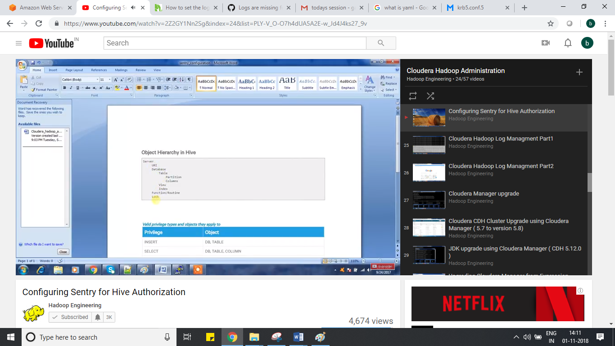

7.grant role admin_role to group group_name

8. he can access all thing.

9. if I want to add particular database only

Create role marketing_role;

Grant all on database marketing to role marketing_role;

Or

Grant all select on database markeing to role marketing_role;

Grant role marketing_role to group marketing;