Monte Carlo Methods
Gadi Cohen
Neural Modeling Lab
1/31/2015
Python printout

import random
import math
import numpy as np
import matplotlib.pyplot as plt

#Question 1

#Histogram of bins of random 100,000 numbers
x=[]

for i in range(0,1000000):
rand=random.random()
x.append(rand)

print np.std(np.array(x))

#STANDARD DEVIATION = .2887 which is ~.2886, the stand dev of uniform distribution

bins=[]
for i in range(0,10):
bins.append([])
for i in range(0,100000):
bins[int(math.floor(10*x[i]))].append(x[i])

plt.hist(x)
plt.title("Problem 1: Uniform Distribution")
plt.xlabel("Bins")
plt.ylabel("Frequency")
plt.show()

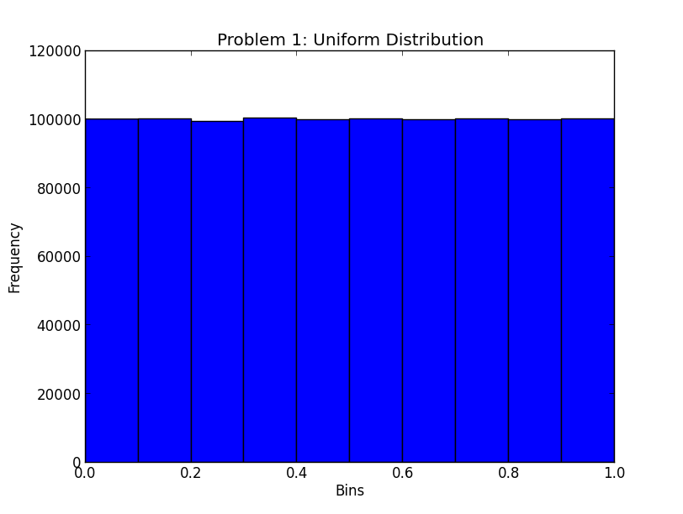

#Question 2

norm=[]

def polar():
def gets():
u1=random.random()
u2=random.random()
v1=2*u1-1
v2=2*u2-1
s=v1**2+v2**2
if s>=1:
v1,v2,s=gets()
return v1,v2,s

v1,v2,s=gets()

if s<1:
x1=v1*math.sqrt((-2*math.log(s))/s)
x2=v2*math.sqrt((-2*math.log(s))/s)
return x1,x2

for i in range(0,50000):
polartuple=polar()
norm.append(polartuple[0])
norm.append(polartuple[1])

plt.hist(norm)
plt.title("Problem 2: Normal Distribution")
plt.xlabel("Bins")
plt.ylabel("Frequency")
plt.show()
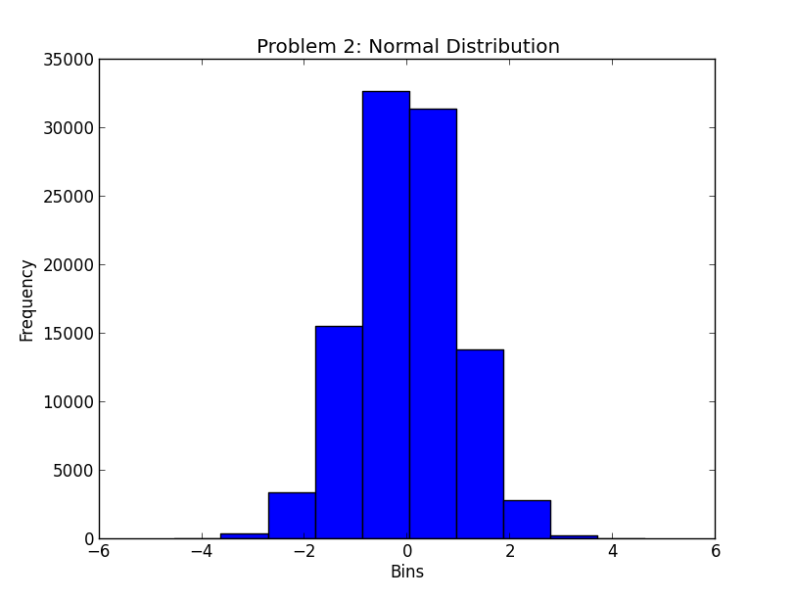

#Question 3
#Generate normalized random vectors with elements taken from a distribution of mean 0

def make_rand_vector(dims):
vec = [random.uniform(-1,1) for i in range(dims)] #gauss: distribution of mean 0, standev 1
mag = sum(x**2 for x in vec) ** .5 #find the magnitude of vector (sqrt of sum of squares of vector values)
return [x/mag for x in vec] #normalize (/mag)

dotprods=[]
for i in range(0,10000):
vec1=make_rand_vector(2)
vec2=make_rand_vector(2)
dotprods.append(np.inner(vec1,vec2))

print np.mean(np.array(dotprods)),np.std(np.array(dotprods))
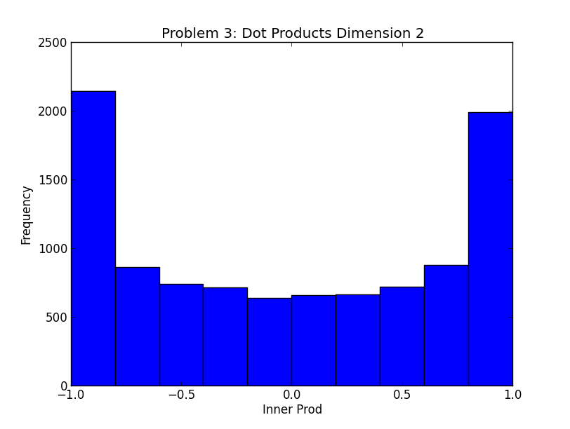
#mean=-.012245, std=.70488

plt.hist(dotprods)
plt.title("Problem 3: Dot Products Dimension 2")
plt.xlabel("Inner Prod")
plt.ylabel("Frequency")
plt.show()

for a in (10,20,50,100,250,500,1000,20000):
dotprods=[]
for i in range(0,10000):
vec1=make_rand_vector(a)
vec2=make_rand_vector(a)
dotprods.append(np.inner(vec1,vec2))
print a, np.mean(np.array(dotprods)),np.std(np.array(dotprods))
if a<1000:
plt.hist(dotprods)
plt.title("Problem 3: Dot Products Dimension "+str(a))
plt.xlabel("Inner Prod")
plt.ylabel("Frequency")
plt.show()

#the dot product of 2 unit vectors on a euclidean plane is the cosine of the angle between them
#the mean should be 0 because that's the average cosine value if we were to generate many vectors

#printed:
“””
standard deviation of uniform
dimensionality, mean of dot products, stand dev of dot products
“””

“””0.288797371988
-0.0150736315765 0.708357662171
10 0.00840605602238 0.31669023373
20 0.00356260969729 0.222631049728
50 0.000467199859086 0.1406881403
100 -0.00032673616364 0.0995615984218
250 -0.000661168091702 0.0632909579607
500 0.00019427610214 0.0444711608658
1000 9.57295556422e-06 0.031605921868”””

