Milestone 2:
Students: Gadi Didi and Ori Levy

ID’s:
Gadi: 208064840
Ori: 206072290

In this project, we’re using four different algorithms in order to find the shortest path of a single pair:
1. BestFirstSearch
2. BreadthFirstSearch
3. DepthFirstSearch
4. A* (A Star)

After creating these four algorithms, we conducted an empiric experiment:
By creating a short python script, we generated 10 matrix-es (We shared that script in the Piazza, in order to help other students). Than, for each matrix, we solved the single pair shortest path problem 10 times, per algorithm (Total of 400 runs, we used our own-written python client to do so).

Afterwards, we analyzed the results in order to determine which algorithm was better.
The race was a close call, but we found that A* is the best algorithm, but the results were very close to BestFirstSearch’s. Both algorithms found the same shortest path, but A* valuated slightly less nodes (Around 1-5 less nodes).

Please have a look at the following diagram:
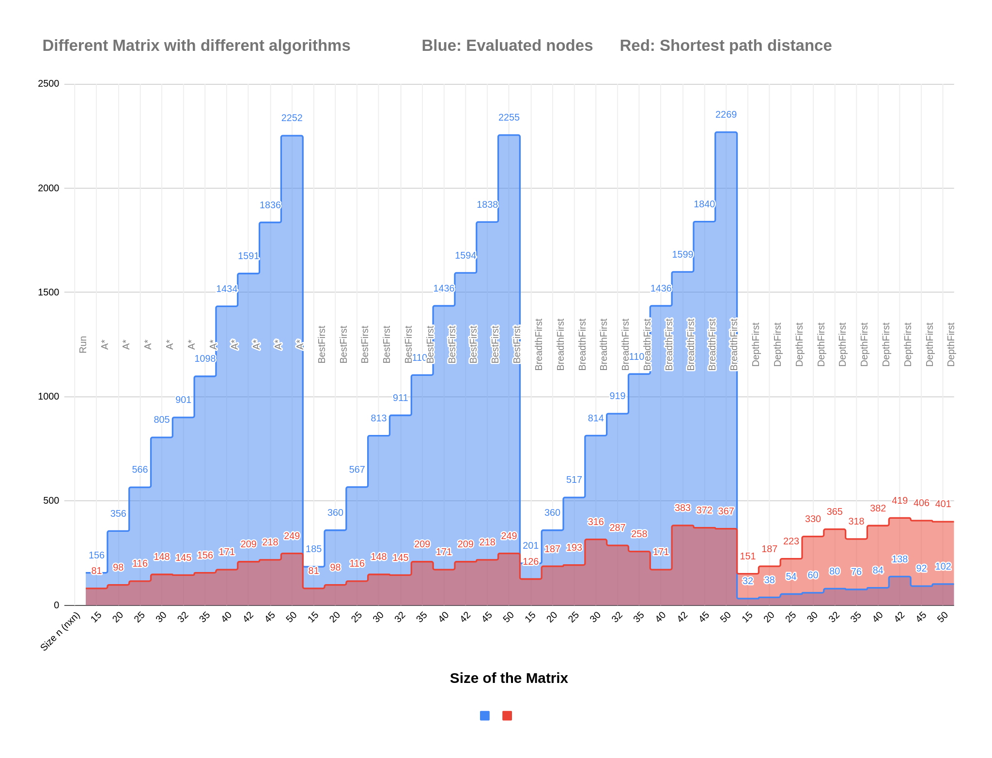
You can also view it in this GDOC:
https://docs.google.com/spreadsheets/d/15jGSk4r3YGXDlGyapMI__yvB7Lvl4o5QdlQ4DBEhqAg/edit?usp=sharing

